# Updates

* According to a report published in DAWN newspaper, the Islamabad police can only spend Rs400 on average per case — around 8,750 cases were investigated last year. For the current fiscal, the capital’s police must work with a meagre sum of Rs3.5m.

# Section-I

## Criminology

### Meaning

An academic discipline that uses the scientific method to study the nature, extent, cause, and control of criminal behaviour. The **subject matter** of criminology ranges from explaining and understanding terrorist activity such as the San Bernardino shootings to preventing white-collar fraud, from drug legalization to cyberbullying. What motivates people like Syed Rizwan Farook and Tashfeen Malik to turn on co-workers and people they knew in the name of jihad? Or was that their real motive? Was their crime a matter of rational choice and decision making or the outcome of delusional thinking and mental illness?

Regardless of which areas of human behaviour they study, criminologists, unlike political figures and media commentators-whose opinions about crime may be colored by personal experiences, biases, and election concerns remain objective, unbiased, and impartial about the behaviours they study; even if it involves horrendous acts such as the marathon bombing.

### Definition

Criminology is the scientific approach to studying criminal behaviour. In their classic definition, preeminent criminologists Edwin Sutherland and Donald Cressey state:

*Criminology is the body of knowledge regarding crime as a social phenomenon. It includes within its scope the processes of making laws, of breaking laws, and of reacting toward the breaking of laws. . . The objective of criminology is the development of a body of general and verified principles and of other types of knowledge regarding this process of law, crime, and treatment.*

Sutherland and Cressey's definition includes some of the most important areas of interest to criminologists:

**Crime is a social phenomenon**. Although some criminologists believe that individual traits and characteristics may play some role in the cause of criminals' antisocial behaviour, most believe that social factors are at the root cause of crime. Even the most disturbed people are influenced by their environment and their social interactions and personal relationships.

**The processes of making laws**. Sutherland and Cressey's definition recognizes the association between crime and the criminal law and shows how the law defines crime. How and why laws are created and why some are strengthened, and others eliminated is of great interest to criminologists.

**Breaking laws and reacting toward the breaking of laws**. At its core, the purpose of criminology is to understand both the onset of crime and the most effective methods for its elimination. Why do people commit illegal acts, and what can be done to convince them-and others who are contemplating crime-that it is in their best interests to turn their back on criminality? These concepts are naturally bound together: it is impossible to effectively control crime unless we understand its cause.

**Development of a body of general and verified principles**. Sutherland and Cressey recognize that criminology is a social science and criminologists must use the scientific method when conducting research. Criminologists are required to employ valid and reliable experimental designs and sophisticated data analysis techniques or else lose standing in the academic community.

## Crime as a social problem

https://www.dawn.com/news/1381283

## Criminology and Criminal Justice

**Def of Criminal Justice**: The field of study that focuses on law enforcement, the legal system, corrections, and other agencies of justice involved in the apprehension, prosecution, defense, sentencing, incarceration, and supervision of those suspected of or charged with criminal offenses.

Although the terms criminology and criminal justice may seem similar, and people often confuse the two or lump them together, there are major differences between these fields of study. Criminology explains the etiology (origin), extent, and nature of crime in society Criminal justice refers to the study of the agencies of social control-police, courts, and corrections-that arrest, prosecute, convict, and treat criminal offenders.

Since both fields are crime-related, they do overlap. Some criminologists devote their research to justice and social control. Their research focuses on how the agencies of justice operate, how they influence crime and criminals, and how justice policies shape crime rates and trends. Conversely, criminal justice experts often want to design effective programs of crime prevention or rehabilitation and to do so must develop an understanding of the nature of crime and its causation. It is common, therefore, for criminal justice programs to feature courses on criminology and for criminology courses to evaluate the agencies of justice.

## Crime and Deviance

Criminology is also related to the study of deviant behaviours. those actions that depart from social norms, values, and beliefs. Included within the broad spectrum of deviant acts are behaviours ranging from violent crimes to joining a nudist colony. The two fields of study are independent because significant distinctions can be made between crime and deviance: many crimes are not unusual or deviant; many deviant acts are neither illegal nor criminal.

Take, for instance, substance abuse. Selling or possessing recreational drugs, such as marijuana, may be illegal in most states and in the federal criminal code , but can it actually be considered deviant? A significant percentage of the population have used or are using drugs; more than half of all high school students have tried drugs before they graduate, and a number of states have legalized the sale and possession of marijuana. For some people smoking marijuana is a routine activity Therefore, it is erroneous to argue that all crimes are deviant behaviours that depart from the norms of society.

Similarly, many deviant acts are not criminal even though they may be both disturbing and shocking to the conscience. Suppose a passerby witness someone floundering in the ocean and makes no rescue attempt. Most people would condemn the onlooker's coldhearted behaviour as callous, immoral, and deviant. However, no legal action could be taken since a private citizen is not required by law to risk his or her own life to save another's. People who let others burn, drown, or starve are not held in high esteem, but according to the law, they are not criminals.

**Criminologist’s concern**: Under what circumstances do deviant behaviours become crimes? When does sexually oriented material cross the line from merely suggestive to obscene and therefore illegal? If an illegal act becomes a norm, should society re-evaluate its criminal status? There is still debate over the legalization and/or decriminalization of abortion, recreational drug use, possession of handguns, and assisted suicide.

## What criminologists do/Criminology in action/Scope of criminology

**Criminologist**: As two noted criminologists, Marvin Wolfgang and Franco Ferracuti, put it: "A criminologist is one whose professional training, occupational role, and pecuniary reward are primarily concentrated on a scientific approach to, and study and analysis of, the phenomenon of crime and criminal behaviour.

**Criminology in action**: Criminology in action refers to the efforts of criminologists to use their insight, training, and experience to understand human behaviour and predict its occurrence. Because criminologists have been trained in diverse fields, several subareas reflecting different orientations and perspectives are now contained within the broader area of criminology. What are some of the specific goals and areas of study on which criminologists focus their attention?

### Criminal stats and crime measurement

The subarea of criminal statistics and crime measurement involves devising valid and reliable measures designed to calculate the amount and trends of criminal activity: How much crime occurs annually? Who commits it? When and where does it occur? Which crimes are the most serious?

The media love to sensationalize crime and report on lurid cases of murder and rape. The general public is influenced by these stories, becoming fearful and altering their behaviour to avoid victimization. 4 These news accounts proclaiming crime waves are often driven by the need to pull in website readers or increase TV viewership. There is nothing like an impending crime wave or serial killer on the loose to boost readership or viewership. Media accounts therefore can be biased and inaccurate, and it is up to criminologists to set the record straight.

Criminologists try to create valid and reliable measurements of criminal behaviour. They create techniques to access the records of police and court agencies and use sophisticated statistical methods to understand underlying patterns and trends. They develop survey instruments and then use them with large samples to determine the actual number of crimes being committed and the number of victims who suffer criminal violations: how many people are victims of crime, and what percentage reports the crime to police.

Criminologists are also interested in helping agents of the criminal justice system develop effective crime control policies that rely on accurate measurement of crime rates. By using advanced statistical techniques to calculate where crime will take place, police departments can allocate patrol officers based on these predictions.

### Socio-legal studies

Socio-legal studies is a subarea of criminology concerned with the role social forces play in shaping criminal law and, concomitantly, the role of criminal law in shaping society. Socio-legal studies involves linking the study of law with such core social issues as social change and stability, order and disorder, the nation-state and capitalism, racial discrimination, income inequality, and justice. Research on socio-legal issues involves methodologically sophisticated empirical investigations as the central means of studying the dynamics of law in society.

Very often the content of the law and the focus of criminological inquiry are highly integrated, making socio-legal research quite relevant. Take for instance the crime of obscenity Typically, there is no uniform standard of what is considered obscene; material that to some people is lewd and offensive may be considered a work of art by others. Nonetheless, anti-porn crusaders have had a long history of trying to curb the manufacture and distribution of sexually related material. In 1969 in the case of Stanley v. Georgia , the Supreme Court ruled that a person can legally possess, read, and view adult material in the privacy of their home. 7 Despite this legal green light, criminologists have conducted research aimed at determining whether viewing pornography is harmful. Are people who view pornography more likely to commit violent crime than nonwatchers?8 Because criminologists have found evidence of a link between watching obscenity and violence toward women, efforts continue to be made to control its creation and dissemination.

The Supreme Court routinely uses and cites research findings by legal scholars and criminologists before it renders an opinion. 10 Social science evidence is routinely used in death penalty cases. In their opinion in the case of Glossip v. Gross, Justices Breyer and Ginsburg relied on social science research by socio-legal scholar Samuel Gross and his colleagues showing that there is a greater likelihood of an initial wrongful conviction in a death penalty case. 11 Why is this so? Because capital cases typically involve horrendous murders and are thus accompanied by intense community pressure on police, prosecutors, and jurors to secure a conviction. This pressure creates a greater likelihood of convicting the wrong person.

### Theory constructing and Testing

Social theory can be defined as a systematic set of interrelated statements or principles that explain some aspect of social life. At their core, theories should serve as models or frameworks for understanding human behaviour and the forces that shape its content and direction. Because, ideally, theories are based on verified social facts-readily observed phenomena that can be consistently quantified, and measured-criminological theorists use the scientific method to test their theories. They gather data, derive hypotheses-testable expectations of behaviour that can be derived from the theory-and then test them using valid empirical research methods. Social learning theory (see Chapter 7) states that people learn behaviour by observing how other people act. Adolescent behaviour is controlled by the influence of parents, peers, and neighbors. If this statement is accurate, then logically there should be a significant association between peer influence and behaviour.

To test this theory, criminologists might conduct an experiment to see if peers who engage in and espouse deviant attitudes actually influence behaviour.

### Criminal behaviour systems and crime typologies

**Crime typology:** The study of criminal behaviour involving research on the links between different types of crime and criminals. Because people often disagree about types of crimes and criminal motivation, no standard exists within the field. Some typologies focus on the criminal, suggesting the existence of offender groups, such as professional criminals, psychotic criminals, occasional criminals, and so on. Others focus on the crimes, clustering them into categories such as property crimes, sex crimes, and so on.

Criminologists who study criminal behaviour systems and crime typologies focus their research on specific criminal types and patterns: violent crime, theft crime, public order crime, and organized crime. Numerous attempts have been made to describe and understand particular crime types. Marvin Wolfgang's famous 1958 study, **Patterns in Criminal Homicide**-considered a landmark analysis of the nature of homicide and the relationship between victim and offender-found that victims often precipitate the incident that results in their death. 13 Edwin Sutherland's analysis of business-related offenses helped coin a new phrase **white-collar crime** to describe economic crime activities.

Criminologists also conduct research on the links between different types of crime and criminals. This is known as a crime typology. Some typologies focus on the criminal, suggesting the existence of offender groups, such as professional criminals, psychotic criminals, amateur criminals, and so on. Others focus on the crimes, clustering them into categories such as property crimes, sex crimes, and so on. While 50 years ago they might have focused their attention on rape, murder, and burglary, they now may be looking at stalking, cybercrime, terrorism, and hate crimes. A number of criminologists are now doing research on terrorism, trying to determine if there is such a thing as a "terrorist personality."

Research on criminal behaviour systems and crime types is important because it enables criminologists to understand why people commit specific sorts of crime, and using this information, gives them the tools to devise crime reduction strategies.

### Punishment, penology and social control

Criminologists also are involved in creating effective crime policies, developing methods of social control, and the correction and control of known criminal offenders; it is this segment of criminology that overlaps criminal justice. Criminologists conduct research that is designed to evaluate justice initiatives in order to determine their efficiency, effectiveness, and impact. Take for instance this important legal issue: should capital punishment continue to be employed or is its use simply too risky? To explore this issue, Samuel Gross and his colleagues looked at death row inmates who were later found to be innocent. The sample of 340 death row inmates (327 men and 13 women), exonerated after having served years in prison, indicated that about half (144 people) were cleared by DNA evidence. Collectively, they had spent more than 3,400 years in prison for crimes they did not commit-an average of more than 10 years each. Gross and his colleagues found that exonerations from death row are more than 25 times more frequent than exonerations for other prisoners convicted of murder, and more than 100 times more frequent than for all imprisoned felons. 15 How many wrongful convictions might be uncovered if all criminal convictions were given the same degree of scrutiny as death penalty cases? The Gross research illustrates how important it is to evaluate penal measures in order to determine their effectiveness and reliability.

### Victimology

In two classic criminological studies, one by Hans von Hentig and the other by Stephen Schafer, the critical role of the victim in the criminal process was first identified. These authors were the first to suggest that victim behaviour is often a key determinant of crime and that victims' actions may actually precipitate crime. Both men believe that the study of crime is not complete unless the victim's role is considered.

The study of victims and victimization has uncovered some startling results. For one thing, criminals have been found to be at greater risk for victimization than noncriminals. 17 Rather than being the passive receptors of criminal acts who are in the "wrong place at the wrong time," crime victims may engage in high-risk lifestyles that increase their own chance of victimization and make them highly vulnerable to crime.

In recent years, criminologists have devoted ever-increasing attention to the victim's role in the criminal process. It has been suggested that a person's lifestyle and behaviour may actually increase the risk that he or she will become a crime victim. Some have suggested that living in a high-crime neighborhood increases risk; others point at the problems caused by associating with dangerous peers and companions.

## Crime

Considering the multidisciplinary nature of the field of criminology, fundamental issues such as the nature and definition of crime itself are cause for disagreement among criminologists. A criminologist's choice of orientation or perspective depends, in part, on his or her definition of crime. This section discusses the three most common concepts of crime used by criminologists.

### The consensus view of crime

**Def:** The belief that the majority of citizens in a society share common ideals and work toward a common good and that, crimes are acts that are outlawed because they conflict with the rules of the majority and are harmful to society.

As the eminent criminologists Edwin Sutherland and Donald Cressey put it: Criminal behaviour is behaviour in violation of the criminal law. . [I]t is not a crime unless it is prohibited by the criminal law [which] is defined conventionally as a body of specific rules regarding human conduct which have been promulgated by political authority, which apply uniformly to all members of the classes to which the rules refer, and which are enforced by punishment administered by the state.

This approach to crime implies that it is a function of the beliefs, morality, and rules established by the existing legal power structure. According to Sutherland and Cressey's statement, criminal law is applied "uniformly to all members of the classes to which the rules refer. " This statement reveals the authors' faith in the concept of an "ideal legal system" that deals adequately with all classes and types of people. Laws prohibiting theft and violence may be directed at the neediest members of society, whereas laws that sanction economic acts such as insider trading, embezzlement, and corporate price-fixing are aimed at controlling the wealthiest. The reach of the criminal law is not restricted to any single element of society.

The consensus view of crime links illegal behaviour to the concept of social harm. Though people generally enjoy a great deal of latitude in their behaviour, it is agreed that behaviours that are harmful to other people and society in general must be controlled.

This position is not without controversy. Although it is clear that rape, robbery, and murder are inherently harmful and their control justified, behaviours such as drug use and prostitution are more problematic because the harm they inflict is only on those who are willing participants. According to the consensus view, society is justified in controlling these so-called victimless crimes because public opinion holds that they undermine the social fabric and threaten the general well-being of society. Society has a duty to protect all its members-even those who choose to engage in high-risk behaviours.

### Conflict view

**Def:** The view that human behaviour is shaped by interpersonal conflict and that those who maintain social power will use it to further their own needs.

The conflict view depicts society as a collection of diverse groups-business owners, workers, professionals, students-who are in constant and continuing conflict. Groups able to assert their political power use the law and the criminal justice system to advance their economic and social position. Criminal laws, therefore, are viewed as acts created to protect the haves from the have-nots. Critical criminologists often compare and contrast the harsh penalties exacted on the poor for their "street crimes" (burglary, robbery, and larceny) with the minor penalties the wealthy receive for their white-collar crimes (securities violations and other illegal business practices), though the latter may cause considerably more social harm. While the poor go to prison for minor law violations, the wealthy are given lenient sentences for even the most serious breaches of law. Rather than being class neutral, criminal law reflects and protects established economic, racial, gendered, and political power and privilege.

Crime, according to this definition, is a political concept designed to protect the power and position of the upper classes at the expense of the poor. Even crimes prohibiting violent acts, such as armed robbery, rape, and murder, may have political undertones. Banning violent acts ensures domestic tranquility and guarantees that the anger of the poor and disenfranchised classes will not be directed at their wealthy capitalist exploiters. According to this conflict view of crime, "real" crimes would include the following acts: Violations of human rights due to racism, sexism, and imperialism ■ Unsafe working conditions ■ Inadequate childcare ■ Inadequate opportunities for employment and education ■ Substandard housing and medical care ■ Crimes of economic and political domination ■ Pollution of the environment ■ Price-fixing ■ Police brutality. Etc.

### Interactionist view

**Def**: The view that one's perception of reality is significantly influenced by one's interpretations of the reactions of others to similar events and stimuli.

The interactionist view of crime traces its antecedents to the symbolic interaction school of sociology, first popularized by pioneering sociologists George Herbert Mead, Charles Horton Cooley, and W. I. Thomas. 20 They created a school of thought that explains social behaviour in terms of how people interact with each other via symbols. How people communicate and interact with each other depends on how they interpret factors such as language, actions, physical status. A person might interpret someone approaching with a raised fist as a threat or a victory sign depending on the context. Sometimes the meaning of symbols change: having a visible tattoo once symbolized rebellion, now it's normative and stylish.

According to this perspective, there is no objective reality. People, institutions, and events are viewed subjectively and labeled either good or evil according to the interpretation of the evaluator. Take for instance how people react to the book and film Fifty Shades of Grey. Some readers/viewers consider it to be obscene, degrading, and distasteful while others view the same book and film as inoffensive, romantic, and provocative.

The same interactions help define crime: ■ The content of the criminal law and consequently the definition of crime often depend on human interaction and perceptions. Marijuana is now legal in some jurisdictions (Colorado and Washington among others) and illegal in others.

Deciding whether an individual act is considered a crime is also a function of interaction and labeling. When a heated argument in a local tavern results in the death of one of the participants, a jury may be asked to decide whether the death was an intentional act-first-degree murder-or a lesser crime such as criminally negligent homicide. They may also find the death was legally justified, a result of self-defense, or merely an accidental fatality Each person on the jury may have his or her own interpretation of what took place: whether the act is labeled a crime and the actor a criminal depends on the juror's personal interpretation of events.

In a classic statement, sociologist Howard Becker argued , "The deviant is one to whom that label has successfully been applied; deviant behaviour is behaviour people so labeled. "21 According to the interactionist view, the definition of crime reflects the preferences and opinions of people who hold social power in a particular legal jurisdiction. These moral entrepreneurs wage campaigns (moral crusades) to control behaviours they view as immoral and wrong (e.g. , abortion) or, conversely, to legalize or decriminalize behaviours they consider harmless social eccentricities (e.g. , smoking pot). Those who hold social and legal power control the definition of the law. Because drug use offends their moral sense, it is currently illegal to purchase cocaine and hashish, while liquor and cigarettes are sold openly, even though far more people die of alcoholism and smoking than from drug abuse each year.

Fifty years ago, a man could not be prosecuted for raping his wife ; today, every state criminalizes marital rape. In sum, the definition of crime is more reflective of prevailing moral values than of any objective standard of right and wrong.

The interactionist view of crime is similar in some ways to the conflict perspective; both suggest that behaviour is outlawed and considered criminal when it offends people who hold social, economic, and political power. However, unlike the conflict view, the interactionist perspective does not attribute capitalist economic and political motives to the process of defining crime. Laws against pornography, prostitution, and drugs are believed to be motivated more by moral crusades than by economic values.

### Summary

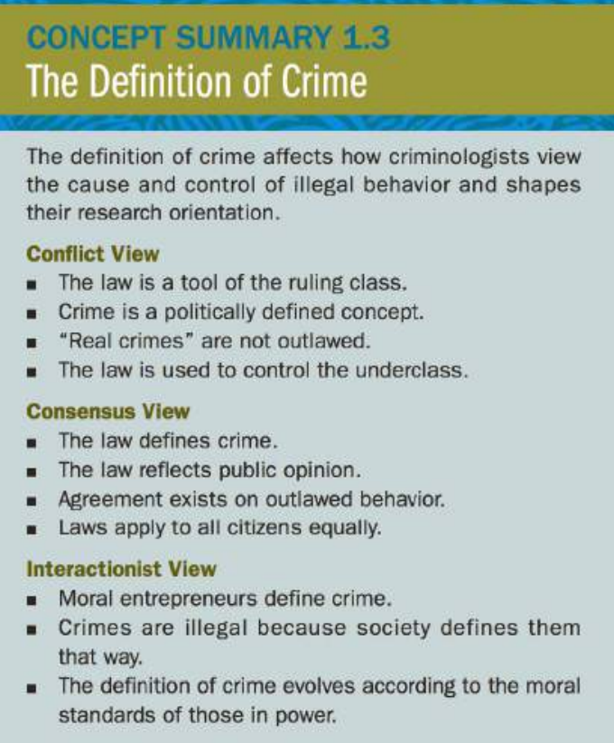

### Definition of Crime

It is possible to take elements from each school of thought to formulate an integrated definition of crime, such as this one:

*Crime is a violation of societal rules of behaviour as interpreted and expressed by a criminal legal code created by people holding social and political power. Individuals who violate these rules are subject to sanctions by state authority, social stigma, and loss of status.*

This definition combines the consensus position that the criminal law defines crimes with the conflict perspective's emphasis on political power and control and the interactionist concept of labeling and stigma. Thus crime, as defined here, is a political, social, and economic function of modem life.

## Crime and Criminal Law

No matter which definition of crime we embrace, criminal behaviour is tied to the law. It is therefore important for all criminologists to have some understanding of the development of law, its objectives, its elements, and how it has evolved.

### Brief History of the Law

The concept of criminal law has been recognized for more than 3,000 years. Hammurabi (1792-1750 BCE), the sixth king of Babylon, created the most famous set of written laws of the ancient world, known today as the Code of Hammurabi. Preserved on basalt rock columns, the code established a system of crime and punishment based on physical retaliation ("an eye for an eye"). The severity of punishment depended on class standing: if convicted of an unprovoked assault, a slave would be killed, whereas a freeman might lose a limb.

More familiar is the Mosaic Code of the Israelites (1200 BCE). According to tradition, God entered into a covenant or contract with the tribes of Israel in which they agreed to obey his law (the 613 laws of the Old Testament, including the Ten Commandments), as presented to them by Moses, in return for God's special care and protection. The Mosaic Code is not only the foundation of JudeaChristian moral teachings but also a basis for the U.S. legal system. Prohibitions against murder, theft, and perjury preceded by several thousand years the same laws found in the modern United States.

Though ancient formal legal codes were lost during the Dark Ages, early German and Anglo-Saxon societies developed legal systems featuring monetary compensation for criminal violations. Guilt was determined by two methods. One was compurgation, in which the accused person swore an oath of innocence with the backing of 12 to 25 oath helpers, who would attest to his or her character and claims of innocence. The second was trial by ordeal, which was based on the principle that divine forces would not allow an innocent person to be harmed. It involved such measures as having the accused place his or her hand in boiling water or hold a hot iron. If the wound healed, the person was found innocent; if the wound did not heal, the accused was deemed guilty Another version, trial by combat, allowed the accused to challenge his accuser to a duel, with the outcome determining the legitimacy of the accusation. Punishments included public flogging, branding, beheading, and burning.

### Common Law

The present English system of law came into existence during the reign of Henry II (1154-1189), when royal judges began to publish their decisions in local cases. Judges began to use these written decisions as a basis for their decision making, and eventually a fixed body of legal rules and principles was established. If a new rule was successfully applied in a number of different cases, it would become a precedent. These precedents would then be commonly applied in all similar cases-hence the term common law.

Crimes such as murder, burglary, arson, and rape are common-law crimes whose elements were initially defined by judges. They are referred to as **mala in se**, inherently evil and depraved. When the situation required it, the English Parliament enacted legislation to supplement the judge-made common law. These were referred to as statutory or **mala prohibitum** crimes, which reflected existing social conditions.

English common law evolved constantly to fit specific incidents that the judges encountered. In the Carriers case (14 73), an English court ruled that a merchant who had been hired to transport merchandise was guilty of larceny (theft) if he kept the goods for his own purposes. 23 Before the Carriers case, it was not considered a crime under the common law when people kept something that was voluntarily placed in their possession, even if the rightful owner had only given them temporary custody of the merchandise. Breaking with legal tradition, the court acknowledged that the commercial system could not be maintained unless the laws of theft were expanded. The definition of larceny was altered in order to meet the needs of a growing free enterprise economic system. The definition of theft was changed to include the taking of goods not only by force or stealth but also by embezzlement and fraud.

## Law in contemporary society: types of law

In contemporary U.S. society, the law governs almost all phases of human enterprise, including commerce, family life, property transfer, and the regulation of interpersonal conflict. It contains elements that control personal relationships between individuals and public relationships between individuals and the government. The former is known as civil law, and the latter is called criminal law. The law then can generally be divided into four broad categories:

#### Substantive criminal law

The branch of the law that defines crimes and their punishment is known as substantive criminal law. It involves such issues as the mental and physical elements of crime, crime categories, and criminal defenses.

#### Procedural criminal law

Those laws that set out the basic rules of practice in the criminal justice system are procedural criminal laws. Some elements of the law of criminal procedure are the rules of evidence, the law of arrest, the law of search and seizure, questions of appeal, jury selection, and the right to counsel.

#### Civil law

The set of rules governing relations between private parties, including both individuals and organizations (such as business enterprises or corporations), is known as civil law. The civil law is used to resolve, control, and shape such personal interactions as contracts, wills and trusts, property ownership, and commerce. Contained within the civil law is tort law, discussed in Exhibit 1.1.

#### Public or administrative law

The branch of law that deals with the government and its relationships with individuals or other governments is known as public law. It governs the administration and regulation of city, county, state, and federal government agencies.

## The Substantive Criminal law

The substantive criminal law defines crime and punishment. Each federating unit and the federal government have their own substantive criminal code, developed over many generations and incorporating moral beliefs, social values, and political, economic, and other societal concerns.

Criminal laws are divided into felonies and misdemeanors. The distinction is based on seriousness: a felony is a serious offense; a misdemeanor is a minor or petty crime. Crimes such as murder, rape, and burglary are felonies; they are punished with long prison sentences or even death.

Crimes such as unarmed assault and battery, petty larceny, and disturbing the peace are misdemeanors; they are punished with a fine or a period of incarceration in a county jail. Regardless of their classification, acts prohibited by the criminal law constitute behaviours considered unacceptable and impermissible by those in power. People who engage in these acts are eligible for severe sanctions. By outlawing these behaviours, the government expects to achieve a number of social goals:

Enforcing social control, discouraging private revenge, expressing public opinion and morality, deterring criminal behaviour, punishing wrongdoing, providing restoration to victims.

### Elements of criminal law

#### Legal def of crime

Today, in all jurisdictions, the legal definition of a crime involves the elements of the criminal acts that must be proven in a court of law if the defendant is to be found guilty. For the most part, common criminal acts have both mental and physical elements, both of which must be present if the act is to be considered a legal crime. In order for a crime to occur, the state must show that the accused committed the guilty act, or **actus reus**, and had the **mens rea**, or criminal intent, to commit the act.

The actus reus may be an aggressive act, such as taking someone's money, burning a building, or shooting someone; or it may be a failure to act when there is a legal duty to do so, such as a parent neglecting to seek medical attention for a sick child. The mens rea (guilty mind) refers to an individual's state of mind at the time of the act or, more specifically, the person's intent to commit the crime.

#### Actus Reus

To satisfy the requirements of actus reus, guilty actions must be voluntary. Even though an act may cause harm or damage, it is not considered a crime if it was done by accident or was an involuntary act. It would not be a crime if a motorist obeying all the traffic laws hit a child who ran into the street. If the same motorist were drinking or speeding, then his action would be considered a vehicular crime because it was a product of negligence. Similarly, it would not be considered a crime if a babysitter accidentally dropped a child and the child died. However, it would be considered manslaughter if the sitter threw the child down in anger or frustration and the blow caused the child's death. In some circumstances of actus reus, the use of words is considered criminal. In the crime of sedition, the words of disloyalty constitute the actus reus. If a person falsely yells "fire" in a crowded theater and people are injured in the rush to exit, that person is held responsible for the injuries because the use of the word in that situation constitutes an illegal act. Typically, the law does not require people to aid others in distress, such as entering a burning building to rescue people trapped by a fire. However, failure to act is considered a crime in certain instances:

**Relationship of the parties based on status**. Some people are bound by relationship to give aid. These relationships include parent/child and husband/wife. If a husband finds his ,vife unconscious because she took an overdose of sleeping pills, he is obligated to save her life by seeking medical aid. If he fails to do so and she dies, he can be held responsible for her death.

**Contractual relationships**. These relationships include lifeguard and swimmer, doctor and patient, and babysitter or au pair and child. Because lifeguards have been hired to ensure the safety of swimmers, they have a legal duty to come to the aid of drowning persons. If a lifeguard knows a swimmer is in danger and does nothing about it and the swimmer drowns, the lifeguard is legally responsible for the swimmer's death.

#### Mens Rea

In most situations, for an act to constitute a crime, it must be done with criminal intent, or mens rea (guilty mind). Intent, in the legal sense, can mean carrying out an act intentionally, knowingly, and willingly. However, the definition also encompasses situations in which recklessness or negligence establishes the required criminal intent. Criminal intent exists if the results of an action, although originally unintended, are certain to occur. When Timothy McVeigh planted a bomb in front of the Murrah Federal Building in Oklahoma City, he did not intend to kill any particular person in the building. Yet the law would hold that McVeigh or any other person would be substantially certain that people in the building would be killed in the blast, and McVeigh therefore had the criminal intent to commit murder.

#### Strict Liability

Though common-law crimes require that both the actus reus and the mens rea must be present before a person can be convicted of a crime, several crimes defined by statute do not require mens rea. In these cases, the person accused is guilty simply by doing what the statute prohibits; intent does not enter the picture. These strict liability crimes, or public welfare offenses, include violations of health and safety regulations, traffic laws, and narcotic control laws. A person stopped for speeding is guilty of breaking the traffic laws regardless of whether he or she intended to go over the speed limit or did it by accident. The underlying purpose of these laws is to protect the public; therefore, intent is not required.

## Evolution of Criminal law

The criminal law is constantly evolving in an effort to reflect social and economic conditions. Sometimes legal changes are prompted by highly publicized cases that generate fear and concern. **Zainab Alert**

The criminal law may also change because of shifts in culture and social conventions, reflecting a newfound tolerance of behaviour condemned only a few years before. In an important 2003 case, Lawrence v. Texas, the Supreme Court declared that laws banning sodomy (a sexual act deemed to be "unnatural" or immoral) were unconstitutional because they violated the due process rights of citizens because of their sexual orientation. As a result of the decision, all sodomy laws in the United States are now unconstitutional and therefore unenforceable.

Add new laws related to harassment, cybercrimes, environment, terrorism, etc.

## Theoretical Perspectives

### Classical Theory

#### Early explanation of criminal behaviour

During the early Middle Ages (1200-1400), superstition and fear of satanic possession dominated thinking. People who violated social norms or religious practices were believed to be witches or possessed by demons and not rational decision makers. St. Thomas Aquinas (1225-1274) argued that there was a God-given "natural law" that was based on people's natural tendency to do good. People who were evil were manifesting original sin and a fall from grace, similar to that experienced by Adam and Eve when they were expelled from the Garden of Eden. The prescribed method for dealing with the possessed was burning at the stake, a practice that survived into the seventeenth century. Beginning in the midthirteenth century, the jurisdiction of central governments reached a significantly broader range of social behaviours. Human problems and conflicts began to be dealt with in a formalized and legal manner. 3 Nonetheless, superstition and harsh punishments did not end quickly. The authorities were on guard against Satan's offspring, who engaged in acts ranging from witchcraft to robbery.

lt was common practice to use cruel tortures to extract confessions, and those convicted of violent or theft crimes suffered extremely harsh penalties, including whipping, branding, maiming, and execution. Almost all felons were punished with death; the law made little distinction between thieves and murderers.

This rather fantastical vision of deviant behaviour and its control began to wane as new insights were developed about human nature and behaviour during the Renaissance. One influential authority, philosopher Thomas Hobbes (1588-1678), suggested the existence of a "social contract" between people and the state: people naturally pursue their own self-interests but are rational enough to realize that selfishness will produce social chaos, so they agree to give up their own selfish interests as long as everyone else does the same thing. Not all agree to the social contract, and therefore the state became empowered with the right to use force to maintain the contract.

#### Bentham

During the eighteenth-century Enlightenment period, social philosophers such as Jeremy Bentham (1748-1833) began to embrace the view that human behaviour was a result of rational thought processes. According to Bentham's "utilitarian calculus," people choose to act when, after weighing costs and benefits, they believe that their actions will bring them an increase in pleasure and a reduction of pain. It stands to reason that criminal behaviour could be eliminated or controlled if would-be law violators could be convinced that the pain of punishment exceeds the benefits of crime. 5 The purpose of law is to produce and support the total happiness of the community it serves. Because punishment is in itself harmful, its existence is _justified only if it promises to prevent greater evil than it creates. Punishment, therefore, has four main objectives:

1. To prevent all criminal offenses

2. When it cannot prevent a crime, to convince the offender to commit a less serious crime

3. To ensure that a criminal uses no more force than is necessary

4. To prevent crime as cheaply as possible

#### Beccaria

The development of rational classical criminology is most closely identified with the thoughts of Italian social philosopher Cesare Beccaria (1738-1794) and his famous treatise "**On Crimes and Punishment**" in which he called for fair and certain punishment to deter crime. Beccaria believed people are egotistical and self-centered, and therefore they must be motivated by the fear of punishment, which provides a tangible motive for them to obey the law and suppress the "despotic spirit" that resides in every person. 7 He suggested that (a) people choose all behaviour, including criminal behaviour; (b) their choices are designed to bring them pleasure and reduce pain; (c) criminal choices can be controlled by fear of punishment; and (d) the more severe, certain, and swift the punishment, the greater its ability to control criminal behaviour.

According to Beccaria, punishment must be proportional to the seriousness of crime; if not, people would be encouraged to commit more serious offenses. If robbery, rape, and murder were all punished by death, robbers or rapists would have little reason to refrain from killing their victims to eliminate them as witnesses to the crime. Today, this is referred to as the concept of marginal deterrenceif petty offenses were subject to the same punishment as more serious crimes, offenders would choose the more serious crime because the resulting punishment would be about the same. 8 Beccaria also suggested that the extremely harsh punishments of the day and routine use of torture were inappropriate and excessive. To deter crime, the pain of punishment must be administered in a fair, balanced, and proportionate amount, _just enough to counterbalance the pleasure obtained from crime.

#### Classical criminology

The writings of Beccaria and his followers form the core of what today is referred to as classical criminology As originally conceived in the eighteenth century, classical criminology theory had several basic elements:

* In every society, people have free will to choose criminal or lawful solutions to meet their needs or settle their problems.
* Criminal solutions can be very attractive because for little effort they hold the promise of a huge payoff.
* A person will choose not to commit crime only if he or she believes that the pain of expected punishment is greater than the promise of reward. This is the principle of deterrence.
* In order to be an effective crime deterrent, punishment must be severe, certain, and swift enough to convince potential criminals that "crime does not pay"

The classical perspective influenced penal practices for more than 200 years. The law was made proportionate to crime so that the most serious offenses earned the harshest punishments. Executions were still widely used but slowly began to be employed for only the most serious crimes. The catchphrase was "let the punishment fit the crime." Beccaria's ideas and writings inspired social thinkers to believe that criminals choose to commit crime and that crime can be controlled by judicious punishment. His vision was widely accepted throughout Europe and the United States.

By the end of the nineteenth century, the popularity of the classical approach began to decline, and by the middle of the twentieth century, this perspective was neglected by mainstream criminologists. During this period, criminologists focused on internal and external factors-poverty, IQ, education, home life-which were believed to be the true causes of criminality Because these conditions could not be easily manipulated, the concept of punishing people for behaviours beyond their control seemed both foolish and cruel. Although classical principles still controlled the way police, courts, and correctional agencies operated, most criminologists rejected classical criminology as an explanation of criminal behaviour.

### Trait theory

#### Foundations

During the late nineteenth century, the scientific method was beginning to take hold in Europe. Rather than relying on pure thought and reason, scientists began to use careful observation and analysis of natural phenomena in their experiments. This movement inspired new discoveries in biology, astronomy, and chemistry. Charles Darwin's (1809-1882) discoveries on the evolution of man encouraged a nineteenth-century "cult of science." Darwin's discoveries encouraged other scholars to be certain that all human activity could be verified by scientific principles. If the scientific method could be applied to the study of the natural world, then why not use it to study human behaviour?

Auguste Comte (1798-1857), considered the founder of sociology, applied scientific methods to the study of society. According to Comte, societies pass through stages that can be grouped on the basis of how people try to understand the world in which they live. People in primitive societies consider inanimate objects as having life (for example , the sun is a god); in later social stages, people embrace a rational, scientific view of the world. Comte called this final stage the positive stage, and those who followed his writings became known as positivists. As we understand it today, positivism has two main elements:

* All true knowledge is acquired through direct observation and not through conjecture or belief. Statements that cannot be backed up by direct observation-for instance, "all babies are born innocent"-are invalid and worthless.
* The scientific method must be used if research findings are to be considered valid. This involves such steps as identifying problems, collecting data, forming hypotheses, conducting experiments, and interpreting results (see Exhibit 5.1).

According to the positivist tradition, social processes are a product of the measurable interaction between relationships and events. Human behaviour therefore is a function of a variety of forces. Some are social, such as the effect of wealth and class; others are political and historical, such as war and famine. Other forces are more personal and psychological, such as an individual's brain structure and his or her biological makeup or mental ability Each of these forces influences and shapes human behaviour. People are born neither "good" nor "bad," and are neither "saints" nor "sinners." They are a product of their social and psychological traits, influenced by their upbringing and environment.

#### Biological Positivism

The earliest "scientific" studies applying the positivist model to criminology were conducted by physiognomists, such as J. K. Lavater (1741-1801), who studied the facial features of criminals to determine whether the shape of ears, nose, and eyes and the distance between them were associated with antisocial behaviour.

Phrenologists, such as Franz Joseph Gall (1758-1828) and Johann K. Spurzheim (1776-1832), studied the shape of the skull and bumps on the head to determine whether these physical attributes were linked to criminal behaviour.

By the early nineteenth century, abnormality in the human mind was being linked to criminal behaviour patterns. 5 Philippe Pine! (1745-1826), one of the founders of French psychiatry, claimed that some people behave abnormally even without being mentally ill He coined the phrase manie sans delire to denote what today is referred to as a psychopathic personality.

English physician Henry Maudsley (1835-1918) believed that insanity and criminal behaviour were strongly linked. He stated: "Crime is a sort of outlet in which their unsound tendencies are discharged; they would go mad if they were not criminals, and they do not go mad because they are criminals. "7 These early research efforts shifted attention to brain functioning and personality as the keys to criminal behaviour. When Sigmund Freud's (1856-1939) work on the unconscious gained worldwide notoriety, the psychological basis of behaviour was forever established.

**Cesare Lombroso’ s biological determinism**: In Italy, Cesare Lombroso (1835-1909), a physician who served much of his career in the Italian army, was studying the cadavers of executed criminals in an effort to scientifically determine whether law violators were physically different from people of conventional values and behaviour. 8 Lombroso believed that serious offenders-those who engaged in repeated assault- or theft-related activities-were "born criminals" who had inherited a set of primitive physical traits that he referred to as atavistic anomalies. Physically, born criminals were throwbacks to more primitive savage people. Among the crime-producing traits Lombroso identified were enormous jaws and strong canine teeth common to carnivores and savages who devour raw flesh. These criminogenic traits can be acquired through indirect heredity, from a degenerate family whose members suffered from such ills as insanity, syphilis, and alcoholism, or direct heredity-being the offspring of criminal parents.

Advocates of the **inheritance school**, such as Henry Goddard, Richard Dugdale, and Arthur Estabrook, traced several generations of crime-prone families (referred to by pseudonyms such as the "Jukes" and the "Kallikaks"), finding evidence that criminal tendencies were based on genetics. 13 Their conclusion: traits deemed socially inferior could be passed down from generation to generation through inheritance. Modem scholars point out that these families lived in severe poverty so that social rather than biological factors may have been at the root of their problems.

The body build or **somatotype school**, developed more than 50 years ago by William Sheldon, held that criminals manifest distinct physiques that make them susceptible to particular types of antisocial behaviour. Three types of body builds were identified:

* Mesomorphs have well-developed muscles and an athletic appearance. They are active, aggressive, sometimes violent, and the most likely to become criminals.
* Endomorphs have heavy builds and are slow moving. They are known for lethargic behaviour, rendering them unlikely to commit violent crime and more willing to engage in less strenuous criminal activities such as fencing stolen property.
* Ectomorphs are tall, thin, and less social and more intellectual than the other types. These types are the least likely to commit crime.

##### Legacy of Biological criminology

The work of Lombroso and his contemporaries is regarded today as a historical curiosity, not scientific fact. Strict biological determinism is no longer taken seriously (later in his career even Lombroso recognized that not all criminals were biological throwbacks). Early biological determinism has been discredited because it is methodologically flawed; most studies did not use control groups from the general population to compare results, a violation of the scientific method. Many of the traits assumed to be inherited are not really genetically determined but could be caused by deprivation in surroundings and diet. Even if most criminals shared some biological traits, they might be products not of heredity but of some environmental condition, such as poor nutrition or health care. Unusual appearance, and not behaviour, may have prompted people to be labeled and punished by the justice system. Because of these deficiencies the validity of a purely biological/psychological explanation of criminality became questionable and is no longer considered valid. Today, criminologists believe that environmental conditions interact with human traits and conditions to influence behaviour. Hence, the term biosocial theory has been coined to reflect the assumed link between physical and mental traits, the social environment, and behaviour.

#### Psychological Trait theories

The second branch of trait theories focuses on the psychological aspects of crime, including the associations among intelligence, personality, learning, and criminal behaviour.

##### Psychodynamic theory

Psychodynamic (or psychoanalytic) psychology was originated by Viennese psychiatrist Sigmund Freud (1856-1939) and has since remained a prominent segment of psychological theory. Freud believed that we all carry with us residue of the most significant emotional attachments of our childhood, which then guide future interpersonal relationships. Today, the term psychodynamic refers to a broad range of theories that focus on the influence of instinctive drives and forces and the importance of developmental processes in shaping personality. Contemporary psychodynamic theory places greaLer emphasis on conscious experience and iLs inLeraction with the unconscious, in addition to the role that social factors play in development. Nonetheless, it still focuses on the influence of early childhood experiences on the development of personality, motivation, and drives.

Psychologists have long linked criminality to abnormal mental states produced by early childhood trauma. For example, Alfred Adler (1870-1937), the founder of individual psychology, coined the term inferiority complex to describe people who have feelings of inferiority and compensate for them with a drive for superiority. Controlling others may help reduce personal inadequacies. Erik Erikson (1902-1984) described the identity crisis-a period of serious personal questioning people undertake in an effort to determine their own values and sense of direction. Adolescents undergoing an identity crisis might exhibit out-of-control behaviour and experiment with drugs and other forms of deviance.

The psychoanalyst whose work is most closely associated with criminality is August Aichom. 197 After examining many delinquent youths, Aichorn concluded that societal stress, though damaging, could not alone result in a life of crime unless a predisposition existed that psychologically prepared youths for antisocial acts. This mental state, which he labeled latent delinquency, is found in youngsters whose personality requires them to act in these ways: ■ Seek immediate gratification (to act impulsively) ■ Consider satisfying their personal needs more important than relating to others ■ Satisfy instinctive urges without considering right and wrong (that is, they lack guilt).

Perhaps because they may have suffered unhappy experiences in childhood or had families that could not provide proper love and care, criminals suffer from weak or damaged egos that make them unable to cope with conventional society. Weak egos are associated with immaturity, poor social skills, and excessive dependence on others. People with weak egos may be easily led into crime by antisocial peers and drug abuse.

According to this view, crime is a manifestation of feelings of oppression and people's inability to develop the proper psychological defenses and rationales to keep these feelings under control. Criminality enables troubled people to survive by producing positive psychic results: it helps them to feel free and independent, and it gives them the possibility of excitement and the chance to use their skills and imagination. Crime also provides them with the promise of positive gain; it allows them to blame others for their predicament (for example, the police), and it gives them a chance to rationalize their sense of failure ("If I hadn't gotten into trouble, I could have been a success").

##### Attachment theory

Attachment theory, a view most closely associated with psychologist John Bowlby, is also connected to the psychodynamic tradition. Bowlby believed that the ability to form attachments-that is, emotionally bond to another personhas important lasting psychological implications that follow people across the life span.

According to this view, failing to develop proper attachment may cause people to fall prey to a number of psychological disorders. Psychologists believe that children with attachment problems lack trust and respect for others.

They often display many psychological symptoms, some of which resemble attention deficit hyperactivity disorder (ADHD). They may be impulsive and have difficulty concentrating, and consequently experience difficulty in school. As adults, they often have difficulty initiating and sustaining relationships with others and find it difficult to sustain romantic relationships. Criminologists have linked people having detachment problems with a variety of antisocial behaviours, including sexual assault and child abuse.

Those who are not attached to parents and get little parental support are at risk to engage in risky sexual behaviour and sexual assaults as teens and young adults. There is also evidence that disrupted parental attachment is related to the onset and persistence of substance abuse and misuse.

##### Behavioural theory

Psychological behaviour theory maintains that human actions are developed through learning experiences. Rather than focusing on unconscious personality traits or cognitive development patterns produced early in childhood, behaviour theorists are concerned with the actual behaviours people engage in during the course of their daily lives. The major premise of behaviour theory is that people alter their behaviour according to the reactions it receives from others. Behaviour is supported by rewards and extinguished by negative reactions or punishments. With respect to criminal activity, the behaviourist views crimes, especially violent acts, as learned responses to life situations that do not necessarily represent psychologically abnormal responses.

##### Social Learning Theory

Social learning is the branch of behaviour theory most relevant to criminology. Social learning theorists, most notably Albert Bandura, argue that people are not actually born with the ability to act violently, but that they learn to be aggressive through their life experiences.

These experiences include personally observing others acting aggressively to achieve some goal or watching people being rewarded for violent acts on television or in movies. People learn to act aggressively when, as children, they model their behaviour after the violent acts of adults. Later in life, these violent behaviour patterns persist in social relationships. For example, the boy who sees his father repeatedly strike his mother with impunity is the one most likely to grow up to become a battering husband and parent.

Though social learning theorists agree that mental or physical traits may predispose a person toward violence, they believe that activating a person's violent tendencies is achieved by factors in the environment. The specific forms that aggressive behaviour takes, the frequency with which it is expressed, the situations in which it is displayed, and the specific targets selected for attack are largely determined by social learning. However, people are self-aware and engage in purposeful learning. Their interpretations of behaviour outcomes and situations influence the way they learn from experiences. One adolescent who spends a weekend in _jail for drunk driving may find it the most awful experience of her life-one that teaches her to never drink and drive again. Another person, however, may find it an exciting experience about which he can brag to his friends.

###### Violence

Social learning theorists view violence as something learned through a process called **behaviour modeling**. In modern society, aggressive acts are usually modeled after three principal sources:

* **Family interaction**. Studies of family life show that aggressive children have parents who use similar tactics when dealing with others. For example, the children of wife batterers are more likely to use aggressive tactics themselves than children in the general population, especially if the victims (their mothers) suffer psychological distress from the abuse.
* **Environmental experiences**. People who reside in areas in which violence is a daily occurrence are more likely to act violently than those who dwell in low-crime areas whose norms stress conventional behaviour.
* **Mass media**. Films and television shows commonly depict violence graphically. Moreover, violence is often portrayed as an acceptable behaviour, especially for heroes who never have to face legal consequences for their actions.

social learning theorists have said that the following four factors may contribute to violent and/or aggressive behaviour:

* *An event that heightens arousal*. Such as a person frustrating or provoking another through physical assault or verbal abuse.
* *Aggressive skills*. Learned aggressive responses picked up from observing others, either personally or through the media.
* *Expected outcomes*. The belief that aggression will somehow be rewarded. Rewards can come in the form of reducing tension or anger, gaining some financial reward, building self-esteem, or gaining the praise of others.
* *Consistency of behaviour with values*. The belief, gained from observing others, that aggression is justified and appropriate, given the circumstances of the current situation.

##### Cognitive *theory*

One area of psychology that has received increasing recognition in recent years is the cognitive school. Psychologists with a cognitive perspective focus on mental processes and how people perceive and mentally represent the world around them and solve problems. The pioneers of this school were Wilhelm Wundt (1832-1920), Edward Titchener (1867-1927), and Williamjames (1842-1920). Today, there are several subdisciplines within the cognitive area. The **moral development branch** is concerned with the way people morally represent and reason about the world. **Humanistic psychology** stresses self-awareness and "getting in touch with feelings." The **information processing branch** focuses on the way people process, store, encode, retrieve, and manipulate information to make decisions and solve problems.

The strengths of the theory are that it shows why criminal behaviour patterns change over time as people mature and develop their reasoning powers.

#### Sociological theories

##### Development of sociological criminology

At the same time that biological positivists were conducting their experiments, others were using social data to scientifically study the major changes that were taking place in nineteenth-century society and in so doing helping to create the field of sociology.

The application of sociological concepts to criminology can be traced to the works of pioneering sociologists L.A. J. (Adolphe) Quetelet (1796-1874) and (David) Emile Durkheim (1858-1917). Quetelet instigated the use of data and statistics in performing criminological research. Durkheim, considered one of the founders of sociology, defined crime as a normal and necessary social event. 8 These two perspectives have been extremely influential on modem criminology.

Quetelet was a Belgian mathematician who began (along with a Frenchman, Andre-Michel Guerry) what is known as the cartographic school of criminology 9 This approach made use of social statistics that were being developed in Europe in the early nineteenth century. Statistical data provided important demographic information on the population, including density, gender, religious affiliations, and wealth.

Quetelet studied data gathered in France (called the Comptes generaux de !'administration de la justice criminelle) to investigate the influence of social factors on the propensity to commit crime. In addition to finding a strong influence of age and sex on crime, Quetelet also uncovered evidence that season, climate, population composition, and poverty were related to criminality More specifically, he found that crime rates were greatest in the summer, in southern areas, among heterogeneous populations, and among the poor and uneducated. He also found crime rates to be influenced by drinking habits. 10 Quetelet identified many of the relationships between crime and social phenomena that still serve as a basis for criminology today His findings that crime had a social basis were a direct challenge to Lombrosian biological determinism.

According to Emile Durkheim's vision of social positivism, crime is part of human nature because it has existed during periods of both poverty and prosperity. 11 Crime is normal because it is virtually impossible to imagine a society in which criminal behaviour is totally absent. Such a society would almost demand that all people be and act exactly alike. Durkheim believed that the inevitability of crime is linked to the differences (heterogeneity) within society Since people are so different from one another and employ such a variety of methods and forms of behaviour to meet their needs, it is not surprising that some will resort to criminality Even if "real" crimes were eliminated, human weaknesses and petty vices would be elevated to the status of crimes. As long as human differences exist, then, crime is inevitable and one of the fundamental conditions of social life.

Durkheim argued that crime can even be useful and, on occasion, healthy for society. He held that the existence of crime paves the way for social change and indicates that the social structure is not rigid or inflexible. Put another way, if such differences did not exist, it would mean that everyone behaved the same way and agreed on what is right and wrong. Such universal conformity would stifle creativity and independent thinking. To illustrate this concept, Durkheim offered the example of the Greek philosopher Socrates, who was considered a criminal and put to death for corrupting the morals of youth simply because he expressed ideas that were different from what people believed at that time.

Durkheim reasoned that another benefit of crime is that it calls attention to social ills. A rising crime rate can signal the need for social change and promote a variety of programs designed to relieve the human suffering that may have caused crime in the first place.

##### Chicago School

The primacy of sociological positivism as the intellectual basis of criminology was secured by research begun in the early twentieth century by Albion W. Small (1854- 1926), who organized the famed sociology department at the University of Chicago.

Chicago School sociologists carried out an ambitious program of research and scholarship on urban topics, including criminal behaviour patterns. Harvey Zorbaugh's The Gold Coast and the Slum , Frederick Thrasher's The Gang , and Louis Wirth's The Ghetto 14 are classic examples of objective , highly descriptive accounts of urban life. Park, with Ernest Burgess and Roderic McKenzie, studied the social ecology of the city and found that some neighborhoods form so-called natural areas of wealth and affluence, while others suffered poverty and disintegration. 10 Regardless of their race , religion, or ethnicity, the everyday behaviour of people living in these areas was controlled by the social and ecological climate.

This body of research inspired a generation of scholars to conclude that social forces operating in urban areas create "natural areas" for crime. 16 These urban neighborhoods maintain such a high level of poverty that critical institutions of socialization and control, such as the school and the family, begin to break down. While normally these social institutions can apply the social control necessary to restrain the neighborhood youth, their weakness means that kids are now free to engage in exciting and enticing law-violating behaviours. As crime rates soar and residents are afraid to leave their homes at night, the neighborhood becomes socially disorganized-unable to apply social control on its residents. It can no longer muster the cohesion needed to protect its residents from crime , drug abuse, and violence. Criminal behaviour is not, then, a function of personal traits or choice but is linked to environmental conditions that fail to provide residents with proper human relations and development.

The Chicago School sociologists supported the view that neighborhood conditions, and not individual pathology, were the key influence on behaviour and in so doing shaped the direction of crime rates. Their writings became the core of sociological criminology, and the social environment and its influence on human behaviour have remained the primary focus of criminology.

#### Social Structure Theories

The problems caused by poverty and income inequality are not lost on criminologists. They recognize that the various sources of crime data show that crime rates are highest in neighborhoods characterized by poverty and social disorder. Although members of the middle and upper classes sometimes engage in crime, these are generally nonviolent acts, such as embezzlement and fraud, which present little danger to the general public. In contrast, lower-class crime is often the violent, destructive product of youth gangs and marginally and underemployed young adults. The real crime problem is essentially a lower-class phenomenon. Recognizing this phenomenon, criminologists have formulated social structure theories , which as a group suggest that social and economic forces operating in disorganized lower-class areas are the key determinant of criminal behaviour patterns. Social forces begin to affect people while they are relatively young and continue to influence them throughout the life course.

Though not all youthful offenders become adult criminals, those who are exposed to the incivility present in deteriorated inner-city neighborhoods are the ones most likely to persist in their criminal careers. 42 Social structure theorists challenge those who suggest that crime is an expression of some personal trait or individual choice. They argue that people living in equivalent social environments tend to behave in a similar, predictable fashion. If the environment did not influence human behaviour, then crime rates would be distributed equally across the social structure, which they are not. 43 Because crime rates are higher in poor urban centers than in middle-class suburbs, social forces must be operating in these blighted innercity areas that influence or control behaviour. 44 There are three independent yet overlapping branches within the social structure perspective-social disorganization, strain theory, and cultural deviance theory.

##### Social Disorganization Theory

Social disorganization theory links crime rates to neighborhood ecological characteristics. Communities where the fabric of social life has become frayed and torn are unable to provide essential services to their residents, such as education, health care, and proper housing. Residents in these crime-ridden neighborhoods want to flee the area at the earliest opportunity Because they want out, they become uninterested in community matters. As a result, these neighborhoods are destabilized. There is constant population turnover; people are not interested in investing in these communities. Soon streets are littered and untidy, housing becomes deteriorated, and the neighborhood is rezoned for mixed use (i.e., residential and commercial property exist side by side).

Because the area is undergoing stress, the normal sources of social control common to most neighborhoodsthe family, school , neighbors, business owners, church, law enforcement, and social service agencies-become ineffective , weak, and disorganized. Personal relationships are strained because neighbors are constantly relocating to better areas. Resident turnover further weakens communication and blocks the establishment of common goals. The result: any attempt at community-level problem solving ends in frustration. 45 As social institutions become frayed or absent, law-violating youth groups and gangs form and are free to recruit neighborhood youth. Both boys and girls who feel detached and alienated from their social world are at risk to become gang members. 46 Gangs form their own subculture with unique names, slang, signs, and graffiti. The problems encountered in this type of disorganized area take the form of a contagious disease , destroying the inner workings that enable neighborhoods to survive; the community becomes "hollowed out. "47 Crime and violence are like a "slow epidemic ," spreading to surrounding areas and infecting them with inner-city problems.

###### Foundations of social disorganization theory

Social disorganization theory was first popularized by the work of two Chicago sociologists, Clifford R. Shaw and Henry D. McKay, who linked life in disorganized, transitional urban areas to neighborhood crime rates. Shaw and McKay began their pioneering work on crime in Chicago during the early 1920s while working as researchers for a statesupported social service agency 49 They were heavily influenced by Chicago School sociologists Ernest Burgess and Robert Park, who had pioneered the ecological analysis of urban life.

While it was then popular to view crime as the property of inferior racial and ethnic groups, Shaw and McKay instead focused on the context of the changing urban environment and ecological development of the city They saw that Chicago had developed into distinct neighbourhoods (natural areas), some affluent and others wracked by extreme poverty. These poverty-ridden, **transitional** neighbourhoods (Areas undergoing a shift in population and structure, usually from middle-class residential to lower-class mixed use. ) suffered high rates of population turnover; those who remained were incapable of defending the neighborhood against criminal groups.

##### Strain Theory

As a group, strain theorists believe that most people share similar values and goals. They want to earn money, have a nice home, drive a great car, and wear stylish clothes. They also want to care for their families and educate their children. Unfortunately, the ability to achieve these personal goals is stratified by socioeconomic class. While the affluent may live out the American Dream, the poor are shut out from achieving their goals. Because they can't always get what they want, they begin to feel frustrated and angry, a condition that is referred to as strain. Strain is related to criminal motivation. People who feel economically and socially humiliated may perceive the right to humiliate others in return. 148 Psychologists warn that under these circumstances those who consider themselves "losers" begin to fear and envy "winners" who are doing very well at their expense. If they fail to use risky, aggressive tactics, they are surely going to lose out in social competition and have little chance of future success. 149 These generalized feelings of relative deprivation are precursors to high crime rates.

According to the strain view, sharp divisions between the rich and poor create an atmosphere of envy and mistrust that may lead to violence and aggression. 151 People who feel deprived because of their race or economic class standing eventually develop a sense of injustice and discontent. The less fortunate begin to distrust the society that has nurtured social inequality and obstructed their chances of progressing by legitimate means. The constant frustration that results from these feelings of inadequacy produces pent-up aggression and hostility and, eventually, leads to violence and crime. The effect of inequality may be greatest when the impoverished population believes they are becoming less able to compete in a society where the balance of economic and social power is shifting further toward the already affluent. Under these conditions, the likelihood that the poor will choose illegitimate life-enhancing activities increases.

###### The concept of anomie

The roots of strain theories can be traced to Emile Durkheim's notion of anomie (from the Greek a nomos, "without norms"). According to Durkheim, an anomic society is one in which rules of behaviour (i.e., values, customs, and norms) have broken down or become inoperative during periods of rapid social change or social crisis such as war or famine. Anomie is most likely to occur in societies that are moving from a preindustrial society, which is held together by traditions, shared values, and unquestioned beliefs (i.e., mechanical solidarity) to a postindustrial social system, which is highly developed and dependent upon the division of labor. In this modem society, people are connected by their interdependent needs for one another's services and production (i.e., organic solidarity). The shift in traditions and values creates social turmoil. Established norms begin to erode and lose meaning. If a division occurs between what the population expects and what the economic and productive forces of society can realistically deliver, a crisis situation develops that can manifest itself in normlessness or anomie.

###### Merton’s theory of Anomie

Durkheim's ideas were applied to criminology by sociologist Robert Merton in his theory of anomie. 1 " 3 Merton used a modified version of the concept of anomie to fit social, economic, and cultural conditions found in modern U.S. society. 154 He found that two elements of culture interact to produce potentially anomic conditions: culturally defined goals and socially approved means for obtaining them. Contemporary society stresses the goals of acquiring wealth, success, and power. Socially permissible means include hard work, education, and thrift. In the United States, Merton argued, legitimate means to acquire wealth are stratified across class and status lines. Those with little formal education and few economic resources soon find that they are denied the ability to legally acquire wealth-the preeminent success symbol. When socially mandated goals are uniform throughout society and access to legitimate means is bound by class and status, the resulting strain produces anomie among those who are locked out of the legitimate opportunity structure. Consequently, they may develop criminal or delinquent solutions to the problem of attaining goals.

###### Criticism

A number of questions are left unanswered by anomie theory. 156 Merton does not explain why people choose to commit certain types of crime. For example, why does one anomic person become a mugger and another deal drugs? Anomie may be used to explain differences in crime rates, but it cannot explain why most young criminals desist from crime as adults. Does this mean that perceptions of anomie dwindle with age? Is anomie shortlived?

#### Social Process Theories

Page 233 siegel book

##### Social Learning Theory

Social learning theorists believe crime is a product of learn - ing the norms, values, and behaviours associated with criminal activity. Social learning can involve the actual techniques of crime-how to hot-wire a car or illegally download videosas well as the psychological aspects of criminality-how to deal with the guilt or shame associated with illegal activities. This section briefly reviews the three most prominent forms of social learning theory: differential association theory, differential reinforcement theory, and neutralization theory.

###### Differential Association Theory

H. Sutherland's differential association theory. Often considered the preeminent U.S. criminologist, Sutherland first put forth his theory in his 1939 text, Principles of Criminology. 80 The final version of the theory appeared in 194 7. When Sutherland died in 1950, Donald Cressey, his long-time associate, continued his work. Cressey was so successful in explaining and popularizing his mentor's efforts that differential association remains one of the most enduring explanations of criminal behaviour. Sutherland's research on white-collar crime , professional theft, and intelligence led him to dispute the notion that crime was a function of the inadequacy of people in the lower classes. 81 To Sutherland, criminality stemmed neither from individual traits nor from socioeconomic position; instead, he believed it to be a function of a learning process that could affect any individual in any culture. Acquiring a behaviour is a social learning process, not a political or legal process. Skills and motives conducive to crime are learned as a result of contacts with procrime values, attitudes, and definitions and other patterns of criminal behaviour.

Principles of DAT

The basic principles of differential association are explained as follows:

**Criminal behaviour is learned**. This statement differentiates Sutherland's theory from prior attempts to classify criminal behaviour as an inherent characteristic of criminals. By suggesting that delinquent and criminal behaviour is learned, Sutherland implied that it can be classified in the same manner as any other learned behaviour, such as writing, painting, or reading.

**Learning is a by-product of interaction**. Criminal behaviour is learned as a by-product of interacting with others. Sutherland believed individuals do not start violating the law simply by living in a criminogenic environment or by manifesting personal characteristics, such as low IQ or family problems, associated with criminality. People-family, friends, peers-have the greatest influence on their deviant behaviour and attitude development. Relationships with these influential individuals color and control the way people interpret everyday events. For example, research shows that children who grow up in homes where parents abuse alcohol are more likely to view drinking as being socially and physically beneficial.

**Criminal techniques are learned**. Learning criminal behaviour involves acquiring the techniques of committing the crime, which are sometimes very complicated and sometimes very simple. This requires learning the specific direction of motives, drives, rationalizations, and attitudes. Some kids may meet and associate with criminal "mentors" who teach them how to be successful criminals and gain the greatest benefits from their criminal activities. 84 They learn the proper way to pick a lock, shoplift, and obtain and use narcotics. In addition, novice criminals learn to use the proper terminology for their acts and then acquire "proper" reactions to law violations. For example, getting high on marijuana and learning the proper way to smoke a joint are behaviour patterns usually acquired from more experienced companions. Moreover, criminals must learn how to react properly to their illegal acts, such as when to defend them, rationalize them, or show remorse for them.

Testing DAT

Numerous research efforts have supported the core principles of differential association.

Romantic partners who engage in antisocial activities may influence their partner's behaviour, which suggests that partners learn from one another. 95 Adolescents with deviant romantic partners are more delinquent than those youths with more prosocial partners, regardless of friends' and parents' behaviour.

The influence of deviant friends is highly supportive of delinquency, regardless of race and/or class. 93 One reason is that within peer groups, high-status leaders will influence and legitimize deviant behaviour. If an admired friend drinks and smokes, it makes it a lot easier for a follower to engage in those behaviours and to believe they are appropriate.

Crime appears to be intergenerational. Kids whose parents are deviant and criminal are more likely to become criminals themselves and eventually to produce criminal children. This supports the contention that children learn from deviant parents.

Analysis

Differential association theory also fails to explain why one youth who is exposed to delinquent definitions eventually succumbs to them, while another, living under the same conditions, is able to avoid criminal entanglements. It also fails to account for the origin of delinquent definitions: How did the first "teacher" learn delinquent attitudes and definitions in order to pass them on? Who taught the teacher?

Differential association theory assumes that youths learn about crime and then commit criminal acts, but it is also possible that experienced delinquents and criminals seek out like-minded peers after they engage in antisocial acts and that the internalization of deviant attitudes follows, rather than precedes, criminality ("birds of a feather flock together"). 107 Research on gang boys shows that they are involved in high rates of criminality before they join gangs, indicating that the group experience facilitates their antisocial behaviour rather than playing a role in its creation.

Despite these criticisms, differential association theory maintains an important place in the study of criminal behaviour. For one thing, it provides a consistent explanation of all types of delinquent and criminal behaviour. Unlike social structure theories, it is not limited to the explanation of a single facet of antisocial activity, such as lower-class gang activity. The theory can also account for the extensive delinquent behaviour found even in middleand upper-class areas, where youths may be exposed to a variety of pro-delinquent definitions from such sources as overly opportunistic parents and friends. The theory appears flexible and able to explain current trends in crime and is not bound by those that existed when the theory was first created. For example, Sameer Hinduja and Jason Ingram found that adolescents who pirate music off the Internet are influenced by both personal friends and also online friends they meet on social media. Internet music piracy is not a crime that Sutherland had in mind when he first proposed the theory more than 70 years ago.

##### Social Control theory

Social control theories maintain that all people have the potential to violate the law and that modern society presents many opportunities for illegal activity. Criminal activities, such as drug abuse and car theft, are often exciting pastimes that hold the promise of immediate reward and gratification. Considering the attractions of crime, the question control theorists pose is: why do people obey the rules of society? A choice theorist would respond that it is the fear of punishment; structural theorists would say that obedience is a function of having access to legitimate opportunities; learning theorists would explain that obedience is acquired through contact with law-abiding parents and peers In contrast, social control theorists argue that people obey the law because behaviour and passions are being controlled by internal and external forces. Because they have been properly socialized, most people have developed a strong moral sense , which renders them incapable of hurting others and violating social norms.

They develop a commitment to conformity, which requires that they obey the rules of society. 132 Properly socialized people believe that getting caught at criminal activity will hurt a dearly loved parent or jeopardize their chance at a college scholarship, or perhaps they feel that their job will be forfeited if they get in trouble with the law. In other words, people's behaviour, including criminal activity, is controlled by their attachment and commitment to conventional institutions, individuals, and processes. On the other hand, those who have not been properly socialized, who lack a commitment to others or themselves, are free to violate the law and engage in deviant behaviour. Those who are "uncommitted" are not deterred by the threat of legal punishments because they have little to lose.

###### Hirschi’s Social Bond Theory

It is Travis Hirschi's vision of social control, articulated in his highly influential 1969 book Causes of Delinquency, that remains the dominant version of the theory.

In his insightful work, Hirschi links the onset of criminality to the weakening of the ties that bind people to society He assumes that all individuals are potential law violators, but they are kept under control because they fear that illegal behaviour will damage their relationships with friends, parents, neighbors, teachers, and employers. Without these social ties or bonds, and in the absence of sensitivity to and interest in others, a person is free to commit criminal acts. Hirschi does not view society as containing competing subcultures with unique value systems. Most people are aware of the prevailing moral and legal codes. He suggests, however, that in all elements of society people vary in how they respond to conventional social rules and values. Among all ethnic, religious, racial, and social groups, people whose bond to society is weak may fall prey to criminogenic behaviour patterns.

Elements of the Social Bond

Hirschi argues that the social bond a person maintains with society is divided into four main elements: attachment, commitment, involvement, and belief.

**Attachment:** When people are attached to others they learn the kinds of behaviour that are required to maintain these relationships and what behaviour others expect in return. Through this process of attachment, people develop a shared understanding of social behaviours and boundaries that prevent self-focus and self-interest. A person who is able to form strong attachments feels like part of the social group, internalizing norms and values that produce conventional behaviour choicesthat is, they would not do anything to jeopardize the relationships they have formed. In contrast, a person who does not form strong attachments to others will be less likely to internalize or recognize the importance of these social boundaries and more likely to engage in risky behaviours-why not get drunk and stay out all night if I don't care about my parents and they don't care about me? Hirschi views parents, peers, and schools as the important social institutions with which a person should maintain ties. Attachment to parents is the most important. Even if a family is shattered by divorce or separation, a child must retain a strong attachment to one or both parents in order to avoid involvement with antisocial behaviours.

**Commitment:** Commitment involves the time, energy, and effort expended in conventional lines of action, such as getting an education and saving money for the future. Commitment represents a person's willingness to accept and observe social norms. People who are unattached to others are probably less likely to be devoted to conventional social behaviours. If people build a strong commitment to conventional society, they will be less likely to engage in acts that will jeopardize their hard-won position. Conversely, the lack of commitment to conventional values may foreshadow a condition in which risk-taking behaviour, such as crime, becomes a reasonable behaviour alternative. The association may be reciprocal. Kids who drink and engage in deviant behaviour are more likely to fail in school; kids who fail in school are more likely to later drink and engage in deviant behaviour.

**Involvement**. Heavy involvement in conventional activities leaves little time for illegal behaviour. When people become involved in school, recreation, and family, Hirschi believes, it insulates them from the potential lure of criminal behaviour, whereas idleness enhances it.

**Belief**. People who live in the same social setting often share common moral beliefs; they may adhere to such values as sharing, sensitivity to the rights of others, and admiration for the legal code. If these beliefs are absent or weakened, individuals are more likely to participate in antisocial or illegal acts.

Testing SBT

One of Hirschi's most significant contributions was his attempt to test the principal hypotheses of social bond theory He administered a detailed self-report survey to a sample of more than 4,000 junior and senior high school students in Contra Costa County, California. 143 In a detailed analysis of the data, Hirschi found considerable evidence to support the control theory model. Among Hirschi's more important findings are the following:

* Youths who were strongly attached to their parents were less likely to commit criminal acts.
* Youths involved in conventional activity, such as homework, were less likely to engage in criminal behaviour.
* Youths involved in unconventional behaviour, such as smoking and drinking, were more delinquency prone.

Critics

One significant criticism concerns Hirschi's contention that delinquents are detached loners whose bond to their family and friends has been broken Some critics have questioned whether delinquents (a) do have strained relations with family and peers and (b) may be influenced by close relationships with deviant peers and family members. A number of research efforts do show that delinquents maintain relationships with deviant peers and are influenced by members of their deviant peer group. 159 Delinquents, however, may not be "lone wolves" whose only personal relationships are exploitive; their friendship patterns seem quite close to those of conventional youth. 160 In fact, some types of offenders, such as drug abusers, may maintain even more intimate relations with their peers than nonabusers. 161 Hirschi would counter that what appears to be a close friendship is really a relationship of convenience and that "birds of a feather flock together" only when it suits their criminal activities. His view is supported by research conducted by criminologists Lisa Stolzenberg and Stewart D'Alessio, who found that most juvenile offenses are committed by individuals acting alone and that group offending, when it does occur, is incidental and of little importance to explaining the onset of delinquency.

There is some question as to whether the theory can explain all modes of criminality (as Hirschi maintains) or is restricted to particular groups or forms of criminality. Control variables seem better able to explain minor delinquency (such as alcohol and marijuana abuse) than more serious criminal acts and associations (such as the association between child abuse and violence). 171 Research efforts have found control variables are more predictive of female than male behaviour. 172 Perhaps girls are more deeply influenced by the quality of their bond to society.

Despite these criticisms, the weight of existing empirical evidence supports control theory, and it has emerged as one of the preeminent theories in criminology For many criminologists, it is perhaps the most important way of understanding the onset of youthful misbehaviour.

##### Social Reaction Theory

Social reaction theory, commonly called labeling theory (the two terms are used interchangeably here), explains how the creation of criminal careers rests on social interactions and encounters. Its roots are found in the symbolic interaction theory of sociologists Charles Horton Cooley and George Herbert Mead, and later, Herbert Blumer. 175 Symbolic interaction theory holds that people communicate via symbols-gestures, signs, words, or images-that stand for or represent something else. A gold band on your ring finger conveys many meanings: married, stable, sexually off limits, conventional. People interpret symbolic gestures from others and incorporate them in their self-image. When a teacher puts an A on your paper, it tells you that you are an excellent student, and the symbol pumps up your self-image. Symbols are used by others to let people know how well they are doing and whether they are liked or appreciated. Wearing a Rolex and driving a Mercedes is a symbolic way of letting people know that you are quite successful. Designer clothes carry a distinctive name or logo to make sure an observer knows the wearer is affluent and stylish-for example, a polo player symbol on a shirt or a double-C on a handbag. How people view reality then depends on the content of the messages and situations they encounter, the subjective interpretation of these interactions, and how they shape future behaviour. These symbolic messages and their interpretation also determine how people view themselves-that is, develop a self-image. More than 100 years ago, Charles Horton Cooley presented his idea of the "looking-glass self': an individual's view of self is formed by interpreting how others in society view him or her. People shape their self-concepts based on their understanding of how they are perceived by others. 176 If we believe others see us as smart, attractive, and appealing, this appraisal will form the basis of our own self-image; if we believe, through thought or action, that people view us as unappealing, foolish, or dangerous, these negative traits will shape our selves.

###### Crime and Deviance

Using an interactionist perspective, labeling theorists see crime as a social construct. A crime exists only when an act is labeled a crime; a criminal is someone so labeled. Even murder and rape are social constructs: When someone takes another person's life, it could be labeled as self-defense or cold-blooded murder, depending on how people interpret the act. The difference between a forcible rape and a consensual sexual encounter rests on how members of a _jury interpret the events that took place and whom they believe. The difference between an excusable act and a criminal one is often subject to change and modification.

Because crime is a social construct, as the social world and its values change over time so too does the concept of what is crime and who is a criminal. criminal definitions have changed to reflect social realities. As you may recall (Chapter 2), the FBI recently changed its definition of rape from "the carnal knowledge of a female forcibly and against her will" to the current one of "penetration, no matter how slight, of the vagina or anus with any body part or object, or oral penetration by a sex organ of another person, without the consent of the victim."

Howard Becker sums up the importance of the audience's reaction:

*Social groups create deviance by making rules whose infractions constitute deviance, and by applying those rules to particular people and labeling them as outsiders. From this point of view, deviance is not a quality of the act a person commits, but rather a consequence of the application by others of rules and sanctions to an "offender." The deviant is one to whom the label has successfully been applied; deviant behaviour is behaviour that people so label.*

Becker refers to people who create rules as moral entrepreneurs. An example of moral entrepreneurs today might be members of an ultra-orthodox religious group who continue to fight against same-sex marriage despite the fact that it was legalized by the Supreme Court in 2015.

###### Interaction and interpretation

Social reaction theory rests on the concepts of intmution and interpretation 184 Throughout their lives, people are given a variety of symbolic labels and ways to interact with others. These labels represent behaviour and attitude characteristics; labels help define not just one trait but the whole person. People labeled insane are also assumed to be dangerous, dishonest, unstable, violent, strange, and otherwise unsound. Valued labels, including smart, honest, and hard working, suggest overall competence. These labels can improve self-image and social standing. Research shows that people who are labeled with one positive trait, such as being physically attractive, are assumed to maintain other traits, such as being intelligent and competent. 185 ln contrast, negative labels----including troublemaker, mentally ill, and stupid-help stigmatize the recipients of these labels and reduce their self-image. Those who have accepted these labels are more prone to engage in deviant behaviours than those whose self-image has not been so tarnished. 186 Though a label may be a function of rumor, innuendo, or unfounded suspicion, its adverse impact can be immense.

Stigma can harm and diminish both the public and private self. Some groups bear public stigma, and being labeled as part of a stigmatized group "robs people of social opportunities."187 Public stigma occurs when there is prejudice about a group that stigmatizes members (i.e., sex workers, mental patients) and helps exclude them from social opportunities, including housing and work. In contrast, self-stigma occurs when negative social attitudes are internalized, subsequently harming a person's self-esteem and inducing shame.

###### Primary and Secondary Deviance

One of the best-known views of the labeling process is Edwin Lemert's concept of primary deviance and secondary deviance. 206 According to Lemert, primary deviance involves norm violations or crimes that have very little influence on the actor and can be quickly forgotten. For example, a college student takes a "five-finger discount" at the campus bookstore. He successfully steals a textbook, uses it to get an A in a course, goes on to graduate, is admitted into law school, and later becomes a famous judge. Because his shoplifting goes unnoticed, it is a relatively unimportant event that has little bearing on his future life. In contrast, secondary deviance occurs when a deviant event comes to the attention of significant others or social control agents who apply a negative label. The newly labeled offender then reorganizes his or her behaviour and personality around the consequences of the deviant act. The shoplifting student is caught by a security guard and expelled from college. With his law school dreams dashed and his future cloudy, his options are limited; people who know him say he "lacks character," and he begins to share their opinion. He eventually becomes a drug dealer and winds up in prison.

Lemert's concept of secondary deviance expresses the core of social reaction theory: deviance is a process in which one's identity is transformed. Efforts to control the offenders, whether by treatment or punishment, simply help lock them in their deviant role.

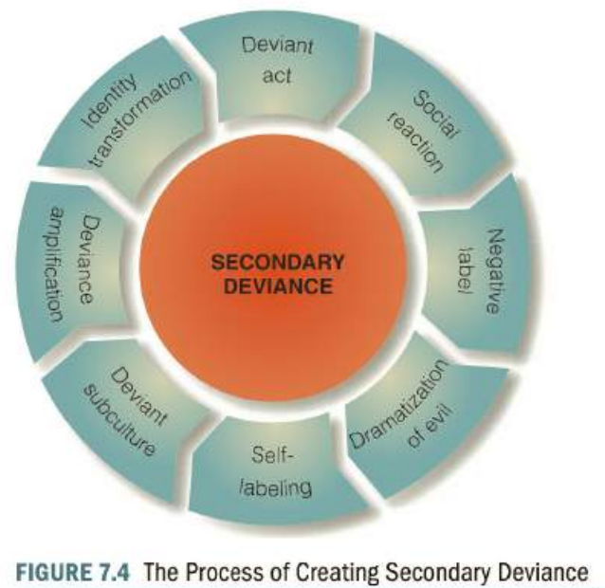

###### Who gets labelled?

An important principle of social reaction theory is that the law is differentially applied, benefiting those who hold economic and social power and penalizing the powerless. From the police officer's decision on whom to arrest to the prosecutor's decisions on whom to charge and for how many and what kind of charges, to the court's decision on release or bail, to the grand jury's decision on indictment, to the judge's decision on the length of the sentence, discretion works to the detriment of minorities, including African Americans, Hispanics, Asian Americans, and Native Americans. 208 The term racial profiling has been used to signify that police suspicion is often directed at minority group males. Minorities and the poor are more likely to be prosecuted for criminal offenses and to receive harsher punishments when convicted. 209 Judges may sympathize with white defendants and help them avoid criminal labels.

Nowhere is this dynamic more visible than in the socalled "war on drugs." African American drug offenders have a significantly higher likelihood of suffering drug arrests, which grow substantially with age. Before age 17, whites and blacks have similar likelihoods of drug arrest. In early adulthood, race disparities in drug arrest increase significantly: by age 22, African Americans have an 83 percent greater odds of a drug arrest than whites, and at age 27 this disparity is 235 percent.

###### Labelling Effects

Empirical evidence supports the view that labeling plays a significant role in persistent offending. 215 Although labels may not cause adolescents to initiate criminal behaviours, those who do are significantly more likely to continue offending if they believe their parents and peers view them in a negative light; they now have a "damaged identity. "21 6 Maintaining a damaged identity after official labeling may, along with other negative social reactions from society, produce a cumulative disadvantage, which provokes some adolescents into repeating their antisocial behaviours.

There is also evidence that people who are involved with official labeling agencies such as the police are the ones most likely to engage in future deviant and criminal behaviours. Using data collected from middle-school students in seven cities to examine the deviance amplification process, Stephanie Ann Wiley and her associates compared youth with no police contact, those who were stopped by police, and those who were arrested; the latter group reported higher levels of future delinquency. Arrest may amplify a person's cumulative disadvantage and trigger exclusionary processes that limit conventional opportunities, such as educational attainment and employment.

###### Validity of labelling theory

Those who criticize it point to its inability to specify the conditions that must exist before an act or individual is labeled deviant-that is, why some people are labeled and others remain "secret deviants.” There are also questions about whether stigma produces crime. Labeling often comes after, rather than before , chronic offending. 222 Getting labeled by the justice system and having an enduring criminal record may have little effect on people who have been burdened with social and emotional problems since birth.2

While these criticisms are telling, there has been significant research showing that, as the theory predicts, people who suffer official labels are prone to a delinquent and criminal way of life. Recent research by Emily Restivo and Mark Lanier found that official labeling may lead to an increased delinquent self-identity, decreased prosocial expectations, and an increased association with delinquent peers, which then lead to an increased likelihood of engaging in subsequent delinquency. Restivo and Lanier conclude that the labeling process creates a new damaged identity for the individual that places them in the company of other damaged people. The result is they are expected to fail and their association with delinquent peers helps make sure that happens.

In a now classic work, criminologists Raymond Paternoster and Leeann Iovanni identified features of the labeling perspective that are important contributions to the study of criminality:

* The labeling perspective identifies the role played by social control agents in the process of crime causation. Criminal behaviour cannot be fully understood if the agencies and individuals empowered to control and treat it are neglected.
* Labeling theory distinguishes between criminal acts (primary deviance) and criminal careers (secondary deviance) and shows that these concepts must be interpreted and treated differently.
* Labeling theory recognizes that criminality is not a disease or pathological behaviour. It focuses attention on the social interactions and reactions that shape individuals and their behaviour.

#### Critical Criminology

Criminologists who view crime as a function of social conflict and economic rivalry have in the past been known by a number of titles, such as conflict, Marxist, left, or radical criminologists, but today most commonly they are referred to as critical criminologists and their field of study as critical criminology.

As their title hints, critical criminologists view themselves as social critics who dig beneath the surface of society to uncover its inequities. They reject the notion that law is designed to maintain a tranquil, fair society and that criminals are malevolent people who wish to trample the rights of others. They believe that the law is an instrument of power, wielded by those who control society in order to maintain their wealth, social position, and class advantage. The ability to control the law has resulted in the accumulation of wealth in the hands of a relatively few creating income inequality that threatens to undermine the economy. They consider acts of racism, sexism, imperialism, unsafe working conditions, inadequate child care , substandard housing, pollution of the environment, and war-making as a tool of foreign policy to be "true crimes. " The crimes of the helplessburglary, robbery, and assaultare often an expression of rage over unjust social and economic conditions rather than selfish acts of greedy people.

Contemporary critical criminologists try to explain crime within economic and social contexts and to express the connections among social class, crime , and social control.5 They are concerned with issues such as these: ■ The role government plays in creating a crime-producing environment ■ The rel ationship between personal or group power and the shaping of criminal law ■ The prevalence of bias in justice system operations ■ The rel ationship between a capitalist, free-enterprise economy and crime rates

##### Historical development

The roots of critical criminology can be traced to the social philosopher Karl Marx (1818-1883), who identified the economic structures in society that control all human relations. Marx's view of society was shaped by the economic trends and structures of that period. He lived in an era of unrestrained capitalist expansion. 8 The tools of the Industrial Revolution had become regular features of society by 1850. Mechanized factories, the use of coal to drive steam engines, and modem transportation all inspired economic development. Production had shifted from cottage industries to large factories. Industrialists could hire workers on their own terms; as a result, conditions in factories were atrocious. Factory owners and the government enforcement agents in their pay ruthlessly suppressed trade unions that promised workers salvation from these atrocities. Marx's early career as a journalist was interrupted by government suppression of the newspaper where he worked because of the paper's liberal editorial policy. He then moved to Paris, where he met Friedrich Engels (1820-1895), who would become his friend and economic patron. By 1847, Marx and Engels had joined with a group of primarily German socialist revolutionaries known as the Communist League.

##### A Marxist vision of crime

Marx did not write a great deal on the subject of crime, but he mentioned it in a variety of passages scattered throughout his writing. He viewed crime as the product of law enforcement policies akin to a labeling process theory. 10 He also saw a connection between criminality and the inequities found in the capitalist system. He reasoned: "There must be something rotten in the very core of a social system which increases in wealth without diminishing its misery, and increases in crime even more rapidly than in numbers." 11 His collaborator, Friedrich Engels, however, did spend some time on the subject in his work The Condition of the Working Class in England in 1844. 12 Engels portrayed crime as a function of social demoralization-a collapse of people's humanity reflecting a decline in society Workers, demoralized by capitalist society, are caught up in a process that leads to crime and violence. According to Engels, workers are social outcasts, ignored by the structure of capitalist society and treated as brutes. 13 Left to their own devices, working people commit crime because their choice is a slow death of starvation or a speedy one at the hands of the law The brutality of the capitalist system, he believed, turns workers into animallike creatures without a will of their own. The writings of Karl Marx greatly influenced the development of the view of crime that rested on the concept of social conflict. Even though Marx himself did not write much on the topic of crime, his views on the relationship between the concept of crime and social conflict were first applied to criminology by three distinguished scholars: Willem Banger, Ralf Dahrendorf, and George Vold. In some instances, their works share the Marxist view that industrial society is wracked by conflict between the proletariat and the bourgeoisie; in other instances, their writings diverge from Marxist dogma.

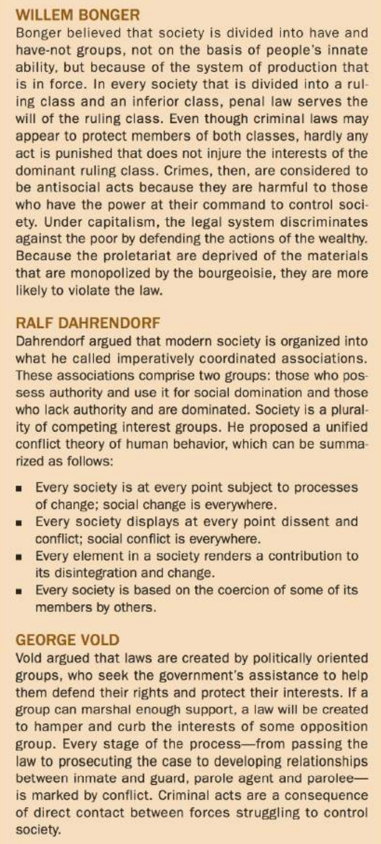

##### Contemporary critical criminology

Today, critical criminologists devote their attention to a number of important themes and concepts. One is the use and misuse of power, or the ability of persons and groups to determine and control the behaviour of others and to shape public opinion to meet their personal interests. Because those in power shape the content of the law, it comes as no surprise that their behaviour is often exempt from legal sanctions. Those who deserve the most severe sanctions (wealthy whitecollar criminals whose crimes cost society millions of dollars) usually receive lenient punishments, while those whose relatively minor crimes are committed out of economic necessity (petty thieves and drug dealers) receive stricter penalties, especially if they are minority group members who lack social and economic power. 21 And once they have done their time, they face a bleak future in a jobless economy in which the poor, minority group members and those with a criminal record are typically un- or under-employed. 22 Critical criminologists are also deeply concerned about the current state of the American political system and the creation of what they consider to be an American empire abroad. The wars in Iraq and Afghanistan are viewed as elements of a global policy designed to control the world through the application of military power, tax cuts for the wealthy, and less money for social programs. Critical criminologists believe they are responsible for informing the public about the dangers of these developments.

##### Types

###### Instrumental theory

According to the instrumental view, the law and the justice system serve the powerful and rich and enable them to impose their morality and standards of behaviour on the entire society. Those who wield economic power are able to extend their self-serving definition of illegal or criminal behaviour to encompass those who might threaten the status quo or interfere with their quest for ever-increasing profits. 55 The concentration of economic assets in the nation's largest industrial firms translates into the political power needed to control tax laws to limit the firms' tax liabilities. 56 Some have the economic clout to hire top attorneys to defend them against antitrust actions, making them almost immune to regulation. The poor, according to this branch of critical theory, may or may not commit more crimes than the rich, but they certainly are arrested and punished more often. Under the capitalist system, the poor are driven to crime because a natural frustration exists in a society in which affiuence is well publicized but unattainable. When class conflict becomes unbearable, frustration can spill out in riots and urban unrest. Because of class conflict, a deep-rooted hostility is generated among members of the lower class toward a social order they are not allowed to shape and whose benefits are unobtainable. 57 Instrumental theorists consider it essential to demystify law and justice-that is, to unmask its true purpose. Criminological theories that focus on family structure, intelligence, peer relations, and school performance keep the lower classes servile by showing why they are more criminal, less intelligent, and more prone to school failure and family problems than the middle class. Demystification involves identifying the destructive intent of capitalist inspired and funded criminology. Instrumental theory's goal or criminology is to show how capitalist law preserves ruling-class power.

###### Structural Theory

Structural theorists disagree with the view that the relationship between law and capitalism is unidirectional, always working for the rich and against the poor. 59 If law and justice were purely instruments of the wealthy, why would laws controlling corporate crimes, such as price fixing, false advertising, and illegal restraint of trade, have been created and enforced? To a structuralist, the law is designed to keep the system operating efficiently, and anyone, worker or owner, who rocks the boat is targeted for sanction. For example, antitrust legislation is designed to prevent any single capitalist from dominating the system. If the free enterprise system is to function, no single person can become too powerful at the expense of the economic system as a whole. Structuralists would regard the efforts of the U.S. government to break up Microsoft as an example of a conservative government using its clout to keep the system on an even keel. The long prison sentences given to corporate executives who engage in insider trading are a warning to capitalists that they must play by the rules.

##### Alternative views of critical theory

###### Left Realism

Some critical scholars are now addressing the need for the left wing to respond to the increasing power of right-wing conservatives. They are troubled by the emergence of a strict "law and order" philosophy, which has as its centerpiece a policy of punishing juveniles severely in adult court. At the same time, they find the focus of most left-wing scholarship-the abuse of power by the ruling elite-too narrow. It is wrong, they argue , to ignore inner-city gang crime and violence, which often target indigent people. 78 The approach of left realism is most often connected to the writings of British scholars John Lea and Jock Young. In their well-respected 1984 work What Is to Be Done About Law and Order?, they reject the utopian views of idealists who portray street criminals as revolutionaries. 79 They take the more "realistic" approach that street criminals prey on the poor and disenfranchised, thus making the poor doubly abused, first by the capitalist system and then by members of their own class.

Lea and Young's view of crime causation borrows from conventional sociological theory and closely resembles the relative deprivation approach, which posits that experiencing poverty in the midst of plenty creates discontent and breeds crime. As they put it, "The equation is simple: relative deprivation equals discontent; discontent plus lack of political solution equals crime."

**Argue for Pre-emptive deterrence**. Pre-emptive deterrence is an approach in which community organization efforts eliminate or reduce crime before police involvement becomes necessary. The reasoning behind this approach is that if the number of marginalized youths (those who feel they are not part of society and have nothing to lose by committing crime) could be reduced , then delinquency rates would decline.

###### Critical feminism

Critical feminism views gender inequality as stemming from the unequal power of men and women in a capitalist society, which leads to the exploitation of women by fathers and husbands. Under this system, women are considered a commodity worth possessing, like land or money 89 Some of the most important issues focused upon by critical feminist criminologists include the unique role of women in policing and corrections, fields that have traditionally been dominated by men. Another important area of study is the role of masculinity in creating the gender gap in serious crime. There is also concern with the role of media in "demonizing" girls and women of color.

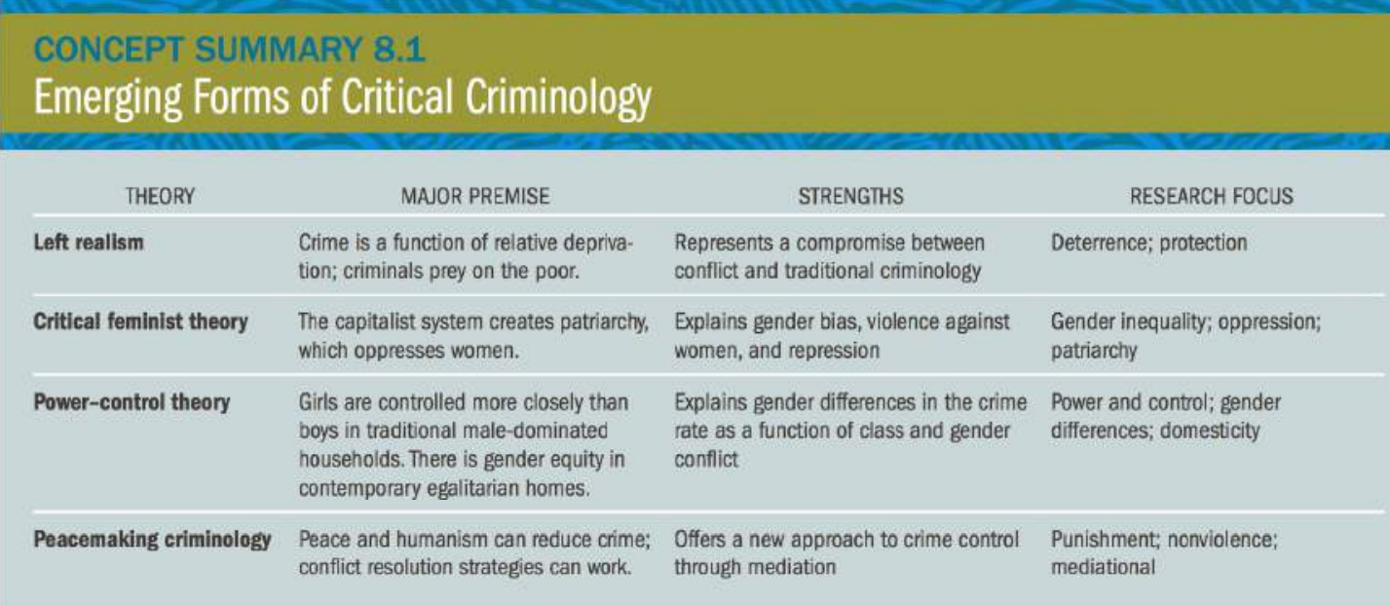

## Crime and Criminals

### Crime typologies

Enterprise crime(White-collar, Corporate), occasional criminals, Habitual criminals, Professional criminals, Organized crime

### Habitual Criminal

Habitual offender, person who frequently has been convicted of criminal behaviour and is presumed to be a danger to society. In an attempt to protect society from such criminals, penal systems throughout the world provide for lengthier terms of imprisonment for them than for first-time offenders.

The idea of habitual-offender legislation reflects the basic assumption of positivist criminology that crime is analogous to disease and should be treated by comparably flexible measures. According to this view, a person with persistent tendencies to commit crimes should be quarantined from society as would someone with a seriously infectious disease. During the first half of the 20th century, advocates of habitual-offender legislation appealed to then-popular biological theories of crime to argue that if a person committed several major crimes, it was reasonable to assume that he was criminal by nature and needed to be imprisoned indefinitely.

#### Issues

In theory, identifying and incapacitating such offenders early in their criminal careers should prevent a large number of serious crimes. In practice, however, it is difficult to devise laws that identify not just habitual offenders but all those who are likely to commit serious crimes. For example, many laws stipulate that once an individual has been convicted of three felonies, he should qualify for habitual-offender status and receive a lengthy prison term. But in various U.S. states, many nonviolent and less-serious offenses—such as committing fraud, bouncing checks, and even committing bigamy—are considered felonious crimes. The incarceration of those who commit such offenses is, at a minimum, controversial. Another point of controversy is that the availability of habitual-offender laws may unfairly enhance the powers of prosecutors, who can entice petty offenders to plead guilty by threatening to charge them with felonies that would earn them habitual status.

### Occasional Criminals

Occasional criminals are those criminals who are not habitual criminals. They commit crime due to some special reason or an inevitable accident. Before committing such a crime their history is clear from any sort of criminal behaviour. It is a possibility that after commissioning such a crime they might not commit further crimes in future. As a situation in which they committed the crime may not occur again.

Example: A person sees or discovers her wife with a man who is a stranger to him, in his bedroom or elsewhere. He kills both as a reaction to the breach of trust will amount to a crime which is committed by an occasional criminal, who might not have committed such crime if the above-stated events did not take place.

### Professional Criminals

Professional criminals are those who have adopted crime as their profession and to them, crime is their full-time job and source of income. They use different skills and techniques for committing crimes. They consider their selves as victims of society and consider their crimes as revenge.

### Concept of Enterprise Crime

Ongoing illegal activities by an individual or a group of individuals involved in commerce that either violate the laws regulating legitimate business or whose acknowledged purpose is profit through illegitimate commercial enterprise.

Business enterprise crimes taint and corrupt the free market system. They mix and match illegal and legal methods and legal and illegal products in all phases of commercial activity. They involve illegal business practices (embezzlement, price fixing, pollution, dumping, bribery, and so on) to merchandise what are normally legitimate commercial products (securities, medical care, disposing of computer equipment). 3 They can also involve using standard business methods and accounting to market illegal goods (drugs) and services (gambling, money laundering).

The public may not view enterprise crime as particularly dangerous. Nonetheless, hundreds of thousands of occupational deaths occur each year from illegal and unsafe working conditions; illegal pollution annually kills and injures more people than all street crimes combined. 4 So while business crimes typically involve stealth and fraud , they may also include violence and death.

### Causes of Enterprise crime

Why do people get involved in risky schemes to use their institutional positions to steal money? Why do people risk going to prison because they pollute the environment? Why do criminal gangs form? Can the same factors that predict other types of criminal offenses also apply to crimes of criminal enterprise? After all, unlike most common-law crimes, enterprise crimes are not committed by impoverished teenagers living in the inner city but by people who are often well-off, highly educated businesspeople. In order to commit an enterprise crime, someone must have already obtained a position of power and trust. This section describes some of the most prominent views of why people commit crimes of criminal enterprise.

#### Rational Choice: Greed

When Kansas City pharmacist Robert Courtney was asked after his arrest why he substituted improper doses of drugs instead of what doctors had prescribed, he told investigators he cut the drugs' strength "out of greed." Courtney is not alone. One view of enterprise crime is that greedy people rationally choose to take shortcuts to acquire wealth, believing that the potential profits far outweigh future punishments. Most believe they will not get caught; they are far too clever to be detected by mere civil servants who work for government agencies.

#### Rational choice: need

Greed is not the only motivation for enterprise crime; need also plays an important role. Some people tum to crime to fulfill an overwhelming financial or psychological need. Executives may tamper with company books because they feel the need to keep or improve their jobs, satisfy their egos, or support their children. A lot of people convicted of white-collar crime typically work in lower-echelon positions, and their acts seem motivated more by economic survival than by greed and power.

#### Rationalization/Neutralization view

Rationalizing guilt is a common trait of enterprise criminals. Organized crime figures rationalize their behaviour by insisting they are only providing a service that people want, even if it's illegal. Some white-collar offenders feel free to engage in business crime because they can easily rationalize its effects. Some convince themselves that their actions are not really crimes because the acts involved do not resemble street crimes. A banker who uses his position of trust to lend his institution's assets to a company he secretly controls may see himself as a shrewd businessman, not as a criminal. A pharmacist who chisels customers on prescription drugs may rationalize her behaviour by telling herself that it does not really hurt anyone. Further, some businesspeople feel justified in committing enterprise crimes because they believe government regulators do not really understand the business world or the problems of competing in the free enterprise system. 153 When asked, enterprise criminals often use techniques of neutralization to defuse guilt: (1) everyone else does it, (2) it's not my fault or responsibility, and (3) no one is hurt except insurance companies and they are wealthy.

#### Cultural view

Those holding the cultural view would point to the Enron scandal as a prime example of what happens when people work in organizations in which the cultural values stress profit over fair play, government scrutiny is limited and regulators are viewed as the enemy, and senior members encourage newcomers to believe that "greed is good." One method of controlling enterprise crime, then, is to redirect institutional culture and focus more on values and trust than profit and greed.

#### Self-control view

In their General Theory of Crime, Travis Hirschi and Michael Gottfredson suggest that the motives that produce enterprise crimes-quick benefits with minimal effort-are the same as those that produce any other criminal behaviours. 156 Enterprise criminals have low self-control and are inclined to follow momentary impulses without considering the long-term costs of such behaviour. 157 Even though bankers and stockbrokers are not a group known for being impulsive, those who commit enterprise crimes are the most impulsive of the bunch.

### White-Collar Crime

While we sometimes think of enterprise crimes as a new phenomenon, they have been around for hundreds of years, ever since the Industrial Revolution began. The period between 1750 and 1850 witnessed the widespread and unprecedented emergence of financial offenses-such as fraud and embezzlement-frequently perpetrated by respectable middle-class offenders as the banking and commercial systems developed. Not surprisingly, scholars have long recognized that some unscrupulous businesspeople use their position of trust to fleece the public. In 1907, pioneering sociologist Edward Alsworth Ross recognized the phenomenon when he coined the phrase "the criminaloid" to describe the kind of person who hides behind his or her image as a pillar of the community and paragon of virtue to get personal gain through any means necessary. 5

In the late 1930s, the distinguished criminologist Edwin Sutherland first used the phrase "white-collar crime" to describe the criminal activities of the rich and powerful. He defined white-collar crime as "a crime committed by a person of respectability and high social status in the course of his occupation."6 As Sutherland saw it, white-collar crime involved conspiracies by members of the wealthy classes to use their position in commerce and industry for personal gain without regard to the law. Often these actions were handled by civil courts because injured parties were more concerned with recovering their losses than with seeing the offenders punished criminally. Consequently, Sutherland believed that the great majority of white-collar criminals did not become the subject of criminological study. Yet the cost of white-collar crime is probably several times greater than all the crimes customarily regarded as the crime problem. And, in contrast to street crimes, white-collar offenses breed distrust in economic and social institutions, lower public morale, and undermine faith in business and government.

Although Sutherland's work is considered a mile - stone in criminological history, his focus was on corporate criminality, including the crimes of the rich and powerful. Contemporary definitions of white-collar crime are typically much broader and include both middle-income Americans and corporate titans who use the marketplace for their criminal activity. Included within recent views of white-collar crime are such acts as income tax evasion, credit card fraud, and bankruptcy fraud. Other white-collar criminals use their positions of trust in business or government to commit crimes. Their activities might include pilfering, soliciting bribes or kickbacks, and embezzlement. Some white-collar criminals set up business for the sole purpose of victimizing the general public. They engage in land swindles (i.e., representing a swamp as a choice building site), securities theft, medical fraud , and so on.

In addition to acting as individuals, some whitecollar criminals become involved in criminal conspiracies designed to improve the market share or profitability of their corporations. This type of white-collar crime, which includes antitrust violations, price fixing, and false advertising, is known as corporate crime.

There have been numerous attempts to create subcategories or typologies of white-collar criminality. The one used here contains seven elements, ranging from an individual using a business enterprise to swindle clients to large-scale corporate enterprises collectively engaging in illegitimate activity

#### White Collar swindlers

As you may recall (Chapter 12), fraud is a common-law crime in which someone uses trickery and deceit to separate a mark from his money. A common-law swindle occurs when the con artist tells people she just inherited a Picasso from her deceased aunt and then sells it to an unsuspecting purchaser who later discovers it to be a forgery. In contrast, white-collar swindles such as the ones created by Stanford, involve a person using his or her institutional or business position to commit fraud and fleece victims over an extended period of time. It would be common-law fraud to sell a forged autograph of Peyton Manning or Tom Brady to someone you just met at a poker game. In contrast, someone who sets up an ongoing sports memorabilia business, advertises the sale of sports posters, photos, and other items allegedly signed by famous athletes, and then sells forgeries to unwitting customers is engaging in a white-collar swindle. Here, a criminal enterprise was created specifically to engage in illegal activity. White-collar swindles take many forms, most prominent among them is a Ponzi scheme.

**Investment Swindlers**: A Ponzi scheme is an investment fraud that involves the payment of purported returns to existing investors from funds contributed by new investors. Ponzi scheme organizers often solicit new investors by promising to invest funds in opportunities claimed to generate high returns with little or no risk. In many Ponzi schemes, the fraudsters focus on attracting new money to make promised payments to earlier-stage investors and to use for personal expenses, instead of engaging in any legitimate investment activity. With little or no legitimate earnings, the schemes require a consistent flow of money from new investors to continue. Ponzi schemes tend to collapse when it becomes difficult to recruit new investors or when a large number of investors ask to cash out.

**Religious Swindles**: Swindlers love to target the religious, taking advantage of their hope. Swindlers take in worshippers of all faiths: Jews, Muslims, Baptists, Lutherans, Catholics, Mormons, and Greek Orthodox have all fallen prey to religious swindles. How do religious swindlers operate? Some create fraudulent charitable organizations and convince devout people to contribute to their seemingly worthwhile cause while pocketing the contributions for themselves. Others create investment funds based on religious values, hoping to draw investors wary of secular investments. These scammers sometimes place scripture verses on their promotional literature to comfort hesitant investors. Others take advantage of people seeking religious pilgrimages. In 2015, Rashid Minhas was sentenced to more than nine years in prison for selling bogus travel packages to devout Muslims who wanted to travel to Saudi Arabia for the Hajj. He claimed he could obtain required Saudi Arabian entry visas, knowing full well he was not authorized to do so by the Saudi government. He sold travel deals to at least 50 customers and deposited approximately $525,000 into his own accounts.

#### White-collar chiselling

White-collar chiseling involves a business owner regularly cheating customers and clients, or an employee stealing from the organization they work for, by deception or deceit. When chiselers target an individual client, they may charge for something they never delivered or overbill them for services they did receive. Because the schemes are so subtle, the victim may not even realize they have been cheated.

Auto repair shops have long been suspected of overcharging customers for bogus auto repairs that were not required or never performed. 20 When someone brings their car in for repair and are told the brakes are shot, how often do they examine them themselves? And auto repair clients seldom ask to see proof that new high-quality parts were used, making it easy for unscrupulous chiselers to substitute off-brands or used parts.

#### White-collar exploitation

White-collar exploitation occurs when an individual abuses their power or position in an organization to extort or coerce people into making payments to them for services to which they are already entitled. If the payments are not made, the services for which the victim is entitled to are withheld..

In most cases, exploitation occurs when the victim has a clear right to expect a service, and the offender threatens to withhold the service unless an additional payment or bribe is forthcoming. On the local and state levels, exploitation may occur when a government official who holds discretionary power-liquor license board members, food inspectors, fire inspectors-demand extortion money.

People who want a license are told that unless they pay the board member he will turn down the request. A fire inspector demands payment for approving an addition to a business or demands that the owner of a restaurant pay him for an operating license to which they are by law entitled. Exploitation involves a threat: "If you don't pay me, I will cause you trouble."

#### WC Influence peddling

Using an institutional position to grant favors and sell information to which their co-conspirators are not entitled.

government employees taking kickbacks from contractors in return for awarding them contracts they could not have won on merit, or outsiders bribing government officials, such as those in the Securities and Exchange Commission, who might sell information about future government activities. A police officer who sells information on future raids or takes a bribe in lieu of handing out a citation or making an arrest is engaging in influence peddling.

#### WC Embezzlement and Employee fraud

Another type of while-collar crime involves individuals' use of their positions to embezzle company funds or appropriate company property for themselves. Here the company or organization that employs the criminal, rather than an outsider, is the victim of white-collar crime.

Such acts include converting company assets for personal benefit; fraudulently receiving increases in compensation (such as raises or bonuses); fraudulently increasing personal holdings of company stock; retaining one's present position within the company by manipulating accounts; and concealing unacceptable performance from stockholders.

#### Client fraud

Client fraud occurs when an organization that either (a) advances credit, (b) provides loans, (c) supports people financially, or (d) reimburses them for services provided to a third party is the target of criminal activity. Victims of client fraud might be an insurance company that pays out on false claims or repays health care providers that put in false claims for bogus charges. Included in this category are insurance fraud, bank fraud, credit card fraud, fraud related to welfare and Medicare programs, and tax evasion.

#### Corporate Crime

Yet another component of white-collar crime involves situations in which powerful institutions or their representatives willfully violate the laws that restrain these institutions from doing social harm or require them to do social good. This is also known as corporate or organizational crime. Interest in corporate crime first emerged in the early 1900s, when a group of writers, known as muckrakers, targeted the monopolistic business practices of John D. Rockefeller and other corporate business leaders. In a 1907 article, sociologist Edward Alsworth Ross described the "criminaloid": a business leader who while enjoying immunity from the law victimized an unsuspecting public. 65 Edwin Sutherland focused theoretical attention on corporate crime when he began his research on the subject in the 1940s; corporate crime was probably what he had in mind when he coined the phrase "white-collar crime.

Corporate crimes are socially injurious acts committed by people who control companies to further their business interests. The target of their crimes can be the general public, the environment, or even company workers. What makes these crimes unique is that the perpetrator is a legal fiction-a corporation-and not an individual. In reality, it is company employees or owners who commit corporate crimes and who ultimately benefit through career advancement or greater profits. For a corporation to be held criminally liable , the employee committing the crime must be acting within the scope of his employment and must have actual or apparent authority to engage in the particular act in question. Actual authority occurs when a corporation knowingly gives authority to an employee; apparent authority is satisfied if a third party, such as a customer, reasonably believes the agent has the authority to perform the act in question. Courts have ruled that actual authority may occur even when the illegal behaviour is not condoned by the corporation but is nonetheless within the scope of the employee's authority.

Some of the acts included within corporate crime are price fixing and illegal restraint of trade , false advertising, and the use of company practices that violate environmental protection statutes. The variety of crimes contained within this category is great, and they cause vast damage. The following subsections examine some of the most important offenses.

### Controlling White-collar crime

In years past, it was rare for a corporate or white-collar criminal to receive a serious criminal penalty. 76 Whitecollar criminals are often considered nondangerous offenders because they usually are respectable older citizens who have families to support. These "pillars of the community" are not seen in the same light as a teenager who breaks into a drugstore to steal a few dollars. Their public humiliation at being caught is usually deemed punishment enough; a prison sentence seems unnecessarily cruel.

The main reason, according to legal expert Stuart Green, is that perception of white-collar crime is clouded by moral ambiguity. White-collar crimes are typically committed by society's success stories, by the rich and the powerful, and frequently have no visible victim at their root. Both the public and the justice system have had trouble distinguishing criminal fraud from mere lawful exaggeration, tax evasion from "tax avoidance," insider trading from "savvy investing," obstruction of justice from "zealous advocacy," bribery from "horse trading," and extortion from "hard bargaining. "77 Hence , white-collar criminals are treated more leniently than lower-class offenders.

The prevailing wisdom, then, is that many white-collar criminals avoid prosecution, and those who are prosecuted receive lenient punishment. What efforts have been made to bring violators of the public trust to justice? Whitecollar criminal enforcement typically involves two strategies designed to control organizational deviance: compliance and deterrence.

#### Compliance Strategies

Compliance strategies aim for law conformity without the necessity of detecting, processing, or penalizing individual violators. At a minimum, they ask for cooperation and self-policing among the business community. Compliance systems attempt to create conformity by giving companies economic incentives to obey the law. They rely on administrative efforts to prevent unwanted conditions before they occur. Compliance systems depend on the threat of economic sanctions or civil penalties to control corporate violators.

One method of compliance is to set up administrative agencies to oversee business activity. Such as SECP.

In sum, compliance strategies attempt to create a marketplace incentive to obey the law. Compliance strategies avoid punishing, stigmatizing, and shaming businesspeople by focusing on the act, rather than the actor, in white-collar crime.

#### Deterrence Strategies

Some criminologists say that the punishment of white-collar crimes should include a retributive component similar to that used in common-law crimes. White-collar crimes, after all, are immoral activities that have harmed social values and deserve commensurate punishment. 82 Even the largest fines and penalties are no more than a slap on the wrist to multibillion-dollar companies. Corporations can get around economic sanctions by moving their rule-violating activities overseas, where legal controls over injurious corporate activities are lax or nonexistent. 83 They argue that the only way to limit white-collar crime is to deter potential offenders through fear of punishment. Deterrence strategies involve detecting criminal violations, determining who is responsible, and penalizing the offenders to deter future violations. 84 Deterrence systems are oriented toward apprehending violators and punishing them rather than creating conditions that induce conformity to the law.

Deterrence strategies should work-and they havebecause white-collar crime by its nature is a rational act whose perpetrators are extremely sensitive to the threat of criminal sanctions. Perceptions of detection and punishment for white-collar crimes appear to be powerful deterrents to future law violations. Although deterrence strategies may prove effective, federal agencies have traditionally been reluctant to throw corporate executives in jail. The government seeks criminal indictments in corporate violations only in "instances of outrageous conduct of undoubted illegality," such as price fixing. 85 The government has also been lenient with companies and individuals that cooperate voluntarily after an investigation has begun; leniency is not given as part of a confession or plea arrangement. Those who comply with the leniency policy are charged criminally for the activity reported.

### Organized and Transnational crime

organized crime, involves ongoing criminal enterprise groups whose ultimate purpose is personal economic gain through illegitimate means. One component involves setting up a structured enterprise system to supply consumers with merchandise and services banned by criminal law but for which a ready market exists: prostitution, pornography, gambling, and narcotics.

A second component involves the use of illegitimate means to dominate and control legitimate enterprises. Organized crime groups enter, buy, or control legitimate industries such as construction and trash hauling. However, rather than play by the rules, they use violence and strongarm tactics to remove rivals, collect money owed, and intimidate people into cooperation. Their ability to operate freely may be the result of their buying off corrupt officials and using graft, extortion, intimidation, and murder to maintain their operations. 117 The economic impact alone is staggering: it's estimated that global organized crime reaps illegal profits of around $1 trillion per year.

Because of its secrecy, power, and fabulous wealth, a great mystique has grown up about organized crime. Its legendary leaders-Al Capone, Meyer Lansky, Lucky Luciano-have been the subjects of books and movies. The Godfather films popularized and humanized organized crime figures; the media often glamorizes them.

#### Origin

Organized crime itself is not a recent phenomenon and can be traced as far back as the 1600s when London wasterrorized by organized gangs that called themselves Hectors, Bugles, Dead Boys, and other colorful names. In the seventeenth and eighteenth centuries, English gang members wore distinctive belts and pins marked with serpents, animals, stars, and the like.

The Mafia originated in Sicily around 1860, and started as a criminal gang employed by wealthy landowners to function as agents of social and land control, keeping peasant workers in line. At the tum of the twentieth century, La Mano Nera (the Black Hand), an offshoot of Sicilian criminal groups, established themselves in northeastern urban centers. Gangsters demanded payments from local businessmen in return for "protection"; those who would not pay were beaten and their shops vandalized Eventually the Black Hand merged with gangs of Italian heritage to form larger urban-based gangs and groups.

#### Transnational Organized Crime

Transnational organized crime (TOC or transnational crime) is a form of organized crime operating across national borders. It involves groups or networks of individuals working in more than one state or even across cultures and nations, to plan and execute illegal business ventures. Cross-national gangs are often large criminal organizations, some with more than 20,000 members. According to criminologist Jay Albanese, the distinction between these new organizations that operate across borders and the traditional Mafia whose activities were bounded by neighborhood territory is actually not that great. They overlap in terms of the crimes committed, the offenders involved, and how criminal opportunities are exploited for profit. They are , he concludes, manifestations of the same underlying conduct and the same pool of criminal offenders who exploit similar criminal opportunities.

##### Characteristics

An offense is transnational if:

* It is committed in more than one state or nation.
* It is committed in one state or nation but a substantial part of its preparation, planning, direction, or control takes place in another state or nation.
* It is committed in one state or nation but involves an organized criminal group that engages in criminal activities in more than one state or nation.
* It is committed in one state of nation but has substantial effects in another state of nation.

##### Activities

What are the main activities of transnational organized crime? The traditional sources of income are derived from providing illicit materials, such as narcotics, and using force to enter into and maximize profits in legitimate businesses. Income is generated from such activities as narcotics distribution, extortion, gambling, pornography, and cargo theft rings. Other activities are discussed here.

* Cultural Property trafficking (antiques, artifacts, relics)
* Piracy
* Human trafficking (prostitution, forced labour, sexual exploitation)
* Migrant smuggling (providing services to irregular migrants to evade national border controls, migration regulations, visa requirements)
* Organ trafficking

##### Why is it so diff to eradicate transnational gangs?

493 siegel book

## Islamic perspective on deviance and crime

## Questions

* Define criminology and what is the subject matter of it and how criminologists’ opinion differs from media commentators or politicians? How Edwin and Cressey explain criminology?
* Define criminal justice. How criminology and criminal justice differ and how both overlap?
* Are all deviances crime or vice versa? Explain with example. What is a criminologist concern with deviance?
* Who is a criminologist? What do you understand by criminology in action?
* What is the scope of criminology in criminal stats and crime measurement? Why media is not reliable for stats? How criminologists create reliable measurements of criminal behaviour? How criminologists help agents of criminal justice? Give an example.
* What is the scope of criminology in socio-legal studies? Explain with example of obscenity. How courts benefit from research by criminologists?
* How criminologists help in constructing and testing theories? What is the focus of criminologists who study criminal behaviour systems and crime typologies? Why such research is important?
* How are criminologists involved in social control? What do you understand by victimology?
* What are different views of crime? Define consensus view and How consensus view is linked with social harm? Why is it considered an ideal legal system?
* Explain conflict view and what are the real crimes in this view?
* What school of sociology is the root of interactionist view? Is crime a function of interaction and labelling? Who are the moral entrepreneurs? Are conflict and interactionist view similar?
* What is code of Hammurabi and how it is stratified? Discuss Mosaic Code of the Israelites application in contemporary society.
* What is compurgation? Differentiate trial by ordeal and combat.
* When present English system came into existence? What is mala in se and mala prohibitum? Do laws evolve? Explain with larceny example.
* How many types of law are in a contemporary society? Explain substantive criminal law, procedural criminal laws, civil law and public law.
* Differentiate between felony and misdemeanor. What govt aims to achieve through criminal law enforcement?
* What are the elements of criminal law? Explain actus reus. What are certain cases in which failure to act is considered a crime? What is Mens Rea? mens rea is not required in which crimes?
* How was criminal behaviour explained in yesteryears and how renaissance changed that? How classical theory was developed and discuss the role of Jeremy Bentham and Cesare Beccaria in its formation. What is the concept of marginal deterrence?
* Explain classical criminology and when its popularity started to decline?
* What were the foundations of Trait theory? What is a positive stage acc to Auguste Comte? What are the two elements of positivism?
* What are the early works of biological positivism? Discuss Lombroso’s biological determinism and explain view of somatotype and inheritance schools. What is wrong with biological determinism? Why is there need for biosocial theory?
* What are psychological theories? Explain psychoanalytic theory in criminology context. Explain attachment theory and how it affects an individual.
* What is behavioural theory? Explain social learning theory. What are primary sources for learning violence? Which four factors contribute to violent behaviour?
* What is cognitive theory? Briefly define its subtypes.
* How quetelet and Durkheim contributed in the formation of sociological criminology? Why crime was healthy in Durkheim’s view? Explain with example.
* Explain the contribution of Chicago school in the identification of criminal behaviour.
* How do you understand social structure theories?
* Explain social disorganization theory. What were its foundations? Also elaborate strain theory and why poor resorts to crime?
* What is strain theory? Explain the concept of anomie. What is Merton’s theory of anomie and what critics have to say about it?
* Explain social learning theory and its most prominent form. What are its basic principles? Report theory findings and analyse them.
* What is Social Control theory and why Hirschi’s social bond theory is most dominant? What are the elements of SBT? Critically analyse SBT.
* What is social reaction theory? How labelling works in forming an individual’s self-view? How SRT views crime and Deviance? What is the concept of interaction and interpretation? How stigma harms public and private self? What is Lemert’s concept of primary and secondary deviance? Who gets labelled and what are its effects? Is labelling theory valid?
* What is enterprise crime? What are the causes of enterprise crime? What is white collar crime and its different subtypes? How it can be controlled? What are compliance and deterrence strategies?
* What Is organized crime? Its origin and characteristics? What activities they are involved in? How to control transnational crime?

# SECTION-II

## Juvenile Delinquency

The behaviour of a minor child that is marked by criminal activities, persistent antisocial behaviour, or disobedience which the child’s parents are unable to control.

A violation of the law by a minor, which is not punishable by death or life imprisonment.

Juvenile delinquency is the participation by a minor child, usually between the ages of 10 and 17, in illegal behaviour or activities. Juvenile delinquency is also used to refer to children who exhibit a persistent behaviour of mischievousness or disobedience, so as to be considered out of parental control, becoming subject to legal action by the court system. Juvenile delinquency is also known as “juvenile offending,” and each state has a separate legal system in place to deal with juveniles who break the law. To explore this concept, consider the following juvenile delinquency definition.

According to the FBI, a juvenile is anyone under the age of 18 regardless of how each individual state defines a juvenile. A delinquent is an individual who fails to obey the laws. Juvenile delinquency is defined as an individual under the age of 18 who fails to abide by the laws.

The children or juveniles who come into contact with law are not termed criminals, in juvenile justice. Rather they are termed delinquents. Their unlawful acts are termed delinquency rather than crime.

### Causes of delinquency

**Individualistic reasons**

Physical Defects or Disorder (Child often confronts embarrassment and then reacts): The empirical evidence testifies that those having physical defects are more prone to delinquency in comparison to the normal children.

ii. Low Intelligence (Encourage anti-social Behaviours). The children with low intelligence are likely to be more prone to criminality in comparison to the normal children. iii. Malnutrition. iv. Abnormal physical and motor development:

**FAMILY REASONS**

Presence of step-father or mother (ii) Lack of parental love and affection (iii) Quarrels among parents (iv) Use of alcohol and other drugs by the parents (v) High ambitions of parents which they want to realize through the achievements of their children. (vi) Loose or very strict discipline at home (vii) Broken home- -divorce, separation or death of any one of the parents (viii) Mother being in service, no control over the children (ix) mental abnormality in the mother or father etc.

**SOCIAL REASONS** i. Peer Groups ii. Schooling, Community and Social Institutions iii. Affiliation with other delinquents

### Explanation through theories

From section 1 theories try to explain juvenile delinquency. For instance, anomie theory would say that a juvenile who has had a goal to get a job and purchase a car and he is not able to find a job to make money so he either steals a car or he steals money to purchase a car.

### Types of Juvenile Delinquents

Juvenile delinquents are often defined as children between the ages of 10 and 17 who have committed a criminal act. There are two main types of offenders: repeat offenders and age specific offenders.

**Repeat offenders** are also known as “life-course persistent offenders.” These juvenile delinquents begin offending or showing other signs of antisocial behaviour during adolescence. Repeat offenders continue to engage in criminal activities or aggressive behaviours even after they enter adulthood.

**Chronic offenders**: This type of juvenile delinquent behaviour begins during adolescence. Unlike the repeat offenders however, the behaviours of the **age-specific offender** ends before the minor becomes an adult. The behaviours that a juvenile shows during adolescence are often a good indicator of the type of offender he will become. While age-specific offenders leave their delinquent behaviour behind when they enter adulthood, they often have more mental health problems, engage in substance abuse, and have greater financial problems than adults who were never delinquent as juveniles.

### Risk factors and predictors of JD

Many children garner the label of juvenile delinquent early, often between the ages of 6 and 12 years. Many juvenile behaviours during the pre-teen and teenage years may be considered normal behaviour for children, as they stretch their boundaries, and struggle to develop their self-perception. There are, however, certain signs that a child might be headed in a bad direction. Predictors of juvenile delinquencies may appear as early as preschool, and often include:

• Abnormal or slow development of basic skills, such as speech and language • Chronic violation of the rules • Serious aggressive behaviour toward other students or teachers

Studies have found that a number of life circumstances constitute risk factors for a child to become a juvenile delinquent. While these are many and varied, the most common risk factors for juvenile delinquency include:

• Authoritarian Parenting – characterized by the use of harsh disciplinary methods, and refusal to justify disciplinary actions, other than by saying “because I said so.” • Peer Association – usually resulting from leaving adolescents unsupervised, encouraging a child to engage in bad behaviours when acting with his peer group. • Low Socioeconomic Status • Permissive Parenting – characterized by lack of consequences for bad behaviour, permissive parenting can be broken down into two subcategories: (1) neglectful parenting, which is a lack of monitoring a child’s activities, and (2) indulgent parenting, which is the enablement of bad behaviour. • Poor School Performance • Peer Rejection • ADHD and other mental disorders

### Dealing with Juvenile Delinquency

The procedures followed in the juvenile justice system differ greatly from those followed for adult offenders. Each state has specific programs or systems that deal with juvenile offenders. Juvenile offenders come into police contact in number of ways. Some are caught committing a crime and arrested, others are referred to police by parents or school officials. Once the police have become involved, they may choose to deal with a juvenile offender in several ways. The police can:

• issue a warning and release of the minor • detain the minor and notify the parents to pick him up • arrest the minor and refer the case to juvenile court

If the case goes to court, the minor and the parents meet with a juvenile court intake officer. The intake officer can handle the case informally, referring the juvenile to a probation officer, he can dismiss the case, or he can file formal charges. When deciding whether to file charges, officers often consider:

• the offense • the offender’s age • the offender’s previous record • the offender’s educational or social history • the ability of the parents to control the offender’s behaviour or seek help

If dealt with informally, the minor reports to a probation officer, and is given advice and ordered to perform community service, pay fines, attend treatment, or enter probation. If charges are filed in juvenile court, the minor is arraigned, at which time his charges are read before a judge. The judge then decides whether to detain or release the juvenile until the hearing takes place. After appearing in court, three things are possible:

**1. Plea Agreement** – the minor may enter a plea agreement with the court. This often requires the juvenile to comply with certain conditions, such as attending counseling, obeying a curfew.

2. **Diversion** – the judge may divert the case, which means he retains control over the matter until the juvenile successfully completes treatment programs or performs community services. If the juvenile fails to comply, formal charges may be reinstated.

3**. Adjudicatory Hearing** – the judge may decide to have an adjudicatory hearing, which is a trial in a juvenile case. While both sides argue the case and present evidence, a juvenile trial takes place in front of a judge, not a jury. If, at the end of the hearing, the judge decides the juvenile is delinquent, he may order punishments such as probation, community service, or even detention in a juvenile center.

### Preventing juvenile Delinquency

Prevention of juvenile delinquency serves at-risk youths, their families, and the public, as it can put a stop to the transition of juvenile offenders to adult offenders. Prevention services are offered by a number of government and private agencies, and include such services as:

• Substance Abuse Treatment • Family Counseling • Individual Counseling • Parenting Education • Family Planning Services

The availability of education, and encouragement of minors in obtaining an education, plays a large role in prevention of juvenile delinquency. This is because education promotes social cohesion, and helps children of all ages learn to make good choices, and to practice selfcontrol.

Use theories to provide solutions

In our country there is a lack of marital adjustment. It will not be out of point here that at least 50% marriages which take place are without mutual consent or even mutual understanding. With the result they fail very soon and create many problems for their innocent children. There is no doubt in it that it all happens due to the lack of information and un-education. Moreover, the people of the rural areas are still under the yoke of old customs and traditions which add more to their problems.

Child-labour must be prohibited by the state very strictly. Child-labour is one of the factors which ultimately lead them to juvenile delinquency. State should take the responsibility of loading and boarding of the orphans so that they may not indulge in this evil.

Such customs, traditions which are in no way useful for the society must be discouraged and cut-down. It should also be the prime duty of the parents that they should not impose their will on their children unnecessarily. Rather the will of the children if correct must be respected.

### Juvenile Law: Status Offenses

Some acts are considered criminal only when minors commit them; these are called juvenile status offenses. In juvenile cases, a "status offense" involves conduct that would not be a crime if it was committed by an adult -- in other words, the actions are considered to be a violation of the law only because of the youth's status as a minor (typically anyone under 18 years of age). Common examples of status offenses include underage drinking, skipping school, and violating a local curfew law. In an average year, approximately 20% of all juvenile arrests involve status offenses.

#### Types

The kind of conduct that might constitute a status offense varies by state. The most common status offenses include:

The kind of conduct that might constitute a status offense varies by state. The most common status offenses include: • truancy (skipping school) • violating a city or county curfew • underage possession and consumption of alcohol • underage possession and use of tobacco • running away, and • ungovernability (being beyond the control of parents or guardians).

#### How to handle

Traditionally, status offenses were handled exclusively through the juvenile justice system. But in the 1960s and 1970s, many states began to view status offense violations as a warning signal that a child needed better supervision or some other type of assistance to avoid future run-ins with the law. This view is grounded in fact -- research has linked status offenses to later delinquency. For the most part, state goals in dealing with status offenses became threefold:

• to preserve families • to ensure public safety, and • to prevent young people from becoming delinquent or committing crimes in the future.

In this vein, the 1974 Federal Juvenile Delinquency Act emphasized "deinstitutionalizing" status offenses. This meant giving prosecutors broad discretion to divert status offense cases away from juvenile court and toward other government agencies that could better provide services to at-risk juveniles. Diverting a case before a delinquency petition was filed also allowed a young person to avoid the delinquent label -- some believed that label itself impeded a juvenile's chances for rehabilitation.

Today, most states refer to status offenders as "children or juveniles in need of supervision, services, or care." A few states designate some status offenders as "dependent" or "neglected children," and give responsibility for these young people over to state child welfare programs. States approach status offenses in a number of different ways. In some states, a child who commits a status offense may end up in juvenile court. In other jurisdictions, the state's child welfare agency is the first to deal with the problem. Some states have increased the use of residential placement for offenders, and others emphasize community-based programs. But, in all states, if informal efforts and programs fail to remedy the problem, the young person will end up in juvenile court.

#### Penalties for Status Offenses

For juveniles who do end up in juvenile court over a status offense, the kinds of penalties the court may impose vary from state to state. Common penalties for status offense violations include:

• suspending the juvenile's driver's license • requiring the juvenile to pay a fine or restitution • placing the juvenile with someone other than a parent or guardian (such as a relative, foster home, or group home), or • ordering the juvenile to attend a counseling or education program.

If a juvenile violates a court order, most courts have the authority to order the juvenile's detention at a secure, locked facility. And, in some states, courts can require that the juvenile's parents attend counselling sessions or parenting classes.

### Mark Wahlberg

Actor Mark Wahlberg grew up one of nine children in a three-bedroom apartment. Though successful in today’s world, he had his fair share of trouble with the law as a minor. At the age of 14, Wahlberg joined a gang, and remained on law enforcement’s radar until he was locked up at the age of 16, with offenses such as drug dealing and assault. Wahlberg had attacked two men, blinding one. Having been originally charged with attempted murder, the charges were later reduced to criminal contempt, for which Wahlberg served only 45 days in a correctional facility.

Wahlberg now has a family with four children, and lives a life dedicated to them, as well as to a number of charity causes. Wahlberg’s 1993 debut into acting has seen him become one of the most popular actors in and he has a long list of TV and big screen credits to his name.

## Juvenile Justice

https://www.dawn.com/news/1670862/juvenile-justice

Modern societies have developed a separate system of justice for adult criminals and juvenile offenders. Juvenile justice system is basically a part of an overall criminal justice system specialized in dealing with children in conflict with law. It is one of the means to achieve justice for all juveniles.

### Why a separate Justice system?

Why do we need a separate juvenile justice system? There is a group of criminologists who argue that a single consolidated system of justice dealing with both adults and juveniles is enough and that there is no need for a separate system of justice for juveniles. But most of the actors in criminal justice argue in favour of a separate system dealing exclusively with children. The following two paragraphs provide good arguments in favour of a separate juvenile justice system.

The basis for the juvenile justice system, separate from the adult criminal justice system, has been provided by social construction of the childhood (Jensen & Jorgen, 2006). At this stage (Childhood/Adolescence) the child's mental and physical faculties are not developed to the level of an adult. The child lacks the ability to realize what he/she exactly is doing and what will be the consequences of his/her actions (Junger-Tas, 2006). Therefore, he/she can not be held responsible for his/her actions unlike adults. On the basis of this notion children in conflict with law are in need of nurturing and guidance to grow into responsible adults, and they deserve a chance to rectify their law violating actions (Jensen & Jorgen, 2006). This is one of the reasons, put forward by international jurists, policy makers and criminologists, for a specialized criminal justice system for juveniles.

Secondly, it has been found by the researches that in most of the juvenile cases they have been used by the adults (Pakistan: Denial of Basic Rights for Child Prisoners, 2003). The juveniles are unaware of the consequences of their act and therefore they less deserve to be blamed for an offence (Jensen & Jorgen, 2006). Therefore, a juvenile justice system separate from the adult criminal justice system is justifiable and the children below a certain age should be dealt with differently than the adult criminals.

### Juvenile court process

Many critical decisions are made at this stage in the juvenile justice system: whether to detain youths or release them to the community; whether to waive youths to the adult court or retain them in the juvenile justice system; whether to treat them in the community or send them to a secure treatment center. Each of these can have a profound influence on the child, with effects lasting throughout the life course. What are these critical stages, and how are decisions made within them?

#### Pre-Trial

##### Release or detain?

After a child has been taken into custody and a decision is made to treat the case formally (i.e., with a juvenile court hearing), a decision must be made either to release the child into the custody of parents or to detain the child in the temporary care of the state in physically restrictive facilities, pending court disposition or transfer to another agency.

Detention can be a traumatic experience because many facilities are prisonlike, with locked doors and barred windows. Consequently, most experts in juvenile justice advocate that detention be limited to alleged offenders who require secure custody for the protection of themselves and others. However, children who are neglected and dependent, runaways, and those who are homeless may under some circumstances be placed in secure detention facilities along with violent and dangerous youths until more suitable placements can be found.25 Others have had a trial but have not been sentenced, or are awaiting the imposition of their sentence. Some may have violated probation and are awaiting a hearing while being kept alongside severely mentally ill adolescents for whom no appropriate placement can be found. Another group are adjudicated delinquents awaiting admittance to a correctional training school.26 Consequently, it is possible for nonviolent status offenders to be housed in the same facility with delinquents who have committed felony-type offenses.

Ordinarily, delinquent children are detained if the police believe they are inclined to run away while awaiting trial, or if they are likely to commit an offense dangerous to the parent. There is evidence that some decision makers are more likely to detain minority youth, especially if they live in dangerous, lower-class areas.37 The use of screening instruments to determine the need for detention has proven useful.

##### The intake process

The term intake refers to the screening of cases by the juvenile court system. The child and his or her family are screened by intake officers to determine whether the services of the juvenile court are needed. Intake officers may (a) send the youth home with no further action, (b) divert the youth to a social agency, (c) petition the youth to the juvenile court, or (d) file a petition and hold the youth in detention. The intake process reduces demands on court resources, screens out cases that are not within the court’s jurisdiction, and enables assistance to be obtained from community agencies without court intervention. Juvenile court intake is provided for by statute in almost all of the states.

##### Diversion

One of the most important alternatives chosen at intake is nonjudicial disposition or, as it is variously called, nonjudicial adjustment, handling or processing, informal disposition, adjustment, or (most commonly) diversion. Diversion is an emerging concept in the criminal justice system. The term diversion is used to refer to various measures to 'divert' juvenile offenders from the formal criminal justice system. According to Sage Dictionary of Criminology “[diversion is] the process of keeping offenders and other problem populations away from the institutional arrangements of criminal justice or welfare” (McLaughlin & Muncie, 2001). It is based on the understanding that formal responses to juveniles who come into conflict with law do not always protect the best interests of children or the community and that it can do more harm than good to certain juveniles. A juvenile may be diverted from the formal criminal justice system on admission of guilt, or if it is the first-time offence, or the matter is a minor one.

The most damaging criticism has been that diversion programs are involving children in the juvenile justice system who previously would have been released without official notice. This is referred to as widening the net. Various studies indicate that police and court personnel are likely to use diversion programs for youths who ordinarily would have been turned loose at the intake or arrest stage.53 Why does net-widening occur? One explanation is that police and prosecutors find diversion a more attractive alternative than both official processing and outright release—diversion helps them resolve the conflict between doing too much and doing too little.

Some experts even argue that diversion has been the centerpiece or at least a core element of the juvenile justice system’s success in limiting the growth of juvenile incarceration rates.

##### The Petition

A complaint is the report made by the police or some other agency to the court to initiate the intake process. Once the agency makes a decision that judicial disposition is required, a petition is filed. Recall from Chapter 13 that the petition is the formal complaint initiating judicial action against a juvenile charged with delinquency or a status offense. The petition includes basic information such as the name, age, and residence of the child; the parents’ names; and the facts alleging the child’s delinquency. The police officer, a family member, or a social service agency can file a petition.

If after being given the right to counsel, the child admits the allegation in the petition, an initial hearing is scheduled for the child to make the admission before the court, and information is gathered to develop a treatment plan. If the child does not admit to any of the facts in the petition, a date is set for a hearing on the petition. This hearing, whose purpose is to determine the merits of the petition, is similar to the adult trial. Once a hearing date has been set, the probation department is normally asked to prepare a social study report. This predisposition report contains relevant information about the child, along with recommendations for treatment and service.

##### Plea bargaining

In the adult criminal justice system, the defendant normally enters a plea of guilty or not guilty. Upward of 95 percent of all adult defendants plead guilty. A large proportion of those pleas involve plea bargaining, the exchange of prosecutorial and judicial concessions for guilty pleas.59 Plea bargaining permits a defendant to plead guilty to a less serious charge in exchange for an agreement by the prosecutor to recommend a reduced sentence to the court.60 In the case of juvenile justice, it involves a discussion between the child’s attorney and the prosecutor by which the child agrees to plead guilty to obtain a reduced charge or a lenient sentence.

A high percentage of juvenile offenders enter guilty pleas—that is, they admit to the facts of the petition. How many of these pleas involve plea bargaining is unknown. In the past it was believed that plea bargaining was unnecessary in the juvenile justice system because there was little incentive to bargain in a system that does not have jury trials or long sentences. In addition, because the court must dispose of cases in the best interests of the child, plea negotiation seemed unnecessary.

Plea bargaining is less common in juvenile courts than in adult courts because incentives such as dropping multiple charges or substituting a misdemeanor for a felony are unlikely. Nonetheless, plea bargaining is firmly entrenched in the juvenile process.

##### Transfer to the Adult court

One of the most significant actions that can occur in the early court processing of a juvenile offender is the transfer process. Otherwise known as waiver, bindover, or removal, this process involves transferring a juvenile from the juvenile court to the adult criminal court.

Most juvenile justice experts oppose waiver because it clashes with the rehabilitative ideal. Basing waiver decisions on type and seriousness of offense rather than on the rehabilitative needs of the child has advanced the criminalization of the juvenile court and interfered with its traditional mission of treatment and rehabilitation.71 And despite this sacrifice, there is little evidence that strict waiver policies can lower crime rates.

Waiver can also create long-term harm. Waived children may be stigmatized by a conviction in the criminal court. Labeling children as adult offenders early in life may seriously impair their future educational, employment, and other opportunities. Youthful offenders convicted in adult courts are more likely to be incarcerated and to receive longer sentences than had they remained in the juvenile court.

Not all experts challenge the waiver concept. Waiver is attractive to conservatives because it jibes with the get-tough policy currently popular. Some have argued that the increased use of waiver can help get violent offenders off the streets and should be mandatory for juveniles committing serious violent crimes.85 Others point to studies that show that, for the most part, transfer is reserved for the most serious cases and the most serious juvenile offenders. Kids are most likely to be transferred to criminal court if they have injured someone with a weapon or if they have a long juvenile court record.

#### Juvenile Court Trial

If the case cannot be decided during the pretrial stage, it will be brought forth for a trial in the juvenile court. An adjudication hearing is held to determine the merits of the petition claiming that a child is either a delinquent youth or in need of court supervision. The judge is required to make a finding based on the evidence and arrive at a judgment. Adjudication is comparable to an adult trial. Rules of evidence in adult criminal proceedings are generally applicable in juvenile court, and the standard of proof used—beyond a reasonable doubt—is similar to that used in adult trials.

At the end of the adjudication hearing, most juvenile court statutes require the judge to make a factual finding on the legal issues and evidence. In the criminal court, this finding is normally a prelude to reaching a verdict. In the juvenile court, however, the finding itself is the verdict—the case is resolved in one of three ways: ■ The juvenile court judge makes a finding of fact that the child or juvenile is not delinquent or in need of supervision. ■ The juvenile court judge makes a finding of fact that the juvenile is delinquent or in need of supervision. ■ The juvenile court judge dismisses the case because of insufficient or faulty evidence.

#### Disposition.

The sentencing step of the juvenile justice process is called disposition. At this point the court orders treatment for the juvenile. According to prevailing juvenile justice philosophy, dispositions should be in the best interest of the child, which in this context means providing the necessary help to resolve or meet the adolescent’s personal needs while at the same time meeting society’s needs for protection. As already mentioned, in most jurisdictions, adjudication and disposition hearings are separated, or bifurcated, so that evidence that could not be entered during the juvenile trial can be considered at the dispositional hearing. At the hearing, the defense counsel represents the child, helps the parents understand the court’s decision, and influences the direction of the disposition. Others involved at the dispositional stage include representatives of social service agencies, psychologists, social workers, and probation personnel.

The Predisposition Report After the child has admitted to the allegations, or the allegations have been proved in a trial, the judge normally orders the probation department to complete a predisposition report. The predisposition report, which is similar to the presentence report of the adult justice system, has a number of purposes: ■ It helps the judge decide which disposition is best for the child. ■ It aids the juvenile probation officer in developing treatment programs if the child is in need of counseling or community supervision. ■ It helps the court develop a body of knowledge about the child that can aid others in treating the child.

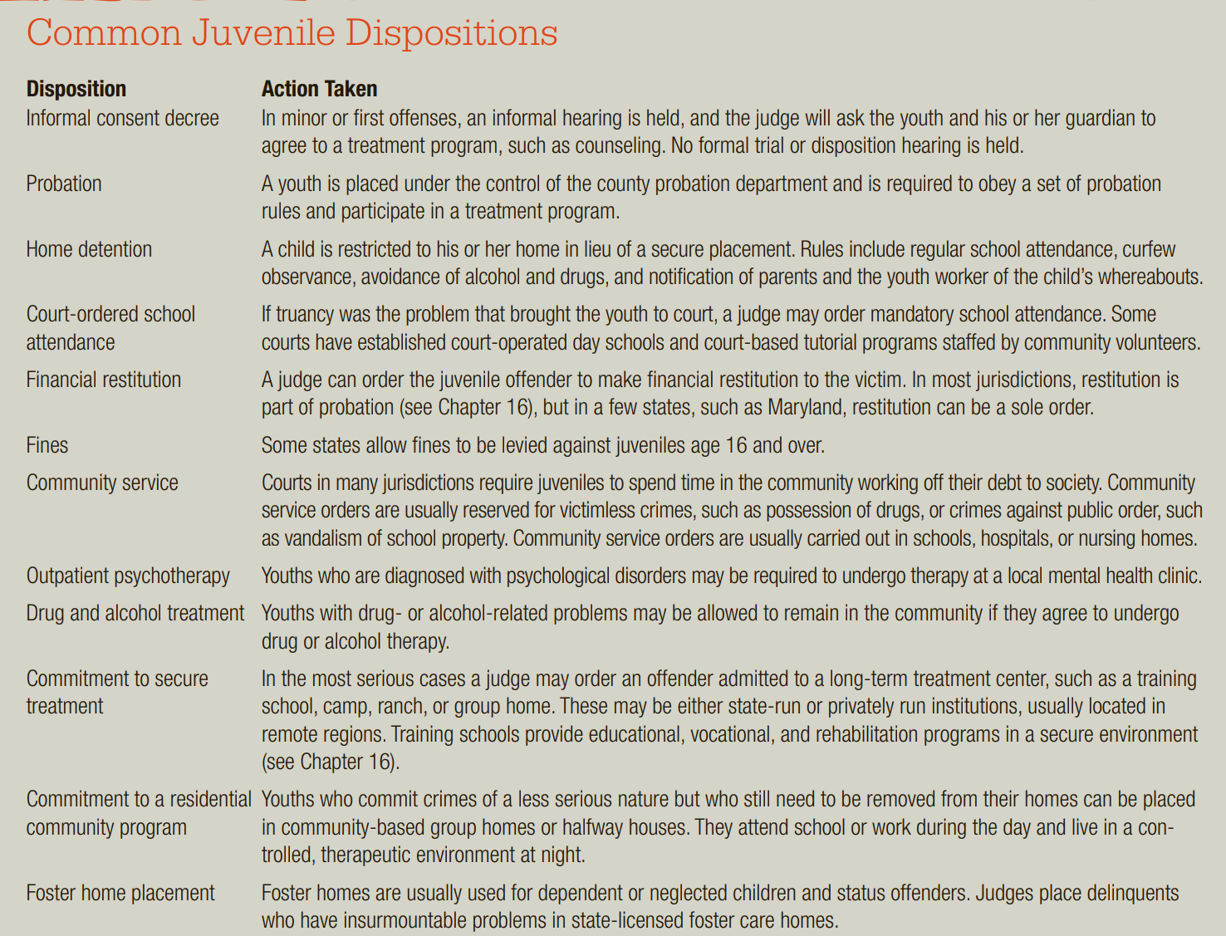

##### The death penalty/ Parole/ appeal

Read JJSA 2018

### JJS in Pak

Pakistan is a signatory to the CRC and other agreements. Article 3 (1) of the CRC states that: “In all actions concerning children, whether undertaken by public or private social welfare institutions, courts of law, administrative authorities or legislative bodies, the best interests of the child shall be a primary consideration.”

International laws in the form of the Universal Declaration of Human Rights 1948 (UDHR) and several international conventions on human rights such as UNCRC, ICCPR, UNCAT, CEDAW and ICESCR, all ratified by Pakistan, protect the rights of juveniles. These conventions put Pakistan under the legal obligation to protect the dignity of children and to take measures for full implementation of the juvenile justice system in the country.

The low minimum age of 10 years for criminal responsibility of juvenile delinquents in the criminal legal system of Pakistan has received criticism from the UNCRC Committee, who has reviewed the fifth periodic report of Pakistan in June 2016 and issued its concluding observations and recommendations to Pakistan on different thematic areas related to protection of children rights. In relation to administration of juvenile justice, the Committee deplores the worsening situation of juvenile justice in Pakistan and urges Islamabad to revise, as a matter of highest priority, its legislation and increase the minimum age of criminal responsibility to an internationally accepted level and to bring its juvenile justice system fully in line with the UNCRC and other relevant standards.

The low minimum age of criminal responsibility for juveniles in Pakistan leads to their involvement in criminal cases as accused persons and subsequently resulted in convictions, and in some tragic cases, their executions. Thus, it needs to be reviewed with immediate effect.

**Age of criminal responsibility** is the age at which a person is held responsible for all her criminal actions. The presumption is that at this age the person becomes capable of understanding the nature of the act and its probable consequences. Different legal systems tend to fix different age limits for this purpose depending on crime rate in the society and local customs and culture.

Domestic laws in the form of Constitution of Pakistan 1973, Pakistan Penal Code (PPC) 1860, Criminal Procedure Code 1898 and Juvenile Justice System Act 2018 provide protection to juvenile delinquents from criminal responsibility. Article 25 of the Constitution of Pakistan 1973 proclaims equality of law, entitlement to equal protection before the law, and that nothing shall stop the State from making any special provision for women and children.

Pakistan Penal Code 1860 provides safeguards to juvenile delinquents to be held responsible for their criminal acts. Under section 82 of the PPC, the minimum age of criminal responsibility for a juvenile delinquent was set as seven years old. But in 2016, section 82 of PPC was amended through Criminal Law (Second Amendment) Act 2016 and age of criminal responsibility for a juvenile delinquent enhanced from seven to ten years old to address the child abuse issue. This means that an illegal action by a juvenile below the age of ten years cannot be considered a criminal offense.

Similarly, before Criminal Law (Second Amendment) Act 2016, section 83 of PPC provided that nothing is an offence which is done by a child above seven years of age, and under twelve, who has not attained sufficient maturity of understanding to judge of the nature and consequences of his conduct at the time of commission of offence. Section 83 of PPC was also amended through Criminal Law (Second Amendment) Act 2016 to provide further protection to juvenile delinquents from criminal responsibility and it declared that nothing is an offence which is done by a child of immature understanding who is above ten and under fourteen years of age. So, section 83 of PPC further extends the relaxation of criminal responsibility up to the age of 14 years, if the juvenile has not attained sufficient maturity of understanding to judge the nature and consequences of his conduct on that occasion.

The Criminal Procedure Code 1898 protects the rights of juvenile delinquents in a number of ways. Section 29B of CrPC provides a special procedure for custody, trial or punishment of juvenile offenders by a special judge appointed by the Provincial Government for any area to hear the cases of juvenile offenders. Section 497 CrPC gives relaxation to juvenile offenders for grant of bail in non-bailable offenses, if the juvenile is below 16 years of age at the time of the commission of an offence. Section 399 CrPC provides that in case of sentencing a juvenile who is below the age of fifteen years, the court may direct that such a juvenile instead of being imprisoned in jail shall be confined in any reformatory for his rehabilitation and re-integration into society.

### Juvenile justice system act 2018

On May 18, 2018, the President of Pakistan approved the Juvenile Justice System Act (JJSA) 2018, which was passed by the Parliament earlier this year. JJSA 2018 overcomes the shortcomings which were present in Juvenile Justice System Ordinance 2000 and provides a much better system for criminal justice and social reintegration for juvenile offenders. The Act defines a child according to the definition of UNCRC as ‘a person who has not attained the age of eighteen years.

Juvenile Justice System Act 2018 (JJSA 2018) is an exclusive law enacted for the protection of rights of juvenile delinquents and provides a specialised procedure for arrest, investigation, bail, trial, detention, and rehabilitation of juvenile offenders. JJSA 2018 safeguards the relaxation in criminal responsibility of juvenile delinquents through different modes. This law prohibits the awarding of a death sentence or life imprisonment to juvenile convicts. No juvenile offender shall be committed to prison, ordered to labour, put in fetters, handcuffed or given any corporal punishment at any time while in custody of the State. Instead of conviction and sentence, JJSA 2018 encourages the use of probation law, for social reintegration and rehabilitation of juveniles. This law provides a mechanism for disposal of cases through Diversion, i.e. out of court settlement of disputes without resorting to formal judicial proceedings. All those offences where the maximum punishment is imprisonment for up to seven years with or without fine are declared compoundable for purpose of exercising Diversion under JJSA 2018. Likewise, all kind of offences mentioned in the PPC are declared bailable for juveniles. Bail shall even be granted to juveniles as a right in heinous offences where the punishment is death or life imprisonment or imprisonment for more than seven years with or without fine provided that a juvenile is below sixteen years of age at the time of commission of offence.

JS Act 2018 classifies the criminal offences into following three different categories:

1) Minor, which means an offence for which maximum punishment under the Pakistan Penal Code, 1860 is imprisonment for up to three years with or without fine. A juvenile is entitled to bail in minor offences, with or without surety bonds by Juvenile court.

2) Major, which means an offence for which punishment under the Pakistan Penal Code, 1860 is imprisonment of more than three years and up to seven years with or without fine. Bail shall also be granted in major offences with or without surety bonds by juvenile court.

3)Heinous, which means an offence which is serious, brutal, or shocking to public morality and which is punishable under the Pakistan Penal Code, 1860 with death or imprisonment for life or imprisonment for more than seven years with or without fine. A juvenile of less than sixteen years of age is entitled to bail in heinous offences, but a bail is on discretion of court if juvenile is more than sixteen years of age.

The JJSA 2018 is very different from JJSO 2000, and the following are some of its salient new features.

1) Right of legal assistance: every juvenile or child victim of an offence shall have the right of legal assistance at the expense of the State. A juvenile shall be informed about his right of legal assistance within 24 hours of taking him into custody.

2) Observation home: this means a place where a juvenile is kept temporarily after being apprehended by police as well as after obtaining remand from juvenile court or otherwise for conducting inquiry or investigation. Observation Homes shall be made separately from police stations.

3) Juvenile rehabilitation centres: this is a special kind of prison established exclusively for keeping juvenile offenders. The convicted juvenile shall be confined to the premises till the completion of period of imprisonment or until they turn 18 years of age. Here convicts can receive an education as well as vocational or technical training for their development and includes certified institutions including women crises centres.

4) Determination of age mechanism: JJS Act 2018 makes it compulsory upon the ranking officer-in-charge, or the investigation officer, to make an enquiry to determine the age of any such alleged offender, who physically appears or claims to be a juvenile. Age shall be determined on basis of accused person’s birth certificate, educational certificates or any other pertinent documents. In absence of such documents, age of such accused person may be determined on the basis of a medical examination report by a medical officer.

The law defines an observation home as “a place where a juvenile is kept temporarily after being apprehended by police as well as after obtaining remand from Juvenile Court or otherwise for conducting inquiry or investigation for the purpose of this Act.”

Similarly, the juvenile rehabilitation centre means “a place where a juvenile may be kept and given education, vocational or technical training for his mental, moral and psychological development and includes certified institutions, juvenile training institutions, borstal institutions, vocational centres, Darul Amaan and women crises centres established by the government or by voluntary organisation certified by the government.”

A novel concept of ‘diversion’, which was not discussed under the JSSO, has been introduced in the JJSA with great emphasis. According to section 9 of the JJSA, all minor and major offences shall be compoundable for the purpose of diversion. The process of diversion can be initiated at any stage (investigation, prosecution, or trial) with the consent of the accused juvenile or his guardian. The case can be resolved through the diversion process with the consent of aggrieved person by adopting different modes such as:

(a) restitution of movable property;

(b) reparation of the damage caused;

(c) written or oral apology;

(d) participation in community service;

(e) payments of fine and costs of the proceedings;

(f) placement in Juvenile Rehabilitation Centre; or

(g) written and oral reprimand.

Section 17 of the JJSA provides a special safeguard for the female juvenile offenders with regards to their arrest and interrogation. The provision states that no female shall in any circumstances be apprehended or investigated by a male officer, or released on probation under the supervision of a male officer. She can only be kept in a juvenile rehabilitation centre established or certified exclusively for female inmates. This distinction between male and female juvenile offenders did not exist under the JJSO. Previously female juvenile offenders were treated equally with adult female offenders and were kept at the same women police stations. The JJSA has acknowledged the fragility of female juvenile offenders and provided a separate place of detention for them.

Another distinct feature of the Act was the establishment of one or more exclusive Juvenile Courts in a session division, within three months from the commencement of the JJSA. This exclusive Court was required by the JJSA to decide juvenile cases within six months of taking cognizance

### Situation of juvenile justice in pak

The custodial death of a teenage boy inside a police lock-up in Peshawar on March 14 2021 has triggered a public outcry with growing demands for implementation of the juvenile justice law in the country.

The boy has allegedly committed suicide inside the lock-up of West Cantt Police Station. The complainant claimed that he had received a phone call from the police station telling him that his son had been arrested as he was not having registration documents of his motorcycle and he should visit the station and bring the said documents.

He claimed that when he reached the police station, he was kept waiting for three hours and finally informed that his son had committed suicide. He alleged that his son was tortured to death.

This unfortunate incident has brought to fore the Pakistan’s Juvenile Justice System Act, 2018, with experts pointing out the violations committed by police officials in the instant case. Questions have been raised as to why the deceased, who was a juvenile, was kept in the lock-up contrary to the provisions of JJSA providing that he should have been kept in an observation home.

So far, no observation home has been set up anywhere in the province where a juvenile in conflict with law could be kept. The present case clearly proved that not only the police, but other stakeholders specially the Khyber Pakhtunkhwa government had also not fulfilled its responsibility towards implementation of the present law as well as the relevant previous law on the subject.

While the previous law (Juvenile Justice System Ordinance, 2000) included provision related to “borstal institution”, the present law has included provisions related to setting up of observation home and juvenile rehabilitation centre.

Interestingly, neither the provision related to borstal institution nor that of observation home and rehabilitation centre provided in the present law have been implemented.

The situation of juvenile justice in Pakistan is really deplorable. The spirit of the CRC and other international rules and guidelines, like the Riyadh Guidelines and the Beijing Rules, is that justice system dealing with child in conflict with law should focus primarily on reintegration of the child into society and encouraging him/her to play a constructive role in the society. But unfortunately the approach and spirit of these international rules and guideline is direly missing in Pakistan. The following presents a brief picture of juvenile justice in Pakistan.

Minimum age of criminal responsibility discussed above.

there is no mechanism in the country for keeping the record of juveniles, who have been in conflict with law, awaiting trial, pending cases, in detention, in prisons, and juvenile probationers etc. There are no proper official statistics available on these variables. The concept of restorative justice is generally not put into practice by many. That's why there are no fruitful and well-received diversionary programmes for juvenile offenders. With regards to diversionary programmes, the probation is the only non-custodial punishment in the country but the lack of awareness about the system and its significance is obvious. The probation system is mostly less known to the key protagonists involved in the juvenile justice system. Furthermore, the probation department is ill-staffed throughout the country.

the national and international laws provide for free legal assistance to the juveniles but rarely a child is provided legal assistance. Only some civil society organizations (hereinafter CSOs) are providing legal assistance to juveniles in conflict with law but their efforts are still not enough to deal with the magnitude of the problem.

Sixth, there is no published official data on juvenile justice indicators. Most of the data contained in the periodic report has been taken from the studies and small surveys conducted by CSOs and other organizations. To many, their reports are not reliable and lack proper presentation. Mostly their studies are not empirical and to rely on that information will present a picture of the situation which is not tangible.

there is no authentic system of birth registration in the whole country. The birth registration rate in the country is only 29.5% as provided in the periodic report. In the absence of such a system it becomes very difficult to determine the exact age of a person accused of having infringed the penal law. This difficulty in age determination results in many mishaps to the child in conflict with law in the country.

### JJS policy and role of key stakeholders

The above discussion fully substantiates that Pakistan needs a comprehensive juvenile justice policy, the blue-print of which is provided in this paper. A policy in any discipline, department, institution, or organization is based on some guiding principles which are “the underlying assumptions in a system of thoughts” (Police, 2008). Some of the guiding principles for a juvenile justice policy in Pakistan, which are considered necessary by the author, are given as:

* All children in conflict with law should be dealt with courtesy and mercifully [Article 37 (c) of the CRC]. ·
* All children in conflict with law shall be treated equally and they shall not be discriminated on any ground [Article 2 (1) of the CRC]. ·
* The best interest of the child shall be the primary consideration in all processes of juvenile justice administration [Article 3 of the CRC]. ·
* All forms of abuse and violence shall be prohibited in all juvenile justice processes [Article 19 of the CRC, The Beijing Rule 17.3]. ·
* Family and religion and other institutions shall be strengthened for the reintegration of the child and prevention of delinquency (Wilson & Howell, 2005).

#### Role and responsibilities of police

Police officers play an important role in the law enforcement system. They control criminal activity, take part in community patrolling, respond to emergency calls, make arrests, investigate crimes and testify in court as needed. In the cases of juvenile, the first contact between a Juvenile and an official from the criminal justice system is normally the Police. Hence, this initial contact is critical. The way in which the treatment of the Juvenile is going to be provided by the police officers might play a decisive role in the due safeguard of the Juvenile's rights and in the whole navigation of the case (including its outcome) throughout the proceedings, impacting even his/her further involvement in criminal activities in some cases. In the case of juvenile justice under JJSO, Police Officer's role and responsibilities are given next.

##### Roles

* Arrest the juvenile (as per Cr.Pc. Sec. 54) ¦
* Immediately inform parents/guardian of the juvenile (Sec. 67 SCA)
* Immediately inform concerned Probation Officer and Protection Officer for record and help (Sec. 88 SCA)
* Maintain Daily Diary Report (Roznamcha entry) (Police Rules 1934 Ch. 22 ¦ Rule # 48) ¦
* Launch First Information Report (FIR) (Cr.Pc. Sec. 154) ¦
* Present the juvenile before Magistrate within 24 hours (Cr.Pc. 61)
* Ensure that the juvenile is medically examined and treated, if needed, ¦ within 24 hours (Police Rules 1934-Ch. 26 Rule # 6)
* Coordinate and support the Probation Officer while conducting Social Investigation Report (SIR)
* Investigate the case (as per Cr.Pc.) ¦ Prepare Challan/present the custody in Juvenile Court (as per C.P.Sc.173)

##### Recommendations

Firstly, the attitude of the police towards the juveniles in conflict with law is a very big problem. In a five days training, organized by Pakistan Society of Criminology (PSC), for educating and sensitizing the police station clerks, called Moharirs and Naib Moharirs, of the NWFP Police, it was observed that they have utter lack of awareness about national and international juvenile laws and the child rights. When asked “who has heard the name of JJSO or CRC?” only a few participants of the trainings-mostly from Peshawar district-raised their hands in affirmation. It gives an idea about the awfully low level of awareness regarding juvenile laws in the police station officials of the NWFP. The situation will not be different in other provinces as well. Therefore, awareness and sensitization in the police officials shall be given priority. The JJSO 2000 and other child related national and international laws should immediately be included in the syllabus of the Police Service of Pakistan (PSP) officers, upper courses and intermediate courses of the upper and lower subordinate officers at the police training institutions.

Secondly, a child in conflict with law cannot be kept at police stations nor he/she can be detained in jails under JJSA. To the contrary in Pakistan due to lack of facilities, the children in conflict with law are kept at police stations before the disposal of their cases. In this regard it is recommended that the Police Station Officers must ensure to contact the Probation Officer(s) immediately on arrest of the juvenile, and give the juvenile under his custody, who can detain the child in conflict with law into any facility etc.

Astonishingly there is no pre-trial detention or remand home facility in Pakistan except Karachi (established under Sindh Children Act 1955), so where on earth the probation officer would keep the child in conflict with law if at all he is given the custody of such a child a legal gap in the implementation of the law?

Thirdly, to collect and analyze the cases of juvenile offenders and victims and find out the causative factors and devise ways and means to curtail the inhumane behaviour towards children, the establishment of a data-base at the Central Police Office (CPO) of all the provinces and at the regional level should be the top priority. The profile of children in conflict with law-by gender, age, offence category etc- be recorded separate from the adults' record.

Fourthly, juvenile delinquency, the world over, is considered to be the problem of urban centers. Therefore in big cities of the country, where the rate of juvenile delinquency is high, special police units for dealing with children in conflict with law can be created on priority basis [The Beijing Rule 12.1]. These police officers shall be trained properly and skillfully on the process of interacting and interviewing with a child while keeping in mind the needs, wishes and feelings of a child. Achild shall be treated by a police officer in light of the internationally agreed guidelines.

Fifthly, there are reports on child sexual and physical abuse by the police authorities. This is something very discouraging on part of the protectors of people. For that reason, an independent and impartial investigation mechanism regarding reports of misconduct, brutality, and the denial of children's rights by the police should be established. There should be specialized units in the police who deal, particularly, with child sexual abuse and child trafficking.

Sixthly, but the most important is that the police officers should pay more emphasis on diversion of the juveniles in conflict with law from the formal justice system. In this regard the police officers can use warnings, fines, restitution, compensation, restorative justice practices, and other diversionary options.

Finally, for all these steps the police should be given special budget immediately, and the police themselves should allocate sufficient amount from its own budget for these direly needed initiatives in the best interests of the child.

#### Role of prosecution

Prosecution is a liaison department between the police and the court. Prosecution plays a pivotal role in the administration of justice. According to Black's Law Dictionary, “Prosecution is a proceeding instituted and carried on by due process of law, before a competent tribunal (court), for the purpose of determining the guilt or innocence of a person charged with a crime” (Prosecution, 1999). A prosecutor or public prosecutor is an expert of the law to represent the state, in court proceedings, against the law breaker. Prosecution in Pakistan was a branch of police but it has recently been separated, with a view to achieving speedy justice process. It is now made an independent department after the promulgation of the Prosecution Ordinance of 2005. This department is highly developed in other countries, but in Pakistan it has not yet developed to that extent. In the area of juvenile justice the prosecution department has several gaps including lack of specialized prosecutors in children's issues, low interest and lack of concern in such cases, and the problem of prosecuting a child like the adult criminal.

##### Roles

* To provide technical assistance to the investigation agency (Sec. 9 SCPSA)
* To assist and provide technical assistance the Court (Sec. 493 Cr.Pc.)
* Act as liaison officer dealing with all stakeholders of the juvenile justice ¦ system (Sec. 493 Cr.Pc.)
* Identify cases where diversion is possible and bring in the notice of Court ¦ (Sec. 493 Cr.Pc.)
* Assist Court in disposing of bail matter and main case of juvenile within stipulated time (Sec. 493 Cr.Pc.)

##### Recommendations

First, special public prosecutors (PP) on juvenile justice are needed to be appointed at first in the big cities and later on at each district. For the existing prosecutors who are frequently dealing with juvenile cases special trainings should be arranged. These trainings should include, besides national and international laws, courses on psycho-social development of child, counseling of a child, proper production of juvenile offenders before the court and securing the rights of the juvenile offenders when they are in police/judicial custody etc.

Secondly, priority should be given to an appropriate conclusion of the case of juveniles through diversion by the prosecutor. The prosecutors should continuously explore the possibilities of alternatives to a court conviction as recommended by UN General Comment No. 10 Para 68.

It is the prosecution department which has to make it certain and ensure that the investigations are properly and timely completed by the police in the stipulated time as required by the law under Section 173 of the Criminal Procedure Code of Pakistan (hereinafter Cr.P.C) by adopting due diligence in the recording of age the most important factor in dealing with child related cases. The District Public Prosecutors (DPP) should perform their duty of taking disciplinary actions against the Investigation Officers who prepare the final report (chalan) inefficiently, misrepresent the facts, and who do not exercise due diligence or honesty in conducting investigation etc [Section 5(d) of the Prosecution Ordinance 2005].

#### Role of courts/judiciary

Judiciary is the third pillar of the state which is responsible for its legal system and which consists of all the judges in the country's courts of law (Judiciary, 2009). Courts are one of the basic components in all justice systems. In fact when we think of the juvenile justice system, the first concept which strikes our mind is the exclusive juvenile court dealing only with the juveniles. The children in conflict with law, who are not diverted from the formal legal system at an early stage, are dealt with by the juvenile courts or by the criminal courts in case of non-existence of juvenile court. Juvenile Court is the heart of the juvenile justice process. It is an agency where the decisions made by all the other child related agencies are supported or altered. A juvenile court is the court responsible for holding hearings and making decisions regarding disposition of juveniles who have entered the juvenile justice process.

##### Roles

* Monitor and supervise investigation process
* Decide issue of age of Juvenile immediately Call for report from probation officer with regard to juvenile's social and ¦ educational status
* Supervise juveniles housed/detained at rehabilitation/reformatory centres
* Dispose of bail matters on priority and main cases within a period of four months

##### Recommendations

Establishment of separate juvenile courts as mentioned in JJSA

If a child found guilty of the alleged offence(s), the court should look for the alternatives to institutional care and deprivation of liberty, to assure that deprivation of liberty be used only “as a measure of last resort and for the shortest possible period of time” [Article 37 (b) of the CRC, & The Beijing Rule 13.1]. Preference should be given by the judges to measures like fines, restitution and compensation, probation, and community services, and group counseling activities etc [The Beijing Rule

Age assessment of the juvenile in conflict with law is a very big problem in Pakistan. Generally there is a very low tendency in masses about birth registration of their children, and education too. Therefore age determination of the children who have no official documents regarding age, becomes a big problem. In such cases the police officers often use their personal judgment by examining the physical appearance of the offender. Although it is the duty of the prosecutors to make it certain that the exact age of the child in conflict with law has been written on the age card (chalan), but whenever the prosecutors fail to do so the court must ensure the proper age assessment in order for child in conflict with law to qualify to the benefits of the JJSA.

#### Role of probation

Imprisonment is not the only way to respond to the criminals. There are various alternative methods to imprisonment including probation which is arguably one of the most progressive contributions to modern criminal policy (Qureshi, 1999). It is a very important agency in juvenile justice system. Those offenders who, according to the court, are likely to be reformed, and who are not dangerous to society, are not sentenced to imprisonment and are kept on probation under the supervision of the state-probation officer. Probation is “a period of time when a criminal must behave well and not commit any more crimes in order to avoid being sent to prison” (Probation, 2009). As defined by Elrod and Ryder, it is the supervised release of an individual by a court (Elrod & Ryder, 2005). Islamic philosophy of crime does not profess hating the criminal rather it professes hating the crime and reforming the criminal (Tahir-Ul-Qadri, 2006). Similarly, the probation system is based on the philosophy of “eradicating the crime not the criminal.” Probation department in Pakistan performs its functions under The Good Conduct Prisoner's Probation Release Act 1926, Probation of Offenders Ordinance 1960, JJSA 2018, and the rules formulated under various laws.

The juvenile probation officer plays an important role in the justice process, beginning with intake and continuing throughout the period in which a juvenile is under court supervision. Their role is so important and influence so great that much research has been generated over the years on how juvenile probation officers perform their duties, including their approach to treatment and punishment.18 Probation officers are involved at four stages of the court process. At intake, they screen complaints by deciding to adjust the matter, refer the juvenile to an agency for service, or refer the case to the court for judicial action. During the predisposition stage, they participate in release or detention decisions. At the postadjudication stage, they assist the court in reaching its dispositional decision. During postdisposition, they supervise juveniles placed on probation.

The probation officer exercises tremendous influence over the youth and the family by developing a social investigation report (also called a predisposition report) and submitting it to the court. This report is a clinical diagnosis of the youth’s problems and of the need for court assistance based on an evaluation of social functioning, personality, and environmental issues. The report includes an analysis of the child’s feelings about the violations and his or her capacity for change. It also examines the influence of family members, peers, and other environmental influences in producing and possibly resolving the problems. All of this information is brought together in a complex but meaningful picture of the offender’s personality, problems, and environment.

##### Roles

* Conduct Social Investigation Report (SIR) and maintain proper record of juvenile [Rules 10(9), 11(2), 64(1), 64(3) POO 1960]
* Coordinate with juvenile released on probation and refer them to the court or Social Welfare Department/Child Protection Authority, if needed.
* Submit juvenile's conduct-reports to the court, immediately after arrest (Sec. 22 SCA)
* Coordinate and assist, if called for, the investigation agencies and trial courts
* Ensure terms and conditions of probation order of the juvenile

#### Role of Institutions

Pakistan Society of Criminology (PSC) has recently conducted a research study on selected prisons of the NWFP (Report on Gaps in Existing System of Jails, 2009) under Juvenile Justice Reforms Project (JJRP) by the UNICEF. Its findings and observations include:

* overcrowding in jails-which has also been noted by Amnesty International's research report on Pakistan 2003 (Pakistan: Denial of Basic Rights for Child Prisoners, 2003); ·
* no separate places for juveniles and likely indoctrination by radical inmates; ·
* no separate sector inspector or officials entitled to handle juvenile inmates; ·
* lack of recreational facilities for juveniles, and no separate transport facility for under-trial juveniles; ·
* no proper record of juvenile offenders; ·
* no formal education provisions for juvenile offenders; ·
* no separate interview facilities for juvenile offenders; and ·
* lack of medical facilities for juvenile offenders.

The situation is almost the same in all prisons throughout the county. The recommendations of PSC report regarding the prisons provide a very good source for policy consideration. In the light of aforementioned findings and observations, the following are a few recommendations for future juvenile justice policy

Establishment of observation homes

, the Beijing Rules 26.3 states that “juveniles in institutions shall be kept separate from adults and shall be detained in a separate institution or in a separate part of an institution also holding adults. ” The placement of children in adult prisons or jails compromises the children's basic safety, well-being, and their future ability to remain free of crime and to reintegrate (General Comment No. 10, 2007, Para. 85). Therefore, every child deprived of liberty should be separated from adult criminals.

Thirdly, the present staff in prisons is trained to deal with adult criminals and their approach to juvenile is also like that of adult criminals. Therefore, there should be special staff in the rehabilitation/reformation institutions, for dealing with juvenile inmates.

Fourthly, recreation plays a key role in child physical and psychological development and there are no such facilities in jails as observed by PSC study. Therefore, wherever possible in jails, some sort of recreational facilities should be created for juveniles such as indoor and out-door games.

as exclusive juvenile courts are missing in the country, so until the creation of exclusive juvenile courts, the proceedings of juvenile offenders should take place within the jails for early disposition.

#### Role of Defense Attorney

In many respects, the role of juvenile defense attorney is similar to that in the criminal and civil areas. Defense attorneys representing children in the juvenile court play an active and important part in virtually all stages of the proceedings. The defense attorney helps clarify jurisdictional problems and to decide whether there is sufficient evidence to warrant filing a formal petition. The defense attorney helps outline the child’s position regarding detention hearings and bail, and explores the opportunities for informal adjustment of the case. If no adjustment or diversion occurs, the defense attorney represents the child at adjudication, presenting evidence and cross-examining witnesses to see that the child’s position is made clear to the court. Defense attorneys also play a critical role in the dispositional hearing. They present evidence bearing on the treatment decision and help the court formulate alternative plans for the child’s care. Finally, defense attorneys pursue any appeals from the trial, represent the child in probation revocation proceedings, and generally protect the child’s right to treatment.

#### Role of associated agencies

The police, probation, prosecution, courts, and correctional institutions are the primary components of the juvenile justice system. But juvenile justice policy must take into account the various secondary components and associated agencies of the juvenile justice system as well. The Social Welfare Department should be utilized to a greater extent for devising diversionary programmes. The Ministry of Human Rights, CSOs, media, Law Department and other agencies associated with criminal justice, rehabilitation, and social services, should be given due attention and specific role in policy making.

##### Recommendations

Firstly, the periodic report Para 539, points out that there is a lack of probation officers and that many districts are still without probation officer. Therefore the number of probation officers should be immediately increased. At least three probation officers should be posted in each district. The female probation officers are only a few in a country of 170 million people, which must be taken into account at once.

Thirdly, diversion is the key element of juvenile justice system. “It avoids child getting criminal record and being labeled at an early age, and avoids being stigmatized and minimizes the deprivation of liberty” (UNODC, 2006). The concept of diversion should be promoted at all levels in the juvenile justice process, right from the initial contact of a child with the police. It is the probation officers who perform key role in diversion programmes-such as close supervision, community services. It has been noted that most often the child diverted to community services is kept as a servant in residences of the officers. This form of service is included in the category of “child labour”, and it is a labour without any fruit. This practice needs to be abandoned at once and other community services should be sought while keeping in view the inherent dignity of the child.

Fourthly, to lower the burden on the courts, where appropriate, the probation officers should be empowered to dispose off juvenile cases at their discretion before lodging of report with the police and institution of trial.

Finally, more Borstal institutions should be established under the probation department and they should be run under the Borstal Act instead of Jail Manual.

### Measures to improve JJS

In India, the Juvenile Justice (Care and Protection of Children) Act, 2015, was enacted in Dec 2015 and through it the relevant law of 2000 was replaced.

An important provision in the Indian previous and present law relates to setting up of Special Juvenile Police Unit, which means a unit of the police force of a district or city or, as the case may be, any other police unit like railway police, dealing with children and designated as such for handling children.

The law provides that in every police station, at least one officer, not below the rank of assistant sub-inspector, with aptitude, appropriate training and orientation may be designated as the child welfare police officer to exclusively deal with children either as victims or perpetrators, in co-ordination with the police, voluntary and non-governmental organisations.

Moreover, the Indian National Commission for Protection of Child Rights and the state-level commissions have been empowered to monitor implementation of the provisions of this Act.

Experts on the subject believe that without wasting time the institutions mentioned in the JJSA such as observation homes, juvenile rehabilitation centres, juvenile justice committees, etc should be set up and made operational at the earliest.

### Juvenile correctional institutions

Peshawar incident highlights the importance of correctional treatment for juvenile offenders. There is a wide choice of correctional treatments available for juveniles, which can be subdivided into two major categories: community treatment and institutional treatment.

Community treatment refers to efforts to provide care, protection, and treatment for juveniles in need. These efforts include probation, treatment services (such as individual and group counseling), restitution, and other programs. Community treatment also refers to the use of privately maintained residences, such as foster homes, small-group homes, and boarding schools, which are located in the community. Nonresidential programs, where youths remain in their own homes but are required to receive counseling, vocational training, and other services, also fall under the rubric of community treatment.

Institutional treatment facilities are correctional centers operated by federal, state, and county governments; these facilities restrict the movement of residents through staff monitoring, locked exits, and interior fence controls. A variety of functions within juvenile corrections are served by these facilities, including (a) reception centers that screen juveniles and assign them to an appropriate facility, (b) specialized facilities that provide specific types of care, such as drug treatment, (c) training schools or reformatories for youths needing a long-term secure setting, (d) ranch or forestry camps that provide long-term residential care, and (e) boot camps, which seek to rehabilitate youths through the application of rigorous physical training.

Choosing the proper mode of juvenile corrections can be difficult. Some experts believe that any hope for rehabilitating juvenile offenders and resolving the problems of juvenile crime lies in community treatment programs.3 Such programs are smaller than secure facilities for juveniles, operate in a community setting, and offer creative approaches to treating the offender. In contrast, institutionalizing young offenders may do more harm than good. It exposes them to prisonlike conditions and to more-experienced delinquents without giving them the benefit of constructive treatment programs.

Those who favor secure treatment are concerned about the threat that violent young offenders present to the community and believe that a stay in a juvenile institution may have a long-term deterrent effect. They point to the findings of Charles Murray and Louis B. Cox, who uncovered what they call a suppression effect—a reduction in the number of arrests per year following release from a secure facility—which is not achieved when juveniles are placed in less-punitive programs.5 Murray and Cox concluded that the justice system must choose which outcome its programs are aimed at achieving: prevention of delinquency, or the care and protection of needy youths. If the former is a proper goal, institutionalization or the threat of institutionalization is desirable.

#### Community treatments

##### Juvenile Probation

Probation and other forms of community treatment generally refer to nonpunitive legal dispositions for delinquent youths, emphasizing treatment without incarceration. Probation is the primary form of community treatment used by the juvenile justice system. A juvenile who is on probation is maintained in the community under the supervision of an officer of the court. Probation also encompasses a set of rules and conditions that must be met for the offender to remain in the community. Juveniles on probation may be placed in a wide variety of community-based treatment programs that provide services ranging from group counseling to drug treatment. Community treatment is based on the idea that the juvenile offender is not a danger to the community and has a better chance of being rehabilitated within the community. It provides offenders with the opportunity to be supervised by trained personnel who can help them reestablish forms of acceptable behaviour in a community setting. When applied correctly, community treatment (a) maximizes the liberty of the individual while vindicating the authority of the law and protecting the public, (b) promotes rehabilitation by maintaining normal community contacts, (c) avoids the negative effects of confinement, which often severely complicate the reintegration of the offender into the community, and (d) greatly reduces the financial cost to the public.

Although the major developments in community treatment have occurred in the twentieth century, its roots go back much farther. In England, specialized procedures for dealing with youthful offenders were recorded as early as 1820, when the magistrates of the Warwickshire quarter sessions (periodic court hearings held in a county, or shire, of England) adopted the practice of sentencing youthful criminals to prison terms of one day, then releasing them conditionally under the supervision of their parents or masters.

###### Conditions

Rules mandating that a juvenile on probation behave in a particular way are the conditions of probation. They can include restitution or reparation, intensive supervision, intensive counseling, participation in a therapeutic program, or participation in an educational or vocational training program. In addition to these specific conditions, state statutes generally allow courts to insist that probationers lead law-abiding lives, maintain a residence in a family setting, refrain from associating with certain types of people, and remain in a particular area unless they have permission to leave.

Although probation conditions vary, they are never supposed to be capricious, cruel, or beyond the capacity of the juvenile to satisfy. Furthermore, conditions of probation should relate to the crime that was committed and to the conduct of the youth. Courts have invalidated probation conditions that were harmful or that violated the juvenile’s due process rights. Restricting a young person’s movement, insisting on a mandatory program of treatment, ordering indefinite terms of probation, and demanding financial reparation where this is impossible are all grounds for appellate court review.

##### Other Non-punitive alternatives

##### Intensive Supervision

Juvenile intensive probation supervision (JIPS) involves treating offenders who would normally have been sent to a secure treatment facility as part of a very small probation caseload that receives almost daily scrutiny.23 The primary goal of JIPS is decarceration; without intensive supervision, youngsters would normally be sent to secure juvenile facilities that are already overcrowded. The second goal is control; high-risk juvenile offenders can be maintained in the community under much closer security than traditional probation efforts can provide. A third goal is maintaining community ties and reintegration. Offenders can remain in the community and complete their education while avoiding the pains of imprisonment.

##### Electronic Monitoring/ House arrest

Another program that has been used with adult offenders and is finding its way into the juvenile justice system is house arrest, which is often coupled with electronic monitoring. This program allows offenders sentenced to probation to remain in the community on condition that they stay at home during specific periods (e.g., after school or work, on weekends, and in the evenings). Offenders may be monitored through random phone calls, visits, or, in some jurisdictions, electronic devices.

##### Restorative justice

Restorative justice is a wide subject and some of its concepts are akin to the Jirga system of the Pukhtoon culture or Panchayat in the Punjab or Sulh in the Arab world. It focuses on the relationships between crime victims, offenders and the community (McLaughlin & Muncie, 2001). Advocates of this restorative justice practices suggest that, once found guilty, the priority should not be to punish the offender but our priority should be to repair the harm done to the victim and ensure that the offender realizes the damage he has done to the victim and community (Johnstone, 2002). It is further argued that this goal can not be achieved through the formal criminal trial and judicial punishment. It needs something other than the formal criminal justice proceedings. Restorative justice practices are based on this theory. It is an ancient practice and has its roots in eastern societies, but the renewed attention to this practice in the west has started in the last few decades. The beginning of the contemporary restorative justice is traced to the Canadian experiments with victim-offender mediation in Elmira, Ontario in 1974 (Johnstone, 2002). This practice is still in its evolutionary process. Restorative justice processes include among other practices; victim-offender mediation, family group conferencing, community conferencing, restorative circles, circles of support and accountability, Victim Offender Reconciliation Programmes (VORPS), and punishment circles.

Restorative justice is a nonpunitive strategy for delinquency control that attempts to address the issues that produce conflict between two parties (offender and victim) and, hence, reconcile the parties. Restoration rather than retribution or punishment is at the heart of the restorative justice approach. Seven core values characterize restorative justice: ■ Crime is an offense against human relationships. ■ Victims and the community are central to justice processes. ■ The first priority of justice processes is to assist victims. ■ The second priority of justice processes is to restore the community, to the degree possible. ■ The offender has a personal responsibility to victims and to the community for crimes committed. ■ The offender will develop improved competency and understanding as a result of the restorative justice experience. ■ Stakeholders share responsibilities for restorative justice through partnerships for action

##### Restitution

Restitution can take several forms. A juvenile can reimburse the victim of the crime or donate money to a charity or public cause; this is referred to as monetary restitution and is one type of an economic sanction. In other instances, a juvenile may be required to provide some service directly to the victim (victim service restitution) or to assist a community organization (community service restitution). Requiring youths to reimburse the victims of their crimes is the most widely used method of restitution in the United States. Less widely used (but more common in Europe) is restitution to a charity.

Restitution programs can be employed at various stages of the juvenile justice process. They can be part of a diversion program prior to conviction, a method of informal adjustment at intake, or a condition of probation. Restitution has a number of advantages: It provides alternative sentencing options; it offers monetary compensation or service to crime victims; it allows the juvenile the opportunity to compensate the victim and take a step toward becoming a productive member of society; it helps relieve overcrowded juvenile courts, probation caseloads, and detention facilities.46 Finally, like other alternatives to incarceration, restitution has the potential for allowing vast savings in the operation of the juvenile justice system.

##### Residential & non-residential community treatment

Placement of a juvenile offender in a residential, nonsecure facility such as a group home, foster home, family group home, or rural home where the juvenile can be closely monitored and develop close relationships with staff.

Non-residential: Juveniles remain in their own homes but receive counselling, education, employment, diagnostic, and casework services through an intensive support system

#### Secure corrections

When the court determines that community treatment cannot meet the special needs of a delinquent youth, a judge may refer the juvenile to a secure treatment program. Secure facilities restrict the movement of residents through staff monitoring, locked exits, and interior fence controls. Open institutions generally do not restrict the movement of the residents and allow much greater freedom of access to the facility.

### Juvenile Aftercare and Re-entry

Aftercare in the juvenile justice system is the equivalent of parole in the adult criminal justice system. When juveniles are released from an institution, they may be placed in an aftercare program of some kind, so that those who have been institutionalized are not simply returned to the community without some transitional assistance. Whether individuals who are in aftercare as part of an indeterminate sentence remain in the community or return to the institution for further rehabilitation depends on their actions during the aftercare period. Aftercare is an extremely important stage in the juvenile justice process because few juveniles age out of custody.

Reentry involves aftercare services, but includes preparation for release from confinement, also called prerelease planning. Reentry is further distinguished from aftercare in that reentry is seen as the whole process and experience of the transition of juveniles from “juvenile and adult correctional settings back into schools, families, communities, and society at large.

## Criminal Justice System

The criminal justice system is defined as the set of agencies and processes established by governments to control crime and impose penalties on those who violate laws. This system has various components which have to work in harmony and support of each other in order to provide justice to not only to the victim but to the accused as well.

A good and reliable system of criminal justice not only caters to speedy remedy for the victims of crime but also safeguards and protects the legitimate rights of the accused. The system is based on fairness, equality, justice and fair-play for all – a system that deals with crime and criminals with the view to maintain peace and order in the society.

Criminal justice is the system of practices and institutions of the government directed at upholding social control, deterring and mitigating crime, or sanctioning those who violate laws with criminal penalties and rehabilitation efforts.

The criminal justice system of Pakistan has been inherited from the British. This system aims to reduce crime, bring more offenders to justice and raise public confidence that the system is fair and will deliver justice for law-abiding citizens.

The major and **important deficiencies** and weaknesses of the criminal justice system of Pakistan are accurate reporting of crime to the police, malpractices during litigation, delayed submission of challans to the courts by public prosecutors, lopsided and long duration of trials where the accused is considered to be the favourite child of the court, overcrowding of jails due to a large number of under-trial prisoners, underdeveloped system of parole and probation and capacity issues. These weaknesses, especially capacity issues, are not restricted to any one segment of the criminal justice system – all components including law enforcement, judiciary and corrections/prisons equally fall short.

The legal basis of the criminal justice system of Pakistan includes the **Criminal Procedure Act of 1898** (popularly known as the **CrPC**) and **Pakistan Penal Code 1860** which lay out the foundations, procedures and functions of all components of the system starting from reporting of the case to police, its trial by courts, appeals and correction at jails. However, even though amendments from time to time had been made in laws to cater for changing needs, Islamize laws and keep them up-to-date, the major shape is still the same. Unfortunately, Pakistan’s system has failed to achieve the wider objectives, that is why the Supreme Court observed that “…people are losing faith in the dispensation of criminal justice by ordinary criminal courts for the reason that they either acquit the accused persons on technical grounds or take a lenient view in awarding sentences [4].” This has resulted more often in people resorting to street justice and incidents involving lynching of criminals by public which have been reported by media a number of times

The main objective of the research is to analyze the flaws of the criminal justice system/criminal prosecution system in Pakistan and to find effective solutions to create an accessible, efficient and reliable justice system in Pakistan.

Owing to the above shortcomings, the whole system of criminal justice is considered to be underperforming. In the past, several attempts were made at amending the legal framework to make the system efficient and improve its efficiency and effectiveness but those were largely in bits and pieces and were done half-heartedly, not yielding any positive results

**SA Rehman Law Commission** examined the causes of delays in civil and criminal litigation and recommended the appropriate amendments in relevant laws. The Commission, however, did not suggest any radical change in the existing judicial system [9].

**Justice Hamood ur Rehman Law Reform Commission Report** is a fairly comprehensive report on the subject of delays in civil and criminal litigation. It did not find any major fault with the existing legal system. The report listed recommendations under three categories namely legislative action, strict application of existing laws/rules and administrative action. It proposed for an increase in the number of judicial officers and allied infrastructure to reduce the time in disposal of cases [10].

**Law Reform Committee Report** recommendations were given with respect to increase the number of judges and provision of infrastructure to improve the work of investigation and prosecution officers [11].

President’s Commission on Law Enforcement and Administration of Justice’s**Challenge of Crime in a Free Society** **(1967)** suggested a systematic approach to criminal justice which improved coordination among law enforcement, courts and correction agencies

### Objectives

Retribution: To make criminal suffer in the same way • Deterrence: Prevention • Incapacitation: ton keep criminals away from society • Rehabilitation: Transformation of an offender in to a healthy individual • Restitution: Compensation to the victims (Diyat)

### Judicature and Criminal Justice System

Part VII of the Constitution of Pakistan provides for separation of judiciary from executive (Article, 175). The separation of judiciary from executive is a constitutional dictate, which has yet to witness fruition. The traditionally strong executive has remained central to power and has kept the legislature and the judicature peripheral by controlling the purse. Since 2007, the judiciary has gained some space by using its suo motu powers (Article 184(3)) to enforce fundamental rights coupled with its power to punish contempt or non-observance of its orders (Article 204); the legislature has not been able to assert its power through its conventions and privileges rules and due to its partisan nature. The Constitution constitutes the constitutional courts of Supreme Courts, High Courts, Federal Shariat Court and provides for constitutional, civil, criminal and service matters related jurisdictions of different courts. The cumulative reading of competence of federal and provincial legislatures, the jurisdictions of constitutional courts and the fundamental rights (Articles 4, 6, 8, 9, 10, 10-A, 11, 12 and 13) provide for the constitutional basis of the criminal justice system in Pakistan.

### Components

Ontologically, the study of crimes is styled as Criminology and the study of the agencies that control or respond to crime is called Criminal Justice (CJ). The US has rich tradition in knowledge production of CJ and offers its separate degree programmes. Based on the US pedagogical practice, the criminal justice system of Pakistan may be divided into five components: (i) Police, (ii) Prosecution, (iii) Courts; (iv) Prisons, and (v) Corrections. Each component has its own functions, organization, budget, working and legal framework. In practice, a typical provincial criminal justice system is managed by the Home Department under which the police and prisons work as its attached departments.

#### Role of police

The police has been entrusted under law to protect the life and property of citizens of the country. Criminal Procedure Code and Police Order 2002 provide necessary legal cover to the police to perform this function and bring criminals to book.

Police is the first and foremost component of the criminal justice system. Persons aggrieved of highhandedness approach the police for legal protection and redressal of grievances. This forms the basis of criminal action and the foundation of criminal justice system.

##### Registration of FIR

Criminal justice begins with a First Information Report (FIR) at a police station. It has been observed and usually complained about that police avoids registering the crime when reported and usually delays the registration of FIR. The delay in registration of FIR is due to a number of reasons, the foremost being non-willingness on the part of police as it will reflect badly on their performance. Other reasons may include extraneous pressures and corruption. The second stage is apprehension or arrest. The law requires any person taken into police custody to be presented before a court within 24 hours, with the magistrate then determining whether, prima facie, there are grounds for a case. This process, more often than not, is honoured. Magistrates commonly order a remand without even seeing the accused. Moreover, when judges do not remand the accused, the police often re-arrest him or her. By law, the accused cannot be in police custody for more than fourteen days, although courts typically grant extensions on the grounds that the police need more time to recover evidence. Meanwhile, the police are said to torture the accused to get a confession.

To provide relief to general public in the registration of FIRs and to counter delays, an amendment was made in **CrPC** and justices-of-peace were introduced by inserting a new **section** **22 A & B**.Delay in registration of FIRs, non-registration of FIRs and the powers of justice-of-peaceare dealt with under the said section.

However, the police still have to register the FIR as justice-of-peace can only pass an administrative order to the concerned Station House Officer (SHO) for registration of FIR. No separate register for registration of such FIRs has been prescribed. If the same is prescribed, a problem will arise as to who would carry out the investigation and submit challan to the court, the police or the justice-of-peace?

It has also been observed that after the introduction of **section 22A and B,** the number of false FIRs has increased as the FIRs which were usually not registered by the local police on suspicion of being false and fabricated, are now ordered under **22A of CrPC** by the concerned justice-of-peace directing local police to register the same. This has largely been misused.

##### Investigation

This is the second most important function performed by the police. After the registration of FIR the matter is assigned to a police officer for investigation. Investigation is carried out under the procedure given in **CrPC** as well as the guidelines given in **Chapter 25** of the **Police Rules 1934**. Investigation is the process of collection of evidence to establish the commission of any offence and the roles played by individuals in commission of those offences. Once evidence is collected and grounds of involvement or innocence of the accused are established, the investigating officer (IO) prepares challan for submission to the court. **CrPC** provides powers to the investigating officer to acquit any accused against whom no evidence of involvement is found under **section 169** but this practice is usually disliked by the courts and they insist that the police should challan them under Column No.2 of the challan. This causes delay in justice and puts the falsely implicated persons under undue torture and delay in getting relief and being discharged. All accused against whom no evidence is received should be released by the police.

##### Issues

Massive Corruption: (One of departments where corruption widely prevails19) • Bureaucratic Structure • No effective accountability • • Outdated Legal Framework • Colonial Legacy • Outdated Legal Framework • Absence of Effective Accountability • Political Interference • Absence of effective HR Management • Overall governance Deficit inflicting the state’s apparatus • Acute Shortage of Manpower • Acute Paucity of Financial Resources

##### Reforms

https://www.dawn.com/news/1674480/colonial-nostalgia

Much has been talked about reforms in the police system but all of these are cosmetic. No real focus has been made on the root causes of the problems. Mere amendment in laws will not yield the desired results.

Police powers under**s.54** and **169 CrPC** are largely criticized by the judiciary for their misuse by the police. Law has given powers to police officers which they should exercise in a transparent manner and in the interests of justice. An SHO has been been given powers of bail but these are not exercised in ordinary circumstances. The application of law and the use of powers of bail by an SHO should be without fear or favor as it will be the first level of redressal or relief to any accused against whom a false FIR has been registered. It should rather be made mandatory that any person against whom an FIR has been registered should be accorded the facility of bail as soon as he or she reports at the concerned police station while investigation on him or her should be conducted in the same manner as of any other person on bail before arrest.

Police stations are also inadequately equipped, sometimes even lacking proper premises. Police budgets do not cover individual stations. Instead, allocations for arms and ammunition, transport, maintenance, stationery and other necessary items are centralized in provincial police budgets and then distributed to stations. Many stations do not have their basic requirements met and their monthly expenditures outpace their allocations. Most stations are self-financed to a significant extent. For example, police may pay for their own stationery and maintenance of vehicles, including petrol. The SHO becomes beholden to others because he or she is relying on them to provide the station with vehicles, equipment, and so on, to be able to carry out their jobs. The SHO is similarly beholden to superiors who often interfere in the business of police stations on behalf of outsiders, including intelligence officials. The **Police Order 2002** made the force even more top-heavy, further weakening police stations’ operational independence and efficacy.

#### Prosecution

A lawyer who conducts criminal proceedings on behalf of the state.(Oxford) Or A lawyer who acts for the government against someone accused of a crime in court.(Cambridge)

The decision to take a case to trial ultimately rests with the prosecutor. While the courts, prisons and police represent the public face of the justice system, the relatively small prosecution services have lesser needs for elaborate infrastructure than the other three. Nevertheless, they form the core of the criminal justice system and their effectiveness determines the effectiveness of the system. Until 2002, prosecution services were part of the police. Each provincial force maintained its own prosecution wing, comprising of law graduates of the rank of sub-inspector, inspector or deputy superintendent. The **Police Order 2002** separated prosecution services from police, bringing them under the Law Department. Between 2003 and 2006, all four provinces passed a **Criminal Prosecution Service Act** to establish “an independent, effective and efficient service for prosecution of criminal cases, for better coordination in the criminal justice system of the province” [18].

A Prosecutor General heads each provincial service, appointed by the provincial government. Below him or her are Additional Prosecutors General, Deputy Prosecutors General and Assistant Prosecutors General – there are District Public Prosecutors, Deputy District Public Prosecutors and Assistant District Public Prosecutors at the district level. Separating police and prosecution was overdue, but the newly established service faces major difficulties. Inducting recruits with criminal law expertise remains a major challenge, particularly as the prosecution services have yet to develop their institutional identity. “Prosecutors with only three or four years of experience are serving as District Attorneys or Assistant District Attorneys,” said a former Inspector General (IG) Punjab [19]. A former Supreme Court Chief Justice added that, “To separate prosecution from the police, you need to properly fund it and equip it with a competent lawyer. That has not happened.”

##### Duties of prosecutor

i. Institution of Criminal Proceedings on behalf of the state in the court(Police Report/Challan is submitted through prosecutor) ii. Represent the state in criminal appeals at higher courts iii. Scrutiny of Police Report iv. May call a report in connection with investigation v. To receive copy of every FIR vi. Assist the court vii. Guide the police in completing legal formalities

##### Problems of prosecution

i. Lowest Conviction rate in the World(8.6%, India 37, US:85%)24 ii. Shortage of Manpower iii. Low Budget iv. Lack of Training v. Lack of effective accountability vi. Lack of Coordination among police and prosecution vii. Lack of Autonomy viii. Lack of incentives

#### Role of courts

The courts that deal with criminal matters are magistrate and sessions courts. In contradistinction to the constitutional courts that are established under the constitution and have the binding effect on all the executive, the magistrate and sessions courts are products of the Code of Criminal Procedure and are essentially court to decide facts. The magistrates have the charge of different police stations and their working is as important as of police stations. Owing to their significance, the Chief Justice of Pakistan Mr. Asif Saeed Khosa called the police and courts as „conjoined twins‟. The courts have to adjudicate the criminal matters by conducting trials in accordance with law. The courts of magistrates and additional sessions are present at the level of tehsil/taluka in every district of the country. All the accused have to be produced before them within twenty four hours in accordance with the constitution (Article 10). The courts follow adversarial system of adjudication. The criminal cases are to be proved beyond any shadow of doubt and the accused is treated as innocent unless proven guilty.

Pakistan’s courts and prisons are overburdened. Police, lawyers and judges agree that the number of courts needs to be doubled at a minimum [16]. Staffing those courts will be an even more crucial task. Around 900 magistrates with civil and criminal jurisdiction for a population of roughly 160 million handle around 75 per cent of all criminal cases

There is the Supreme Court with its principal seat in Islamabad, High courts in all provinces and sessions courts in each district of the province headed by sessions judges who deal with criminal cases. Then there are further subordinate courts of additional sessions judges and judicial magistrates.

Criminal cases punishable with death and life imprisonment as well as cases arising out of the enforcement of laws relating to Hudood are tried by sessions judges. Offences not punishable with death or life imprisonment are tried by judicial magistrates.

An appeal against the sentence passed by a sessions judge lies to the High Court and against the sentence passed by a judicial magistrate, a special judicial magistrate or a special magistrate to the sessions judge if the term of sentence is up to four years, otherwise to the High Court.

##### Trial Stage

Trials are carried out at district levels where subordinate judiciary undertakes the same. There is a rampant delay in deciding cases and it is owing to this delay in framing charges, recording evidence, examining witnesses and other delaying tactics used by lawyers for ulterior motives, that derail due process for the benefit of the accused. There is no fixed time-frame for the completion of trial in criminal cases.

##### Procedure of Trial

i. Submission of Police Report ii. Commencement of Proceedings iii. Framing of Charge iv. Examination of Witnesses v. An opportunity to accused to tender statement vi. Argument vii. Order/Judgement/Verdict

##### Issues

• Huge Back log of Cases (3 Million Cases Pending20) • Acute Shortage of Judges • Corruption mostly in lower ranks(6th most corrupt department21) • Adjournments • Non Professional Conduct of Bar • Lack of effective Accountability • Outdated Legal Framework

#### Prisons

A place in which people are legally held as a punishment for a crime they have committed or while awaiting trial.

https://www.dawn.com/news/1666438/missing-prison-reform

##### History

Prisons and the plight of prisoners are not new in criminological discourses. Before 19th century, the criminals were hanged to death, branded and subjected to severe torture which may cause death. These punishments are evident from Hammurabi Code which is unearthed in Susa in 1902 (Durant, 1975). However, Norman Johnston, in his famous book “The Human Cage” states that the earliest prisons cannot be accurately traced and dated. However, it is clear that the concept of captivity existed throughout human history. The early prisons aimed to captive inmates rather to improve them for the wellbeing of society. The early captivities consist of abandoned structures and strong cages. Mostly prisons were located in fortress or castle enclosures. These structures are existed in Rome. These prisons were stone made and known as Mamertime Prisons.

Most of the reformation processes were initiated by philanthropists. Likewise, John Howard name is closely associated with the reformation process of penitentiary system. He was an Englishman and worked as Sheriff. He was assigned the task of inspecting prisons in the country. He viewed that inmates were abused in different ways. He highlighted the problems of prisons and thus was considered as the first philanthropist to highlight these problems. Afterward, the transformation of the prisons started.

The prisons and reformatories we know today, and the way of dealing with prisoners in the current era, originated from United States (Anderson and Newman, 1993). During the last two decades of 17th century in Philadelphia, a religious reformer William Penn made creative amendments in prison system. He limited death penalty for murder and few other heinous crimes. He imposed fines and imprisonment for minor as well as some heinous offenses. Flogging remained for arson, adultery and rape. Penn contributed a lot to transform prisons and added the idea of jail as workhouse for offenders. Hence, the first jail was established in Philadelphia in 1682 known as High Street Jail (Inciardi, 2005). Later on, during the 19th century, treatment philosophy developed. The prisons were considered as centers for rehabilitation of offenders. The purpose and prisons changed from incapacitation or captivity to rehabilitation (Siegel, 2009). Rehabilitation is the act of restoring something or someone to its/his original state.

##### Prisons in Pakistan

Like other systems, the prison system of Pakistan is a colonial legacy. After partition, Pakistan was facing multiple problems. Among these problems, the law governing the state was pivotal. The only option in that critical time was adaptation therefore, the colonial laws were enacted for the time being. In this regard the prison system was regulated under the Prison Act 1894. For reformation of the prison system different reforms were carried out. The reformation process passed through several reform committees (Akbar and Bhutta, 2009). In 1978, the Prison Rules were enacted known as Prison Rules 1978 (GoP, 1978). The aim behind all these struggles was to strengthen the prison system in order to minimize the crime rate in the country through rehabilitation of offenders. However, the crime rate in the country is increasing day by day

Prisons are overcrowded, with prisoners on trial accounting for more than 80 percent of the prison population. Prison resources, which would be inadequate even for a smaller prison population, are overstretched. Conditions are abysmal and prisoners’ rights are regularly violated, for example, remand prisoners are assigned to laborious work in contravention of the law.

This huge prison population also poses serious security implications – law enforcement officials refer to prisons as the ‘think-tanks’ of militant groups, where networks are established and operations are planned, facilitated by the availability of mobile phones and a generally permissive environment. Prisons have thus become major venues of jihadi recruitment and activity.

There have been a few sustained efforts to address overcrowding and the conditions of prisoners under-trial, and to even implement existing codes and procedures. In 1972, Pakistan’s first elected government led by Zulfikar Ali Bhutto’s People’s Party, introduced a reforms-package aimed at improving delivery of justice and provision of relief for prisoners through bail.

The legal framework of prisons is very old in the whole country; the prisons in all the provinces are constituted and function under the Prisons Act, 1894 save as Sindh where the Sindh Prisons and Corrections Services Act, 2019 has been enacted recently.

##### Functions of Jails

i. Execution of Sentence ii. Maintenance and Care iii. Discipline iv. Rehabilitation v. Reformation of prisoners vi. Welfare of prisoners vii. Enforcement of Jail Laws

##### 6C Model of Prison Management

• Custody: Safe placement • Care: Proper lodging and sanitary • Control: Discipline • Correction: Rehabilitation • Cure: Medical and psychological Treatment • Community : Socialization

##### Issues

i. Overcrowding (102114 against capacity of 50709 across the Pakistan HRCP) ii. Corruption iii. Shortage of Jail Staff iv. Lack of sanitation and health facilities, v. Violence against prisoners particularly women and children, vi. Lack of proper food, external oversight mechanism, vii. lack of educational and skill training facilities, sexual and drug abuse etc.

Due to overcrowding, there is a chronic shortage of edible food and potable water and a severe lack of hygiene, especially in lavatories and kitchens. Hepatitis, HIV/AIDS, TB and other diseases are widespread. There is a dearth of medicines, nursing staff and ambulances, and no services for mentally challenged or ill patients. Shackles and fetters are still used and whipping administered. Torture remains the foremost instrument of disciplining prisoners.

THE condition of prisons in Pakistan is appalling, although many reform committees since 1950 have made different recommendations for their improvement. Some have proposed exhaustive amendments in the law, statutes and manuals relating to prison management. Although the incarceration rate is 43 per 100,000, the prison population has increased without a proportionate increase in staff and buildings. According to the HRCP, as of November 2017, there were 82,591 prisoners against a capacity of 45,210.

Two-thirds of those behind bars are undertrials. There are 1.8 million cases pending for want of hearing because of shortage of judges, non-availability of vans or policemen and postponement of cases on flimsy grounds. Oppressive vagrancy laws and the prosecution of petty offences result in excessive use of lengthy pre-trial detention. Modern case management systems are missing.

There is no segregation between the convicted and undertrials, minor offenders and those with heinous crime records. Shortage of borstals means that juveniles are detained in adult prisons. Inmates are traumatised not only because of complex legal procedures and poor living conditions, but also because once incarcerated, they are forgotten by the justice system.

From the record-high level of recidivism, it can be easily concluded that prisons are failing to reform inmates.

##### Reforms

The efficacy of incarceration for criminal offences has long been questioned. The rationale of ‘correction’ seems illogical because conviction prevents social reintegration not only because of the stigma attached to imprisonment, but also because degrading living conditions, cohabitation with other convicts, and exposure to violence and abuse take their toll on prisoners’ mental health of prisoners, resulting in anger against society and state.

Deterrence can be achieved through means other than incarceration.

The Prisons Act 1894 and the Prison Manual of 1978 need to be amended within the international human rights framework. More parole and probation officers, upgradation and capacity building of the prison service cadre and an enhanced role of the IG prisons would help.

The recommendations of the various commissions must be implemented, including building more prisons on the pattern of the Badin Open Jail.

National Academy of Prison Administration director general Waqar Ali Khan has said the prison staff should make efforts for the reformation of inmates to prevent their recidivism and help them readjust in society and become self-dependent economically.

He called for the provision of better education, skill development and reformation facilities to prisoners and said the oversight committee should regularly visit the jail and recommend to the home department and his office some practical steps for turning prisons into the prisoner reformation and rehabilitation hubs.

Read recidivism

#### Corrections

The prison departments in Pakistan also contain the corrections facilities that are aimed at providing skills to the prisoners so that they can rehabilitate in society on their return. Unfortunately, due to low levels of investment in corrections, the results of the corrections system are limited and are their facilities are virtually merged into prisons establishments. The regime of parole and probation that work as alternatives to imprisonment were introduced in 1927 through the Directorates of Parole and Probation under Home Department. After Independence, such directorates were introduced in all the provinces within the Home Departments.

services and programs aimed at correcting the criminal conduct of the Prisoners in order to rehabilitate and integrate them in the society” (Section 4(l) of the Sindh Prisons and Corrections Services Act, 2019);

##### Probation

Release of an offender by the judge instead of sending him to the jail in anticipation that the offender will mend his way and become healthy individual of the society.

Probation is the judicial action that allows the offender to remain in the community, subject to conditions imposed by court order, under the supervision of a probation officer. It enables the offender to continue working while avoiding the pains of imprisonment. In developed countries, social services are provided to help the offender adjust in the community – counselling, assistance from social workers and group treatments as well as the use of community resources to obtain employment, welfare and housing, etc. are offered to the offender while on probation. In some countries community-based correctional centers have been established for first-time offenders where they live while keeping their jobs or obtaining education.

###### History

Started in England in middle ages when offenders were conditionally set free in anticipation of good behaviour. John Augustus is said to be the father of Probation. He offered voluntary probation service to rehabilitate and reform the offenders. In 1841 he rescued an offender who was convicted on the charge of drinking. The offender was given three weeks to mend his ways. When he appeared in the court after three weeks , his look was completely changed.

Law used in Pak: Probation of Offenders Ordinance 1960

###### Who can award probation?

i. A High Court ii. A Court of Sessions iii. A Magistrate of Ist Class

Conditions

i. First time offender (Not given in the law but evolved traditionally) ii. Not applicable for the offences punishable with death and life imprisonment for male offenders. iii. Not applicable for the offences punishable with death for female offenders iv. Submission of Bond to the effect of not repeating the offence v. Fixed Place of residence or occupation in local jurisdiction vi. Placement under the supervision of a probation officer vii. Revocation of the Order on repetition of offence viii. The Court can alter terms and conditions of Bond ix. The offender is not discharged from conviction

###### Objectives and Utility

* **Reformation and rehabilitation**: The accused/offender is provided an opportunity to reform himself. o
* **Beneficial instead of being burden to the society**: The offender if placed in prison he become the liability of state. He is fed and taken care of by the state. He cannot therefore contribute economically towards the society. However, in case of being provided with an opportunity of probation, an offender not only relives the state of its responsibility to feed him but also can serve as an economically productive individual of the society. o
* **Ultimate Good**: The ultimate object of criminal justice system is collective good and not to punish the offender. So, if the offender can be made to mend his ways without being punished, it will result into ultimate benefit of the society. o
* **Provide a chance to mend ways**: The offender is provided a chance by the state to leave the criminality. o
* **Moral obligation**: It is assumed that the offender will be under moral obligation to reciprocate the state in return of the favour made with him with regard to his release after even committing a crime.

###### Duties of probation officer

Detailed duties of the Probation Officer are spelled out under section 13 of Probation of Offenders Ordinance 1960.

“13. Duties of a probation officer.– A probation officer shall, subject to the rules made under this Ordinance,– (a) visit or receive visits from the offender at such reasonable intervals as may be specified in the probation order or, subject thereto, as the Officer-in-charge may think fit; (b) see that the offender observes the conditions of the bond executed under section 5; (c) report to the Officer-in-charge as to the behaviour of the offender; (d) advise, assist and befriend the offender, and when necessary endeavour to find him suitable employment ; and (e) perform any other duty which may be prescribed by the rules made under this Ordinance.”

###### Probation and community service

A judge is empowered to order the offender to do community service while releasing him on probation as an alternative to imprisonment. Though no specific provision has been made in Law about community service, this power of the court has been endorsed by superior courts. A document published by Punjab Judicial Academy sheds light upn the role of probation in following manner22:

“Community service or social service is a mode of punishment provided by law which the offender can escape imprisonment or fine. Community service acts as an alternative to criminal punishment. Generally, community service can be handed down by a Judge or Magistrate to the first time offender or teenage offender etc. Court may require minor offenders to perform work for city or county agencies often on weekends, as an alternative to confinement in jail. The offender is required to perform unpaid work or other activity in the community under the supervision of a Probation Officer. Meaning to say, community service is designed to ensure that the guilty party is punished in some way other than simply paying a fine which can be nothing in the way of a deterrent. Many individuals convicted of a crime and have to pay a fine simply done the same offence again and this leads only to their continual committing of crime. The community service is imposed for a specific period which measured by hours of service. The hours imposed is vary, depending on the nature of the offence”.

Following types of duties may assigned to the offered under community service:

a. Cleaning up roadside or parks. b. Attending educational programs and presenting speeches and seminars concerning the negative effect of crime. c. To appear before school groups to explain why drunk driving a crime. d. Light manufacturing. e. Repair work. f. Office work on labour camps or farms or on land conservation projects. g. Cleaning up graffiti. h. Working with a charity. i. Teaching a law school course. j. Tutoring children. k. Building homes in low-income areas. l. Assisting the elders. m. Socializing animals at animal shelters. n. Contributing to the operations of volunteer fire departments and emergency services. o. Helping with civic beautification. p. Raking leaves. q. Mowing the grass. r. Washing the windows. s. Cleaning the house. t. Putting up and taking down Christmas decorations. u. Theatre and work as backstage running the lights and sound. v. Working at a breast cancer awareness organization. w. Working with a group that promote water conservation.

##### Parole

The parole system in our country is not much established. In other developed countries the convicted are selected for early release on the condition that they obey a set of restrictive behavioural rules under the supervision of a parole officer. The main purpose of early release is to help the ex-inmate bridge the gap between institutional confinement and positive adjustment within the community [22].

After their release offenders are supervised by parole authorities who also help them find jobs, deal with family and social difficulties and gain treatment for emotional or substance abuse problems. If the offender violates the conditions of community supervision, parole may be revoked and that person may be sent back to jail for completion of his or her remaining term [23]. A system of remissions is in practice whereby a remission/reduction in sentence is granted keeping in view the good behaviour of the convict and the nature of crime committed by him or her.

Pakistani law: Good Conduct Prisoners Probational Release Act 1926

###### Conditions

i. Good Conduct ii. The offender is not discharged from conviction iii. The period of parole should be equal to the remaining part of sentence iv. Awarded by the Government v. Consultation with Jail Superintendent vi. Placed under an employer and the supervised by a “Parole Officer” vii. Undertaking to meet condition of license

###### Duties of Parole officer

i. To work under the control of Assistant Director Parole ii. Supervision of licensee/prisoners iii. Agreement with the employer iv. Ensuring reasonable lodging/sanitary conditions for licensee/prisoners v. Ensuring payment of wages to licensee/prisoner vi. Report breach of conditions by the prisoners

###### Objectives and utility

o Reformation and rehabilitation o Beneficial instead of being burden to the society o Ultimate Good o Provide a chance to mend ways o Morally obliged

##### Difference btw probation and parole

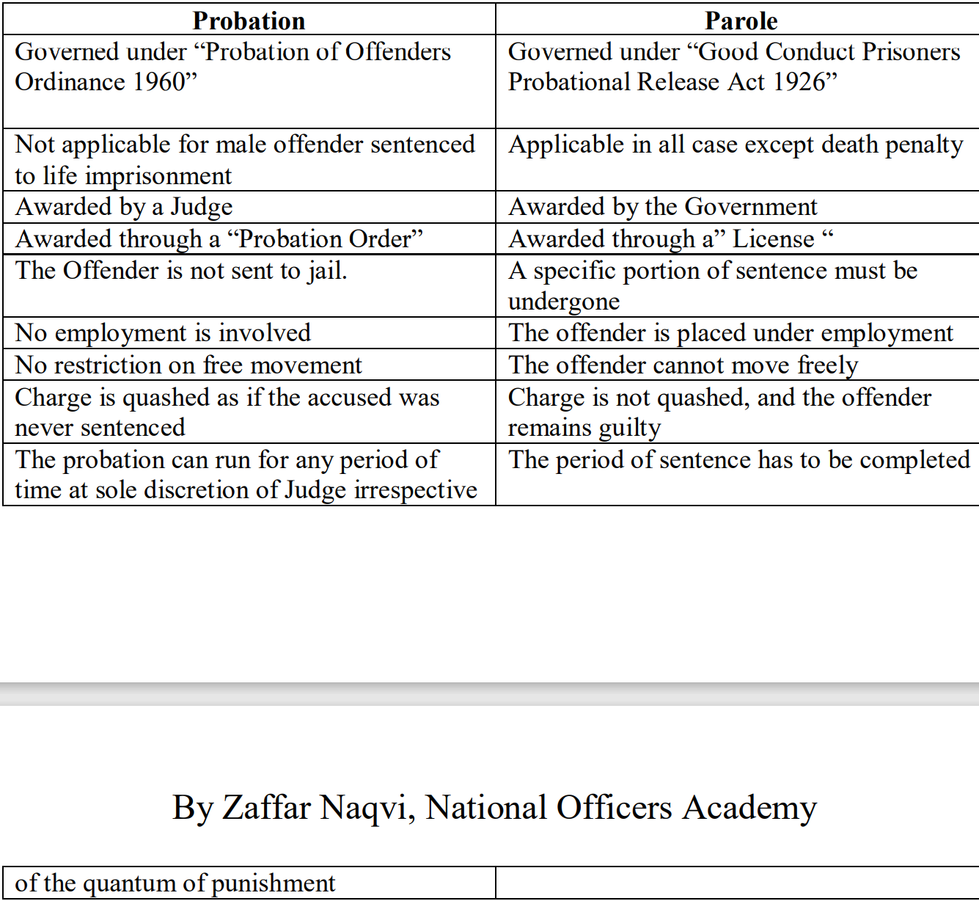

### Recommendations

The criminal justice system of Pakistan is not performing according to the wishes and expectations of the public and the values of society. Dispensation of justice gets delayed in the process of registration of FIRs by police, poor quality of investigations, long duration of trials, poor prosecution, overcrowded jails, rampant corruption among all departments dispensing justice, lack of infrastructure facilities for police, courts, prosecutors and jails to adequately and properly meet workload and the absence of a conducive work environment. This is resulting in constant increase in pendency and poor disposal ratio.

The following recommendations are proposed for the improvement of criminal justice system:

1. The **Criminal Procedure Code** needs to be redrafted and amended with specific reference to police responsibilities and powers for:

a. Registration of FIR **Section 154**. Redesigning business procedure for simplified registration of FIR.  
b. Police powers to release accused during course of investigation if no evidence found under **Section 169.**c. Repealing **section** **22A and B** relating to justice-of-peace for the purposes of registration of FIR.  
d. Redesigning the form for submission of challan under **s.173** and the time-frame for submission of challan.  
e. Fixation of time-frame to conclude trial by the courts once challan is submitted by police.

2. Amendments in **Qanoon-e-Shahadat Ordinance** should be made by:

a. Including confession before a police officer as admissible evidence.  
b. Giving more weightage to circumstantial evidence as compared to eye-witness account.

3. All offences to be made cognizable and the distinction of cognizable and non-cognizable to be abolished.

4. Registering FIR by police and amending law to provide for FIR should not be the basis for the arrest of any accused. Arrest can be made based on warrants duly issued by the court after examination of evidence produced by the police.

5. The importance of police stations in maintaining computerized records of all FIRs cannot be over-emphasized. It is necessary to devise a process for citizens to check the status of their FIRs and complain to the proper authority in case of neglect. Online computerization of the registration of FIRs, criminal investigation and court proceedings, along with jail authorities maintaining proper coordination among all components of the criminal justice system will improve transparency and reduce delays.

6. A monthly progress review should be made on district as well as provincial level by the Deputy Commissioners/ DCOs and Chief Secretary to assess the working performance of all the components of criminal justice system.

7. All provincial High Courts and district courts be made accountable for their performance to the government, as there is often a gross misuse of the term ‘independence of judiciary’ by the judiciary itself to ridicule other government institutions, for personal gains and satisfaction of egos. Since judiciary is being financed by taxpayers’ money, they should also be held accountable to the public and the state, through an independent system as well as through internal checks.

8. Infrastructure development is necessary at police station level as well as trial-court level.

9. The cost of investigations should be realistically calculated and budgeted accordingly.

10. Production of witnesses from both prosecution and defense sides should be ensured and the process of serving should be updated electronically by developing a mechanism to record their evidence in one sitting.

11. Ongoing empowerment and capacity building of police, judiciary and jail staff for timely and efficient dispensation of justice and quick disposal of cases must be ensured.

12. Human resources must be enhanced i.e. the number of investigation officers and judicial officers, in order to conduct trials more efficiently and reduce pendency of cases under trial.

13. Videoconferencing should be encouraged to save the time and cost of travel otherwise carried out to physically produce the accused before court from the police station or jail.

14. Establishment of separate prisons for under-trial and convicted prisoners and a more organized system of probation and parole to reduce the burden on existing jails should be ensured.

### Punitive and Reformative Treatment of Criminal

#### Corporal Punishment

It is inflicting physical pain on a person. Or Punishment that involves hitting someone.

Punishments Prescribed by Islam:

i. Amputation of Hands ii. Whipping iii. Stoning to Death iv. Beheading

Whipping was added as a mode of mode punishment in subcontinent in year 1909. General Zia promulgated The Execution of the Punishment of Whipping Ordinance of 1979. Abolished in Pakistan 1996 via Abolition of Punishment of Whipping Act 1996.

The ICT Prohibition of Corporal Punishment Bill effectively bans all forms of corporal punishment “however light” at the workplace, in all types of educational institutions including formal, informal, and religious — both public and private, in child care institutions including foster care, rehabilitation centres and any other alternative care settings.

The proposed law, which will now go to the Senate, will penalise teachers for assault and hurt inflicted upon children, regardless of intention, cancelling out the provisions of Section 89 of the Pakistan Penal Code which had allowed teachers and guardians to administer physical punishment “in good faith” and “for the benefit” of the child, according to a statement by Zindagi Trust, which termed the development "historic".

Organisations and activists working for child protection had impressed upon the parliament to pass the legislation urgently. A petition in the IHC by musician Shehzad Roy's Zindagi Trust, which has been campaigning to get the practice banned for several years, had last year led to a court order suspending Section 89 and effectively banning corporal punishment.

##### Criticism

i. Against Human Dignity ii. Flouts the principle of Reformation iii. Indicate barbarous face of the state iv. Not approved by modern standards of civilization v. Open to abuse vi. Against UN Convention (The Convention against Torture and Other Cruel, Inhuman or Degrading Treatment or Punishment 1985

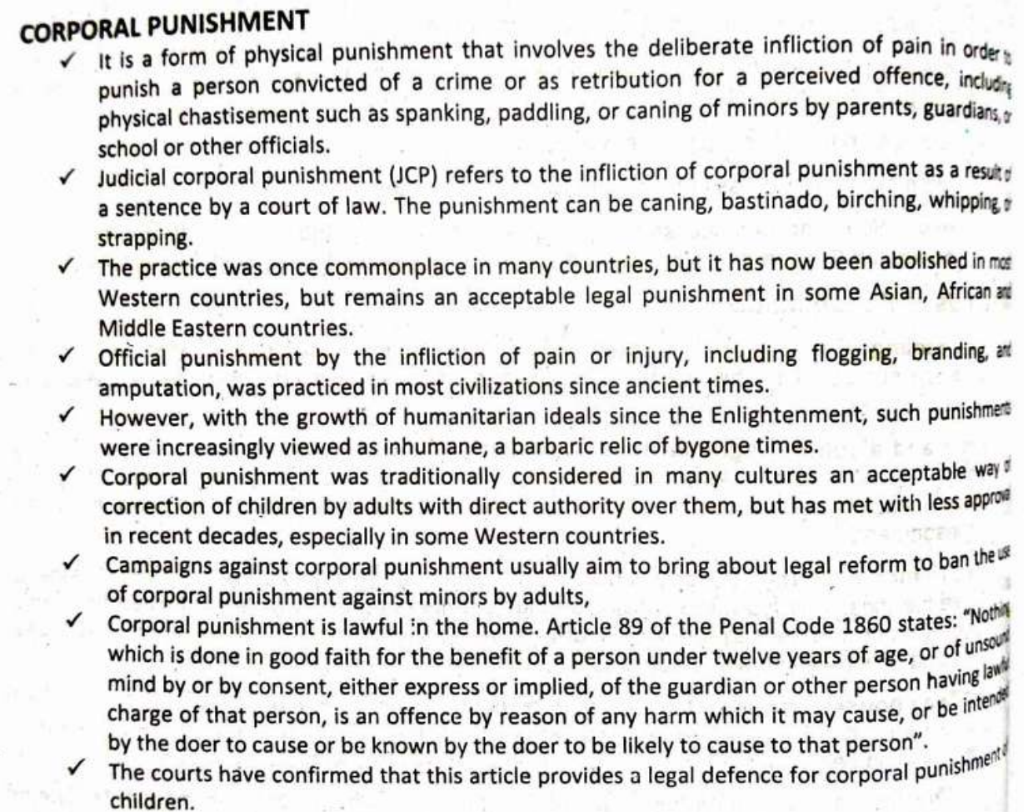

#### Imprisonment



#### Rehabilitation

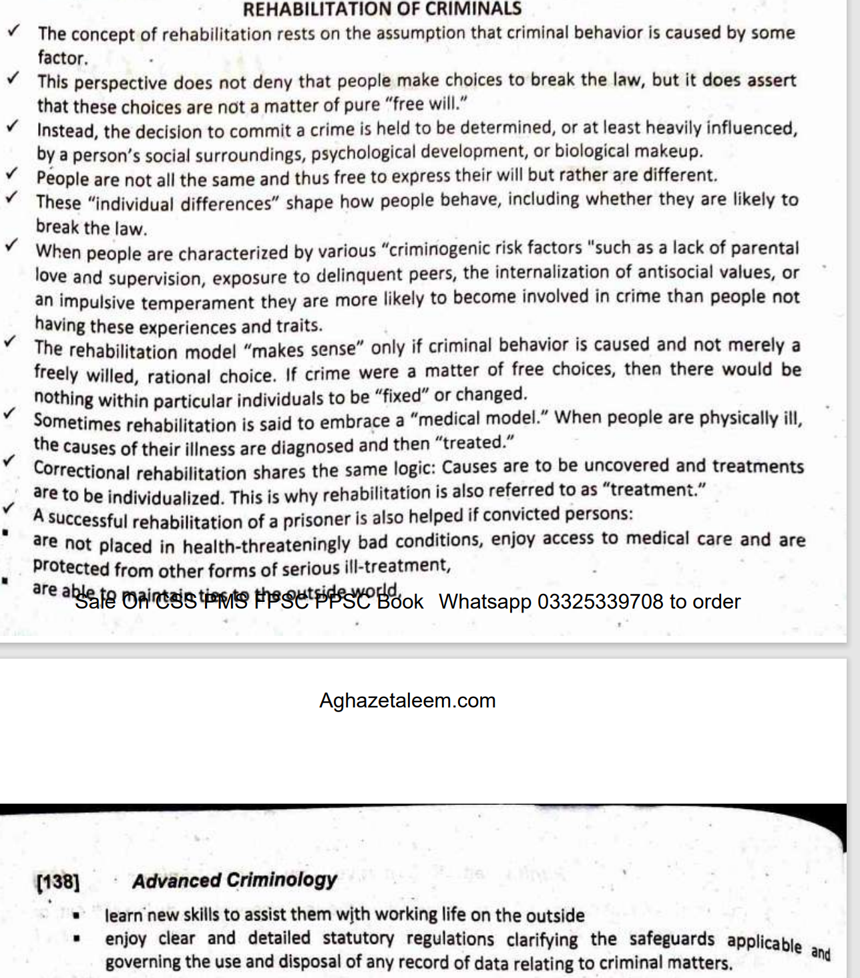

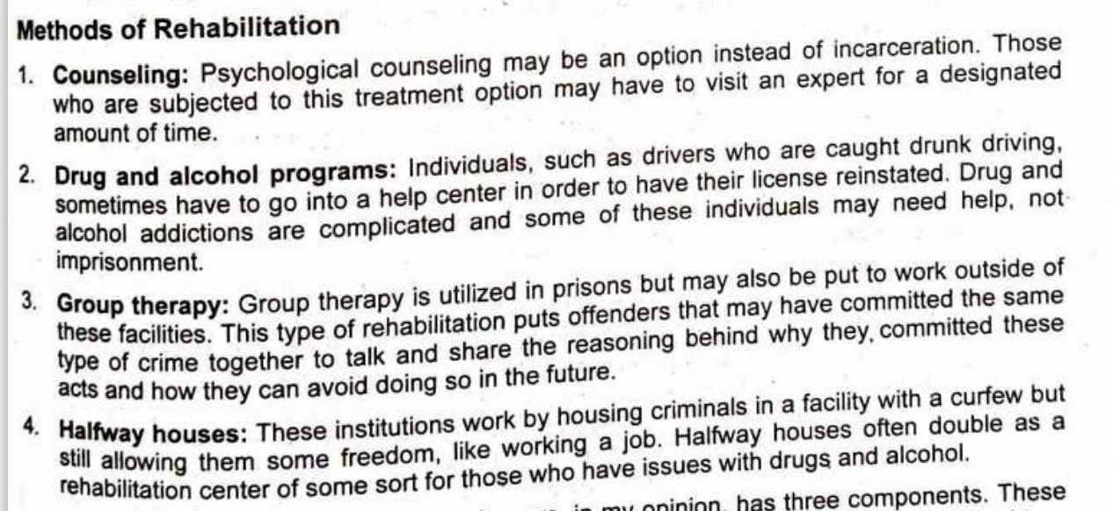

Naeem Shah, a Karachi Central Jail inmate who has been sentenced to life imprisonment for murder and has been incarcerated for the past 11 years, has won a scholarship worth Rs1 million for outstanding academic performance. While in jail, Shah decided to resume his studies. He subsequently passed his matric and intermediate exams and even attained a position among the top 20 students. The tenacity of this young prisoner to pursue his education while in jail serving life in prison despite all odds should convince people and authorities that little redemption can go a long way.

Jail authorities had not only encouraged him but also provided him with whatever resources he needs in order to study. And now due to his good mannerisms in jail, he will be given a once-in-a-lifetime opportunity to become a respectable Chartered Accountant and hopefully integrate back into society as a worthy citizen. This in a nutshell is what prison is supposed to be.

The government with the help of civil society organisations must create rehab training programmes in jails across the country. This will indeed go a long way in improving the prison system, reducing the prison population, and encouraging criminals to choose a better path.

# SECTION-III

## Criminal Investigation

### Abstract

Investigation is the backbone of every Criminal Justice system. Prosecution is responsible to prove guilt of accused beyond reasonable doubt and accused is presumed to be innocent and cannot be convicted in absence of trustworthy, confidence inspiring evidence. This high standard of proof can only be achieved if evidence is properly collected, secured and documented at stage of investigation so that it can later on be produced in court to prove charges against accused. Its importance can be estimated from the fact that any evidence either not collected by investigating officer or not collected in accordance with the prescribed law and rules can directly affect the result of litigation. Courts in any Criminal Justice system are not involved in collecting evidence, its exclusive domain of investigating officer. Functions of court are to draw inference from evidence and then conclude either an offence has been committed or to give judgment that a particular person is not guilty.

### Investigation

It is process of collection and analysis of information and evidence to identify and prove the guilt of an offender. (general)

In legal terms investigation includes all the proceedings for the collection of evidence conducted by a police officer or by any person who is authorized by a Magistrate in this behalf.

*A lawful search for people and things to reconstruct the circumstances of an illegal act, apprehend or determine the guilty party, and aid in the state’s prosecution of the offender. (*Bruce L. Berg and John J. Horgan: Criminal Investigation)

A good investigation is a rigorous process that consist of identification, collection, preservation and presentation of evidence in court of Law.

Investigation is:

* A multidisciplinary approach.
* Involves systematic and logical thinking.
* Requires minutes and detailed inspection.
* Includes observation, examination and fact-finding inquiry of witnesses.
* A rigorous process based on evidence

Investigation begins with a response to a reported incident i. e; lodging of FIR u/s 154 Cr.P.C, and ends when it is closed either with the assessment that there is no sound evidence that the crime was committed (cancellation report) or with the submission of one or more reports describing what was done (submission of challan in Court through prosecutor).

#### Distinction btw Inquiry and Investigation

Inquiry and investigation are often used as interchangeable terms by non-practitioners. In practice, the two concepts are different in their scope. While inquiry is limited to fact-finding generally, investigation goes beyond mere fact-finding and focuses on evidence collection besides its preservation, processing and presentation. Code of Criminal Procedure draws distinction between investigation and Inquiry.

Section 4(l) of Code of Criminal Procedure defines Investigation as following: - “Investigation includes all the proceedings under this code for the collection of evidence conducted by a police officer who is authorized by a Magistrate in this behalf.”

Section 4(k) states as under: - “Inquiry includes every inquiry other than a trial conducted under this Code by a Magistrate or Court.”

Cr.P.C. limits the scope of investigation only to collection of evidence; an investigating officer is confined only to collect evidence without formulating any opinion as to guilt or innocence of accused.

In terms of **authorization**, inquiry is conducted by a magistrate, but investigation is done by police.

##### Evidence

Evidence means “anything that tends to prove or disprove anything”. In strict sense of Qanun-e-Shahdat Order 1984, evidence includes:

* All statement which the court permits or requires to be made before it by witness in relation to matters of fact under inquiry; such statements are called Oral Evidence
* All documents produced for the inspection of the court, such documents are called Documentary Evidence.

#### Investigation types and authorizations

Each type of offence may be investigated differently resulting in as many types of investigations as many species of offences. For example, offences against person may involve collection of medical evidence alongside the testimonial evidence. On the other hand, for offences against property, the documentary evidence may be collected along with testimonial evidence. In similar manner, white collar and tax fraud offences require an investigator to collect documentary evidence comprising bank accounts, wealth statements and incorporation certificates to build up his case. The investigations may also be classified on the basis of the officers’ authorizations. For example, a terrorism case is to be investigated by a Joint Investigation Team under Section 19 of the Anti-Terrorism Act, 1997. The police officer investigating a terrorism case has to be an officer of no less than rank of an inspector. Similarly, a narcotics case can only be investigated by a sub-inspector of police or above. The blasphemy case is to be investigated by an officer of the rank of Superintendent of Police or above. The authorizations have been included in law to ensure that experienced officers investigate heinous offences.

**On the basis of crime nature** o Fraud investigation o Crime scene investigation o Sexual crime investigation o Theft investigation o Kidnapping investigation o Homicide/suicide investigation o Assault investigation etc.

**On the basis investigation nature** o Preliminary investigation o Forensic investigation o Electronic investigation o Database investigation

#### Goals/objectives of investigation

**To recognize evidence**: This is done by a detailed survey and research of crime scene. Everything that is present on a crime scene may or may not have a probative value; an investigator must be able to recognize what evidence can be helpful and what should be collected.

**To identify the offender:** The major purpose of the investigator is to identify the person who committed the crime.

**To Collect Evidence**. Most of the crime scene involves massive physical evidence that can be collected by the investigator to be later produced in court i-e, empty cartridges, DNA, finger prints and other trace evidence etc. Evidence must be labeled properly describing FIR No. No, nature/type of evidence, position and place of its collection, time date and name of witness in whose presence such evidence was collected.

**Preservation of Evidence**. It is as essential as collection of evidence because if integrity of evidence is compromised it cannot be made basis for conviction of accused. To achieve this goal chain of custody must be maintained. Chain of custody is described as chronological log of handling of evidence from place of seizure/collection to its presentation in the court of law. It implies principle that there should be no unauthorized handling of evidence at any stage.

**Documentation of crime and other proceedings**. Recording of statement of eyewitnesses must be done at crime scene and witness must be separated before recording their statement eliminating possibility of fabrication. Crime sketch that can be scaled or unscaled. But it must show North, important landmarks, presence of accused and witnesses if any. Modern techniques involve crime scene photography at different range, angle and even videography can be done.

**To establish the Guilt in Court of Law**: The entire exercise is rendered useless if the offender’s guilt is not proved before the court of LAW.

#### Principles of Criminal Investigation

The law does not prescribe principles of investigation in the statutes. For instruction purposes, however, the following cardinal rules emanating out of statutory law, case law and international best practices are considered principles of investigation:

**Statutory Right of Investigation**: Investigation agencies/police have a statutory right to investigation implying non-interference from all. The basis of this statutory right is the is deep rooted in jurisprudence of Pakistan. It owes its origin to a Privy Council judgement in Emperor v. Kh Nazir Case (1944) that acknowledged the right to investigation and expounded its rationale in the following words:

“The functions of the judiciary and the police are complementary, not overlapping, and the combination of individual liberty with a due observance of law and order is only to be obtained by leaving each to exercise its own function…”.

**Duty to Find the Truth**: As noted above, the duty of an investigator is to find the truth. The number of versions and formalism of reports are no obstacles to his duty. This principle is based on Rule 25.2(3) of the Police Rules, 1934 as well as by decision of the Supreme Court of Pakistan in Sughran Bibi Case (2018), wherein, the duty of police to find truth irrespective of the formal process was reiterated.

**Objectivity**: A condition of being free from bias which implies that the investigation process should not be influences by personal interests or inclinations of the investigator.

**Neutrality**: The investigator should be neutral by avoiding leanings towards any of the parties to the case.

**Competence**: The investigating Officer should be well equipped the requisite skills and techniques of investigation.

**Compliance with Law and Procedures**: Non-Compliance with Law and set Procedures may cost the Investigation/Prosecution losing its case in the Court of Law

**Investigation Report**: The investigation report should be under stable, clear, concise and relevant.

**Professionalism**: Reasonable degree of professionalism should be observed by the investigating officers.

**Primacy of Crime Scene**: Primacy of crime scene investigations increased with the advancement of use of scientific methods for investigations. It was already well known that best investigations are based on connecting criminals with the crime scenes. The scientific basis of this knowledge was buttressed by Locard’s Exchange Principle that became a cornerstone of modern criminal investigations. The principle is based on Dr. Edmond Locard’s theory that ‘every contact leaves a trace’. It may be interesting to note that Locard belonged to France and was known as its Sherlock Holmes. This principle reaffirmed the importance of crime scenes leading to development of techniques regarding protection, preservation, photography, labelling, packaging, lifting, documenting and processing evidence from crime scene. Statutory rules regarding crime scene management are:

* Police Rule 25.10 requires police to preserve crime scene and secure presence of witnesses;
* Police Rule 25.13 requires police to prepare plan of scene
* Police Rule 25.14 enables police to take technical assistance from experts
* Police Rule 25.17 empowers supervisory officers to supervise and inspect crime scenes
* Police Rule 25 deal with use of footprints and track evidence
* Police Rule 25.33 provides actions required from an investigation officer at the scene of occurrence in cases of death
* Police Rule 25.54 holds it mandatory for an investigation officer to send record of case-diaries from scene of occurrence (crime scene) to police station.
* Police Rule 21.35(2) codifies the instructions that an investigation officer has to follow in cases of crimes against property on the examination of crime scene.

**USE OF INFORMATION TECHNOLOGY**: Use of all pervasive information technology must now be counted in the principles of investigation. From crime scene to furthering investigation to trial, information technology remains central. In form of centralized data of identity like National Database and Registration Authority, information technology-based identity system serves as basic tool for identifying the complainant, victim, unknown accused, witnesses and experts. Likewise, the data of convicted and challaned criminals is also frequently used as a basic tool to further the investigation. IT based communication systems in the form of telecommunication companies and service providers help in verifying and corroborating varying stances in investigations. Information technology serves in two ways: one, it helps in maximizing the information base for furtherance of investigation; two, it may be used to collect, collate, preserve and process evidence in efficient manner.

#### Powers of police officers under code of criminal procedure regarding investigation

1. Under sec. 156 of the code of Criminal procedure 1898, a police officer is authorized to conduct investigation in cognizable cases without order of the Magistrate,

2. A police officer may by order in writing require the attendance of any person who from information given or otherwise appears to be acquainted with the circumstances of the case u/s 160 Cr.P.C.

3. Under Section 161 Cr.P.C. a police officer may examine orally any person supposed to be acquainted with the facts and circumstances of the case

4. Police officer shall day by day enter his proceedings in investigation diary u/s 172 Cr.P.C.

#### History of Criminal investigation in pak

Pakistan inherited its criminal justice system from its former colonial master, the United Kingdoms, where, initially Detective Department was established in 1842 in Metropolitan Police of London which was renamed as Criminal Investigation branch 1878. In subcontinent, the investigation department was established in Punjab in 1905 under Sir Edward Lee as its first DIG which was followed by other provinces. The techniques used at that time included the following:

1. **Fingerprints**: Evidentiary value of fingerprints was established in China in relation to ancient pottery. In sub content finger prints were used back in 1858 in Bengal for authentication of contractual deeds. Fingerprints are now considered as an important (almost conclusive until rebutted) evidence of an individuals’ identity.
2. **Dog Branch**. Dog branch was established in subcontinent in the province of NWFP (now KPK). Two officials were sent to south Africa for training. However, for religious regions, both Hindus and Muslim were averse to this idea.
3. **Forensic Science Laboratories**: The first ever forensic laboratory was founded in Lahore in a photographic section of the criminal investigation branch during 1930. In 1947 the lab was serving as a training center in addition to the examination of firearms, cloth, fibres, dust, counterfeit, coins, forged currency, secret inks, handwritten and typed material
4. **Foot Tracking**: People of sub-continent are deemed as being experts in foot tracking (Khoji). However, no substantial support was extended to utilize the expertise. However, Foot trackers were hired to trace the criminal especially in rural areas and in certain cases were promoted to the rank of DSP.

#### Facilities of investigation in pak

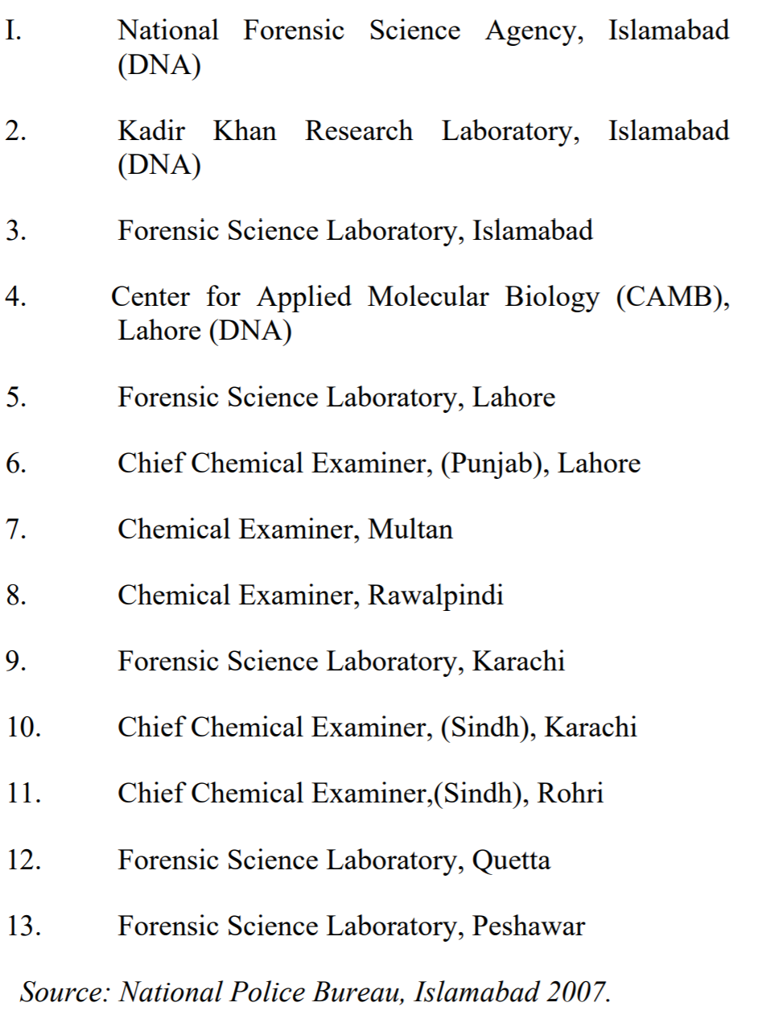

#### Defects in investigation carried out in pak

Unfortunately, investigation in Pakistan is not conducted properly and thoroughly and is responsible for collapse in Criminal Justice system. Integrity of investigation is very critical for admissibility of evidence in court of law. Major defects in Criminal investigation in Pakistan are:

**Lack of proper knowledge of prescribed procedures to conduct investigation**

Investigation is a failure in our country due to lack of knowledge, proper training and development of skills. Common examples of lack of knowledge and skills that results in failure of investigation are:

1. Lack of knowledge of different provisions of law especially when offence falls under different jurisdictions e.g., provision of Anti-terrorism Act, or provisions of sec. 5(2) of Prevention of Corruption Act 1947.

2. Lack of knowledge as to offense falls under what jurisdiction and which agency shall hold investigation.

3. Lack of knowledge of proper procedure e.g., procedure for proclamation of accused and seizure of property.

4. Lack of training to collect biological and other evidence at crime scene and due to improper collection important evidence at crime scene is contaminated before it reaches labortary for analysis and consequently important evidence is either lost or compromised at crime scene.

**Lack Of Professionalism**: A major reason for failure of our Justice system is lack of professionalism and irresponsible attitude towards Criminal investigation. Procedures are not followed and adherence to standards is not in existence. Investigation process is influenced by media, political pressure and corrupt practices. Investigators mostly hold panchayats instead of collecting evidence to support charge or establish guilt. Similarly, opinions as to innocence or guilt are given by police officer without reasoning and in absence of evidence. They do not verify alibi of accused if claimed and usually give opinion on basis of suspicion without realizing the fact that determining the guilt or innocence is the duty of the court and investigation is only confined to collection of evidence.

**Biased Investigation, Lack of Impartiality:**

Impartiality means decisions must be based on sound reasoning and without any undue influence or favor to anyone. It is an ability of a person to formulate his decision on the basis of facts and without being prejudiced. Preconceived notions, conjectures, suppositions, presumptions and suspicion are different forms of prejudice. There should be no personal belief or intuition or a judgment not founded on proof or certainty.

Prejudice or bias can seriously effect results of investigation. Various elements can affect impartiality of an investigator. Bias can take various forms e.g., religious bias, racial discrimination, gender, ethnicity, sect, class or caste, all can influence investigation. However, there is a distinction between holding a bias and acting as bias.

**Role of Logic, Good Observation and Good Judgment:**

Every crime is unique. There is no universal formula to investigate a case. A good investigation requires proper planning. it is a team work that cannot be done in isolation. Composition of team depends on nature of crime. Crime scene is a scene of incident irrespective of the whether a Criminal or illegal action has been established. When arriving at crime scene an officer must determine what offence has been committed and what level of investigation he is required to conduct. It is common that investigating officers do not apply their own reasoning and are only confined to story narrated to them by witness. Even in that case they even do not bother to corroborate their testimony, verify presence of witness at the spot and collect other circumstantial evidence, usually police officers acts in mechanical way by recording FIR, statement of witness, drawing rough sketch, making or planting recovery and then submission of challan. Have they collected evidence properly from crime scene, it can help prosecution to prove their case. It could also be kept in mind that there is tendency in our country to rope falsely all family members of the accused.

**Integrity:** Twisting of facts is not very uncommon. It happens in almost in every case. Facts are twisted by parties in order to either involve innocent or to destroy evidence. In unseen murder case usually witness are planted, in dacoity cases usually identification parade are not held, instead this requirement of law is fulfilled by insertion of supplementary statement that never discloses source of information. Observations made are not brought on record. Confession are not recorded before Magistrate and police confession forms part of police diary which is neither admissible nor can secure conviction. Injured victim dying declaration is not recorded, or if recorded no independent person is cited in whose presence such dying declaration is recorded. Similarly statement of injured witness is recorded without making enquiry from doctor regarding whether such injured is in position to make statement or not. These are all issues that have impact on integrity of evidence collected and produced during trial. How a court can convict a person when there is no evidence or there is evidence which is tainted.

**Improper Documentation:** The gravest defect of our investigation is improper and inadequate documentation. Court can formulate opinion only on basis of those facts that are relevant and are brought on record. If statement of an important witness is not reduced to writing by a police officer, how court can determine facts that were witnessed by a witness which is not included in the calendar of witnesses by police officer during submission of challan. Similarly omission on part of the police officer to mention the description of crime scene, position of body and articles found on crime scene can seriously destroy prosecution case. Usually police officers do not take into possession crime empties and thus prosecution is deprived of opportunity to prove an important piece of evidence that can establish link between crime, victim and suspect.

**Chain Of Custody:** It means documentation of evidence from time to time when it was taken into possession describing time, place or condition, or brief description of item and name of persons/witnesses in whose presence such articles were taken into possession to its production in laboratory/agency or court. It also signifies that there should be no unauthorized handling of evidence. It is very common that proper chain of custody is not maintained and report of expert i-e, ballistic expert, chemical examiner, serologist become inconsequential which results not only in damage to prosecution case but also amounts to wastage of time and money consumed in obtaining expert opinion.

**Delay:** Delay which is unnecessary has fatal impact on fate of Criminal case. Delay on part of police in sending corpse for postmortem examination, delay in recording statement of witness, delay in holding identification parade, delay in sending parcels to laboratory for expert opinion are all considered fatal to prosecution case and this delay is caused by negligence of police.

**Others**

• Overall Problems of Police Organization • Disappointingly Low Budget • Non separation of watch and ward from investigation • Non availability of specialists • Shortage of Staff • Lack of Independence • Corruption • Lack of Competence • Reliance on old methods of Investigation • Lack of Infrastructure • Non-Optimal use of technology • Lack of equipment • Shortage of Laboratories • Delayed adjudication of Cases • Use of Torture

#### Remedies

Following measures can be taken to rectify the above defects:-

1. **Reorganization of investigation wing**: An investigator should be authorized to investigate the case on basis of his qualification, experience and training. For major offences like murder, rape, forgery/fraud, electronic crimes, kidnapping investigator should have relevant expertise to investigate that crime. An investigator who have never conducted investigation in forgery should not be allowed to investigate that offence instead of this he should be assigned task according to his expertise and interest and knowledge.

2. **Development of investigation protocols**: It is very important to develop various protocols in shape of guidelines and instructions or standard procedures that must be followed in investigation of different offences.For example an investigation of a murder case should include more than just formality of injury statement and inquest report and conducting postmortem. various steps of investigation must be described and there should be a clear policy statement regarding procedure and proceedings of investigation. Police trainings must be carried out in letter and spirite rather than being conducted as formality

3. **Development of professional attitude**: Police officer should develop professional attitude. Government and our media also plays vital role. Both government and media should stop exploitation and should not interfere with process of investigation. Media should be briefied only when investigation has been completed. Political parties should not dictate police officers rather they should be allowed to proceed with investigation without being influenced. Illegal practices of holding panchayats, formulating opinions of investigation on basis of oath, and deciding cases in police station must be stopped. It is duty of police to collect evidence without compromising its integrity and it is duty of court to determine guilt or innocence on basis of evidence. An investigator is not party to Criminal case. He must be impartial. We cannot correct police until we provide hosnest police officers privilege of not being dimissed on frivilous grounds and stop safarish and baradari system we are facing two problem one is we promote baradari culture by giving undue favors and second honest persons are threatened Of being dismissed from service.

4. **Independence of investigation wing Investigation wing of police must be independent**. There should be no interference at level of investigation. It offen happens that media causes exploitation of cases and this causes undue harrasment and biased investigation. Similarly political pressure groups must not be allowed to approach the officials.Another important aspect in this respect is frivolous registration of cases must be strongly discouraged

5. **Punishment of investigator for corrupt practices**: Investigators who are properly trained and skilled in investigation if destroy evidence or temper it, they must be punished exemplary to have deterrent effects. However it must be kept in mind before punishing an investigator that whether he had willfully caused destruction of evidence or not because parties may often lodge frivolous complaints against police officers and gross negligence are sometimes remains unchecked. There must be clear and logical criteria for punishment.

6. **Proper Training & Continuous Professional Development**: Due to rapid development of technology, investigators must be provided with training and continuous development. Incentive should be given on basis of merits otherwise they shall further deteriorate the existing system.

#### Case of Defective Investigation

<https://www.pakistantoday.com.pk/2021/07/25/defective-investigation/>

#### Concluding remarks

To conclude, police investigation in Pakistan is not conducted properly due to which our Criminal Justice system has become ineffective. Investigations must be provided specific training to investigate different crimes. Investigation in Pakistan can never yield best results unless investigators develop an impartial professional attitude and investigate case on basis of what facts are actually rather than twisting with facts to produce desired results.

From practical view point, if we make a detailed analysis; one may observe that we ourselves have destroyed the system. Our ego, show off and abuse of power, majboori (need), and baradari system have rotten the whole system from top to bottom and no one is ready to accept his mistake and rectify himself. People enter in service just to secure their career and remains mum during performance of duties to save their service. Those who dare to perform their duties are dealt with iron hands.

The criminal investigations define police performance in Pakistan besides reassuring trust in them by all and sundry. A good mix of preventive and detective policing strategies affects crime control and police image. Pakistan’s quest for the rule of law very much depends on its commitment to introduce reforms relating to police and policing.

### Preliminary investigation

The Preliminary' Investigation Manual is a police officer's guide for conducting effective initial or preliminary criminal investigations. It attempts to place in their proper perspectives the options available to the investigating officer so that the total time spent in investigative activities will be minimum and results maximum. The suggestions included do not deal with every conceivable type of initial investigation, but they will insure that investigations will have an increased chance of reaching their objectives: crime identification, crime solution with apprehension, and successful prosecution of the criminal.

#### Objectives

The preliminary or initial investigation is the police agency's first response to a report that a crime h.as occurred. As in every investigative effort, the primary objective of the preliminary investigation is to determine who committed the crime and to apprehend the criminal. The preliminary investigator collects evidence which solidly supports: the crime, the identification of the person responsible for the crime, and the arrest and subsequent conviction of the criminal. These objectives seem simple. Yet, they are vital. Unfortunately; they are often completely forgotten,by preliminary .investigators. All to often the preliminary investigator sees his role as no more than that of a mechanical report tak.er, when in fact the report is the vehicle for reporting the results of 'the preliminary investigation. The police officer should remember he is the preliminary investigator, and that his work at this early stage will uncover the majority of useable informa·- tion about the case.

**Framework**

The framework of the preliminary investigation is based on the following major tasks. 1. Verifica'tion that an offense actually occurred, 2. Identification of the victim, the place of the crime, and the time the crime occurred. 3. Identification of solvability factors. 4. Communication of the circumstances of the crime. S. Identification of those investigative tasks completed and of those yet to be done.

Completion of these actions is the total 'objective of the preliminary investigation and will guide the activities of the initial investigator during his work.

##### Verification of occurrence

To verify the occurrence of a crime, the preliminary investigator must do four things, as follows: a. Respond to the scene. b. Document that a crime has actually happened. c. Determine when the crime occurred. d. Identify and assist the victim.

##### Identification of Solvability factors

Throughout the investigation process, we search for leads upon w--n.ich further investigative efforts can be based. And since only some leads later may become useful, preliminary investigators should concentrate their efforts on finding those leads, or solvability factors.

Twelve Solvability Factors 1; Witnesses to the crime; 2. Knowledge of a suspect's name; / 3. Knowledge of where a suspect can be located; 4. Description of a suspect; 5. Identification of a suspect; 6. Property with identifiable characteristics, marks, or numbers so it can be traced; 7. Existence of a significant MO; 8. Presence of 'significant physical evidence; 9. Presence of a description which identifies the automobile used by the suspect; 10. Positive results from a crime scene evidence search; 11. Belief that a crime may be solved with publicity and/or reasonable additional investigative effort; 12. An opportunity for but one person to have committed the crime.

The preliminary investigator's job is to determine which, if any, of these solvability factors exist. Effective investigative strategy dictates that the investigator consider each solvability factor separately and thoroughly to see if evidence pO'ints to the solvability factor's existence.

##### Communication and Decision-making

If the case is not closed immediately by arrest, the work of that preliminary investigator concludes when a decision is made to continue or halt the investigation. It is at this stage that the investigator must insure that his work is as complete as time and circumstances will permit ;. , and is properly documented. . - Further efforts by the police agency will depend upon this evaluation and upon the quality of his/her work.

At the end of the preliminary investigation process, the investigator should ,decide whether sufficient "leads" have been dev:elop'ed to make solution of the crime possible. This decision is based on whether solvability factors have been identified. If solvability factors are present, it is probable that future investigative effort may solve the case. Research has shown that if '" solvability factors are not present, there is little chance, if any, that additional investigative effort will solve the case.

**Legal Position as to Preliminary Investigation in Pakistan**

### Intelligence operations

The intelligence concept has meant many different things to people. It conjures up images of clandestine, high technology, risk-taking for the purposes of gathering sensitive information about crimes and criminals. To be sure, this is part of intelligence. However, this image is a one-dimensional view of selected intelligence methods.

In general terms, law enforcement intelligence (LA WINT) has three basic goals. • Development of evidence for prosecution of criminal cases. • Identification and seizure of illegal commodities (contraband and fruits of unlawful transactions). • Development of information to direct the allocation and deployment of law enforcement resources.

These needs, with specific reference to drug enforcement, were articulated in the National Drug Control Strategy, which stated: "The war against drugs cannot be fought-much less won without good intelligence. No military commander goes into battle without the best available information about both his adversary and about the field of battle itself. If we are to target our efforts effectively where traffickers are most vulnerable, we must know the enemy far better than we do now .... That means we must collect critical information ... in imaginative and efficient ways; analyze data from all sources; produce intelligence tailored to the varying needs of decisionmakers from the national to tactical levels; and see that the intelligence is disseminated to users in a timely fashion".

#### Role

the roles of law enforcement intelligence can be summarized as follows:

1.Obtaining and integrating information into a cohesive and logical case File or description of crime trends 2. Identifying crimes and crime trends through information assessment, report review, data comparisons, and crime analysis 3. Identifying criminals through the use of deduction, information assessment, and application of the scientific method 4. Developing cases for prosecution in court 5. Providing support to investigators involved in long term and complex case investigations 6. Projecting crime trends for purposes of planning and law enforcement resource allocation

#### Information v. intelligence

There are clear distinctions between "information" and "intelligence"

a. Intelligence takes "raw' information-facts, evidence, events, etc.-and integrates it all together through the application of logic

1) Thus, with "information" one has pieces of data

2) With "intelligence" one has knowledge

b. Another distinction is ...

1) Information is passive-it is simply data which has been accepted and stored

2) Intelligence is proactive-it can ... a) Forecast b) Correlate c) Offer supposition d) Direct an investigation/inquiry

#### Classification of Intelligence agencies

The Pakistani intelligence community comprises the various intelligence agencies of Pakistan that work internally and externally to manage, research and collect intelligence necessary for national security.[1] Consolidated intelligence organizations includes the personnel and members of the intelligence agencies, military intelligence, and civilian intelligence and analysis directorates operationalized under the executive ministries of the Government of Pakistan.[2]

There are numbers of intelligences services are active working on varied intelligence programs including the collection and production of foreign and domestic intelligence, contribute to military planning, and perform espionage.[3] However, its best-known intelligence services are the Inter-Services Intelligence (ISI), Intelligence Bureau (IB) and the Federal Investigation Agency (FIA).

**Exclusive** - Intelligence gathering agencies whose responsibility and resources are focused solely on information which may be used in national policy decisions. For instance, ISI.

**Non-exclusive** - Intelligence gathering agencies whose responsibilities and resources address both issues of national security and enforcement of criminal laws. For instance, FIA.

### Electronic investigation

Digital forensics (sometimes known as digital forensic science) is a branch of forensic science encompassing the recovery and investigation of material found in digital devices, often in relation to computer crime.

According to the U.S. Department of Justice defines digital evidence as information and data stored on, received, or transmitted by an electronic device and determined to be of value to an investigation. Digital evidence can be latent, time-sensitive, easily changed, damaged, or destroyed, and can transverse jurisdictional borders (National Institute of Justice, 2008). As with any evidence, to be useful in proving or disproving criminal actions, the evidence and how it is obtained and analyzed must be reliable. Therefore, the processes used to obtain, handle, and analyze digital evidence should conform to accepted practices and utilize industry recognized and accepted tools. Additionally, persons responsible for identifying, collecting, transporting, storing, and analyzing digital evidence must be knowledgeable and properly trained in this field as well as having a good understanding of the legal requirements for search and seizure of electronic evidence.

Digital evidence is found on a variety of electronic devices and many of these are utilized daily in almost all societies and enable people to interact with each other both near and far. This form of instant communications and e-mail provides a means for criminals to communicate with each other as well as with their victims (U.S. Department of Homeland Security & U.S. Secret Service, 2007). When used in the planning and commission of a crime, the digital evidence stored on computers, network servers, storage devices and media, digital cameras, and other such digital devices can be valuable in solving crimes.

For digital evidence to be useful in solving crimes, it must be relevant and its reliability must be maintained throughout the process of search, seizure, examination, and analysis. First, and foremost, the search and seizure of any evidence must be conducted using a legal means, by either executing a search warrant or by one of the exceptions to a search warrant (National Institute of Justice, 2008). Once it is determined or suspected that digital evidence is involved in the commission of a crime, it is paramount that the scene is controlled and any digital devices and electronic storage media at the scene be secured to prevent potential damage, corruption, or destruction of any digital evidence. The scene should be fully documented to create an official record of the scene for later use by investigators and to aid in reconnecting any computers or devices seized. Care should be taken when documenting the scene to ensure running computers are not powered down or any evidence moved until the entire scene is documented.

### Forensic Investigation

Forensic science is performing a pivotal role in the criminal justice system all over the globe. After the birth of renaissance, science and technology brought improvement in every field but on the other side – with the help of science and technology – different new techniques have evolved to commit crime. The menace of terrorism and suicide attack is prevailing all around the world. In developed countries, detectives and forensic scientists are adopting latest criminal investigation techniques to minimise the crime ratio but unfortunately, in Pakistan, the way of investigation to trace the perpetrator is same as were in the many decades ago.

If we discuss the history of forensic science in Pakistan – the first forensic laboratory was established before Partition. In 1906, the British government established the first forensic photographic department on Birdwood Road, Lahore. By 1947, this forensic lab was assiduously serving as a British training centre and also dealing with the examination of physical evidence like dust sample examination, firearm, cloth fibres, ink detection, counterfeit coin examination, forged currency, typed and handwritten material. After Partition, the government set up three other forensic science laboratories in Karachi, Quetta and Peshawar.

With the passage of time, the trend of investigation methodologies took a turn and confession or ocular testimony was not enough to grab the culprit. In 2001, on the basis of requirement the federal government decided to improve forensic science infrastructure to upgrade the existing one and establish more laboratories in the different regions of Pakistan. In 2002, the Executive Committee of the National Economic Council approved the National Forensic Science Agency (NFSA) as an autonomous body having different departments. The agency became functional in 2006 with the initial budget of Rs 1.29 billion. The fundamental objective of NFSA was to provide training and teaching facilities and to establish more forensic labs throughout Pakistan. The comprehensive plan was developed to strengthen the capacity of law enforcement agencies and use of latest forensic techniques to ensure the quality investigation. Despite the significant obstacles in the way of forensic investigation and limitations in the police department the agency have solved more than 96 percent cases with the collaboration of other law enforcement agencies to counter these challenges but much more need to be done for the prosperity of criminal justice system.

Some high profile cases have been solved with the help of forensic investigation tool are the Marriot Hotel blast in 2008, Lal Masjid operation in Islamabad, suicide blast on a political rally in Karachi, Kasur incident and different others. On the basis of their demand and to reduce the NFSA burden, the Punjab province was passed the PFSA Act on October 2007 to establish well-equipped laboratory in Punjab to improve and ensure the standard investigation. PSFA was established in 2012 having 14 different well equipped forensic laboratories include DNA and serology, latent fingerprints, narcotics, polygraph, toxicology, trace chemistry, computer forensic, questioned documents and different other investigation departments. The PSFA is the second largest laboratory in the world and which is no doubt the creditable step of Punjab government but only a single lab cannot fulfil the requirement of a large province with the population of 110 million.

There is a crucial need to establish forensic labs in other provinces of Pakistan to solve cases on merit. The modern world justice system is not only relying on the ocular or oral witness testimony and also shifting to scientific evidence testimony for smooth and liable functioning of judiciary system but it is unfortunate that we are also depending on the traditional system of investigation. A huge amount of cases are pending in our police department and the police personnel are unfamiliar to Personal Protective Equipment and not trained to secure the crime scene and to collect the physical evidence without contamination. Apart from Punjab, Sindh, Khyber Pakhtunkhwa and Balochistan have not well developed and satisfactory forensic investigation facilities and responsible chain of custody. The liquor case against Pakistan People’s Party leader Sharjeel Memon is the paradigm of the investigation team’s dishonesty.

Recently, Punjab Chief Minister Usman Buzdar visited different sections of PFSA and commended its performance. He has also lifted ban on forensic science agency jobs and to increase the allowances of scientists and staff which is an admirable step of Punjab government. No one can ignore the importance and standard of forensic science and the government will have to take a step to omit the demon of crime, brutality, barbarism and terrorism.

#### Forensic protocols

The forensic protocol provided special follow-up measures during the investigation. These protocols support and offer expectations and standards of action, so there is consistency and uniformity in every investigation. It also helps to reduce the risk of contamination (Sternberg, 2001). Forensic protocols during criminal investigations include:

• Keep the crime scene safe • Maintaining / set aside witnesses • accomplish a walk-through of sight • Investigate for verification • testimony the crime sight • Find all the proof • gather and store all evidence

The forensic investigative protocol can be applied to first Acknowledgers, medical investigators, offense sight investigators, spies and other proficient concerned in a particular case. Following the forensic investigative protocol permits each member to play their part in the investigation and helps retain the reliability of the inquiry and the proof.

#### Types of forensic evidence

A victorious criminal investigation is based on the gathering and examination of a variety of evidence (Ralph, 2007). Forensic scientists categorize proof in diverse ways and have explicit conducts of dealing with it. Two types of evidence in crime investigation can be:

**Physical Evidence**

Physical evidence refers to everything that comes from a non-living being. The most imperative types of physical evidence are fingerprints, tire marks, footprints, fibres, paint, and building materials.

**Biological Evidence**

Biological evidence always comes from an organism. Biological proof comprises blood stains and DNA.

Evidence is an important element for an investigation; therefore, it is imperative for investigators of crimes consider different legal definitions of evidence, the different evidence types, and the mode in which it is measured and seen by the court. Evidence forms the main component to the investigation procedure, in order to properly construct the final product, it is necessary to recognize, gather, document, preserve, validate, investigate, and unveil the evidence, and should be presented in a way which will be adequate to the court document, preserve, validate, investigate, and unveil the evidence, and should be presented in a way which will be adequate to the court.

### Database investigation

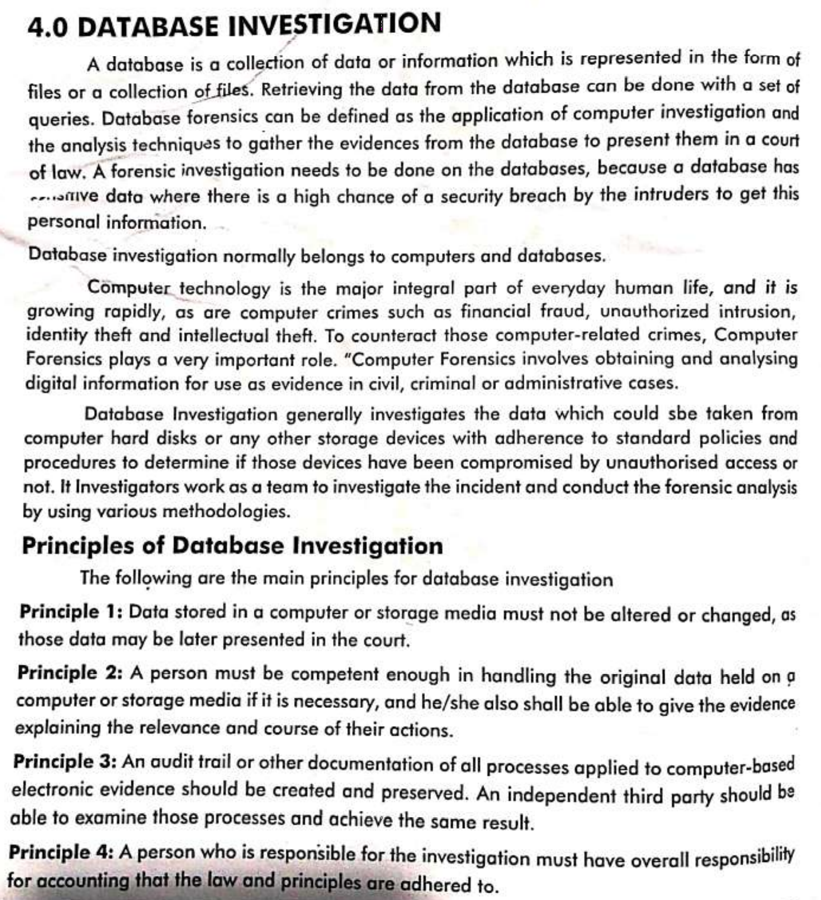

### Techniques of investigations

#### Gathering information from persons

**Interview and Interrogation**

Too often these terms are interchanged as though they refer to the same process, when in fact, there are significant and important distinctions between the two.

##### Interview

An interview is non accusatory. This should be the case even when the investigator has clear reason to believe that the suspect is involved in the offense or has lied to him. By maintaining a nonaccusatory tone, the investigator is able to establish a much better rapport with the suspect that will assist in any interrogation that might follow the interview. A guilty subject is more likely to volunteer useful information about his or her access, opportunity, propensity, and motives ifthe questions are asked in a nonaccusatory fashion. In addition, the suspect’s behavioural responses to interview questions can be more reliably interpreted when the questions are asked in a conversational, rather than challenging, manner. The investigator should remain neutral and objective throughout the interview process.

**The purpose of an interview is to gather information**. During an interview the investigator should be eliciting investigative and behavioural information. Examples of investigative information would be to develop the relationship between the suspect and the victim and to establish the suspect’s alibi or access to the crime scene. During an interview the investigator should closely evaluate the suspect’s behavioural responses to interview questions. The suspect’s posture, eye contact, facial expression, and word choice, as well as response delivery may each reveal signs of truthfulness or deception. Ultimately, the investigator must make an assessment of the suspect’s credibility when responding to investigative questions. This is primarily done through evaluating the suspect’s behavioural responses during the interview, along with independent assessment offactual information. There may be occasions when the subject makes an incriminating admission or full confession during the interview process without any accusatory interrogation**.**

**An interview may he conducted early during an investigation**. Because the purpose of an interview is to collect information, it may be conducted before evidence is analyzed or all the factual information about an investigation is known. Obviously, the more information the investigator knows about the crime and the suspect, the more meaningful will be the subsequent interview ofthe suspect. However, on a practical level, the investigator should take advantage of any opportunity to conduct an interview regardless ofsketchy facts or the absence of specific evidence.

**An interview may he conducted in a variety of environments**. The ideal environment for an interview is a room designed specifically for that purpose. Frequently, however, interviews are conducted wherever it is convenient to ask questions—in a person’s home or office, in the back seat of a squad car, or on a street corner.

**Interviews are free flowing and relatively unstructured**. Although the investigator will have specific topics to cover during the interview, the responses a suspect offers may cause the investigator to explore unanticipated areas. The investigator must be prepared to follow-up on these areas because the significance of the information may not be known until later during the investigation.

**The investigator should take written notes during a formal interview**. Note taking during a formal interview (one conducted in a controlled environment) serves several important functions. Not only will the notes record the subject’s responses to interview questions, but the investigator will be more aware of the subject’s behaviour by taking notes. Note taking also slows down the pace of the questioning. It is much easier to lie to questions that are asked in a rapid-fire manner. When faced with silence between each question and given time to think about his deceptive response, the deceptive subject experiences greater anxiety and is more likely to display behaviour symptoms of deception. Furthermore, an innocent suspect may become confused or flustered when a rapid-fire approach to questioning is used. Note taking can inhibit information if it is done sporadically. For example, if the investigator has not taken any notes during the early stages of the interview but then, all of a sudden, writes down something the suspect has said, the suspect will attach significance to that statement and is likely to become much more guarded in subsequent answers. However, ifat the outset ofthe interview the investigator establishes a pattern of taking written notes following each ofthe suspect's responses, note taking will not inhibit information.

##### Characteristics of an Interrogation

**An interrogation is accusatory**. Deceptive suspects are not likely to offer admissions against self-interest unless they are convinced that the investigator is certain of their guilt. Therefore, an accusatory statement such as, “Joe, there is absolutely no doubt that you were the person who started this fire,” is necessary to display this level of confidence. If the investigator merely states, “Joe, I think you may have had something to do with starting this fire,” the suspect immediately recognizes the uncertainty in the investigator’s confidence, which reinforces his or her determination to deny any involvement in committing the crime. **An interrogation involves active persuasion**. The fact that an interrogation is conducted means that the investigator believes that the suspect has not told the truth during nonaccusatory questioning. Further questioning of the suspect is unlikely to elicit the presumed truth. In an effort to persuade the suspect to tell the truth, the investigator will use tactics that make statements rather than ask questions. These tactics will also dominate the conversation; for someone to be persuaded to tell the truth that person must first be willing to listen to the investigator’s statements. **The purpose ofan interrogation is to learn the truth**. A common misperception exists in believing that the purpose of an interrogation is to elicit a confession. Unfortunately, there are occasions when an innocent suspect is interrogated, and only after the suspect has been accused of committing the crime will his or her innocence become apparent. If the suspect can be eliminated based on his or her behaviour or explanations offered during an interrogation, the interrogation must be considered successful because the truth was learned. Oftentimes an interrogation also will result in a confession, which again accomplishes the goal oflearning the truth. **An interrogation is conducted in a controlled environment**. Because of the persuasive tactics utilized during an interrogation, the environment needs to be private and free from distractions.

**An interrogation is conducted only when the investigator is reasonably certain ofthe suspect’s guilt**. The investigator should have some basis for believing a suspect has not told the truth before confronting the suspect. The basis for this belief may be the suspect’s behaviour during an interview or inconsistencies within the suspect’s account, physical evidence, or circumstantial evidence, coupled with behavioural observations. Interrogation should not be used as a primary means to evaluate a suspect’s truthfulness; in most cases, that can be accomplished during a nonaccusatory interview. **The investigator should not take any notes until after the suspect has told the truth and isfully committed to that position**. Premature note taking during an interrogation serves as a reminder to the suspect of the incriminating nature of his statements and can therefore inhibit further admissions against self-interest. Only after the suspect has fully confessed, and perhaps after the confession has been witnessed by another investigator, should written notes be made documenting the details ofthe confession.

##### Benefits of conducting an interview before an interrogation

The majority of interrogations are conducted under circumstances in which the investigator does not have overwhelming evidence that implicates the suspect—indeed, the decision to conduct an interrogation is an effort to possibly obtain such evidence. Frequently, prior to an interrogation, the only evidence supporting a suspect’s guilt is circumstantial or behavioural in nature. Under this condition, conducting a nonaccusatory interview of the suspect is indispensable with respect to identifying whether the suspect is, in fact, likely to be guilty. Furthermore, when there is sparse incriminating evidence linking a guilty suspect to the crime, the information learned during the interview will be needed to conduct a proper interrogation. In those instances where there is clear and convincing evidence of a suspect’s guilt, it may be tempting for an investigator to engage directly in an interrogation, bypassing the interview process.

An exception to the foregoing suggestion may be a situation in which the suspect is caught in an incriminating circumstance or clearly evidences a desire to tell the truth during initial questioning. Under this circumstance, an immediate interrogation may be warranted. As an example, a car that was recently reported stolen may be pulled over after a brief chase. In this circumstance, conducting a nonaccusatory preliminary interview of the driver makes little sense.

##### Conclusion

Traditionally, investigators have made little or no distinction between interviewing and interrogation. However, advancements in these specialized techniques suggest that clear differences exist and ought to be recognized. As will later be presented, some investigators are inherently good interviewers but lack the same intrinsic skills during an interrogation— and vice versa. An effective investigator will have gained skills in both ofthese related, but distinctly different, procedures. Fundamental to any effective interview or successful interrogation are the analysis of investigative information, the environment in which the interview or interrogation is conducted, and the qualifications and demeanor ofthe investigator during an interview or interrogation. The remaining chapters in this first section will address these topics, as they relate to both interviews and interrogations.

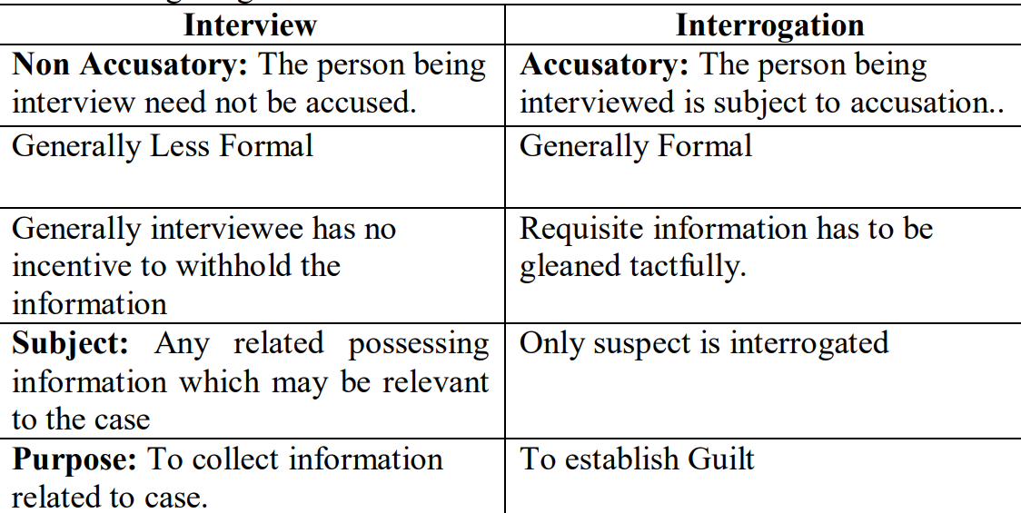

#### Techniques of interview

##### Behavioural Symptom Analysis

The Reid website describes the Behaviour Analysis Interview (BAI) as a non-accusatory question and answer session, involving both standard investigative questions and “structured 'behaviour provoking' questions to elicit behaviour symptoms of truth or deception from the person being interviewed.”

The investigator first asks background questions, to establish personal information about the suspect and allow the investigator to evaluate the suspect's “normal” verbal and nonverbal behaviour. The investigator then asks “behaviour-provoking” questions intended “to elicit different verbal and nonverbal responses from truthful and deceptive suspects.” The investigator will also ask some investigative questions during this stage. The Reid website states that the BAI:

provides objective criteria to render an opinion about the suspect's truthfulness through evaluating responses to the behaviour-provoking and investigative questions. In addition, the BAI facilitates the eventual interrogation of guilty suspects . . . by establishing a working rapport with the suspect during the non-accusatory BAI and developing insight about the suspect and his crime to facilitate the formulation of an interrogation strategy.

##### Baiting Technique

The bait question is one ofthe standard behaviour-provoking questions used in the behaviour analysis interview (BAI). It is nonaccusatory in nature but at the same time presents to the subject a plausible probability of the existence of some evidence implicating him in the crime. Its intended purpose is to entice a deceptive subject to change, or at least to consider changing, an earlier denial of opportunity or access to commit the crime. The following example illustrates its application.

In the arson case presented in Chapter 11 assume thatJim, the subject, had stated that he was home at the time ofthe crime. The investigator may ask, Jim, is there any reason you can think of why one of your neighbors would say that they saw you drive into your driveway around 10:00 that evening?” Without waiting for an answer, the investigator should state: “Now, I’m not accusing you of anything; maybe you had to leave to run an errand.” IfJim is innocent and was home all evening, he will emphatically deny the possibility. IfJim is guilty, he must pause to evaluate the possibility that someone did see him drive home after starting the fire. He must decide whether to lie about it or to take his chances on an acknowledgment ofthat fact and consider what explanation he should offer. In any event, there will be a delay in his response. Most often, the forthcoming answer would be a denial, but it will be accompanied by the significant nonverbal behaviour described in Chapter 9. However, on some occasions a guilty person in Jim’s position will change his denial and say, “I’m sorry, I forgot; I now remember that I did run to the store for a short period oftime that evening.”

##### Evaluating Memory

When attempting to verify the accuracy of an alibi during an interview, the investigator may consider the following specialized technique. Ask the subject for a detailed account of his activities before and after, as well as during the crime period. Lawyers occasionally use a similar technique in the cross-examination ofa witness whose testimony they seek to discredit by showing that, although the witness's memory of activities prior to and since the event in question is very bad (or perhaps is very good), his memory of occurrences at the time when the offense was committed is, by comparison, unreasonably good (or unreasonably bad) and is, therefore, an apparent indication of untruthful testimony. Criminal investigators also may obtain indications of a subject’s guilt or innocence by using this technique.

#### Techniques of interrogation

Good Cop Bad Cop: This is a psychologically manipulative technique wherein one official /cop earn antipathy of the suspect through hostile behaviour while the other one extend sympathy through friendly conduct. The suspect is made to divulge information through this tactic.

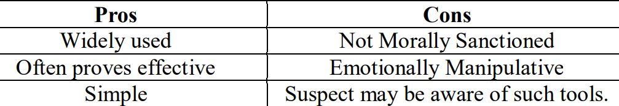

##### REID Technique

RIED technique is named after its author, John E REID, who has got it registered as a trademark “REID Technique of Interviewing and Interrogation”.

“The Reid Interrogation technique has been the dominant method used by police in the United States and Canada to interview suspects of crime. This method is commercially marketed to police departments and other law enforcement agencies with the promise that 80 percent of those interrogated will confess. However, there is growing evidence that the Reid technique results in a significant number of false confessions, especially among the young, the mentally impaired and those of low intelligence. Other countries, especially England have rejected the Reid technique in favor of other methods that work equally well in obtaining confessions but without the risk of false confessions. In the United States, too, there is growing suspicion of the Reid technique and other hard interrogation tactics such as those employed in interrogating suspected terrorists at Guantanamo and Abu Ghraib”.

###### Components of REID

**Factual Analysis**: A provisional profile of the offender is drawn from the facts of the case. According to Joseph P. Buckley, “This represents the collection and analysis of information relative to a crime scene, the victim and possible subjects. Factual analysis helps determine the direction an investigation should take and offers insight to the possible offender.”

**BEHAVIOURAL INTERVIEW**: Following factual analysis, the suspects are shortlisted on the basis of characteristics identified during the process. According to Joseph P. Buckley, The second stage of the process is the interview of possible subjects. This highly structured interview, referred to as a Behaviour Analysis Interview, is a non-accusatory question and answer session intended to elicit information from the subject in a controlled environment. The clinical nature of the interview, including the asking of specific behaviour provoking questions, is designed to provide the investigator with verbal, paralinguistic and nonverbal behaviour symptoms which either support probable truthfulness or deception. A significant portion of training in The Reid Technique is devoted to the interpretation of a subject's behavioural responses during the structured interview.

**Interrogation**: The accused persons who are shortlisted from the second stage , are subjected to Interrogation which is accusatory in nature and intended at procuring confession. According to James Orlando, there are nine steps of interrogation.

1. The positive confrontation. The investigator tells the suspect that the evidence demonstrates the person's guilt. If the person's guilt seems clear to the investigator, the statement should be unequivocal. 2. Theme development. The investigator then presents a moral justification (theme) for the offense, such as placing the moral blame on someone else or outside circumstances. The investigator presents the theme in a monologue and in sympathetic manner.

3. Handling denials. When the suspect asks for permission to speak at this stage (likely to deny the accusations), the investigator should discourage allowing the suspect to do so. The Reid website asserts that innocent suspects are less likely to ask for permission and more likely to “promptly and unequivocally” deny the accusation. The website states that “[i]t is very rare for an innocent suspect to move past this denial state.”

4. Overcoming objections. When attempts at denial do not succeed, a guilty suspect often makes objections to support a claim of innocence (e.g., I would never do that because I love my job.) The investigator should generally accept these objections as if they were truthful, rather than arguing with the suspect, and use the objections to further develop the theme.

5. Procurement and retention of suspect's attention. The investigator must procure the suspect's attention so that the suspect focuses on the investigator's theme rather than on punishment. One way the investigator can do this is to close the physical distance between himself or herself and the suspect. The investigator should also “channel the theme down to the probable alternative components.”

6. Handling the suspect's passive mood. The investigator “should intensify the theme presentation and concentrate on the central reasons he [or she] is offering as psychological justification . . . [and] continue to display an understanding and sympathetic demeanor in urging the suspect to tell the truth.”

7. Presenting an alternative question. The investigator should present two choices, assuming the suspect's guilt and developed as a “logical extension from the theme,” with one alternative offering a better justification for the crime (e.g., “Did you plan this thing out or did it just happen on the spur of the moment?”). The investigator may follow the question with a supporting statement “which encourages the suspect to choose the more understandable side of the alternative.”

8. Having the suspect orally relate various details of the offense. After the suspect accepts one side of the alternative (thus admitting guilt), the investigator should immediately respond with a statement of reinforcement acknowledging that admission. The investigator then seeks to obtain a brief oral review of the basic events, before asking more detailed questions.

9. Converting an oral confession to a written confession. The investigator must convert the oral confession into a written or recorded confession. The website provides some guidelines, such as repeating Miranda warnings, avoiding leading questions, and using the suspect's own language.

**Criticism**

Critics argue that various features of the Reid interrogation method may lead certain innocent suspects to confess. For example, one critique argues that “the guilt-presumptive nature” of the Reid method “creates a slippery slope for innocent suspects because it may set in motion a sequence of reciprocal observations and reactions between the suspect and interrogator that serve to confirm the interrogator's belief in the suspect's guilt” (Moore and Fitzsimmons, 513). According to some critics of the Reid Technique, aspects of Reid-style interrogation that may lead to false confessions include (1) misclassification (the police attributing deception to truthful suspects); (2) coercion (including psychological manipulation); and (3) contamination (such as when police present non-public information to a suspect, and the suspect incorporates that information in his or her confession) (Gudjonsson 2012, 695, discussing Leo and Drizin among other studies).

Reid and Associates, Inc. disputes the contention that their methods lead to false confessions. They argue that:

False confessions are not caused by the application of the Reid Technique . . . [but instead] are usually caused by interrogators engaging in improper behaviour that is outside of the parameters of the Reid Technique . . . such as threatening inevitable consequences; making a promise of leniency in return for the confession; denying a subject their rights; conducting an excessively long interrogation; etc.

The company also cites court cases upholding their methods or denying the admission of expert testimony that would link those methods to false confessions (e.g., U.S. v. Jacques, 784 F.Supp.2d 59, D. Mass. (2011)).

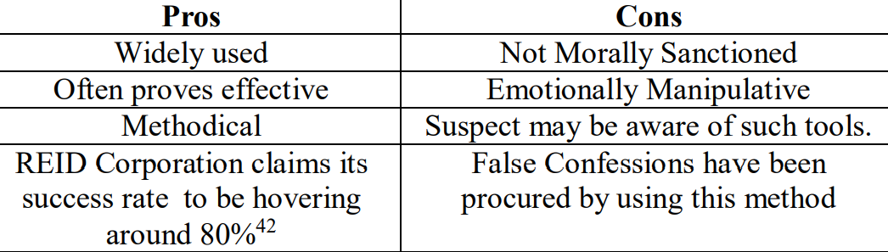

##### PEACE Technique

Peace technique has been developed by in England and Wales during 1990s. This technique is said to have been developed in response to allegation of false confessions through Reid Technique. This technique is meant to conduct interrogation in transparent and ethical manner. According to Durham College43, it is:

*A non-accusatory, information-gathering approach to investigative interviewing, the PEACE model is considered to be best practice and is suitable for any type of interviewee, victim, witness or suspect.*

PEACE is Acronym of the following terms. P: Preparation and Planning E: Engage and Explain A: Account, Clarify and Challenge C: Closure E: Evaluation

Step I -P: Preparation and Planning The interrogator at the first step should be well cognizant of the facts pertaining to the case and the role of the person being interrogated upon. The questions to b e asked during the course of interrogation should be well planned ahead of the interrogation.

Step-II: E: Engage And Explain The suspect should be called upon and explained the purpose and methodology of the interrogation process.

Step-III A: Account, Clarify and Challenge The response so solicited should be properly accounted for . Any ambiguity should be clarified and any clarification should be sought promptly.

Step-IV: C: Closure The process should be properly closed which implies that any missing link should be reconstructed, and ambiguities left should be clarified.

Step-V: Evaluate The entire process should be reviewed , analyzed in order to draw conclusions.

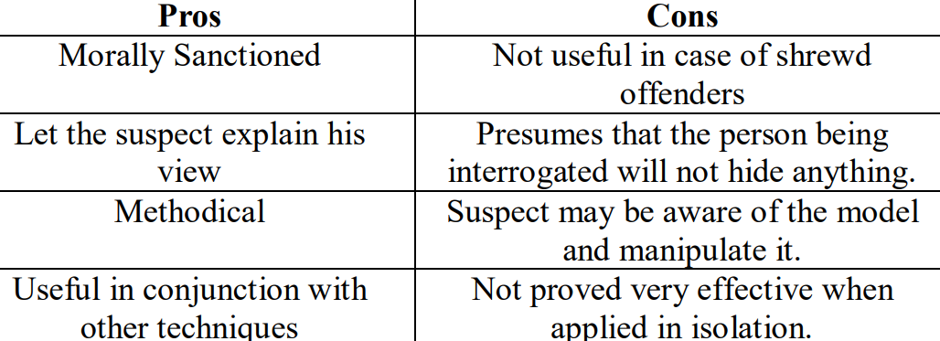

##### HR violation/Use of torture

Employing torture is prohibited by the Constitution and Law. The Article 14(2) of the Constitution provides that: Article14(2): “No person shall be subjected to torture for the purpose of extracting evidence”. Likewise, section 156 of Police Order 2002 makes the torture an offence punishable with 5 years rigorous imprisonment.

However, the fact remains that the legal provisions to the contrary notwithstanding, the police excessively employ torture in certain cases in very inhumane and disgracing manner.

According to an Article titled “The Investigation in Pakistan: Reality and Trends”, Pakistan Vision , Volume 10 No 2 p. 175-17935 , the author observed that: “There are various physical tortures used by police during criminal investigation including slapping on the face, beating by stick on any place of body, torture by fan belt on the ground by laying upside down or hanged by ropes in the tree or roof of the building, keeping person long time to wake up by using various tactics, pulling out the nails or crossing/pricking of needle below nails, apply of electric current on the genitals, pushing of the legs in opposite directions by force that joint between two legs is cracked, passing the iron ring through the nose to rope with roof or tree for long time, use of chilly and petrol in anus, pour of lime stone and tobacco water mixed in the nose, compel to take human urine and stool by mouth etc”.

INTERNATIONAL law prohibits the use of torture and so evidence obtained through torture must necessarily be excluded. As a state party to the Convention Against Torture and to the International Covenant on Civil and Political Rights (ICCPR), Pakistan is required to “take effective legislative, administrative, judicial or other measures to prevent acts of torture in any territory under its jurisdiction”. Pakistan signed CAT a decade ago, and ratified it in 2010.

International law separately provides that legal assistance must be made available during pretrial procedures including police questioning. For instance, the Human Rights Committee has stated that “[i]n cases involving capital punishment, it is axiomatic that the accused must be effectively assisted by a lawyer at all stages of the proceedings”. It is unclear if the Pakistani citizens undergoing this cruel, inhumane and degrading treatment were represented by a lawyer during detention.

Second, the use of torture undermines the justice system’s fairness and legitimacy. Article 14(g) of the ICCPR guarantees the right of defendants “[n]ot to be compelled to testify against himself or to confess guilt”. The Human Rights Committee elaborates that “[d]omestic law must ensure that statements or confessions obtained in violation of Article 7 of the Covenant are excluded from the evidence”.

In a 2007 report on the death penalty in Pakistan, the International Federation of Human Rights concluded that “[t]orture in order to obtain confession, to intimidate and terrorise is widespread, common and systematic”. According to research by Justice Project Pakistan, it is commonly linked to other violations of human rights, such as illegal detention and forced confessions. This often results in wrongful convictions.

The Constitution provides that “[e]very person who is arrested and detained in custody shall be produced before a magistrate within a period of twenty-four hours of such arrest”. Yet, many victims of police torture are being detained for days without being entered into the system.

As a result of this practice, police have the ability to abuse prisoners prior to bringing them before a magistrate. Once a defendant has confessed under torture, few procedural protections exist. Under Pakistani law, interrogations are supposed to be excluded on a showing of torture, but in practice, coercive interrogations are admitted regularly during trial. Often, such ‘confessions’ are the only evidence prosecutors have against defendants. In practice, the lack of use of sophisticated methods of investigation leaves the investigation team with only one method to solve a crime ie confession. Too often, this leads the police to use torture to force confessions in order to proceed with a case. The admission of such testimonies is made easier by the low-quality of representation of defendants who fail to challenge it.

Worse still, there is no meaningful system in place to prosecute perpetrators or provide remedies to survivors. And as a result, such treatment continues to remain socially and politically acceptable.

An important way to dismantle this acceptance is ending the impunity for perpetrators. The National Commission on Human Rights, a state body working independently of the government and directly acco­untable to parliament, has already prepared a report on torture which was sent to the federal government and finds mention in our previous yearly report. The misfortune is that torture, both physical and psychological, are not defined under the law formulated in Pakistan, despite ratifying CAT.

##### False confession

There is no question that innocent suspects have been induced to confess to crimes they did not commit. The most prevalent form of a false confession is coerced compliant. Although the Miranda ruling and education of interrogators has undoubtedly decreased the incidents of “third-degree” tactics used since 1966, abusive interrogation practices continue into the twenty-first century. These tactics have been admonished by the courts and correctly used as grounds to suppress confessions. However, a small group of psychologists and sociologists would like to expand the grounds for excluding confessions, by persuading courts to suppress confessions obtained through the use of “psychologically sophisticated” interrogation techniques. The studies and research citing support ofthe beliefthat psychologically sophisticated interrogations routinely produce false confessions, in our opinion, offer no substantive evidence to support this claim. To the contrary, our experience has been that such inter¬ rogation techniques, ifused in accordance with the guidelines offered in this text, greatly reduce the risk of an innocent suspect confessing. The self-preservation instincts of an innocent suspect during an interrogation, conducted in accordance with the techniques taught in this text, are sufficient enough to maintain the suspect’s stated innocence. When an innocent suspect accepts responsibility for a crime he did not commit, it strongly suggests that improper inducements, such as threats and promises or deprivation ofbiological needs, were used. When evaluating the trustworthiness of a confession, a key question to ask is: “What motivated the suspect to confess?” Some incentives are much more likely to result in false confessions than others. In addition, the nature ofthe confession itself may offer helpful insight. A confession that contains no corroborative information, beyond merely accepting personal responsibility for committing the crime, suggests the possibility that improper inducements were used to elicit the confession and the confession may well be false. The research conducted on false confessions offers little specific direction to courts when deciding whether a particular confession is true or false. A summary ofthe research findings presented in this chapter reveals that false confessions do occur but that they are rare occurrences, even when “coercion” is judged to have been present during an inter¬ rogation. Finally, as a population, suspects suffering from diminished mental capacity or mental illness appear to be more likely to offer false confessions.

#### Criminal Investigation Analysis

Criminal Investigative Analysis (CIA), also known as criminal profiling, is an investigative tool used within the law enforcement community to help solve violent crimes. The analysis is based on a review of evidence from the crime scene and from witnesses and victims. The analysis is done from both an investigative and a behavioural perspective. The analysis can provide insight into the unknown offender (characteristics and traits) as well as investigative suggestions and strategies for interviews and trial. A CIA cannot replace a thorough investigation; and the accuracy and detail of a CIA is limited by the accuracy and detail of the information on which it is based. CIA does not use crystal balls or psychic experiences; it is a logical, systematic approach for analyzing behaviour. CIA services can assist in the investigation oCIA services can assist in the investigation of interpersonal violence, particularly homicide and sexual assault cases. CIA is suitable for singleincident or serial cases with one or more victims, including:

homicides; kidnapping, including infant kidnapping; sexual assault; child molestation and abuse; hostage taking; bombings; arson; threat cases; and extortion.

CIA analysts are experienced investigators with extensive training in behavioural analysis. They have been certified by the International Criminal Investigative Analysis Fellowship to provide analyses of criminal behaviour.

##### Consulting Services

The consulting services that CIA analysts offer to criminal investigators include the following areas:

**Personality Profile**: This is a detailed behavioural analysis to derive information about an unknown offender. The analyst examines information about the victim and the offence to determine the characteristics and traits of the offender. Such a personality profile may allow those involved to recognize someone as a possible offender. Based on the analysis, the analyst can usually offer suggestions for further investigations.

**Indirect Personality Assessment**: This is an assessment of a known individual believed to be responsible for committing a violent crime. The assessment, based on an evaluation of the individual's personality, can help to determine:

whether or not the suspect's personality fits the crime under investigation; suspect's strengths, weaknesses and areas of vulnerability ; interview techniques appropriate for the suspect; strategies for a successful undercover operation; strategies for negotiating successfully with a hostage-taker; strategies for investigating offenders of sexual homicide or serial rape, particularly to elicit predictable actions on the part of the offender; and most appropriate trial and courtroom strategy.

**Equivocal Death Analysis**: This is an in-depth crime scene reconstruction undertaken to provide an opinion on the manner of death: homicide, suicide, accidental death, death by natural causes, or death by misadventure. This is generally done in conjunction with a psychological autopsy.

**Assessment of Threat or Extortion Communications**: The analyst examines a threat or extortion communication for content and stylistic characteristics in order to assess the validity of the threat and the level of risk to the victim and suggest ways to minimize the risk to the victim. In some cases it is possible to provide a profile of the unknown author or caller.

**Consulting to Provide Expert Analysis**: This service is provided to help investigators focus and fine tune interview techniques, develop investigative strategies including undercover operation strategies, and develop an appropriate trial and courtroom strategy. A CIA analyst can provide services such as:

crime scene reconstruction; expert evidence/reports to coroner's inquest; expert opinions for use in search warrant and privacy act applications; expert evidence/reports regarding the 'signature' of serial violent offenders; analysis of stalking cases; research on unusual areas of expert examination;and consultation on media strategy and releases.

### Legal/Ethical Guidelines for Investigators

A professional police organisation defines and implements ethical standards. Such volunteerism easily resolves the question of ‘who will police the police?’

In Pakistan, observance of ethical norms in policing remained confined to individuals primarily, and not institutions. However, to inculcate ethical values that were synchronised with the ideals of human rights, Article 114 of the Police Order (PO) 2002 was formulated. To regulate police practices under Article 114 of PO 2002, it is imperative that the provincial and capital cities’ chiefs issue the Code of Conduct. It includes practical guiding principles regarding stop, search and the arrest of individuals, the search of premises, seizure of property, interviewing victims and the interrogation of the suspects. A police officer violating the Code of Conduct shall be punished under Article 113 with dismissal, suspension, compulsory retirement or reduction in rank. Under Article 24 of the PO 2002, upon appointment, every police officer shall take oath of his responsibilities.

The Code of Ethics is not to be merely regarded as a bunch of ideals and hence, requires conversion into reality. Its practical manifestation is linked with numerous variables, including the commitment of the political elite with public safety, efficacy of the public safety apparatus, quality of training, public cooperation and the work-station environment of police stations. Article 156 of the PO 2002 defines penalties for certain types of misconduct of a police officer. Under article 15(3) of the PO 2002, in exceptional circumstances, on the basis of misconduct, the CCPO and the DPO may be removed from their assignments. Article 44 empowers the district public safety commission to receive complaints regarding the misconduct of a police officer and take action. Article 100 empowers the National Public Safety Commission to receive complaints of misconduct against the law-enforcement officer working for any federal law-enforcement agency. Article 155 prescribes a penalty for certain types of misconduct. Though PO 2002 provides an elaborate apparatus for ethical conduct, since Sindh and Balochistan reverted to the Police Act of 1861, two provinces are without a legal framework for ethical conduct. In the remaining two provinces, the ideals of PO 2002 are yet to be converted into reality.

In developing societies, blind compliance culture within the police badly compromised the observance of the ethical code of conduct. Because, in such countries, the police edifice rests on colonial fabrication, hence the elite class gets preference over the weaker segments.

Police organisations, established on colonial preferences, are averse to ethical standards; hence its democratic transformation seems a gigantic task. Maintenance of order in a society warrants observance of ethical policing standards. However, police leadership, having respect for ethics, supports the reporting of professional misconduct. The inclusion of ethical standards requires a better understanding of minor misconduct issues and expeditious complaint disposal apparatus.

In Pakistan, the motorway police is the only exception where, as per procedure, the duty officer himself goes to the violator and after greeting the violator informs him about the nature of violation and the consequence. Furthermore, whenever a new traffic regulation is introduced in the first phase, the commuters are educated through briefing officers and road safety literature.

Punitive behaviour, inculcated during training sessions, badly affected the curative passions of law enforcers. Arrogance within the chain of command kills the positive virtues, and thus, often, low-ranking officials feel frustrated. Consequently, the low-ranking officials are averse to professional ethical norms.

In Pakistan, police reforms neither focused on the improvement of police stations nor on public service delivery. A mere increase in the number of the constabulary may improve the visibility of the police, but may not improve the service delivery.

In our cultural context, reporting of professional misconduct within an organisation is regarded unethical. Therefore, those who are conscious of this obligation, avoid the reporting of professional misconduct of fellow officers. The few who dare, are not seen as part of the fraternity.

The British police are known as the most ethical law enforcement agency in the world. In 2014, with public consultation, a code of ethics for England and Wales was drafted. Codes of ethics are a bunch of ideals primarily defining the purpose of policing and they humanise the police in the eyes of public. A code of ethics not only enables the police to assert their independence, but also guarantees the protection of human rights.

In decision-making processes the ‘character of officers’ and ‘quality of leadership’ are the most influential factors. However, a strong lobby within the police thinks imparting knowledge about ethics is a waste of time.

To improve ethical standards, technological solutions may also help police organisations. Policies, as well as procedures for lodging complaints, need to be available on websites. Furthermore, ethics are to be incorporated in the training curriculum.

Police misconduct includes impolite behaviour, corruption and the misuse of power. With increased quality of supervision the incidence of misconduct may be reduced. The resolution of minor complaints is not to be taken merely as a punitive action, but rather, as a developmental issue. Prior to the observance of ethical standards, the police need to understand the needs of vulnerable segments.

To improve ethical standards, professional police organisations introduced the concept of ‘whistleblowing’. Introduction of such practices requires encouragement, reward and protection. A strong lobby within police organisations believes that measure like whistleblowing may weaken the team spirit and chain of command. However, advocates of whistleblowing argue that a police officer is not only supposed to be loyal to the chain of command, but also to the public interests. In Pakistan, the K-P police, for the first time, fired those officers from service, who allegedly had links with criminals and smugglers. Though it was a move to weed out the corrupt from service, owing to procedural and legal lacunas, the majority of them took advantage and were reinstated.

An effective policing apparatus clearly defines and prevents ‘misconduct’ otherwise ‘misconduct’ may become a complaint. Therefore, the police management should not wait for the intervention of the media, human rights organisations or civil society.

#### Stop and frisk operation/terry stop/snap checking

A situation where a police official being suspicious of an individual detains the person an d runs his hands lightly over the suspect's outer garments to determine if the person is carrying a concealed weapon. It is also called Terry Operations because the term evolved after an American named Terry was stopped and then booked on account of possessing illegal weapon. The act of police was challenged for flouting the guarantees as to personal liberties and protection against undue search as enshrined in US Constitution vide Fourth Amendment to US’ Constitution. However, the US Supreme Court found it Lawful on the part of Police to stop and check someone randomly towards discharge of the duties entrusted upon the Police. The case was reported as Terry Vs Ohio State (1968).

**Snap Checking in Pakistan**: It is permissible in Pakistan under section 125 of Police order 2002 in following manner.

Section 125 of Police Order 2002 **Power to search suspected persons or vehicles in street, etc**.– When in a street or a place of public resort a police officer on reasonable grounds suspects a person or a vehicle to be carrying any article unlawfully obtained or possessed or likely to be used in the commission of an offence, he may search such person or vehicle; and if the account given by such person or possessor of the vehicle appears to be false or suspicious, he may detain such article after recording in writing the grounds of such action and issue a receipt in the prescribed form and report the facts to the officer in-charge of the police station for informing the court for proceeding according to law against the person.

However, these powers are not meant go be used recklessly rather section 156 of the same Act duly protects against unreasonable search in following manner.

**Protection against Unnecessary Search**

156. Penalty for vexatious entry, search, arrest, seizure of property, torture, etc.– Whoever, being a police officer–

(a) without lawful authority, or reasonable cause, enters or searches or causes to be entered or searched any building, vessel, tent or place; (b) vexatiously and unnecessarily seizes the property of any person; (c) vexatiously and unnecessarily detains, searches or arrests any person; or (d) inflicts torture or violence to any person in his custody; shall, for every such offence, on conviction, be punished with imprisonment for a term, which may extend to five years and with fine.”

**Features of Stop and Frisk Operations** • A necessity for Law and Order • Lawful procedure as sanctioned under Police Order 2002 • Open to Abuse • Arbitrary • Often evokes resentment amongst the people • A cause of Public Grievances against Police. • Not regulated by specific SOPs • No practical remedy against misuse

**How to reform the process**? The procedure can be made public friendly and useful through following measures. • Framing of SOPs • Ensuring self-respect of the citizens stopped for checking • Installation of Online Cameras • Toll Free complaint Number at Police pickets • Periodic visits of the Higher Officials • Behavioural Training of the Staff • Educating the Public at Large • Applying innovative techniques such as Mystery Shopping

#### Arrest Procedures

**Definition**: To take or keep in custody by authority of law.

**Who Can Arrest**:

Official authority as to arrest and detention rests with following three officials • Magistrate • Police • Justice of Peace

However, under section 59 CPC, arrest can be made by a private person in following manner:

(1) Any private person may arrest any person who in his view commits a nonbailable and cognizable offence, or any proclaimed offender, and without unnecessary delay, shall make over any person so arrested to a police-officer or, in the absence of a police-officer, take such person or causes him to be taken in custody to the nearest police-station.

(2) If there is reason to believe that such person comes under the provisions of section 54, a police-officer shall re-arrest him.

(3) If there is reason to believe that he has committed a non-cognizable offence, and he refuses on the demand of a police-officer to give his name and residence, or gives a name or residence which such officer has reason to believe to be false, he shall be dealt with under the provisions of section 57. If there is no sufficient reason to believe that he has committed any offence, he shall be at once released.

**Manner and Condition of Arrest**: The manner of arrest is provided under section 46 CRPC

“*Arrest How to be Made (46 CRPC)*

In making an arrest the police-officer or other person making the same shall actually touch or confine the body of the person to be arrested, unless there be a submission to the custody by word or action. (2) Resisting endeavor to arrest. If such person forcibly resists the endeavor to arrest him or attempts to evade the arrest, such police-officer or other person may use all means necessary to effect the arrest. (3) Nothing in this section gives a right to cause the death of a person who is not accused of an offence punishable with death or with [imprisonment for life.]”

#### Search and Seizure

“A hunt by law enforcement officials for property or communications believed to be evidence of crime, and the act of taking possession of this property.” (Black Law Dictionary)

During the course of an investigation, a police officer is required to search persons; buildings; vehicles etc. which can lead to the recovery or discovery of weapons; stolen property; documents; CDs; mobile phones or some other materials become strong pieces of evidence against the accused persons. Indeed, evidence that is collected during search can tie the accused to the crime. Therefore, all searches must be carried out strictly in accordance with the requirements of law, otherwise the recoveries may become doubtful, and damage the case of the prosecution. As a first step, whenever searches are to be made, the police officer must be mindful about the constitutional protection of privacy as enshrined in Art. 14 of the Constitution. This, however, is subject to permissibility of law which enables the police officer to enter a house for the purpose of arresting a wanted criminal or to make a searches to find something incriminating. Gazetted officers supervising investigations shall take disciplinary action against investigating officers who carry out searches under section 165Cr.P.C,64 without sufficient justification. Indeed, the police does not have unlimited powers to make search of a house or a person, and disturb the privacy and dignity in violation of mandate of the constitution of Pakistan.

##### Types

* Search with warrant where permission is required from a magistrate as per s.96 of the Cr.P.C.
* Search without a warrant during the course of an investigation as per s.165 of the Cr.P.C.

When is a warrant not required?

Section 165 empowers the police officer specified to make a search without warrant subject to certain safeguards. The prerequisites for a search as per this section are that:

Search must be necessary for investigation ii. The offence must be such as the police officer is authorized to investigate, i.e., a cognizable offence. iii. Reasonable grounds must exist for believing that the thing required will be found in a place. iv. (iv.) There would be undue delay in getting the things in any other way. v. Grounds of belief as to necessity of search must be previously recorded by the police officer.

Raids/Search on Spy Information

Raids for recovery of narcotics, terrorism offences under the Anti-Terrorism Act, 1997 and illegal weapons by police on spy information are a regular phenomenon and are conducted without warrant. Accordingly, it is important that police officers need to differentiate between raids for recovery of narcotics and searches conducted pursuant to terrorism offences from illegal weapons. Finally, it is advisable not to act rashly on receipt of information which could be motivated due to a number of factors. Therefore, emphasis must be placed on the credibility of the informer and the quality of information should be carefully analysed. In cases of doubt, senior officer should always be consulted.

##### Guidelines to follow

i. An officer in-charge of a police station or the police-officer making an investigation must ensure that the place being searched is in the correct jurisdiction. ii. The officer must record in writing the grounds of his belief if the search is made without a warrant iii. The officer must specify in writing the place of his search if the search is made without a warrant iv. The officer must justify the undue delay in the search if the search is made without a warrant v. Conversely, when a search is being made without a warrant, during an investigation, the occupants of the premises may be reluctant. In such a scenario, the police must be in sufficient numbers and two respectable witnesses of the locality should be present. Provided, that the search is to take place within the jurisdiction of another police station, Section 166 of the Cr.P.C. stipulates that the station house officer of that police station may conduct the search who shall proceed with it in accordance with s.165 of the Cr.P.C. vi. An officer-in-charge of a police station receiving a requisition to search u/s 166 of Cr.P.C, should comply without unnecessary delay and should take all necessary precautions to ensure a successful search. vii. If the object in question can be obtained otherwise, the officer is not required to make the search. viii. The officer should ensure that the precautionary measures are not avoided.71 ix. Whatever recoveries are made from the searches they must be done in accordance with Form 25.23(I)(a)(b) and (c). x. Whenever a closed place is to be searched under a warrant, the police officer is to inform any person residing in, or being in charge of such a place and show the search warrants. Any such person, on production of search warrant, should allow free ingress and afford all reasonable facilities for a search. Provided that ingress cannot be obtained, the police officer can break open to gain access with use of reasonable force and due care for decency.

### Organizations

#### UNAFEI

The United Nations Asia and Far East Institute for the Prevention of Crime and the Treatment of Offenders (UNAFEI) is a United Nations regional institute, established in 1962 by agreement between the United Nations and the Government of Japan, with the aim of promoting the sound development of criminal justice systems and mutual cooperation in Asia and the Pacific Region. UNAFEI activities include training courses and seminars for personnel in crime prevention and criminal justice administration, and the research and study of crime prevention and the treatment of offenders. It also conducts special seminars outside of Japan. UNAFEI annually organizes two international training courses and one international seminar. Participants represent mainly Asia and the Pacific Region, but some come from other regions of the world such as Africa and Latin America. This program contributes significantly to the training of personnel in criminal justice, and to providing ideas and knowledge for effective measures to combat crime in developing nations. For over 50 years, UNAFEI's efforts in training personnel have helped those individuals play leading roles in the criminal justice administration of their respective countries.

##### Organization

In 1970, the Government of Japan assumed full administration of UNAFEI in terms of finance and personnel. The United Nations Training Cooperation Department in the Ministry of Justice is in charge of its administration. Since UNAFEI is still affiliated with the United Nations, it submits an annual report to the Secretary-General of the United Nations, and the Director of UNAFEI is assigned in consultation with the United Nations. Customarily, the Director of the United Nations Training Cooperation Department in the Research and Training Institute of the Ministry of Justice serves as the Director of UNAFEI. The Deputy Director and the professors are selected from among public prosecutors, judges, correctional officers and probation officers. In addition, there are approximately 20 administrative officers and a linguistic adviser, who is a native English speaker.

#### UNICEF

United Nations Children's Emergency Fund Abbreviation: UNICEF Established: December 11, 1946; 69 years ago Headquarters: New York

The United Nations Children's Fund is a United Nations (UN) programme headquartered in New York City that provides humanitarian and developmental assistance to children and mothers in developing countries. It is one of the members of the United Nations Development Group and its executive committee.

UNICEF was created by the United Nations General Assembly on 11 December 1946, to provide emergency food and healthcare to children in countries that had been devastated by World War II. The Polish physician Ludwik Rajchman is widely regarded as the founder of UNICEF and served as its first chairman from 1946. On Rajchman's suggestion, the American Maurice Pate was appointed its first executive director, serving from 1947 until his death in 1965.In 1953, UNICEF's mandate was extended to address the needs of children in the developing world and became a permanent part of the United Nations System. At that time, the words "international" and "emergency" were dropped from the organization's name, making it simply the United Nations Children's Fund, or popularly known as "UNICEF".

UNICEF relies on contributions from governments and private donors. Governments contribute two-thirds of the organization's resources. Private groups and some six million individuals contribute the rest through national committees. It is estimated that 92 per cent of UNICEF revenue is distributed to programme services.UNICEF's programmes emphasize developing community-level services to promote the health and well-being of children. UNICEF was awarded the Nobel Peace Prize in 1965.

Most of UNICEF's work is in the field, with staff in over 190 countries and territories. More than 200 country offices carry out UNICEF's mission through programmes developed with host governments. Seven regional offices provide technical assistance to country offices as needed. UNICEF's Supply Division is based in Copenhagen and serves as the primary point of distribution for such essential items as vaccines, antiretroviral medicines for children and mothers with HIV, nutritional supplements, emergency shelters, family reunification,and educational supplies. A 36 member executive board establishes policies, approves programmes and oversees administrative and financial plans. The executive board is made up of government representatives who are elected by the United Nations Economic and Social Council, usually for three-year terms.

#### IPA

The International Police Association (IPA) is the largest organisation for police officers in the world, founded by British sergeant Arthur Troop (1914–2000). The Association has 64 national Sections and over 420,000 members and associate members.

The International Police Association was founded on 1 January 1950 under the Esperanto motto on its emblem, Servo per Amikeco (Service through Friendship), to create friendly links and encourage cooperation between individual police officers around the world. It organizes participation in international, national and local professional, cultural and social events and offers opportunities for professional development in its educational facility, IBZ Gimborn (Germany) www.ibz-gimborn.de, with funding for individual members through the Arthur Troop Scholarship. It also offers exchange of best practice and topics faced by the police in today’s world by attending World Seminars, in particular for young police officers and professional Police exchange programmes, emergency aid for disasters, coordinated by the International Social Commission and accommodation opportunities in more than 70 IPA Houses established in more than 20 countries. The IPA organises the International Youth Gatherings for children of IPA members aged 16-17 in a different country each year. The IPA has 5 international commissions, each chaired by a member of the Permanent Executive Board and with members from various countries around the world. The External Relations Commission provides liaison officers at various UN, European and American organisations. The International Cultural Commission looks after the cultural events and competitions, runs the International Youth Gathering amongst its tasks. The International Professional Commission runs the police placement programme, the Arthur Troop Scholarship, Young Officers' Seminars and carries out professional surveys. The International Social Commission looks after emergency and humanitarian aid to members following natural disasters, looks after IPA houses and coordinates social and sporting events, as well as youth holiday exchanges. The International Internal Commission is responsible for maintaining and revising the international rules and statute of the Association. The main offices of the organization (IAC) are at Nottingham.

##### History

The IPA - the largest police organisation in the World - was founded on 1 January 1950. Since that time, its Esperanto motto "Servo per Amikeco" (Service through Friendship) has reached more people than could have been imagined.

The Association was formed because a police sergeant from Lincolnshire, England, Arthur Troop, wanted to create a channel for friendship and international co-operation amongst police officers. With the help of early pioneers he helped to found other national sections in Western Europe, Africa, America (north and south), Asia and Australasia. In 1955, at the first International Executive Committee meeting in Paris, he became the first International Secretary General, a post he held until 1966.

In the Queen’s Birthday Honours List of 1965 Arthur Troop was awarded the British Empire Medal for his work in founding the IPA. At the 26th IEC Conference in Vienna, in 1995, he was awarded the IPA World Police Prize. The association's 50th Anniversary World Congress was held in Bournemouth in May 2000.

#### Europol

Europol is the European Union law enforcement organisation that handles criminal intelligence. Its mission is to assist the law enforcement authorities of Member States in their fight against serious forms of organised crime. Europol, in close co-operation with Member States, Candidate Countries and other law enforcement bodies, is actively involved in the fight against organised crime whilst maintaining full respect for individual integrity and human rights. The Europol Convention states that Europol shall establish and maintain a computerised system to allow the input, access and analysis of data. The Convention also provides the legal framework for the management of these systems, in particular as regards data protection, confidentiality and external supervision. The Europol computerised system has three principal components: - An information system; - An analysis system; - An index system. In addition to the above systems aimed at processing personal data, Europol is developing and managing many more information products and services, either as part of or in support of its core business. In order to fight international organised crime effectively, Europol cooperates with a number of third countries and organisations. On the basis of agreements concluded in accordance with the Europol Convention, particularly close cooperation exists with a number of third countries and organisations as follows (in alphabetical order): Albania, Australia, Bosnia and Herzegovina, Canada, CEPOL, Colombia, Croatia, Eurojust, European Central Bank, European Commission, European Monitoring Centre for Drugs and Drug Addiction, Former Yugoslav Republic of Macedonia, Frontex, Iceland, Interpol, Moldova, Norway, OLAF, Russian Federation, Switzerland, SITCEN, Turkey, United Nations Office on Drugs and Crime, USA, World Customs Organisation.

Europol is the European Union’s law enforcement agency whose main goal is to help achieve a safer Europe for the benefit of all EU citizens. We do this by assisting the European Union’s Member States in their fight against serious international crime and terrorism. Large–scale criminal and terrorist networks pose a significant threat to the internal security of the EU and to the safety and livelihood of its people. The biggest security threats come from terrorism, international drug trafficking and money laundering, organised fraud, counterfeiting of the euro currency, and people smuggling. But new dangers are also accumulating, in the form of cybercrime, trafficking in human beings, and other modern-day threats. This is a multi–billion euro business, quick to adapt to new opportunities and resilient in the face of traditional law enforcement measures.

Europol headquarters in The Hague, the Netherlands. support centre for law enforcement operations • hub for criminal information and organisations • centre for law enforcement expertise • one of the largest concentrations of analytical capability in the EU • produces regular assessments and reports • high-security, 24/7 operational centre • central platform for law enforcement experts from the European Union countries

##### Mandate of Europol

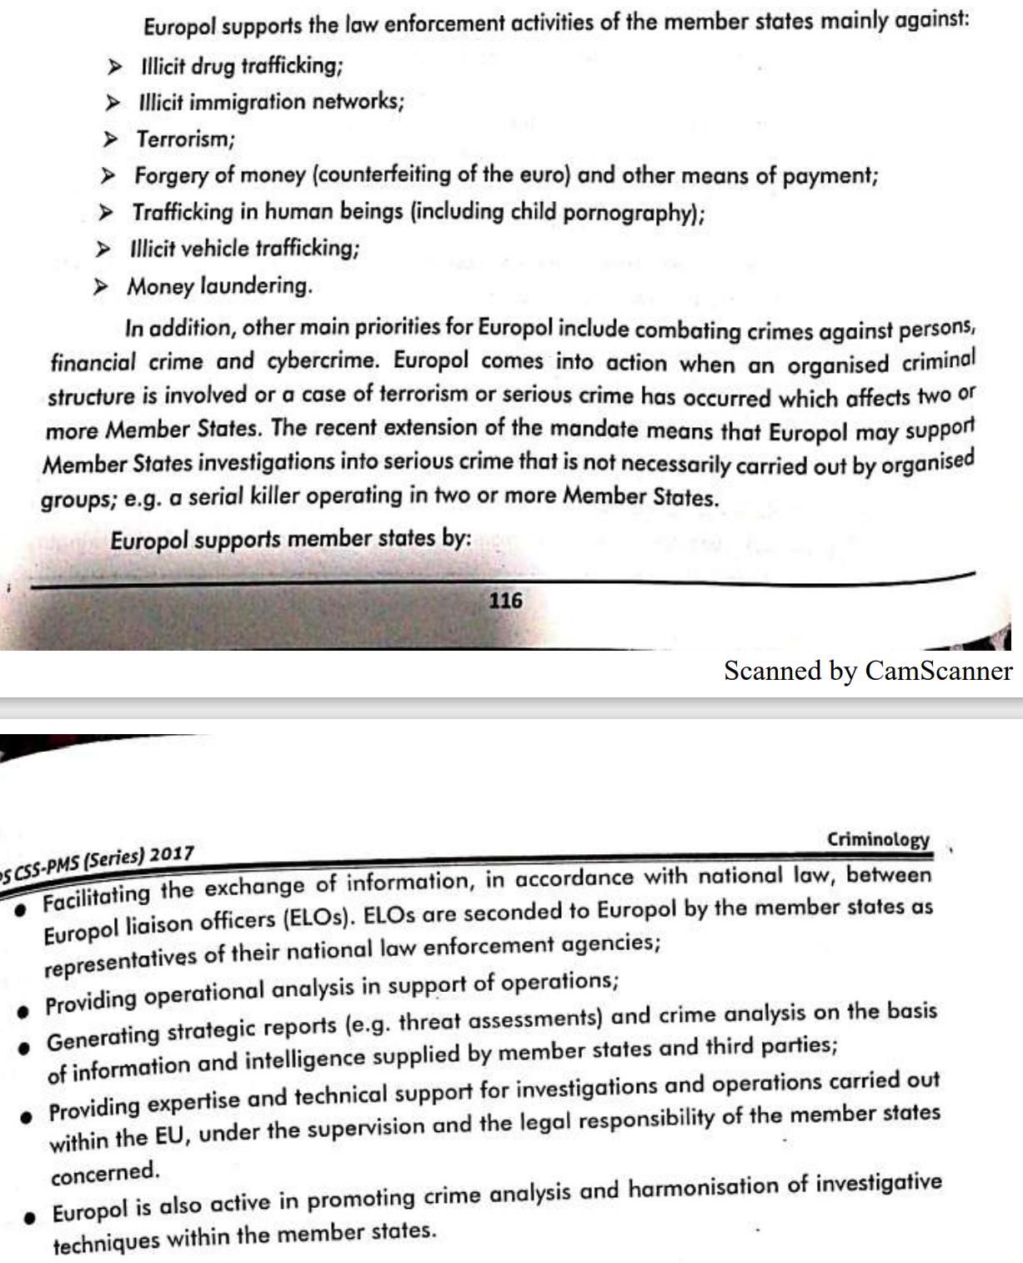

##### History

Europol has its origins in TREVI, a forum for internal security cooperation amongst EEC/EC interior and justice ministers created in 1975 and active until the Maastricht Treaty came into effect in 1993. Germany, with its federal organisation of police forces, had long been in favour of a supranational police organisation at EC level. It tabled a surprise proposal to establish a European Police Office to the European Council meeting in Luxembourg in June 1991. By that December, the Intergovernmental Conference was coming to an end and the member states had pledged themselves to establishing Europol through Article K.1 of the Maastricht Treaty. Europol was given the modest role of establishing ‘a Union-wide system for exchanging information’ amongst EU police forces.

Delays in ratifying the Maastricht Treaty led to TREVI ministers agreeing a "Ministerial Agreement on the Europol Drugs Unit" in June 1993. This intergovernmental agreement, outside of EU law, led to the establishment of a small team headed by Jürgen Storbeck, a senior German police officer who initially operated from some temporary cabins in a Strasbourg suburb (shared with personnel of the Schengen Information System) while more permanent arrangements were made. Once the Maastricht Treaty had come into effect, the slow process of negotiating and ratifying a Europol Convention began. In the meantime, the Europol Drugs Unit (EDU) had its powers extended twice, in March 1995 and again in December 1996 to include a range of trafficking offences in its remit. During this period, information amongst officers could only be exchanged bilaterally, with a central database to be established once the Europol Convention was ratified. The Europol Convention finally came into effect in October 1998 after ratification by all 15 EU national parliaments though some outstanding legal issues (primarily data protection supervision and judicial supervision) ensured it could not formally take up duties until July 1999.

The Europol Convention was superseded by the Council Decision of 6 April 2009 establishing the European Police Office (Europol), converting Europol into a formal EU agency as well as increasing some of its powers. The European Parliament was given more control over Europol by the Council Decision as well.

The establishment of Europol was agreed to in the 1992 Maastricht Treaty, officially known as the Treaty on European Union (TEU) that came into effect in November 1993. The agency started limited operations on 3 January 1994, as the Europol Drugs Unit (EDU). The Europol Convention was signed on 26 July 1995, and came into force in October 1998 after being ratified by all the member states. Europol commenced its full activities on 1 July 1999. Europol came under the EU's competence with the Lisbon Treaty and the Convention was replaced by a Council Decision in 2009. It was reformed as a full EU agency on 1 January 2010. This gave Europol increased powers to collect criminal information and European Parliament more control over Europol activities and budget.

#### UNODC

The United Nations Office on Drugs and Crime (UNODC) (in French Office des Nations unies contre la drogue et le crime) is a United Nations office that was established in 1997 as the Office for Drug Control and Crime Prevention by combining the United Nations International Drug Control Program (UNDCP) and the Crime Prevention and Criminal Justice Division in the United Nations Office at Vienna. It is a member of the United Nations Development Group and was renamed the United Nations Office on Drugs and Crime in 2002. In 2016 - 2017 it has an estimated biannual budget of US$700 million.

Organizational structure

The agency, employing between 1,500 and 2,000 people worldwide, has its headquarters in Vienna (Austria), with 21 field offices and two liaison offices in Brussels and in New York City. The United Nations Secretary-General appoints the agency's Executive Director. Yuri Fedotov, the former Russian Ambassador to the United Kingdom, has held this position since his appointment in 2010, when he succeeded Antonio Maria Costa in his personal capacity, and also as DirectorGeneral of the United Nations Office at Vienna. The office aims long-term to better equip governments to handle drug-, crime-, terrorism-, and corruption-related issues, to maximise knowledge on these issues among governmental institutions and agencies, and also to maximise awareness of said matters in public opinion, globally, nationally and at community level. Approximately 90% of the Office's funding comes from voluntary contributions, mainly from governments.

##### Aims and Functions

UNODC was established to assist the UN in better addressing a coordinated, comprehensive response to the interrelated issues of illicit trafficking in and abuse of drugs, crime prevention and criminal justice, international terrorism, and political corruption. These goals are pursued through three primary functions: research, guidance and support to governments in the adoption and implementation of various crime-, drug-, terrorism-, and corruption-related conventions, treaties and protocols, as well as technical/financial assistance to said governments to face their respective situations and challenges in these fields. These are the main themes that UNODC deals with: Alternative Development, Corruption, Criminal Justice, Prison Reform and Crime Prevention, Drug Prevention, -Treatment and Care, HIV and AIDS, Human Trafficking and Migrant Smuggling, Money Laundering, Organized Crime, Piracy, Terrorism Prevention.

##### Campaigns

UNODC launches campaigns to raise awareness of drugs and crime problems. On 26 June every year, UNODC marks the International Day against Drug Abuse and Illicit Trafficking. On 9 December every year, UNODC commemorates the International Anti-Corruption Day.

The United Nations Office on Drugs and Crime (UNODC) started this international campaign to raise awareness about the major challenge that illicit drugs represent to society as a whole, and especially to the young. The goal of the campaign is to mobilize support and to inspire people to act against drug abuse and trafficking. The campaign encourages young people to put their health first and not to take drugs.

The United Nations Office on Drugs and Crime (UNODC) has teamed up with the United Nations Development Program (UNDP) to run this campaign as a focus on how corruption hinders efforts to achieve the internationally agreed upon MDGs, undermines democracy and the rule of law, leads to human rights violations, distorts markets, erodes quality of life and allows organized crime, terrorism and other threats to human security to flourish.

Blue Heart Campaign Against Human Trafficking. The Blue Heart Campaign seeks to encourage involvement and action to help stop trafficking in persons. The campaign also allows people to show solidarity with the victims of human trafficking by wearing the Blue Heart. The use of the blue UN colour demonstrates the commitment of the United Nations to combat this crime.

#### Interpol

##### Introduction

Created in 1923 · With its 190 member nations, Interpol is the world's largest international police organization. · Its primary objective is to reduce criminal activity across the world by facilitating the cross-border exchange of police information and promoting cooperation among law enforcement authorities in its member nations. · One of Interpol's most important functions is to assist its members through the ‘issuance of notices’ that facilitate the sharing of crime- related information among countries and are the main instruments of international police cooperation.

##### Structure and Governance:

· General Secretariat in Lyon, France, · Six Regional Bureaus, one Liaison Office, and · Special Representatives of INTERPOL to the UNO and to the EU in Brussels. · A National Central Bureau (NCB) in each member country

**Official Languages**: Four official languages: Arabic, English, French and Spanish

##### INTERPOL’s Functions

· INTERPOL works closely with all member countries and international organisations such as the UN and EU to combat transnational crime. · INTERPOL performs the following four core functions:

1. **Secure global police communications services.** INTERPOL has developed a global police communications system, known as I-24/7, · This system enables any member country to request for, and submit and access, vital data instantly in a secure environment. Ø Liaison Bureau (LB) is connected to this system and frontline officers can obtain INTERPOL services via LB.
2. **Operational data Services and databases for police** · Through I-24/7, member countries, including the Force, have direct and immediate access to a wide range of databases, including Nominal Data; Stolen and Lost Travel Documents; Stolen Motor Vehicles; Stolen Works of Art; DNA Profiles; Fingerprints, and Counterfeit Payment Cards. · For instance, in 2008, Organised Crime and Triad Bureau utilised the Stolen Motor Vehicles Database during an operation and identified three recovered vehicles as the ones reported stolen by the National Police Agency of Japan.
3. **Operational police support services** · Based at IPSG (Interpol Secretariat General), the Command and Co-ordination Centre operates around the clock. · It links IPSG, National Central Bureaux and regional offices, · It serves as the first point of contact for any member country faced with a crisis situation. · This may include deployment of Incident Response Teams or Disaster Victim Identification Teams to the sites of terrorist attacks or natural disasters. · It may also send INTERPOL Major Event Support Teams (IMEST) to assist the host countries of sporting events or world summits with security efforts. · For example, INTERPOL sent their IMEST to render assistance to the Force during Hong Kong's hosting of the WTO MC6 Conference in 2005.
4. **Police training and development** · INTERPOL Global Learning Centre is a Learning Management System composed of a directory of experts, e-learning packages and a depository of research papers and best practices. · Together with regular training programmes, the organisation ultimately aims at enhancing member countries' capacity in combatting transnational crime and terrorism.

##### Interpol notices and Diffusions

· INTERPOL Notices are international requests for cooperation or alerts allowing police in member countries to share critical crime-related information. · In the case of Red Notices, the persons concerned are wanted by national jurisdictions for prosecution or to serve a sentence based on an arrest warrant or court decision. · INTERPOL's role is to assist the national police forces in identifying and locating these persons with a view to their arrest and extradition or similar lawful action. · Notices are used by the United Nations, International Criminal Tribunals and the International Criminal Court to seek persons wanted for committing crimes within their jurisdiction, notably genocide, war crimes, and crimes against humanity.

**Diffusion**: · Similar to the Notice is another request for cooperation or alert mechanism known as a 'diffusion'. · This is less formal than a notice but is also used to request the arrest or location of an individual or additional information in relation to a police investigation. · A diffusion is circulated directly by an NCB to the member countries of their choice, or to the entire INTERPOL membership and is simultaneously recorded in INTERPOL’s Information System.

The Diffusion has been defined under Article 1 of the INTERPOL’S RULES ON THE PROCESSING OF DATA, in following manner. “Diffusion” means any request for international cooperation or any international alert from a National Central Bureau or an international entity, sent directly to one or several National Central Bureaus or to one or several international entities, and simultaneously recorded in a police database of the Organization.

The purpose of Diffusion is given in Article 97 in following manner:

The diffusions system consists of standardized requests for cooperation and alerts each corresponding to a specific purpose: (a) to arrest, detain or restrict the movements of a convicted or accused person; (b) to locate and trace; (c) to obtain additional information; (d) for identification purposes; (e) to warn about a person’s criminal activities; (f) for information purposes.

The diffusion system has been criticized from various quarters for having been used by dictatorial regimes against the dissidents residing abroad.

###### Types of Notices

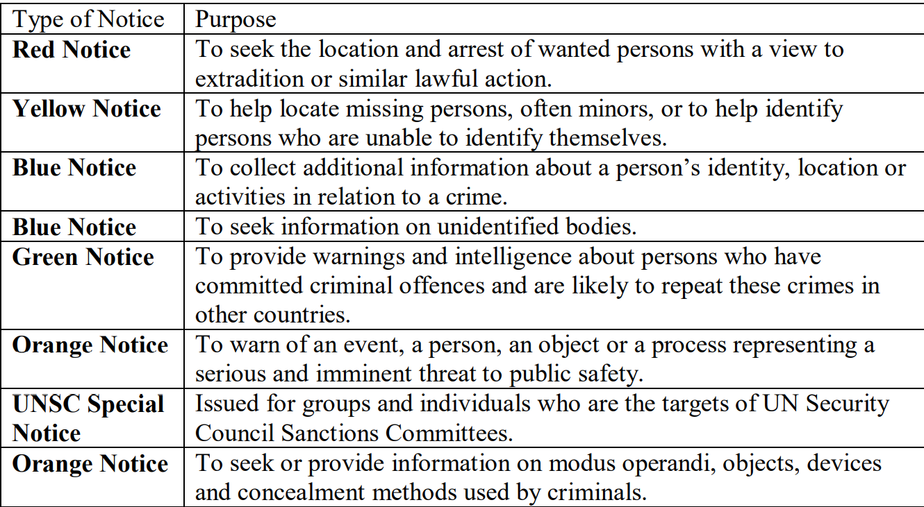

**Rules relating to Red Notice (Mistakenly called ‘Red Warrant’)**

Article 82 and 83 of INTERPOL’S RULES ON THE PROCESSING OF DATA contains provisions on red notice “Article 82: Purpose of red notices Red notices are published at the request of a National Central Bureau or an international entity with powers of investigation and prosecution in criminal matters in order to seek the location of a wanted person and his/her detention, arrest or restriction of movement for the purpose of extradition, surrender, or similar lawful action.”

Article 83: Specific conditions for publication of red notices: (1) Minimum criteria (a) Red notices may be published only if the following cumulative criteria are met: (i) The offence concerned is a serious ordinary-law crime. Red notices may not be published for the following categories of offences: - offences that in various countries raise controversial issues relating to behavioural or cultural norms; - offences relating to family/private matters; - offences originating from a violation of laws or regulations of an administrative nature or deriving from private disputes, unless the criminal activity is aimed at facilitating a serious crime or is suspected of being connected to organized crime.

##### Criticism

1. **Targeting Political Opponents and Dissidents by Dictatorial Regimes** There are number of instances where Interpol issued Red Notices on the request of countries with checkered record of human rights. For instance, Shahram hamyoon, a critic of Iranian Govt who left his home country to settle in USA where he is running a Satellite TV, remains on red notice on the request of Iranian Government.
2. **Questions on Financial Propriety vis a vis Private Partnerships**: Interpol entered in multi million deals with international organizations and multi national companies which have been criticized from certain quarters. Interpol had to cancel its deal with FIFA on account of such concerns. According to politico46 “Interpol’s deal with FIFA is just the tip of a fiscal iceberg. Since 2011, Interpol has signed deals with a large number of private “partners,” including tobacco giants, pharmaceutical firms and tech companies — such as Philip Morris International, Sanofi, and Kaspersky Lab — the proceeds of which have swollen its operational budget by almost a third. This pecuniary relationship between international policing and big business has passed largely below the radar in recent years. Interpol enjoys an unparalleled global reputation, and as a truly international organization has largely escaped sustained journalistic scrutiny, which tends to put stories of national interest first. serious doubts are arising about Interpol’s private sector strategy, which has made the organization financially dependent upon corporate interests”.
3. **Political Cases**: The Article 3 of the Constitution of the Interpol prohibit from taking up political cases, but the organization has on many times issued red notices in such cases.
4. **No defined Process of Appeal**: The appeal against issuance of Red Notice , though can be filed to Commission for Control of Files yet there are no clear cut principles and procedures spelled out on this count.
5. **Abuse of Diffusion system**: The Diffusion system has been subjected to wide criticism for being non-transparent. The person whom the Diffusion has been initiated against is caught unaware and has no remedy to challenge the same.

##### Achievements

From flagging stolen passports used on the missing Malaysia Airlines flight to offering help in locating the kidnapped Nigerian schoolgirls, the organization keeps popping up in the world’s most prominent investigations. All of which raises the question: What exactly has Interpol become, 100 years since it was set in motion? And is its model of international policing succeeding against today’s international criminals?

Rather than creating a new breed of cop with a global beat and a responsibility for international law enforcement, Interpol established a mechanism for helping local police do their local jobs. As the anthropologist Meg Stalcup wrote last year in a fascinating history of the organization, “Interpol was not designed to act as a scaled-up version of local policing.”

In fact, the popular image of Interpol as a global police force chasing down jet-setting rogues with stacks of fake passports is a myth. Interpol officers do not bust down doors to apprehend dashing art thieves. There isn’t any such thing as an Interpol officer, and the people who work for Interpol can’t conduct investigations or make arrests. In the case of the sextortion rings, for example, Filipino cops were the ones hauling off the alleged cyberperps; Interpol just helped them know where to look for the suspects.

Interpol’s key role in that operation, as in others, was as an information clearinghouse. The organization, which is based in Lyon, France, performs this function both by maintaining international criminal databases and facilitating contacts among officers from different national police forces—tasks that have been greatly refined in recent years with advances in communications technology. Whereas Interpol’s big innovation of 1935 was an international radio network for police, today it has “I-24/7,” a secure communications network described as “a bit like a private Internet just for police.” This year, the organization will open a Global Complex for Innovation in Singapore as an R&D headquarters for combating cybercrime. At the lower-tech level, annual general-assembly meetings convene delegates from member countries to vote on policies and resources. Interpol’s National Central Bureaus in each member country serve as contact points among them, with actual law enforcement performed by the relevant national institutions.

It is this built-in notion of sovereignty that leaves Interpol better able than some other international organizations to function amid political tensions among, or even a lack of diplomatic relations between, its members (the U.S. is a member, as are Iran and Cuba). Interpol’s constitution emphasizes that the cooperation it facilitates must take place “within the limits of the laws existing in the different countries and in the spirit of the ‘Universal Declaration of Human Rights.’”

The other edge of this sword, however, is that these constraints limit Interpol’s practical utility. Deflem says that when national law-enforcement agencies do international work—for example, pursuing a fugitive who committed a crime at home and then fled overseas—they often prefer to partner directly with the relevant country rather than involving Interpol. Interpol’s size, he says, limits its value. Its resources—the organization had an operating budget of €70 million ($90 million) in 2012, the bulk of it provided by member countries based on their ability to pay—“are very minimal” compared to those of many local police forces. The entire staff, mostly international civil servants and police on loan from national police forces, is roughly 650 people. For comparison’s sake, the New York City Police Department had a budget of nearly $4.9 billion in fiscal year 2012, and it has about 34,500 uniformed officers.

Even so, Interpol has facilitated major law-enforcement successes, such as an operation last month that rescued 76 suspected child-trafficking victims in Ivory Coast. And one of its main services—issuing “notices” at the request of members to help locate fugitives or missing persons—is now widely used. In 2012, Interpol issued 8,100 Red Notices—notifications for the arrest and possible extradition of wanted persons. That represented a nearly sevenfold increase in the use of such notices since 2002.

But despite Interpol’s constitutional prohibition against “any intervention or activities of a political, military, religious or racial character,” there have been reports that authoritarian regimes are abusing the Red-Notice system in pursuing dissidents overseas. Last November, Fair Trials International published a damning report detailing cases like that of Petr Silaev, a Russian activist arrested and imprisoned in Spain after being slapped with a Red Notice on charges of hooliganism (following months of legal wrangling, Spain ultimately refused to extradite him to Russia). A 2011 investigation found that 28 percent of Interpol Red Notices studied were from countries Freedom House identified as having no civil liberties, and that half were from countries Transparency International ranked among the most corrupt in the world. For his part, Interpol Secretary-General Ronald Noble has maintained that these high-profile cases obscure a low rate of problems; there were 49 official complaints about such notices in 2012. Nor is the system solely a tool of authoritarian governments: “Almost half of wanted subjects currently in our nominal databases are from the European Union,” he wrote last year.

The controversy over Red Notices highlights a central dilemma for Interpol in the post-September 11 and theoretically imminent post-“global war on terrorism” era. For generations prior to 9/11, terrorism of both the domestic and the international variety was perceived and combated as crime (indeed, anarchist terrorism was among the problems spurring Interpol’s formation in the first place). But the political motivations necessary for violence to qualify as terrorist in nature, and the political judgments required for labelling violence as terrorism, would seem to put the crime of terrorism outside Interpol’s constitutional scope.

for example, in 1998, when Osama bin Laden became the subject of a Red Notice for murder, at Libya’s request, four months before al-Qaeda bombed U.S. embassies in Africa. The bin Laden case illustrates both Interpol’s potential and its limitations. As a nexus for information from police organizations all over the world, Interpol is well-positioned to anticipate events—even if doing so inevitably involves entertaining requests from authoritarian countries such as Muammar al-Qaddafi’s Libya. But as an organization that is something short of a “global police force,” Interpol is only as good as its local partners.

##### Pakistan and Interpol

Pakistan became member of ICPC (International Criminal Police Commission) in 1952. National Central Bureau (NCB) of Pakistan was created under the new constitution of ICPO in 1957. It is attached with Federal Investigation Agency since its inception. The Director General FIA is an ex- officio, the Head of NCB-Pakistan.

# Section-IV

## Terrorism and Radicalization

**Radicalism**: A view which advocates extremist measures to achieve socio-political and religious gaols. ‘The phenomenon of people embracing opinions, views and ideas which could lead to acts of terrorism’.(European Union)

Radicalization leading to violence may take diverse forms depending on the context and time period, and may be associated with different causes or ideologies.

**Right-wing extremism**

A form of radicalization associated with fascism, racialism/racism, supremacism and ultranationalism. This form of radicalization is characterized by the violent defence of a racial, ethnic or pseudo-national identity, and is also associated with radical hostility towards state authorities, minorities, immigrants and/or left-wing political groups.

**Politico-religious extremism**

A form of radicalization associated with a political interpretation of religion and the defence, by violent means, of a religious identity perceived to be under attack (via international conflicts, foreign policy, social debates, etc.). Any religion may spawn this type of violent radicalization.

**Left-wing extremism**

A form of radicalization that focuses primarily on anti-capitalist demands and calls for the transformation of political systems considered responsible for producing social inequalities, and that may ultimately employ violent means to further its cause. This category includes anarchist, maoist, trotskyist and marxist–leninist groups that use violence to advocate for their cause.

**Single-issue Extremism**

A form of radicalization essentially motivated by a sole issue. This category includes: radical environmental or animal rights groups, anti-abortion extremists, certain anti-gay/anti-feminist movements, and ultra-individualist or independent extremist movements (such as Free Men on the Land and sovereign citizens) that use violence to promote their causes. Mass murderers whose motivations are partially or wholly ideological may also fall under this category.

Acts of terrorism have been known throughout history The assassination of Julius Caesar on March 15, 44 BCE is considered an act of terrorism. Terrorism became widespread at the end of the Middle Ages, when political leaders were frequently subject to assassination by their enemies.

### Religious roots

The first organized terrorist activities were committed by members of minority religious groups who engaged in violence to (a) gain the right to practice their own form of religion, (b) establish the supremacy of their own religion over others, or (c) meet the requirements of the bloodthirsty gods they worshipped.

In some instances, a conquered people used force and violence to maintain their right to worship in their own aith. Zealots, Hebrew warrior groups, were active during the Roman occupation of Palestine during the first century CE. A subgroup of the Zealots, the Sciari (literally translated as "daggermen"), were so named for the long curved knives they favored as a weapon to assassinate Romans or their sympathizers. The Zealots carried out their attacks in broad daylight, typically with witnesses around, in order to send a message that the Roman authorities and those Jews who collaborated with them would not be safe.

Some religious terrorists want to promote the supremacy of their own sect over a rival group. The (Shi'ite) Muslim Order of the Assassins (assassin literally means "hashisheater," a reference to the commonly held belief that gang members engaged in acts of ritual intoxication and smoked hashish just prior to undertaking their missions) was active in Persia , Syria, and Palestine from 1090 to 1272, killing a great number of their enemies, mainly Sunnis whom they considered apostates, but also Christians who were then the rulers of the kingdom of Jerusalem. 49 The Assassins also were prone to stabbing their victims in an effort to spread their vision of Islam, and carried out missions in public places on holy days in order to publicize their cause. Successful assassinations guaranteed them a place in heaven.

Another form of religious terror is inspired by the requirements of belief. Some religious beliefs have focused on violence, the gods demanding the death of nonbelievers. In India, members of the Thugee cult (from which the modern term thug was derived) were devoted to Kali, the goddess of death and destruction. The thugs believed each murder prevented Kali's arrival for 1,000 years, thus sparing the nation. The thugs traveled in gangs of up to 100 with each member having a defined role-some lured unwary travelers, while others strangled the chosen victim. The gang used secret argot and jargon, which only they could understand, and signs so that members could recognize each other even in the most remote parts of India. Cult members may have killed hundreds of thousands of victims over a 300-year span. They would attach themselves to travelers and when the opportunity arose, strangle them with a noose around their necks, steal their money, and bury their bodies. The killings were highly ritualistic and involved religious rites and prayers. By the mid-nineteenth century the British made it a policy to end Thugee activities, hanged nearly 4,000, and all but eradicated the cult. Thugees represented the last serious religion-inspired terrorist threat until the emergence of Islamic terrorism in the 1980s.

### Political roots

The term terrorist first became popular during the French Revolution. Use of the word terrorism began in 1793 in reference to the Reign of Terror initiated by the revolutionary government during which agents of the Committee of Public Safety and the National Convention were referred to as terrorists. In response, royalists and opponents of the Revolution employed terrorist tactics in resistance to the Revolutionists. The widespread use of the guillotine is an infamous reminder of the revolutionary violence; urban mobs demanded blood, and many government officials and aristocrats were beheaded in gruesome public spectacles. From the fall of the Bastille on July 14, 1789, until July 1794, thousands suspected of counterrevolutionary activity were killed on the guillotine. Here again, the relative nature of political crime is documented: most victims of the French Reign of Terror were revolutionaries who had been denounced by rival factions, whereas thousands of the hated nobility lived in relative tranquility. The end of the terror was signaled by the death of its prime mover, Maximilien Robespierre, on July 28, 1794, as the result of a successful plot to end his rule. He was executed on the same guillotine to which he had sent almost 20,000 people.

In the hundred years following the French Revolution, terrorism continued to be a political tool around the world. Terrorist acts became the preferred method of political action for national groups in the early years of the twentieth century. In Eastern Europe, the Internal Macedonian Revolutionary Organization campaigned against the Turkish government, which controlled its homeland (Macedonia became part of the former Yugoslavia). Similarly, the protest of the Union of Death Society, or Black Hand, against the Austro-Hungarian Empire's control of Serbia led to the group's assassination of Archduke Franz Ferdinand, which started World War I.

Between the World Wars, right-wing terrorism existed in Germany, Spain, and Italy One source of tension, according to author Michael Kellogg, was the virulently anti-Communist exiles who fled Russia after the 1917 Revolution (called White Russians) and took up residence in Germany and other Western nations. According to Kellogg, between 1920 and 1923, Adolf Hitler was deeply influenced by the Aufbau (Reconstruction), the emigres' organization. Members of the Aufbau allied with the Nazis to overthrow the legitimate German government and thwart German communists from seizing power. The White Russians' deep-seated anti-Semitism may have inspired Hitler to go public with his campaign to kill the European Jews, prompting both the Holocaust and the invasion of Russia, which spelled the eventual doom of Hitler and National Socialism.

Since the end of World War II, terrorism has accelerated its development into a major component of contemporary conflict. Primarily in use immediately after the war as a subordinate element of anticolonial insurgencies, it expanded beyond that role. In the service of various ideologies and aspirations, terrorism sometimes supplanted other forms of conflict completely It became a far-reaching weapon capable of effects no less global than the intercontinental bomber or missile. It has also proven to be a significant tool of diplomacy and international power for states inclined to use it.

### Forms

Today the term terrorism encompasses many different behaviours and goals. Some of the more common forms are briefly described here.

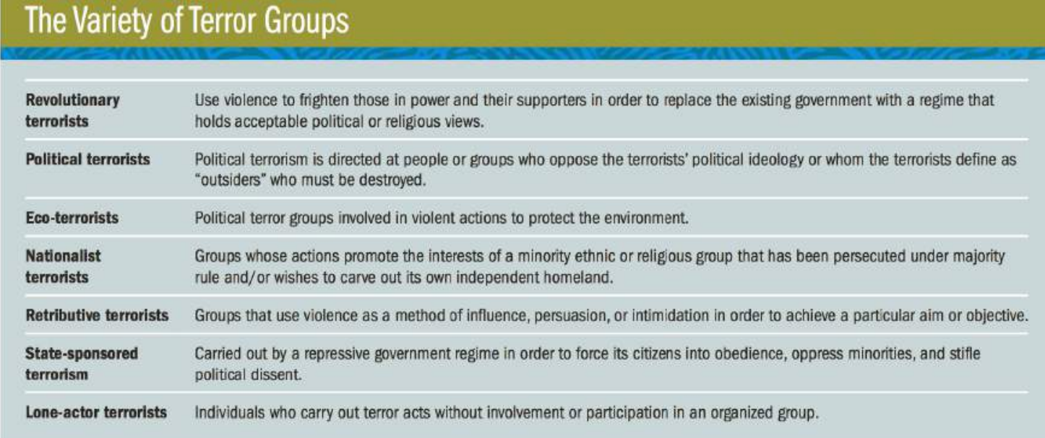

### Motivation

Before terrorism can be effectively fought, controlled, and eradicated, it is important to understand something about the kind of people who become terrorists, what motivates their behaviour, and how their ideas are formed. Unfortunately, this is not an easy task. Terrorism researchers have generally concluded that there is no single personality trait or behaviour pattern that distinguishes the majority of terrorists or sets them apart so they can be easily identified and apprehended. Some seem truly disturbed, whereas many others have not suffered long-term mental illness or displayed sociopathic traits and/or tendencies; if that were so, bizarre or violent behaviour in their early childhood would be a giveaway 71 As such, there have been a number of competing visions of why terrorists engage in criminal activities such as bombings, shootings, and kidnappings to achieve a political end. Four views stand out.

#### Psychological view

One of the most controversial views of terrorists is that some if not all suffer from psychological deficits, and that the typical terrorist can be described as an emotionally disturbed individual who acts out his or her psychoses within the confines of violent groups. According to this view, terrorist violence is not so much a political instrument as an end in itself; it is the result of compulsion or psychopathology Terrorists do what they do because of garden variety emotional problems, including but not limited to self-destructive urges and disturbed emotions combined with problems with authority.

Some terror experts say that the majority of research on terrorists indicates that most are not psychologically abnormal74 Even suicide bombers, a group that should show signs of psychological abnormality, exhibit few signs of the mental problems such as depression that are typically found in people who choose to take their own life. Rather than acting disturbed and disoriented, those terrorists willing to die for their cause display a heightened sense of purpose, group allegiance, and task focus. 75 After carefully reviewing existing evidence on the psychological state of terrorists, mental health expert Randy Borum concludes:

■ Mental illness is not a critical factor in explaining terrorist behaviour. Also, most terrorists are not psychopaths. ■ There is no "terrorist personality," nor is there any accurate profile-psychological or otherwise-of the terrorist. ■ Histories of childhood abuse and trauma and themes of perceived injustice and humiliation often are prominent in terrorist biographies, but do not really help to explain terrorism.

#### Alienation view

Another explanation for terrorist activity is that a lack of opportunity creates a sense of alienation that motivates men and women to embrace terrorism. 77 Regions such as South Asia breed terrorists because they house an incendiary mix of strong ethnic identities and diverse religious communities, many of which are concentrated within exclusionary ghettos. Young men and women residing in these areas are motivated to join terror groups when they feel left out of the social and economic mainstream because of their religious or ethnic status. 78 According to this view, terror recruits suffer alienation from friends, family, and society 79 Many have been raised to hate the groups who are in power and believe that they have been victimized by state authorities whom they view as oppressors.

Terrorism has also become an alternative for people whose religious beliefs alienate them from our postmodern, technological, global society in which foreign influences routinely clash with age-old traditions. They may believe that modern forms of communication, entertainment, and social interaction have brought foreign influences that are corrupting and disrespectful to their traditional way of life. Some may join terror groups whose goal is to eliminate these corrupting external influences-for example , the name of the terrorist group Boko Haram can be translated as "Western education is sin. " Alienation can become so powerful that the terrorist may even believe that a suicide mission will help cleanse them of the corruption of the modern world while at the same time scaring off outsiders.

While at first glance terrorists seem alienated from modern society, when Marc Sageman studied members of extremist Islamist groups he found that most tend to be well educated; about 60 percent had some form of higher education. More than 75 percent came from upper- or middleclass backgrounds. When they joined a terror organization, the majority had professional occupations such as doctor or engineer, or semiskilled employment, such as a civil servant; fewer than 25 percent were unemployed or working in unskilled jobs. Surprisingly, Sageman found that almost three-quarters were married and that most had children. 80 These findings suggest that terrorists are not suffering from the social problems usually associated with alienation: poverty, lack of education, and ignorance.

#### Socialization/friendship view

Many jihadist recruits were living in foreign countries when they got involved with terrorist organizations. Feeling homesick, they sought out people with similar backgrounds, whom they would often find at mosques. If they appeared to be motivated by religious fervor, it was because they were seeking friends in a foreign land. They moved in together in order to share the rent and also to eat together under strict Muslim dietary laws. The group solidified their beliefs and created a sense of solidarity with like-minded people. If one became committed to terror, others may follow rather than let him down.

#### Ideological view

Another view is that terrorists hold extreme ideological beliefs that prompt their behaviour. They may have developed heightened perceptions of oppressive conditions, believing they are being victimized by some group or government for their beliefs or way of life. Once they conclude that the government will not help people with their beliefs, they decide to resort to violence to encourage change. Facilitating the use of violence is the ability to divide people based on religious, ethnic, racial, or other cultural criteria into two categories: those with common interests and beliefs who are avenged through terrorist activities ("us") and those against whom the terrorist activities are to be directed ("them"). Those associated with "us" are viewed as moral, right, good, and strong. Those associated with "them" are seen as immoral, wrong, bad, and weak. 85 Once this division is made, the terrorist can act with impunity to further their ideological beliefs because those harmed have beliefs that make them less than human.

##### Religious fanaticism

Some terrorists, like the Tsarnaev brothers, are motivated by extreme religious beliefs, which often coincide with their ideological views. But how can they justify using violence if they are truly religious, since most of the world's religions eschew violence? Islamic terrorists believe that their commitment to God justifies their extreme actions. They regard the actions of people they trust as a testimony to the righteousness of their acts. They trust significant others, and rely on their wisdom, experience, and testimony and accept their expressions of faith. To the terrorist, someone like Osama bin Laden has demonstrated the strength of his faith by living in poverty and giving up a more luxurious and leisurely life in the name of God. When he calls them to jihad, they are likely to follow, even if it means killing those who deny their faith or beliefs. Perceived miracles, such as the defeat of a superpower through faith alone (e.g., the SovietJAfghan war or the fight against the United States in Iraq), also increase confidence in the righteousness of the cause. Some have mystical experiences during prayers or dreams that demonstrate the existence of God and reinforce faith. In a videotape in the fall of 2001, Osama bin Laden said that he had banned the reporting of dreams of airplanes flying into buildings prior to September 11 for fear of revealing the plot.

#### Why State-sponsored terrorism?

How can state-sponsored terrorism be explained? After all, these violent acts are not directed at a foreign government or overseas adversaries but against natives of one's own country. In her book Reigns of Terror, Patricia Marchak finds that people willing to kill or maim their fellow countrymen are likely to be highly susceptible to unquestioning submission to authority. They are conformists who want to be part of the central group and who are quite willing to be part of a state regime. They are vulnerable to ideology that dehumanizes their targets and can utilize propaganda to distance themselves psychologically from those they are terrorizing. 87 So the Nazis had little trouble recruiting people to carry out horrific acts during the Holocaust because many Germans wanted to be part of the popular social/political movement and were easily indoctrinated by the Nazi propaganda that branded Jews as subhuman. Stalin was able to carry out his reign ofterror in Russia because his victims were viewed as state enemies who were trying to undermine the Communist regime. How can these tendencies be neutralized? Marchak sees little benefit to international intervention that results in after-the-fact punishment of the perpetrators, a course of action that was attempted in the former Yugoslavia after death squads had performed "ethnic cleansing" of undesirables. Instead she argues for a prevention strategy that involves international aid and economic development by industrialized nations to those in the Third World that are on the verge of becoming collapsed states, the construction of social welfare systems, and the acceptance of international legal norms and standards of human rights.

### Causes of Terrorism and Radicalization in pak

Socio Economic (Social Injustice, Under development, Poverty, illiteracy, food insecurity, unemployment, Governance Deficit etc) Political (Instability, religion based politics, Law enforcement) Religious( persecution of Kashmiris and Palestinians gives justification, Intolerance, Distortion of Islamic injunctions etc) External causes ( WOT, Soviet War, Iranian Revolution, Rise of Alqaida , Daesh etc)

Sialkot incident: The state’s policy of appeasement and in some cases using religion out of political expediency has contributed hugely to the rise of violent extremism. It’s the weaponisation of faith that has been the main reason for the spread of such brutality in society.

Falsely accused of blasphemy, Mashal Khan was beaten and shot to death because of his views. there is hardly any talk about how a Christian couple was thrown alive into a furnace on baseless charges of blasphemy.

This culture of violence and rising religious intolerance cannot be attributed to emotions running high among young people as per Khattak. Religious extremism is entrenched so deeply that it threatens to rip apart the entire social fabric. Downplaying the seriousness of this societal disease will lead to greater disaster.

The situation of terrorism in the world right now is quite complex and exhaustive, particularly in Pakistan. Whether it is the Safora Ghot Karachi massacre2 or the murder of Sabeen Mahmud3 or the case of medical student Noreen Leghari4 (who was indoctrinated by the Islamic State [IS]), the unabated truth that needs to be realized by Pakistani counter-terrorism strategists and policy-makers is that the extremists and terrorists have infiltrated Pakistan’s modern educational institutions and they are indoctrinating the youth with their delusional ideologies.

Pakistani society was mainly radicalized during the Afghan Jihad against the Soviet invasion the in 1980s and 1990s. The youth of Pakistan was one of the prime victims of this radicalization.

According to the experts of terrorism studies such as Dr. Khurram Iqbal, “the current trend of increased radicalization in educated youth in Pakistan has much to do with the extremist’s narrative which is based on certain religious and political beliefs that shapes an individual’s convictions and motivates him/her to become radicalized and ultimately resort to violent activities.”

Causes of radicalization of the educated youth in Pakistan need to be inquired at the micro-level along with meso and macro-levels as well. The levels are best explained by experts as follows:

1. Micro-level, i.e. the individual level, involving e.g. identity problems, failed integration, feelings of alienation, marginalization, discrimination, relative deprivation, humiliation (direct or by proxy), stigmatization and rejection, often combined with moral outrage and feelings of (vicarious) revenge;

2. Meso-level, i.e. the wider radical milieu – the supportive or even complicit social surround – which serves as a rallying point and is the ‘missing link’ with the terrorists’ broader constituency or reference group that is aggrieved and suffering injustices which, in turn, can radicalize parts of a youth cohort and lead to the formation of terrorist organizations;

3. Macro-level, i.e. role of government and society at home and abroad, the radicalization of public opinion and party politics, tense majority-minority relationships, especially when it comes to foreign diasporas, and the role of lacking socio-economic opportunities for whole sectors of society which leads to mobilization and radicalization of the discontented, some of which might take the form of terrorism.

The first approach, micro-level, deals mainly with how ‘vulnerable’ youth in the Pakistani society (often 1980s, 1990s and early 2000s generations and/or students) are brainwashed and convinced by the terrorist propaganda or recruiters, ideologically and psychologically.10 The second approach focuses on the proceedings and influences of the enabling environment – the **radical milieu** – or an outfit or organization which offers them amenable atmosphere to conjoin the pleasures of adventure, the satisfaction of comradeship within brotherhood or opportunity to achieve martyrdom. The third level of analysis deals with actions of a government domestically and abroad and respective society’s interaction and relationship with members of minorities in that society, especially diaspora migrants, who face the dilemma of being caught between two different cultures, leading some to embark on the path of rebelling against the very society that hosts them.

In the first level of analysis, a Pakistani educated youth in the contemporary times is facing severe identity problems as the Pakistani society is divided not only along socio-economic and political lines but also on the basis of class, ethnicity, sect and language as well. The decline in the concept of the combined family system in Pakistan (where family cohesion was strong and all members were part of a larger group) and failure of integration (as a nation in particular) has led to the feelings of alienation and relative deprivation of educated youth in Pakistan. Many a Pakistani educated youth, feeling stigmatized and rejected in such a segmented environment often harbour feelings of moral outrage and revenge which makes them a prime and easy target for radicalization.

Building upon the first level of analysis (micro-level), and in the second level of analysis, the alienated, frustrated, outraged educated Pakistani youth is looking for something to relate to. They are in a constant struggle for identity and desperate to achieve the feeling of belonging to something larger than their own self. Given the presence of an extremist infrastructure, the impeccable organizational discipline and widespread social networks of Islamic, political and militant outfits operating in Pakistan, the educated youth easily gravitate towards radicalization power-houses who not only provide these individuals with a purpose (no matter how distorted or demented), a group to affiliate with and a sense of belonging to something larger than life itself (such as martyrdom for a greater ‘good’).

On the macro-level, which is the third level of analysis, the Pakistani educated youth is even more vulnerable to being radicalized at this level. Given the political instability, the myopic government policies at home, and the negative influence of external actors (such as the US and India in this context), combined with petty party-politics and tense majority-minority relationship in the country, leads to the discontent of the educated youth of the Pakistani society. This increases their chances of being radicalized and fall prey to the ideologies of the terrorist outfits (which offer a relatively different alternative to the prevailing circumstances).

According to Dr. Moeed, education is one of the strongest enablers for radicalization in the educated youth of Pakistan since Pakistani textbooks (under the conscious effort to promote religion as the prime identity of the country) underwent an Islamized transformation. Dr. Moeed also states that: “Pakistan’s educational system has evolved into a fairly rigidly stratified one: the three school systems – elite private schools, public schools and non-elite private schools, and the deeni madaris (religious seminaries), provide distinct type of environments, teaching experience, and exposure, potentially creating fresh fault lines among the youth.

It is high time for Pakistani policy-makers to re-think and reformulate the education policy of Pakistan and devise a neutral curriculum that is in sync with the local norms and values and fulfils the international quality standards.

### Measure to control radicalization

Others: Our universities and research institutes should take up the intellectual task of re-interpreting the Islamic injunctions in the light of modern knowledge and 21st century challenges (with emphasis on social justice). In order to fight terrorism, Pakistan’s media should play a key role. It must point out the criminal activities of the militants like hostage-taking, killing of the innocent people?

There is a need for a national narrative that not only acts as a cohesive force that will help unite the Pakistani masses as one nation but will also be a strong and effective counter to the terrorist and radical ideologies that are prevalent in the country today.

A cohesive, moderate, and progressive national narrative that Pakistan desperately needs should be constructed keeping Pakistan’s cultural, historical and religious ethos in mind.

The Government of Pakistan did embark on a path of constructing an effective counter terrorism strategy under the National Counter Terrorism Authority (NACTA) and submitted a National Narrative document to the Government of Pakistan.

Moving beyond the formulation process of a strong national narrative of Pakistan, the effective communication of the national narrative to the Pakistani masses, especially the educated youth of Pakistan, could produce results. One of the most consequential impacts could be a single education system. Unified education policy needs to be implemented across all the educational institutes of the country, from schools and colleges to universities. A unified education system and policy will ensure the same level and quality of knowledge. The unanimity thus created would help reduce the feelings of alienation, marginalization, and misunderstanding among students belonging to different strata of society. Furthermore, a unified education system and a coherent national narrative will ensure that the entire student body of Pakistan is on the same page regarding the national narrative apropos violence and Pakistan’s standing in the world by the elimination of the biases in the curriculum that are well known.

The efficacy of a unified education system in Pakistan to achieve the desired results would rest on the proper dissemination of knowledge of the revised and improved curriculum in all education institutes. Nevertheless, the national narrative of the country, which would act as an element of cohesion and as a counter narrative of the terrorist elements which are radicalizing the educated youth, would mainly rest on the efficiency of good and credible "messengers." Messengers in this context are the teachers, professors and instructors who will be responsible for imparting the knowledge about the curriculum and the national narrative to the students in the educational institutions across the country.

Hence, the selection and training of the speakers who will deliver the "message" to the "target audience" would lie with the Government of Pakistan. The government will need to ensure the selection and training of the appropriate personnel in order to establish their proficiency in delivering the national narrative to counter the narrative of extremism and terrorism. Only then the consequent results could be referred to as desirable. It is also imperative to ascertain that the messengers have strong credibility among the target audience (the educated youth) of Pakistan, so that the message could have the worth and acceptance. Without the credibility of the messenger/speaker, the message will be ineffective and the desired results cannot be achieved.

This strategy can be extended to religious seminaries in Pakistan as well as the de-radicalization camps across the country. However, the first and foremost task should be the formulation of a strong, cohesive, coherent, and progressive national narrative of Pakistan. Unless there is a strong national narrative, all other strategies that will be implemented will have temporary or no effect at all.

By using the tools of print, electronic and social media, the Pakistani youth can be reached and delivered the message. A media campaign should be launched, disseminating the knowledge about the national narrative of Pakistan and the distorted view of the elements spreading radicalization among the youth

The government should invest in a young cohort of religious scholars who will also be experts in the conventional fields of knowledge such as social sciences, management sciences and natural sciences. These experts will produce neutral and progressive 'messages' about Islam and Pakistan's national narrative which will help in countering the growing radicalization trend among the educated youth. Similarly, they can be used as 'credible' messengers as well.

Formal training of the local mosques’ Imams, who are the teachers at the religious seminaries, should also be done by the government. Local research think tanks and research institutes should be used and encouraged by the government to produce and spread knowledge and create awareness about the distorted views of the elements spreading radicalization.

Learning from international best practices would also be extremely beneficial for Pakistan and aid in improving Pakistan's status and image internationally. Seminars, conventions, and conferences should be arranged that will help project Pakistan's national narrative among the Pakistani expatriates as well as the international community.

### Role of LEAs in the control of terrorism

Pakistan has done its level best to rid terrorism and terrorists from its soil. In first step, many terrorist organisations were banned by the Musharraf government. After those successful military operations namely Rah-e-Nijat and Rah-e-Rast have been conducted. Pakistan army has fought bravely against terrorist and has destroyed their safe dens. It has broken the backbone of the terrorists and has forced them to flee. These operations still keep ongoing in some tribal areas. In this context, it is worth-mentioning that public support to military operations is very essential, and without people’s backing no army can win this ‘different war’ against terrorism.

Operation Zarb-e-Azb, on the one hand, highlights the obliteration of targets through ground operations and air force/ army aviation campaigns, it brings to light also the importance of intelligence planning based on information gathered through ground, technical and human sources through the analyses of reports about the preparation of weapons, their use and other technical aspects, on the other. In all parts of the world, better, and timely, availability of intelligence information is required not only by the militaries but the governments, too, as they cannot draw up defence and economic policies unless they have before them the reports on the factors that may affect those. In war against terrorism, the first and foremost requirement is to collect the beforehand information of enemy’s plans through a consolidated, effective intelligence system. It is an undeniable fact that war against terrorism cannot be decidedly won unless the government, security forces and law-enforcement agencies are well aware of the organizational structure of terrorist groups, their methods of attacks, financial sources and foreign funding and also of their facilitators in the civil populace of the country. A cursory glance at history reveals that in any war, the self-created regional, religious and linguistic beliefs of miscreant elements and organizations within a country do have some sort of support or backing, in men and money, by some external groups or foreign intelligence agencies. In such a war, the enemy sponsors the elements which it can later use to cause chaos and upheaval in order to destabilize the state.

Terrorist attacks at the start of the year 2016 highlighted the flaws and shortcomings in our intelligencegathering system that is responsible for our failure in penetrating into the groups behind these attacks. At present, the task of intelligence-gathering is being performed under the umbrella of Pakistan army by Inter-Services Intelligence (ISI), Military Intelligence (MI), and to some extent, Pakistan Rangers. On the civilian side, the provincial governments have assigned this task to Counter Terrorism Departments (CTDs), Special Investigation Units (SIUs) and to some sections of the Intelligence Bureau (IB).

Although interception of telecommunications forms a major part of intelligence-gathering through technical sources, which is necessary for effective action against terrorists and state enemies, yet a brief analysis would prove that the technical sources our agencies have currently at their disposal are too meagre. Satellite images play a key role in locating the hideouts and movements of the terrorists, but even for this, we have to rely on CIA’s satellite system. It’s a great hindrance to timely availability of information; and the pieces of information we get from this source also often doesn’t come within the ambit of our requirements. For example, we need to permanently have a keen eye on terrorists’ hideouts in Afghanistan as well as their activities. But, we are facing numerous problems in this regard as well. Given all these obstacles, we need to incorporate the latest sophisticated technology in our intelligence infrastructure in order to develop a highly secretive system wherein, besides military and civilian intelligence agencies, representatives and resources of FIA’s highly-equipped cybercrime wing, customs intelligence, Ministry of Science and Technology and Suparco are consolidated at one platform to strive for a unified purpose.

In war against terrorism, cooperation and coordination among agencies and law-enforcement institutions is indispensable. But, at present, unfortunately, there exists no mechanism whereby intelligence agencies and the enforcement institutions could exchange their information for timely identification of threats and neutralising those thereupon. Currently, every agency is making a solo flight in order to prove its worth and effectiveness. Although, coordination meetings are arranged every now and then; they prove merely a damp squib as the proceedings of the meetings remain limited to the own personal gossip of the attendees.

#### Effectiveness of intelligence

The effectiveness of Pakistan‟s counter terrorism apparatus has an objective measurement in the form of number of terrorist attacks experienced throughout the country. Lately, a downward trend has been witnessed i.e less than 800 attacks per year (785 in 2016 and 681 in 20172 ) as compared to 2,061 attacks reported in 2010. Kinetic Operations provided the framework and initial experience of Intelligence Based Operations (IBOs) through an Integrated Security Apparatus(ISA).It consists of local police in the front line as the first line of defence, to be assisted by paramilitary forces (Rangers/ Frontier Corps)as the second line of defence and Pakistan Army as the last resort reserve force. As of 31st December 2017, a total of 12,859 IBOs had been carried out across Pakistan. Increased public security is directly attributable to surge in IBOs, which effectively prevent manifestation of terrorist threats. IBOs also serve as an indicator of effectiveness of Pakistan‟s operational CT paradigm. Development, evolution, improvement and perfection of entire CT operations paradigm is responsible for the fivefold increase in IBOs from 2016 to 2017. The experiences of these kinetic measures and the lessons learned from operations in North Waziristan, were thereafter extended to the entire country in February 2017. IBOs and kinetic operations are undertaken wherever required across Pakistan to root out terrorist operatives and sleeper cells. IBOs are complemented by Combing Operations which provide the fundamental basis for clearance of areas where terrorists were attempting to operate / attack targets. Other hard components to improve the effectiveness of the intelligence mechanism against terrorists (particularly) include strengthening of NACTA, Capacity Building of LEAs, and establishment of dedicated Counter Terrorism Forces (CTFs) at the provincial level. To complement kinetic CT measures, Non-Kinetic Measures (soft component) have also been instituted in order to consolidate the gains achieved and to deal with threats such as extremism, sectarianism, radicalization, and other factors contributing to terrorism and lawlessness.

The first National Internal Security Policy (NISP) of Pakistan was formulated in 2014, and was effective till 2018; subsequently, the second NISP (2018-2023)3 has been instituted. The National Action Plan (NAP 2014) was formulated after the ghastly terrorist attack on the Army Public School at Peshawar on 16th December 2014, in which over 150 students and faculty members lost their lives. Objective of the NAP was to provide overall direction to the national Counter Terrorism effort in the country and to ensure that the whole political and military leadership and the citizens of the country (whole of the government and society approach) join in to uproot terrorism in all its forms. The NAP had both counter terrorism and counter violent extremism components. Such holistic reforms can empower state structure to combat threats posed by terrorists in both kinetic and non-kinetic dimensions. These transformations will modernize the state, make it more effective in terms of public service delivery and more sensitive to the needs of its citizenry, thus neutralizing many enticing aspects ofand many propaganda tools used by it. Current system of intelligence is marred with problems and that is the reason why despite efforts, it is not as successful against terror network as it should have been. There have been major intelligence successes and a significant number of attacks preempted and terrorists neutralised. It can be significantly improved. Some of the issues are listed as follows:

#### Issues

Efforts to strengthen the civilian CT agency, NACTAwere not made inearnest. The mandated meeting of the Board of Governors (BoG) of NACTA has not been convened even once during the last 5 years. The premier intelligence sharing and dissemination agency, NACTA‟s Joint Intelligence Directorateis still non-functional. NISPs largely remain unimplemented and implementation of NAP after the initial efforts, too is a forgotten document.

Pakistan is marred with acute bureaucratic lethargy. Ministries and departments do not talk to each other and decisions are not taken. Some important ministries are mockingly called as the black-holes. This is seriously hampering system‟s progression. While funding for NACTA are allocated in the budget, these are not released on time resulting in hopeless delays in improving efficiency.

There are serious turf issues between the top intelligence agencies. There is some level of cooperation at the tactical level, the same is lacking at the strategic level. Interagency rivalries are nothing new as long as the competition is healthy. Intelligence agencies look at each other with suspicion to the extent of undermining each other. This is an issue of grave concern, more so as there is hardly any attempt to address it.

There is no mechanism of intelligence fusion. NACTA receives intelligence primarily from two sources (ISI & IB) whereas provincial CTDs and Special Branches generally share intelligence at the provincial level. At NACTA, there is at present no system whereby intelligence from different sources is compared to confirm its authenticity, is analysed and then shared with security forces. NACTA is at present more of a post office where every piece of intelligence received is forwarded to everyone thus inundating law enforcement leadership with raw intelligence.

As there is no intelligence fusion system and there is a continuous stream of intelligence, LEA officials do not pay heed to Threat Alerts received by them. Ignoring threat alerts have proved to be disastrous at times, resulting in loss of precious lives. Even in cases where intelligence agencies were able to provide precise and accurate intelligence, in certain cases attacks have been carried out by terrorists.

#### Way forward

Let the military and paramilitary forces continue with the kinetic measures and the civilian must be tasked to take charge of the soft components of the struggle.

Information sharing on Terrorism and Extremism should not only be at the tactical level but more importantly at the strategic level.

There should be sharing of working procedure between the intelligence agencies. Currently, intelligence agencies in Pakistan guard their assets, working procedures from their own agencies.

NACTA‟s JID must be operationalised on war footings. Culture of the top intelligence agencies at the strategic level must be changed through reforms aimed at improving intelligence sharing and dissemination mechanisms.

Hardly any analysis of intelligence gathered or shared is carried out. Intelligence is gathered, shared and forgotten about. Same is generally the fate of threat alerts issued. It is imperative that a thorough and scientific analysis of all intelligence gathered is carried out to predict trends, terrorism hotspots, organisations involved in terrorism are mapped and recommendations prepared for policy makers. - JID is supposed to carryout all these tasks, which is currently non-functional and chances of its becoming so are slim even now.

A system of accountability for the security agencies as well as intelligence agencies needs to be put in place. Intelligence agencies should be questioned about accuracy and authenticity of the intelligence provided and security agencies should be taken to task for not heeding terrorist attack alerts.

Pakistan needs to completely overhaul its intelligence sharing protocols. Whereas intelligence collection system in place is effective, it is the dissemination, analysis and sharing that is defeating the whole raison d'être of the intelligence network in the country.

### Role of parliament

Institutions play an important role in the development of a state as well as the state behaviour. The Parliament of Pakistanis the highest forum of debating national issues that relate to both domestic and international politics. The War on Terror (WoT) added to the significance and responsibilities of the Parliament as it triggered several challenges to national security and economy. However, unlike the legislatures of the developed states, the Parliament of Pakistan could play a limited role in shaping the course of action with regard to the WoT. On some occasions it asserted the public opinion while on some occasions it remained inactive and hence could not represent the sentiments of people properly. Parliament’s role in the WoT has been fragile or vulnerable, over the last almost two decades, in deciding terms and conditions with the foreign states especially with the United States in the on-going WoT.Generally, policy matters regarding war on terror in Pakistan have been formulated by the security establishment. Lack of consensus among its members has been one of the main causes of minimizing the role Parliament in this vital issue of national security.

**Law making** process in Pakistan Parliament is weak and slow. It is not only weak in law making but the implementation of existing laws is also disappointing. In the context of WoT, the Parliament just passed a few laws in the last fifteen years. Pakistan’s first counter terrorism legislation was introduced in 1993 as the Anti-Terrorism Act (ATA) and was passed in 1997, establishing the Anti-Terrorism Courts in the country. This Act was criticized by the civil society on the basis of violation of human rights by its legal and investigation process.

a new intelligence agency was established in the name of **National Counter Terrorism Agency** (NACTA) in 2011. Its main purpose was to coordinate the efforts and working of more than dozens of intelligence agencies in Pakistan on one platform. However, it is disappointing that after more than five years, it still is not functional and operative due to lack of sufficient financial resources and seriousness of the leadership in the country on one hand, and due to lack of coordination among the different security agencies on the other. Only after the Peshawar school tragedy in December 2014, it was decided in the **National Action Plan** (NAP) that the NACTA should be strengthened and functional. Soon after the Army Public School killing of more than one hundred students by the terrorists, a comprehensive action plan was introduced. The National Action Plan which consists of twenty points of action which surrounded all the important matters related to terrorism. In the Parliament after the long time, **the 21st Constitutional Amendment** was passed which paved the way for the establishment of military courts to try the people who are involved in the terror activities(Amin, 2015).This was the most important contribution of the Parliament to chalk out a legal process which could curtail the activities of terrorists in the country.A **National Security Council** (NSC) was created by Pervaiz Musharraf in 2004 to discuss the security related issues bypassing the Parliament role in such important matters. It did not function well till 2008 when the new government established the **Defense Committee of the Cabinet** (DCC) which fulfilled the role and purpose of the NSC. The DCC became the **Cabinet Committee on National Security** since 2013. There are also other committees of the Parliament which are working on the national security and defense related matters. These are Standing Committee on Defense and Defense Production, Parliamentary Committee on National Security, Standing Committee on Defense, and Public Accounts Committee. These committees give input and suggestions to the Parliament on important national issues. In the Parliament, there have been debates and constructive engagement among the Parliamentarians. An enquiry commission was established after the **Abbottabad incident** on May 02, 2011 which shocked every Pakistani and demoralized the state institutions. The establishment of such commission on national security related matters is a positive step in Pakistan. Such commission proved in pinpointing gray areas in security, made responsible the person or institution for failure to defend the state and give suggestions to the government for future actions.

Resolutions are the reflections of the opinion of the representatives of the people. There are two kinds of resolutions; majority and consensus or unanimous resolution. The resolutions passed with majority of votes in the Parliament are not binding on the government to enforce them but have a positive sign in the debates of the Assembly. The unanimous or consensus resolutions were those on which the government was bound to work or implement them in letter and spirit. The Resolutions reflected the sentiments of the honorable members’ views and ultimately of the people of Pakistan. The resolutions which were passed related to terrorism concerning the people and their leaders, on the one hand, and to chalk out a policy, on the other. The first resolution which was unanimously passed in the National Assembly of Pakistan regarding terrorism was in November 2003. The House condemns the terrorist act of bombing in Riyadh, Saudi Arabia, as a result of which about twenty one persons were killed and several injured. The House also condemns the killing of all Pakistanis and the foreigners through act of terrorism and sends its profound condolences to the bereaved families here in Pakistan and in the world.

The unanimous resolutions of the Parliament are binding on the government to implement them but they never did that because there was a lack of consensus between the government and military leadership on the strategy to resolve the issue of terrorism. There was also a lack of unanimity among the political parties too.

### Women militancy

https://www.dawn.com/news/1664100/women-militancy

### Violent Extremism

Note: Countering Violent Extremism is a solution in hindsight to counter terrorism.

Violent extremism (VE) is a multifaceted phenomenon that undermines peace, security, human rights, and sustainable development. Misinterpretation of religion, weak rule of law, ungoverned or poorly governed areas, poverty, unemployment and unfair resource distribution, social marginalisation and political disengagement are push factors; the promise of empowerment and revolutionary change, implementation of Shariah, Islamic political system and jihad are pull factors.

Owing to statistical quantification, CT gets instant attention of the ruling elite, bureaucracy, media, and public. It is easy to quantify the number of operations, arrests, killings, recovery of ammunition, weapons, and explosives. However, CVE is a long-term, non-coercive and difficult to quantify endeavour to reduce space for violent extremists and make it difficult for them to attract volunteers. A proportion of existing funds dedicated for CT needs to be allocated for CVE while departments like education, health and social welfare should be provided funds for CVE.

A CVE policy needs to be based on a diagnostic approach: it needs to uncover why extremists see joining such a bandwagon as an aspirational social act and why, despite low educational credentials, the majority of them desire to reshape the world.

Traditionally, extremist organisations preferred to reach out to the youth but now women are also their priority. Women are disproportionately affected by conflicts. Their extreme social exclusion and victimisation in patriarchal societies create incentives for some women to seek power and mobility by aligning with extremist organisations. The role of women as social influencers and agents of change in stabilising communities and preventing extremism needs rethinking.

Encrypted communication facilitates extremists to strengthen networking, seek finances and build capacity. Administrative reforms and policing cyberspace should therefore be accorded top priority.

Violent extremists effectively utilised ideology and technology to their advantage. However, countries are yet to use technology to the optimum level in countering VE. Through technology, public awareness can be created about the techniques of extremists regarding recruitment, funding, propaganda and facilitation. The recent establishment of an outreach branch by the National Counter Terrorism Authority (Nacta) will strengthen CVE efforts with the help of the community.

A fair understanding of CVE dynamics requires credible research. That is not possible without collaboration between LEAs, including CTDs, and universities. The Higher Education Commission needs to encourage CVE research. Section 4 of the Nacta Act mandated Nacta to collaborate research in the fields of CVE and CT. The signing of a letter of intent between Nacta and HEC and an MOU between Nacta and the Higher Educ­ation Regula­tory Aut­h­ority KP are practical manifestations of the Nacta law.

The National Counter Extremism Policy Guidelines (NCEPG) drafted by Nacta, is in the CVE domain. An outcome of 24 rounds of discussions with 305 stakeholders, the NCEPG cover 50 points primarily focusing on six areas including rule of law and service delivery, citizen engagement, media engagement, integrated education reforms, reformation, rehabilitation, reintegration, renunciation and promotion of culture. It is imperative upon all stakeholders including civil society, federal and provincial governments to convert these guidelines into reality.

## Media’s representation of crime and criminal justice system

**Negative Role**: Negative attitude on behaviours and attitudes thereby prompting criminal tendencies (Imitation, Desensitization, Transmission of knowledge on Criminal tools and techniques, Temptations for undesirables, Portraying incompetence of police)

**Positive Role**: (Awareness, Counseling, Promotion of compliant behaviours, Negative Portrayal of Criminals)

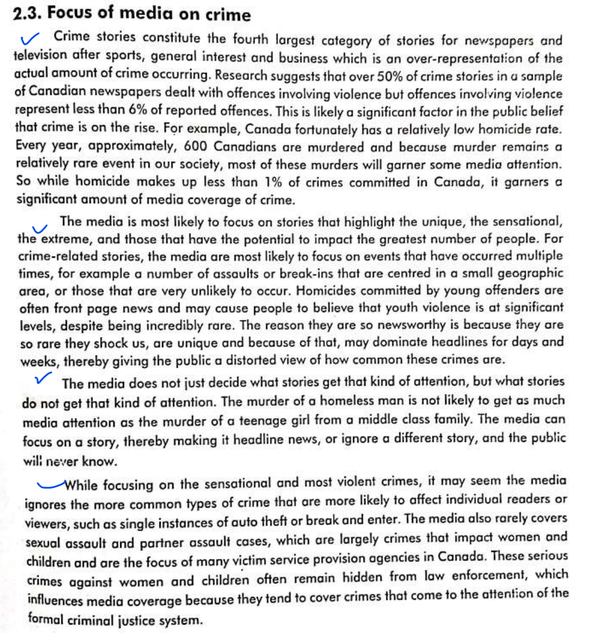

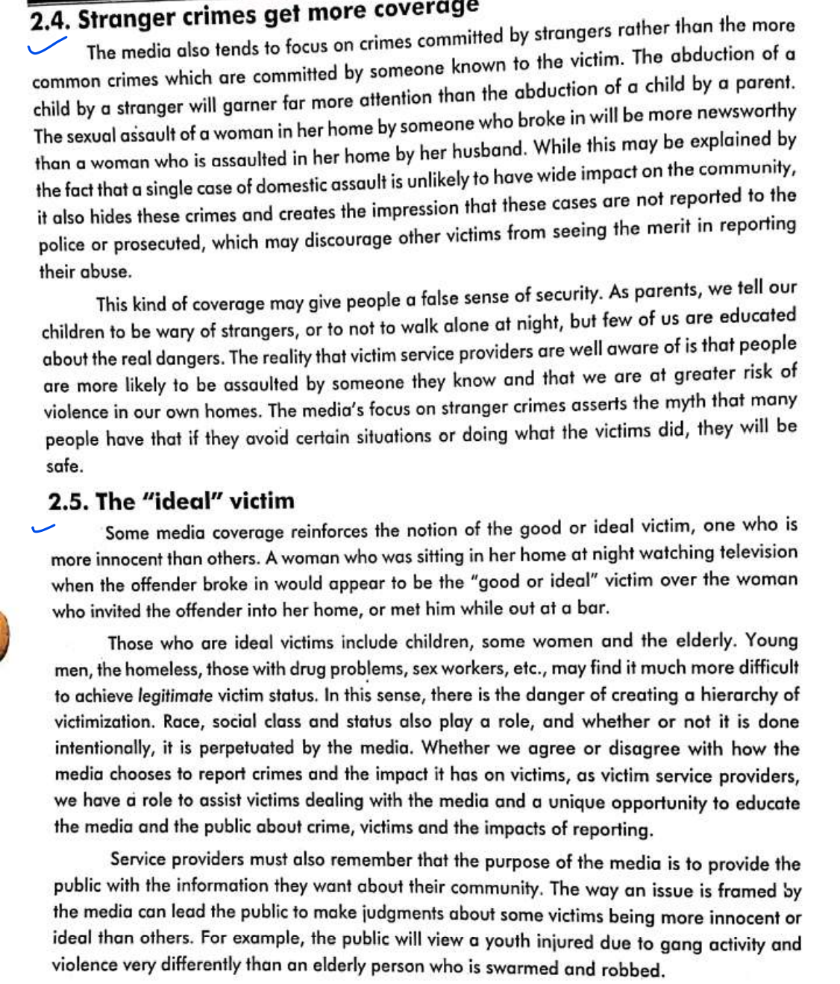

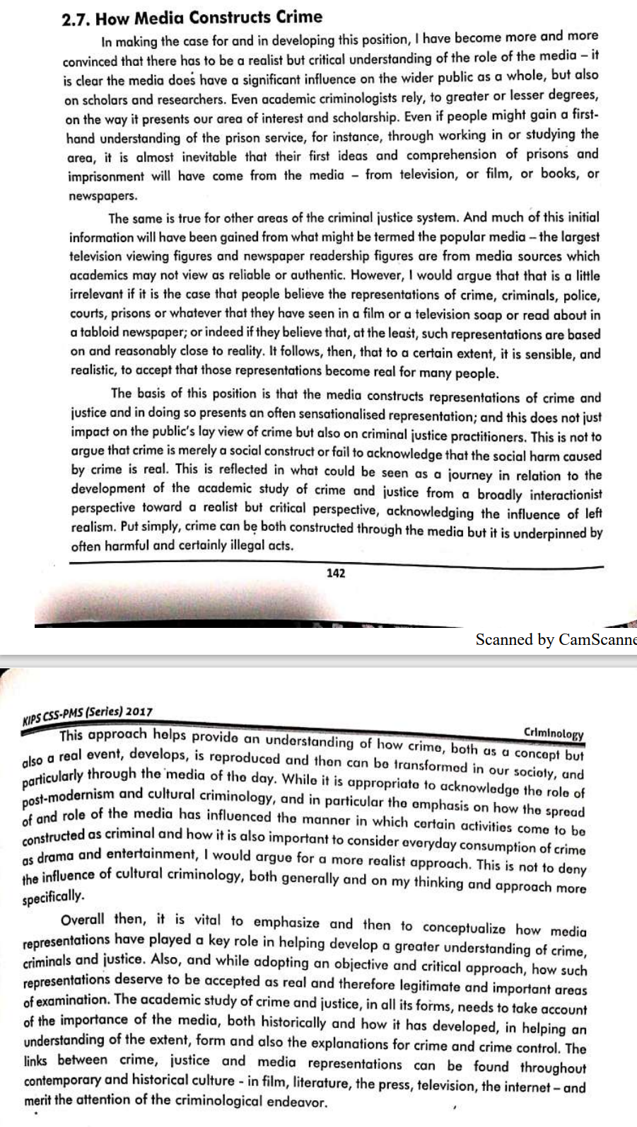

### Terrorism and Media

Recent history, specifically the past decade, has provided plenty of examples of the mutually beneficial relationship between terrorist organizations and the media (Rohner and Frey 2007). As some remarkable terrorist attacks in history indicate, whether it is in the United States (US), Europe, or the Middle East, it is by and large the case that the architects of terrorism exploit the media for the benefit of their operational efficiency, information gathering, recruitment, fund raising, and propaganda schemes (Nacos 2006). In the words of Nacos (2002), whether it is the relatively inconsequential arson by an amateurish environmental group or mass destruction by a network of terrorists, the perpetrators’ media-related goals are the same: attention, recognition, and perhaps even a degree of respectability and legitimacy in their various publics (Nacos 2002a). Media, in return, receives the attention of the public that is vital for its existence and benefits from record sales and huge audiences. To put it briefly, just as terrorism has to be communicated to have effect (Seib and Janbek 2011), the media has to cover the incidents in such a way to benefit from the public’s eagerness to obtain information about terrorist attacks. It is, therefore, fair to argue that there is a mutually beneficial relationship between terrorism and today’s media.

“without the media’s coverage, the act’s impact is arguably wasted, remaining narrowly confined to the immediate victim(s) of the attack, rather than reaching the wider ‘target audience’ at whom the terrorists’ violence is actually aimed.” In a similar vein, Stohl (in Staci, Bennett, and Flickinger 2002) argues that terrorists are primarily interested in audience, not the victims, and emphasizes that how the audience reacts is as important as the act itself. Accordingly, winning the attention of the media, national and foreign publics, and decision-makers in a government is one of the primary goals of terrorists. To this end, terrorists carefully select the places in which they carry out their attacks in order to provide the best media coverage.

In addition to that, through the media, they aim to publicize their political causes, inform both friends and foes about the motives for terrorist deeds, and explain their rationale for resorting to violence (Nacos 2006). They further aim to be treated like regular, accepted, legitimate world leaders, as the media gives them a similar status. That is to say, for terrorists, the media functions as a tool to shrink the power asymmetry between them and the entity they fight against in an actual and ideological warfare, create an atmosphere of fear and suspicion, legitimize their acts, and reach greater audiences. Given these motives, terrorists arguably carry out their attacks rationally and strategically with full awareness of the influence of the media coverage on almost every segment of a society and government officials of almost all levels. To illustrate this, Ayman al-Zawahiri, the current leader of al-Qaeda, argues that “[al-Qaeda is] in a battle, and more than half of this battle is taking place in the battlefield of the media. [Al-Qaeda is] in a media battle for the hearts and minds of the ummah”

The new and emerging media has made it easier for terrorists to publicize their messages to the world via websites at their own discretion and “new technologies have simply allowed the dissemination of terrorist messages to reach a broader audience with a more concise message” (Baran 2008). In the words of Moutot, “terrorists do not really need [printed media] anymore to convey their message. The ‘official’ media have been replaced by the Internet which, in the end, is much easier to use, much quicker and much more effective” (Nacos 2006). In other words, the Internet has arguably replaced the role of the printed media in the field of terrorism, as, for the first time in history, terrorists can take whatever message and images they decide to straight to the online world, which is global in reach (Klopfenstein in Kavoori 2006). As their stories and messages reach the general public either through the “old” media or the “new” media, terrorists use this publicity specifically in their recruitment efforts. In brief, the Internet clearly increased the scope of terrorist propaganda and activities, and became a perfect tool for terrorists in terms of advancing their operational goals with little expense and risk.

The problem does not lie in why the media covers terrorism, but lies in how the media covers terrorism. It is by and large the case that the media covers terrorist acts by writing sensation-seeking, enlarging anecdotic stories, especially on who is to blame, repeating the same images over and over again, separating physical and mental health consequences of disasters, and creating new syndromes (Vasterman, Yzermans, and Dirkzwager 2005). In addition, the media traumatizes the audience by exaggerating the threats, or, as it was in the case in the US after 9/11, showing nonstop footage of combat scenes (Long 2002). In other words, as Altheide underlines, the politics of fear is a dominant motif for news and popular culture today. Moreover, within this framework, news reporting about terrorism is linked with “victimization” narratives that make crime, danger, and fear very relevant to everyday experiences

To understand how the media portrays terrorists and covers related stories and news, one should take a closer look at the mediums the media employs. The media generally uses agenda setting and framing to highlight and make certain issues more prominent than others. Agenda setting is the theory that the more attention a media outlet pays to a certain phenomenon, the more importance the public attributes to such an issue (Terrorism and the Media 2008). Framing, on the other hand, is “selecting some aspects of a perceived reality and making them more salient in a communicating text, in such a way as to promote a particular problem definition, causal interpretation, moral evaluation, and/or treatment recommendation for the item described” (Papacharissi and Oliveira 2008). Thus, the words and images that make up the frame can be distinguished from the rest of the news by their capacity to stimulate support of or opposition to the sides in a political conflict (Entman 2003).

To illustrate this, Muslims and Arabs were discussed and apprehended either as suppliers of oil or as potential terrorists after 9/11. Very little of the detail, the human density, the passion of Arab-Muslim life has entered the awareness of even those people whose profession it is to report the Islamic world (Nacos and Torres-Reina 2002). In a similar vein, the media covered the 9/11 attacks in such an immediate way that, through its lens, the problematic effect was the death of thousands of civilians in an act of war against America, the cause was terrorists, and the remedy quickly became war against the perpetrators (Entman 2003). As both examples point out, public perception may be negatively affected by the media’s rhetoric, its bias toward certain groups, and framing of certain ethnic and/or religious groups as terrorists, and of events as acts of terrorism.

#### Recommendations

The media plays a central role in the calculus of political violence and are put into positions where they can magnify or minimize these kinds of acts and their perpetrators, or, of course, they can provide coverage that avoids either one of those extremes (Nacos 2002a). Under this light, the recommendations below can be implemented to minimize the media-related effects of terrorism:

De-securitization

– There is no doubt that terrorism must be reported. However, the way the events are framed and the extent to which it is covered is also important. Accordingly, in order to alter the symbiotic relationship between terrorism and the media, it is of high importance for the media to re-evaluate and change its rhetoric when covering the terrorism-related news and stories. Just as the security elite can de-securitize issues in international affairs through speech-acts, media can adopt the same approach and de-securitize terrorism-related acts and stories through covering those incidents just as any other story in a more responsible and less “sensational” manner. Achieving this may not only prevent terrorists from using media coverage as an important publicity and recruitment tool but may also prevent the emergence of an atmosphere of fear at the public level. It may also force government and security elite to make more rational decisions regarding countering terrorism and dealing with public outrage. Hence, news coverage with less repetition of horrific scenes, less traumatization, less sensation and more information and prudence are essential in the first place to break the symbiosis.

Objectivity

– The media should have a conscious sense of its responsibilities to the public, as one of the goals of terrorists it to shake public confidence in their own security. Thus, objectivity and bipartisanship should be key when reporting a story. The media should present both sides of the story to the audience fairly and accurately without bias, so that the audience can make their own opinion of the news and/or story independent of the media’s negative influence. The media coverage of success stories should be balanced with the coverage of failure stories without speculation and dramatization in order to add to the credibility of the source and public order in the aftermath of an attack.

Clarity –

Since a critical part of counterterrorism is information warfare, it is among the goals of terrorists to misinform the public and exploit the uncertainty and suspicion emerged afterwards. Given these, the media should provide the clearest, most factual, and most balanced information to the extent it is possible to prevent the misinterpretation of terrorism-related incidents by the public and government officials who can possibly make suboptimal decisions regarding the countering moves. The media should especially avoid presenting extreme and blindly partisan viewpoints to raise ratings and use a plain language that everybody can understand in order not to invite panic.

Selective use of soft power

– Even though some advocate the use of media tools for propaganda against terrorists, specifically in the narrative warfare in radical extremism, this is generally fruitless, given that the media has certain limits and legal and moral obligations, while terrorists do not. It is also counterproductive, as media propoganda amplifies the perceived power of a terrorist organization. Instead, media can be employed as a public affairs and public diplomacy tool instead of a propaganda tool to influence foreign publics and potential recruits. To this end, without propaganda, through the “new” and “traditional” media tools, the extremist narrative can be countered with an equally clear and appealing narrative to deny access to the public terrorists draw their support from.

Differentiation

– Since no terrorist group is alike, the media should differentiate between different types of terrorism and terrorist groups in order not to provoke and mobilize public against certain ethnic and/or religious minorities. In other words, it is of high importance not to cover news and stories in such a way to contribute to the “otherization” of the group in question and create an “us vs. them” scenario. Such dichotomy can give way to social unrest in multicultural societies that fail to integrate certain groups and trigger further attacks, as the anger and hopelessness become pushing forces for potential recruiters, sympathizers, and even moderates to uprise.

Counter cyber-terrorism

– The Internet has become a central forum in a global scale for debate among numerous communities that are being directly affected by the global political violence. The communication of violent and oppressive groups has also heavily relied on the Internet. In other words, the age of the Internet has brought an age of online terrorism and enabled terrorists to use the web to recruit, raise money, and spread their messages. Even though the regulation of the media, specifically the Internet, presents a fundamental dilemma due to the inherent tension between censorship and the democratic tradition of free speech, privacy, and press freedom, it is crucial to take countering measures against the cyber activities of terrorists. These measures can include tracking their activities on online forums, following their conservations and activities on social media, and prevent the spread of radicalizing materials from specific websites. In addition to that, enacting laws at national level to punish the ones using the Internet to provoke the public, recruit and train, and propagandize can identify terrorists and prevent a potential attack.

Government assistance

– Governments can give assistance to media organs by giving the political context and background of any terrorism-related act or story, as it is ideally the ultimate goal of the media to correctly inform the audience. To this end, a government-media partnership that is better informing the public, refuting the arguments of terrorists, and depriving them of the publicity they need can be formed.

## Questions

* Briefly define role of media in our lives. Discuss diff types of media. How media focuses on crime? Does it differentiate? What are disadvantages of giving stranger crimes more coverage? Who is an ideal victim? How media constructs crime?

## Modern Law enforcement and crime prevention

### Intelligence-led policing

#### History

#### In the wake of the terrorist attacks of September 11, 2001, law enforcement agencies across local, state, and federal levels recognized a vulnerable gap in the existing approach to policing. In short, this gap was the failure to systematically collect, analyze, share, and leverage information related to possible threats. Indeed, this gap was a focal point of the Final Report of the National Commission on Terrorist Attacks upon the United States, also known as the 9/11 Commission Report. Intelligence-led policing (ILP) was developed as a promising solution to remedy this operational shortcoming. However, this is the story of ILP in the United States. The origins of ILP can be traced to the United Kingdom, specifically to Her Majesty’s Inspectorate of Constabulary, which developed the National Intelligence Model (NIM). A central focus of the NIM was to focus on habitual offenders and develop efficiency gains with police resources. In these two simply presented respects, the US model of ILP was focused heavily on terrorism threats, whereas the UK model of ILP sought reductions of crime and disorder. The operational foci of ILP in the United States and the United Kingdom were drawn closer together following the Intelligence Reform and Terrorism Prevention Act of 2004, wherein US law enforcement acknowledged the need to leverage intelligence practices to impact “all-crimes, all-threats, all-hazards.”

#### Explaining ILP

In the never-ending search for ways to combat crime more effectively, one thing is clear: the ideal solution is to prevent crimes from occurring in the first place. Since the 1990s, many law enforcement agencies around the world have been using some form of intelligence-led policing for crime prevention.

After nearly three decades, however, there is still much controversy and, surprisingly, not much empirical evidence to either support or discredit this data-driven approach to crime prevention. Nevertheless, agencies that have implemented intelligence-led policing have reported compelling results.

So, where does intelligent policing stand today? Is it truly a viable, practical approach to crime prevention? And can it be implemented successfully while avoiding issues like profiling?

What ILP boils down to, according to Dr. Jeremy Carter, the author of “Intelligence-Led Policing: A Policing Innovation” and associate professor and director of criminal justice at Indiana University-Purdue University Indianapolis, is a policing philosophy that's driven by collecting information from a variety of sources and analyzing it in order to predict and understand threats in your community.

“The idea behind ILP is that you cast this wider or more encompassing net of potential information inputs and you push that information into some type of analytic process, and the result of that analytic process creates intelligence,” Carter told Police1. “That's a key distinction – raw information is just information. It's a tip, it's a lead. But it has to go through some sort of analytic process to become intelligence. And the idea behind intelligence is that it creates actionable things – what a police department can do specific to a problem, a threat, complex criminality, or whatever it's being applied to.”

#### Strategies

In its report on how intelligence-led policing reduces crime, the Bureau of Justice Assistance listed 10 steps for the successful deployment of intelligence-led policing initiatives, including problem clarity, effective intelligence and continuous assessment. The BJA looked at agencies of varying size and organizational and operational structures that serve as case studies law enforcement agencies can use as models for their own implementation of ILP.

Here’s a breakdown of these 10 steps, as well as some examples from the report to demonstrate how your agency can apply ILP to get ahead of crime trends in your community.

1. PROBLEM CLARITY

It’s not enough to know your community has a problem – it must be clearly understood before you can take the proper action to address it.

For example, in 2007, the city of San Diego was dealing with an increase in violence tied to Asian gangs. The first step for the San Diego Police Department was to thoroughly assess the problem before moving forward with a plan. Through that assessment, the agency found that gang leaders and key players weren’t being identified or specifically targeted in its gang enforcement operations. The agency recognized that tackling the uptick in violence required a more organized approach (enforcement activity was uncoordinated and seemingly done at random). More importantly, the agency saw a need for the collection of better data, with a deeper emphasis on analysis and information sharing (detectives who transferred out of the gang unit took their information with them). The department also realized it needed to foster an environment of collaboration between different units, as well as with state and federal agencies.

2. CLEARLY DEFINED GOALS

Once you understand the problem in your community, you need to create easily measurable goals that clearly define what you’re attempting to do.

In the SDPD case, the agency understood that to tackle the violence and dismantle the gangs responsible for it, it needed to focus on gang leadership and the “shooters” – the small number of gang members who carry out most of the violence.

3. RESULTS-ORIENTED TACTICS AND STRATEGIES

After defining a goal, the next step is crafting new strategies to achieve that goal. The most important thing to keep in mind about this step is that these strategies need to be designed to directly tackle the problem – using tactics specifically tailored to the issue at hand. The SDPD had tried a number of different, broad law enforcement tactics and strategies to combat the gangs prior to implementing ILP, but none had been effective in curbing the violence. Once the problems were assessed and goals were defined, the agency knew it needed to:

Identify the individuals through intelligence gathering;

Work collaboratively within the department and with other agencies, rather than in isolation;

Apply maximum pressure to get the targeted individuals off the street.

4. EFFECTIVE INTELLIGENCE

Information collection that provides substantive insight into crime threats is the core of intelligence-led policing.

“Traditional crime analysis and investigations rely on talking to witnesses, talking to victims, talking to the offender or the accused, capturing information related to the incident, those kinds of things,” Carter said. “But the idea behind intelligence and ILP is it's intended to be proactive and focus on threats generally. And to do that, you want to try and collect information from places that may not traditionally be considered sources of information for the police. Talking to business owners, hospitals, certain service providers, mental health clinicians – then systematically collecting information that can be used to input into some type of analytic process.”

In San Diego, this meant dramatically expanding its information sources – from local citizens to community resources – and processing that information through a higher level of analysis and sharing. It also meant the SDPD needed to launch a dedicated effort of intelligence gathering through informants. After a year of work, the gang unit had cultivated 60 informants – up from just four when the work began. Through this intelligence, they were able to identify the key players in the gangs and determine the best method to prevent or stop recalcitrant crime, according to the report.

Carter stressed that it's important to note the distinction between crime analysis and intelligence analysis.

“Crime analysis is backward-facing – you're looking at known data points regarding an event that happened. Intelligence analysis is looking to the future. You are forecasting or trying to predict based on information that you have. An analogy could be weather forecasting. A crime analysis approach would say, 'OK, tell me what the weather was – temperatures, the amount of rainfall – for the past week.’ Intelligence is more the forecasting of, 'Well, based on all these different indicators we have related to weather, we can anticipate that we will receive this much rain at these temperatures.’ The idea behind intelligence is to be proactive and to be forward-looking.”

5. ACTIVE COLLABORATION

Another key pillar to ILP is active collaboration both internally and with other local, state and federal agencies. It may be a cliché, but it’s true: there is power in numbers. Tackling complex law enforcement issues like terrorism prevention and crime reduction successfully is likelier with a collaborative, coordinated effort. Agencies that partner with each other can leverage resources they wouldn’t have alone.

In San Diego, the gang unit completely changed how they operated – going from an isolated approach to collaborating with other investigative units, street cops, and police in other local jurisdictions and at state and federal levels to look at the links between violent crime in the city, collect and share information, and ultimately target the gang leaders and “shooters.”

6. INFORMATION SHARING

Collaboration is nothing if you’re not sharing information with your partners. Like most of these steps, solutions vary from agency to agency. Information sharing could come in the form of designated sharing systems like RISS (Regional Information Sharing Systems), or it could be in the form of a fusion center. Carter said one of the most effective ways for an agency to share information is through an Intelligence Liaison Officer (ILO).

“ILOs are a designated point of contact for an agency and can help agencies get more directly to the information they're looking for from a specific department. And then those agencies have a single point of contact where they know who to call for such information,” Carter said.

Thanks to the environment of information sharing the SDPD fostered, units within the department and agencies outside of it were all involved in the development of plans to tackle the gang issue. Information ranging from police records to interviews with local citizens and gang members were collected and shared – nothing was viewed as too small or inconsequential. The PD also looked at academic research and other gang enforcement models and applied them to its own work.

7. HOLISTIC INVESTIGATIONS

It’s important to think holistically when it comes to ILP. The BJA suggests merging investigations instead of having isolated units focused on one type of crime. Many criminals aren’t specialized in doing one thing. For example, auto theft has been linked to other high-impact, violent crimes. If you were looking at taking a more holistic approach to vehicle crime, it makes sense to combine auto theft units with other investigative units that handle issues linked to auto theft – like burglaries, identity theft, and financial crimes.

This holistic approach was key in the SDPD’s efforts – by fostering relationships in different investigative units within the agency, the SDPD was able to more effectively explore the connections between crimes in the city and get a bigger, clearer picture of what was happening.

8. OFFICER ACCOUNTABILITY

Once you’ve established clearly defined objectives, you need to hold your cops accountable for reaching them. In San Diego, it wasn’t enough to make any gang arrest – every officer was given the specific goal of taking the leadership and those responsible for the violence off the streets. As a result, gang-related violence fell dramatically in the city.

9. CONTINUOUS ASSESSMENT

As with any new initiatives, it’s important to keep reviewing the ILP program and strategies you’ve implemented. Don’t let things become stagnant; diminishing returns are avoided by constantly evolving and tweaking your ILP program. According to Carter, your agency should be asking these questions:

Are we getting the information we want?

Do we need to refine our collection requirements? Do we need to think differently about the type of information we collect?

Are we having any type of the intended impact of what we're trying to do?

Are we seeing any types of measurable outcomes?

10. COMMAND COMMITMENT

Finally, a long-term, sustainable ILP initiative is obviously dependent on the support of leadership – even through a change in leadership. The BJA found this to be a primary concern among all 10 agencies they surveyed, and many of them addressed this issue by having an internal succession plan that ensured the incoming leadership had already committed to the ILP programs. In other agencies, leadership tenure was long enough that the ILP initiatives became institutionalized.

#### How it works?

Although today’s data-driven approaches incorporate sophisticated technology and analysis, predictive policing has been in use for decades, albeit in a more rudimentary form. Police have long used information about crimes in a particular area to identify patterns and anticipate where the next crime is likely to occur. With the advancements in technology, agencies now use computers and data models designed to track patterns, along with additional factors, such as time of day, weather, geography, and “aftershock” areas—those in which a crime has been successful and are ripe for repeats of the same crime (e.g., gang retaliation)—to build complex models that identify the potential for future crimes.4 Law enforcement can then focus their resources on these hot spots.

Likewise, intelligence-led policing leverages data. The data on which it focuses, however, are already in the law enforcement agency’s system, and the analysis centers around an individual, not a geographic area. Intelligence-led policing gathers domestic incidents, arrests, criminal records, traffic stops, and gang activity, and allows law enforcement to run analytics against those data. These analytics help law enforcement identify offenders who are more likely to be repeat offenders of a particular crime or group of crimes. Law enforcement can then track those individuals, observing when they move from one class of offense to another. If an offender repeats an offense, police are alerted of that individual’s history, giving them an opportunity to intervene in an effort to prevent more criminal activity.

#### Does it really work?

Intelligent-led policing sounds very promising in theory, but does it work in the real world? As evidenced by the agencies across the United States who have been using it for the past decade, the answer is yes. What do statistics say?

the police force in High Point, North Carolina, applied intelligence-led policing to domestic violence offenders and found these offenders were often connected with other criminal activity, such as drugs, assault, and robbery.7 Domestic violence offenders have a tendency to believe their chances of being caught are very low because only one out of every five incidents are reported. However, knowing that perpetrators of one type of crime are likely to commit other types of crime makes it easier for law enforcement to track and identify these individuals if they are picked up for other crimes. When this happens, the police take the opportunity to warn them of the consequences of continued violence and, hopefully, deter them from further abuse.

High Point has been successful in applying this same technique to gang intervention.8 When one gang is attacked, police know there will often be retaliation, so they talk to the members of both gangs and give them a deterrence message, telling them what to expect from law enforcement if retaliation does occur.

ILP allows for the existence of a forward-looking and pro-active approach to curbing crime. Its proven application in a number of countries in recent years to address issues such as, but not limited to, terrorism, crime, and transnational threats, has pushed ILP from the realm of being a concept, to a general application strategic business model to address a plethora of policing issues at local, regional, and national levels.

In recent years, the demand for law enforcement services and response needed, have far outpaced the availability of police officers available, thus pushing law enforcement agencies to increase efficiency and output per employee. Intelligence-led policing has offered the ideal solution for this problem.

#### Social and Civil rights concerns

One of the biggest concerns about intelligence-led policing is that it perpetuates over-policing in minority neighborhoods, rather than eliminating bias.

Opponents of intelligence-led policing have raised the following objections:

• The entire premise is flawed because the computer-based analysis looks only at data entered by humans, and those data are taken from an already biased police force that targets minorities and minority neighborhoods.

• Intelligence-led policing could lead to hostile confrontations between police and residents. For example, if a car theft occurs in one neighborhood, police might consider everyone walking down a street in that neighborhood a suspect and possibly unnecessarily harass them.

• Predicting more crime in a specific neighborhood will encourage more officers to be assigned to that area, which will naturally lead to more arrests. In this scenario, a feedback loop would form, which perpetuates the notion that the neighborhood in question is more susceptible to crime than another neighborhood.

• Tracking specific individuals who are considered potential perpetrators or victims of crime, even when they have done nothing wrong, borders on an invasion of a person’s right to privacy.12

Proponents of intelligence-led policing counter these arguments by citing some compelling details behind areas where the approach has been tested and found to be successful. Computer-based analysis, they claim, eliminates any bias that might be inherent in human-based decisions to target perpetrators and neighborhoods where crimes are predicted to appear.

#### ILP in PAK

With the advent of terrorism in Pakistan after 9/11, the police have been burdened with additional responsibility to tackle the terrorists on the streets. Inherently, the police force is trained for crime control and its hands were already full with it therefore it was neither ready nor equipped to take the added responsibility of confronting the terrorists. The terrorist attack on Sri Lankan cricket team in Lahore in 2009 was the turning point in this regard. It was then that the police realised that it had to tackle this hydra too, but of course with the help of intelligence agencies.

Besides surge in terrorism, there has been a rise in crime rate in major cities of Pakistan for last one and a half decade that has jeopardised the security, safety and serenity of the society. So now law-enforcement officers have to grapple with both the problems; rampant terrorism and burgeoning crime. Like other countries of the world, they are facing menaces, more severe and complex, than any they have ever faced. Ironically, they are plagued with dearth of manpower and paucity of funds. They are over-stretched and under-resourced therefore they need to resort to innovations and alternatives to handle the new challenges.

One conceivable way is introduction of Intelligence-led policing (ILP). The concept of ILP is to spend more time to target offenders than responding to crime. The modus operandi is to increase the use of intelligence, surveillance and informants to target major offenders so that police could preemptively fight crime rather than responding to it. ILP can help develop strategy and priorities through a more objective analysis of criminal environment.

Our police force is designed to come into action after a crime is committed or at times when it’s taking place. The yardstick of success is to arrest the culprit or recover the looted articles. The police don’t have the training, capacity and mandate to take pre-emptive action. Watch and ward system, considered to be meant for pre-emptive action to deter the criminals, is also in doldrums.

Historically, the police of subcontinent used to rely on informants to track and trace absconders and offenders. There used to be detective foot constables (DFC) in pre-partition era police of subcontinent. There were institutions like Crime Investigation Agency (CIA) and District Intelligence Branch (DIB), which used to carry out intelligence in the realm of crime control. Special Branches also used to keep an eye on the crime and police performance. Over years these arrangements have either paled into inactivity or have become non-existent. Special Branch, despite being the part and parcel of police, is not expected or allowed by the uniformed police to dabble in crime control affairs.

Despite limitation, ILP is considered to be the most important law enforcement innovations of the twenty-first century. It has been employed in UK and the United States. Pakistan can follow the suit as per its own requirements. Here ILP can be introduced in urban centres in a gradual manner with the active assistance of intelligence agencies to fight crime guided by effective intelligence gathering and analysis. Police and CTD are already maintaining close liaison with Intelligence Bureau for countering terrorism. Seeking help of intelligence agencies is also important because increased use of surveillance is not only expensive but can also be questioned as an intrusive and excessive tactic for the government to employ against (often minor) offenders.

before fully adopting ILP, the government should go through long-term studies of police forces that have fully implemented and adopted ILP to know its crime reduction benefits. It is also imperative to identify the likely limitations, hiccups and internal implementation problems including technical, organisational and cultural factors that might inhibit an adoption of intelligence-led policing. For example, our police associates success in crime reduction with higher number of arrests. ILP and community based policing aim at preventing crime therefore a different yardstick would be required to assess the effectiveness of these paradigms.

ILP can be greatly helpful in ensuring foolproof security on sensitive events like Muharram processions, public gatherings, and VVIP security and against extortionists, land grabbers and gangs. Patterns developed through intelligence can help devise preventive strategies. It is time to give ILP a try in order to deal with the challenge of an increased crime rate with innovative methods.

Intelligence capacity building of the police personnel plays a key role in enhancing their capacity to counter terrorism. In order to face challenges of terrorism, training of police personnel should focus on improving their intelligence capacity building. This will not only help the investigation process but will also be helpful in prevention of terrorism in advance. The process of intelligence and information involves the following steps.



The process of intelligence involves the collection of critical information related to target criminality that provides huge insight into terrorist's threats; it also identifies those individual who are having direct or indirect relationship to a specific crime. Along with ongoing information analysis and verification, collection of information is a continuous process.

Majority of the police work is incident-focused and reactive rather than proactive and strategic. Traditionally, it is argued that police favored the law enforcement approach for crime control that is based on theory of deterrence. Activities like random patrol, emergency response, stop and search, investigation and detection and intensive enforcement are very dominant in policing activities. But it is evident of the fact that such type of activities is ineffective in reducing terrorism and detecting the offenders. It is very important for police personnel to identify the terrorist risks rather than relying on arrest, conviction and punishment. Police personnel still are following the old traditional approach of intelligence practice, which is needed to be reform and substitute with intelligence led-policing.

Pakistan's domestic intelligence system is so far failed to identify and dismembered the terrorist networks. There is lack of systematic intelligence information to prevent the terrorism. Countering terrorism by police involves a detail and proper process i.e. Covert detection, disruption/dismantling of plots, risks analysis, target hardening, community mobilization, protection of persons and infrastructure, emergency assistance after attacks, order maintenance during and after the attacks, mitigation of damage and criminal investigation of incidents.

There is a dire need to build consensus to develop a national model for countering terrorism and intelligence sharing like USA and England. Egger (2003) argues that for increasing in police abilities, policy makers should build a new intelligence training system. With proper intelligence training and intelligence sharing police personnel can identify terrorist groups. Intelligence system of the police should be developed on modern grounds and proper intelligence training should be given at all levels of policing. Pakistan is a federation and there should be a uniform system of national intelligence. In this way the operational effectiveness of the police intelligence and their capabilities would be increased. Police officials should be provided sound training and police personnel needed to be send to highly advance developed countries for intelligence and counter terrorism training. Community involvement should also be making possible in intelligence sharing. War on terror has changed the character of policing due to that the role of front line policing has increased because they are the first target of the terrorists. Training related to Intelligence-led-policing should be given to all the police personnel in all categories. For preventing the terrorist accidents, police personnel should be more efficient with the resources available to them. All the branches of the LEAs should share intelligence information with each other. Brodeur and Dupont (2006) argued that a larger network of intelligence should be created to prevent the terrorists in advance. Intelligence-led-policing is still a new policing paradigm and it is in its early stages. For a successful intelligence process, information should be generated and intelligence should be actionable. Abbas (2011) mentioned that effective intelligence education should be introduced in police training. Intelligence training must be incorporated in all levels of police training. The budget of intelligence related techniques should be increased. There is need of increasing cooperation in information gathering and intelligence sharing to counter terrorism. The use of technology for terrorist identification should be increased. The informers should be confidential and newspaper reports along with internet sources must also be consulted.

### Community policing

Community policing is a philosophy that promotes organizational strategies that support the systematic use of partnerships and problem-solving techniques to proactively address the immediate conditions that give rise to public safety issues such as crime, social disorder, and fear of crime. US DOJ

Sir Robert Peel , a British Statesman known as Father of Modern Policing in UK put forth 9 principles of Policing of which Rule 7 provided that: PRINCIPLE 7 “Police, at all times, should maintain a relationship with the public that gives reality to the historic tradition that the police are the public and the public are the police; the police being only members of the public who are paid to give full-time attention to duties which are incumbent on every citizen in the interests of community welfare and existence.”

#### Components/elements

The three essential elements of community policing as identified by COPS are:

1-Partnerships: Police does not perform its work in isolation and requires constant contact and interaction with the community. A strong and healthy relationship with the community does not only help the police in their functions of crime prevention/control and maintaining social order but it also provides the community a greater sense of security and subsequent reduction in fear of crime. Under the philosophy of community policing, police develops partnerships with other government agencies, private businesses, media, nongovernmental organizations and community members/ groups to come up with solutions to the problems.

2-Organizational transformation: Community policing requires organizational transformations that are supportive to formation of partnerships and problem solving. Without adequate changes in agency management, organizational structure, recruitment criteria, and upgrading technology at par with society, community policing cannot flourish. Although, police departments might undergo varied organizational transformations, however, most essential modifications include enhanced transparency and accountability, decentralized decision making, empowerment of beat officers, introduction of modern information systems for problem solving, financial allocations, supportive leadership, and hiring, selection, training and evaluation of officials with a greater consideration to community policing.

3-Problem solving: The proactive nature of community policing focuses on prevention of crimes rather than their reactive control. Community policing, therefore, seeks to address problems before they lead to incidences of crimes. Amongst the various problem solving models devised, the most prominent is the SARA model5 that presents the systematic approach of Scanning, Analysis, Response and Assessment. Another problem analysis model commonly used is the problem analysis triangle 6 (also referred as the crime triangle) that puts offender, time/place and victim into perspective to understand and come up with a solution to the problem at hand.

#### Pakistan

Community policing is a philosophy as well as a strategy whereby police, with the partnership of community, identifies and searches for proactive solutions to the chronic problems faced by society. With escalating volume and enhanced complexity of crimes, compounded with inadequacy of the police in terms of funds and resources to combat societal disorders, countries around the world have experimented and recognized the potential that community policing carried over traditional policing. In Pakistan, community policing has failed to evolve as a philosophy ingrained in organizational strategy of police. The failure to incorporate community policing in police ethos can be attributed to a number of factors. Most prominent amongst the barriers posed to community policing are lack of conceptual clarity of police personnel on the subject, consideration of community policing as fancy policing, a police culture strongly resistant to change, gaping trust deficit between police and the community, and an absence of sincere commitment to implement a long term strategic community policing framework in police department. Community policing is a long term approach that requires a collaborative partnership between police and the community, therefore, a mutual bond of trust and respect is imperative for its success. Police in Pakistan, however, lacks the confidence of citizens due to a number of factors. A high rate of police corruption and brutality, coupled with the failure of internal accountability and lack of external oversight mechanisms over the police account for the widening citizen-police trust deficit. Even though the overall policing culture in Pakistan is not supportive to the implementation of community policing, nevertheless, police leadership, in various parts of country, have advanced several community policing initiatives in the past and the present that need to be brought to limelight.

Police Order 2002 provides two institutions with regard to Community Policing in Pakistan.

I. Citizen Police Liaison Committee: II. Public Safety and Police Complaints Commission

##### Citizen Police Liaison Committee

Section 168 of Police Order 2002 provides for establishment of Citizen Police Liaison Committees in following manner.

The Government may establish Citizen Police Liaison Committees as voluntary, self financing and autonomous bodies, in consultation with National Public Safety Commission or Provincial Public Safety Commission, as the case may be, for– (a) training and capacity building of Public Safety Commission; (b) developing mechanism for liaison between aggrieved citizens and police for providing relief; and (c) assistance to Public Safety Commissions, Police Complaints Authority and the police for the expeditious and judicious discharge of their duties.

Public Safety and Police Complaints Commission:

Police Order 2002 introduced Public Safety and Complaint Commission at District, Provincial and National Level with vide ranging powers to redress public grievances against the Police. However , in spite of being the legally incumbent upon the Government, the Commissions were established only once during Mushrafas Government and now they only exists on book of statute with no practical existence.

#### Need

One of the dominant reasons of inadequate police performance, aside from inadequate training, outdated equipment, low morale and lack of operational and investigative coordination amongst law enforcement agencies, is lack of public trust. A public survey conducted across the country on a sample of 2,679 men in both rural and urban areas by Gallup Pakistan in May 2014 revealed that 24% of Pakistanis themselves or the people in their neighborhood have no trust in police, 49% have very little trust in police and 27% have a lot of trust in police.12 Transparency international global corruption barometer 2013 ranks police as the most corrupt institution in the country as regarded by household survey and approximately three out of five respondents reported of having paid a bribe.

Police in Pakistan have been severely stigmatized and have lost public credibility. Trust, the most important factor in establishing police legitimacy and forging strong relationship with the public has remained lacking in Pakistan. The reasons for public’s lack of trust are many. Most prevalent factor that has contributed to the ever deteriorating public-police trust is an imbalanced power relationship, wherein police has sustained the dominant oppressive role of a colonial force established to enforce, rather than uphold, law. The tendency of the police to adapt brutal and unlawful measures during public contact has resulted in enhancing public distrust. Moreover, failure of internal and lack of external oversight and accountability mechanisms has rendered the police department susceptible to being categorized as an untrustworthy department. Assessments made by the police themselves acknowledge the police force’s lack of credibility in the public eye.13 Without an adequate oversight mechanism in place, police in Pakistan has remained affixed to abuse of force and discretionary authority. Grievances of citizens against law enforcement agencies in Pakistan are usually based on their rude behaviour, refusal to file first information reports (FIR) and illegal detentions mainly for extorting money14 - all these add up to the quagmire of lost legitimacy. The isolation of police from the public has resulted in the emergence of security structure devoid of citizen participation. Without a friendly two-way flow of information between police and the public and stronger partnerships the law and order situation is destined to deteriorate.

In such a scenario where police lacks public confidence and are failing to uphold law and order in society, the need to incorporate community policing as a philosophy as well as organizational strategy becomes imperative. Police need to come out of their confined office walls to interact with citizens for forging partnerships bonds and gaining trust and legitimacy. Unless police proves itself as an accountable, corruption free and public friendly department, community policing cannot establish firm roots in the country. This trust would enable a strong information sharing mechanism between public and police whereby both stakeholders can not only identify their needs and priorities but also take up their roles in achievement of goal of preventing crime and disorder in the society. Through a greater interaction with public, police can earn goodwill of the citizenry and can advance a joint quest to identify, understand and solve the problems that might result into societal crimes if not proactively addressed.

#### Benefits

According to CPDI, following are the benefits of Community Policing

• Enhanced public confidence in police department; • Reduction in societal violence • Police-public partnership; • Peaceful co-existence in neighborhoods • Savings in police time from unnecessary arrests and trials • Speedy dispute resolution • Diminishing the need for use of physical force by the police

In addition to the above , Community Policing also contains following benefits

• Less Burden upon Criminal Justice System • Cost Reduction • Sense of Empowerment amongst masses • Social Cohesion • Informal Resolution of Disputes • Less focus on petty issues

#### Measure for effective CP

CPDI has recommended following measures on making community policing an effective tool in Pakistan.

##### For govt

Make community policing a statutory obligation; ¬ Budgetary provisions must be made and staff for community policing must be specified. ¬ Develop guidelines and rules to govern functioning of structures such as CPLCs or Community Policing Centers; ¬ Security of tenures of police officers to be ensured so that community policing efforts initiated by police leadership do not go in vain due to untimely and abrupt transfers. ¬ As per the spirit of devolution, police powers must be delegated so that local units have the freedom to act, with the provincial police playing a supervisory role. Asghar Mehmood, Former AIG police expressed the importance of locally maintained police service, saying that: “In Pakistan we have political policing system. It is controlled by politicians, managed by bureaucrats and manned by confused professionals. Community policing has become a buzz wordin Pakistan. Community policing can be expected from a locally maintained police service as inBritain and USA. But the bait is that in these societies local government system is very strong. In Pakistan, Chief Ministers would not allow local governments to develop, which is sine qua nonfor success of community policing.” ¬ Recruitment of better educated and people-friendly police officers must be made an essential part of the police department’s selection criterion. If police department aims to inculcate community policing philosophy in the long run then it becomes necessary to select people who are more likely to adopt the approach; ¬ External oversight and accountability mechanisms over police must be strengthened to build public confidence on the department; ¬ Politics to be kept out of community policing initiatives, such as during selection of initiative members or program execution; ¬ Support by Federal, Provincial, District Governments and NGOs (CSOs) should be provided to supplement the community policing efforts.

##### For NGOs/civil society

• Training programs for police on theory and practice of community policing should be organized while keeping the local culture and context into perspective. • Importance of community policing must be raised in print and electronic media as a focal area of Reform. • Focused lobbying with parliamentarians and senior police leadership to incorporate community policing and make it a statutory requirement. • Research in different components and aspects of community policing such as public trust in police, citizen-police cooperation, effectiveness of police accountability and police perception etc must be undertaken; • Responsibility for sensitization of public and civil society on community policing practices must be undertaken. • Civil society can play a strong role in bridging contacts between citizens and the police.

### Public Private partnership

Public Private Partnership signifies collaboration between Public and Private Institution for financing, building or operating public projects: According to IPDF, PPP is defined as under:

Public Private Partnerships (PPP) involve the financing, development, operation and maintenance of infrastructure by the private-sector which would otherwise have been provided by the public sector. Instead of the public sector procuring a capital asset and 3 providing a public service, the private sector creates the asset through a dedicated standalone business (usually designed, financed, built, maintained and operated by the private sector) and then delivers a service to the public sector entity/consumer in return for payment that is linked to performance. Therefore the public sector is able to redirect its efforts to serving other urgent social and economic needs. A PPP may include an equity joint venture between GOP and the private sector.

Following are the **benefits** of Public Private Partnership in Pakistan, as per IPFD • Development of more infrastructure on time and within budget • Encouraging the private sector in innovative design, technology and financing structures and including increased international and domestic investment • Risk sharing by GOP with private sector partners • Ensuring good quality public services and their wider availability • Real financial benefits, and a better utilization and allocation of public funds • Economic growth and increased and wider employment opportunities

In addition to above, following benefits also accrue from Public Private Partnership • Synergies are created by combination of Public and Private Sector • Meets the paucity of resources by the Government • Enhances confidence of the Private Sector • Brings more transparency

Different Ventures of PPP in connection with Criminal Justice System:

• Observation Homes and Rehabilitation Centers under JJSA 2018 • Juvenile Justice Committees • Dispute Resolution Councils in KPK • Community Policing • CPLCS • Parole Licensing

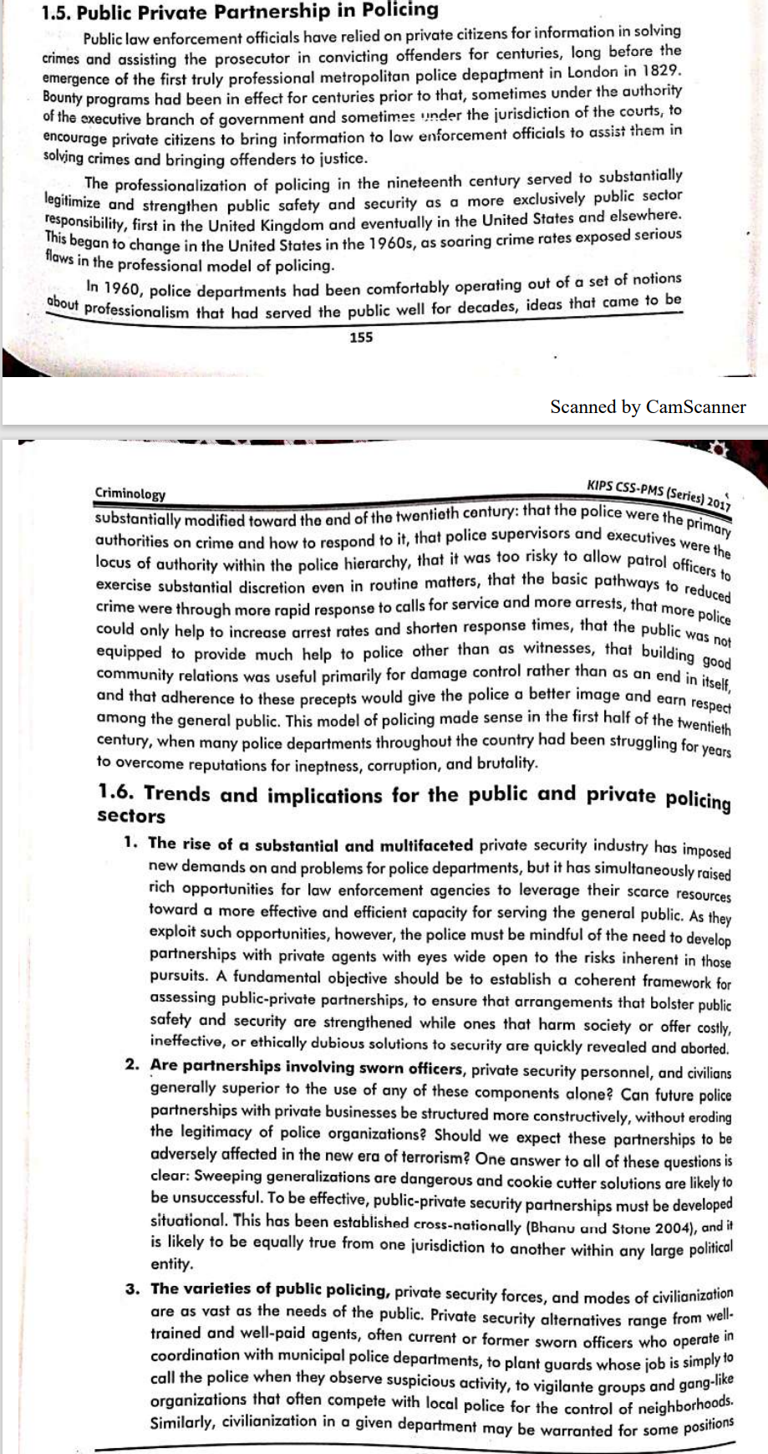

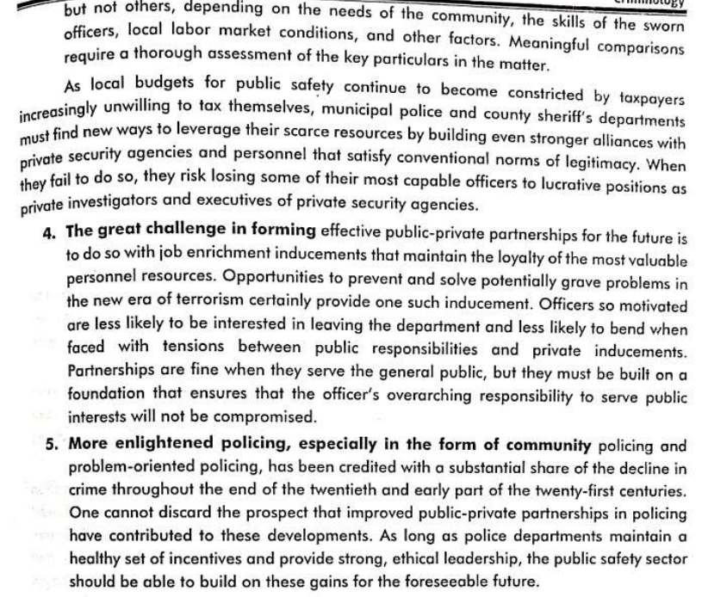

**Legal Framework for Public Private Partnership in Pakistan**

Public Partnership Authority established vide Public Private Partnership Act 2017 is the key agency of the Government mandated by the statute to explore avenues of cooperation with Private Sector in Public Projects.

Challenges in connection with Public Private Partnership in Pakistan: • Governance Deficit • Corruption • Bureaucratic Hurdles • Trust Deficit • Legal and Judicial System • Political Uncertainty

### Modern policing strategies in Pak

<https://www.dawn.com/news/1365970/modern-policing>

<https://www.dawn.com/news/1641269/modern-policing>

<https://www.dawn.com/news/1673765/crime-analytics>

#### Evidence-based policing

to prevent crime, a new discipline has been evolving since 2008: evidence-based policing. It is an approach that helps policymaking and tactical decision-making in police departments. The main emphasis is on statistical analyses, empirical research and randomised controlled trials with a view to adopting data-driven policing methods. Evidence can be used in a number of ways from enforcing laws to preventing crimes. This led the British Home Office to establish the College of Policing in 2012 and make use of crime reduction toolkits. Data is collected and analysed at the Centre for Crime Reduction and evidence-based policing decisions are made at the policy and tactical level. These can range from the effectiveness of CCTV cameras and hotspot policing to neighbourhood watch, victim-offender mediations and mass media campaigns. If there is evidence that the intervention works, the practice continues; if it does little to bring down crime levels, the practice is discontinued.

Fortunately, Pakistan police has been able to instal an evidence-based policing system in a few cities in line with the ‘safe city’ concept. With this progressive model, evidence-based policing appears to be the logical next move to bring the police nearer to their goal of crime prevention. Research and development units can be utilised to process data so that policy decision-making can take its cue from the available evidence.

Apart from its modern character, evidence-based policing is cost-effective. A lot of time, energy and resources can be saved by applying its principles to criminology. It offers a practical solution to the need to balance out public safety, community service needs, available funds and taxpayer expectations. It is a brilliant blend of science and community policing to control crime and disorder.

An added advantage is that instead of completely overhauling the system, which would be tedious and time-consuming, such evidence-based interventions can help achieve bigger results.

Dr James Martin, author of The Meaning of the 21st Century, believes that just like fire-proof cities were built in the 20th century, terrorism- and crime-proof cities will be built in the 21st century. To this end, evidence-based policing opens up a vast horizon of possibilities to look forward to and work upon.

## HR abuses and Protection

Some governments, such as Iran, routinely deny their citizens basic civil rights, holding them without trial and using "disappearances" and summary executions to rid themselves of political dissidents. The Chinese government has been criticized for taking a heavy hand with the Muslim Uighur minority The Beijing government claims that its crackdown is necessary to fight separatism and terrorism, but its tactic is to impose discriminatory policies against Uighurs, including prohibitions on wearing beards and veils, restrictions on fasting, and overt discrimination with respect to religious education. 48 Another example: the United Arab Emirates (UAE) government has been accused of serious human rights problems. The government detains, and in some cases forcibly disappears, individuals who criticize the authorities, and its security forces have used torture against detainees. Most troubling has been allegations that imported foreign workers are used as slave labor. The workers obtain the visas needed to work in the UAE by paying hefty fees to "labor-supply agencies"; many workers sell their homes or land or borrow money at high rates of interest to pay the agencies' fees. Upon arrival in the UAE, the indebted workers-many of whom are illiterateare required to sign contracts with the construction companies on much worse terms than they had been promised back home, ensuring that their debts can never be paid off. In the worst cases, they are subjected to what may be considered forced labor or virtual slavery 49 Female domestic workers are excluded from regulations that apply to workers in other sectors. Another state-organized crime involves the operation of the correctional systems in nations that are notorious for depriving detainees of basic necessities and routinely using hard labor and torture to punish political dissidents. The CIA has made use of their brutal regimes to soften up terror suspects for interrogation and sent suspected terror suspects to secret prisons abroad, without trial or indictment. There they can be subject to harsh interrogation tactics forbidden in the United States.

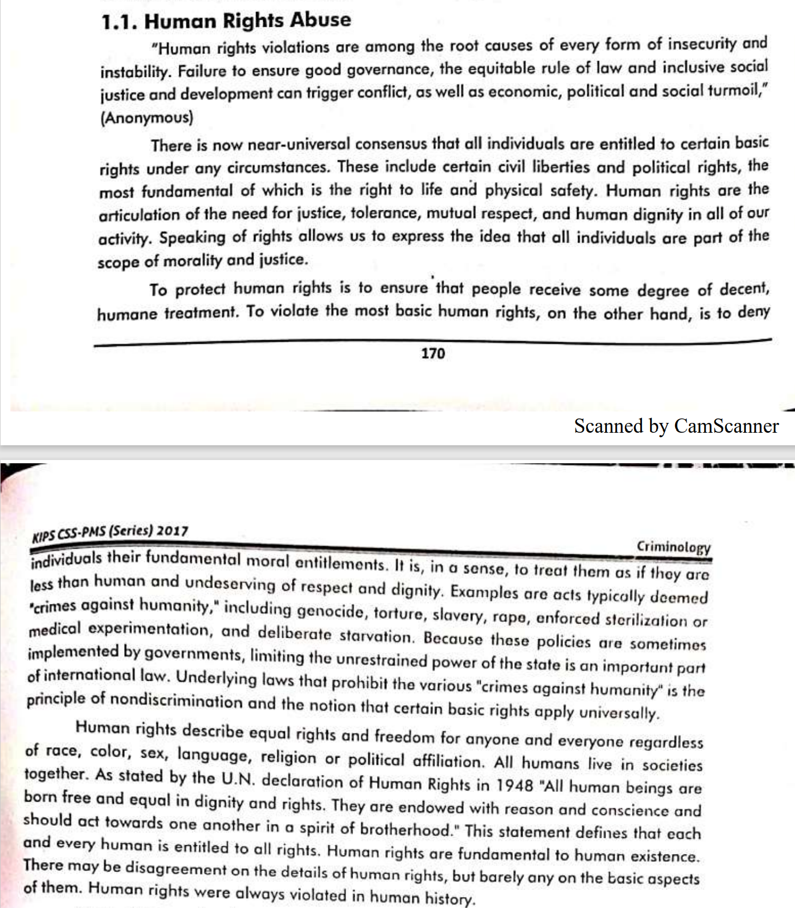

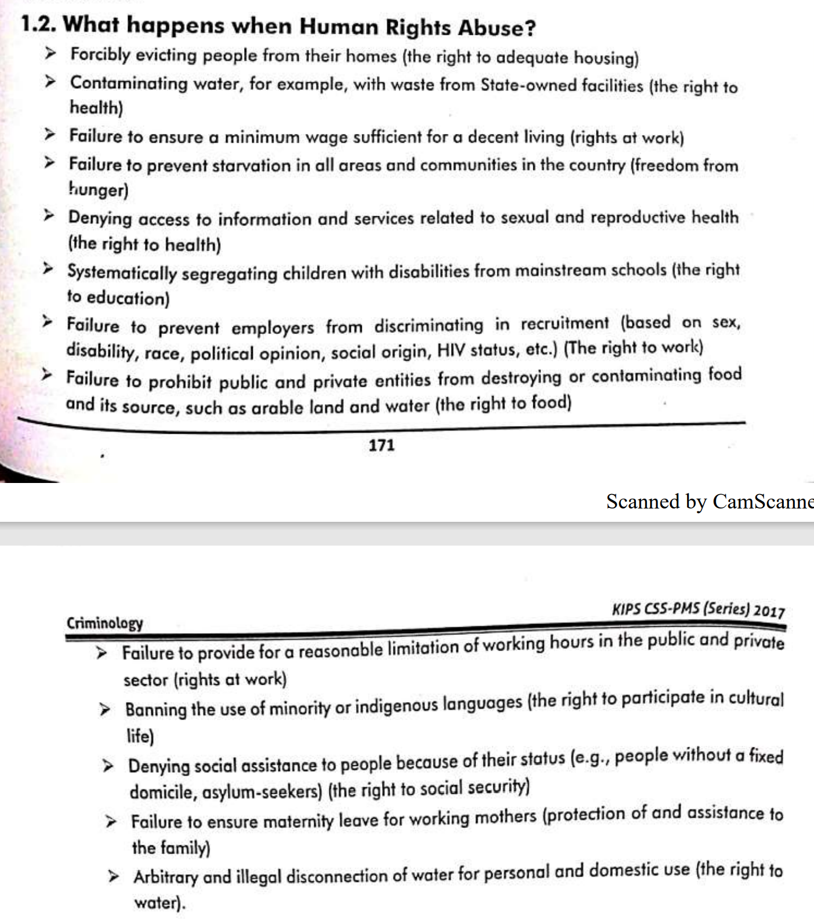

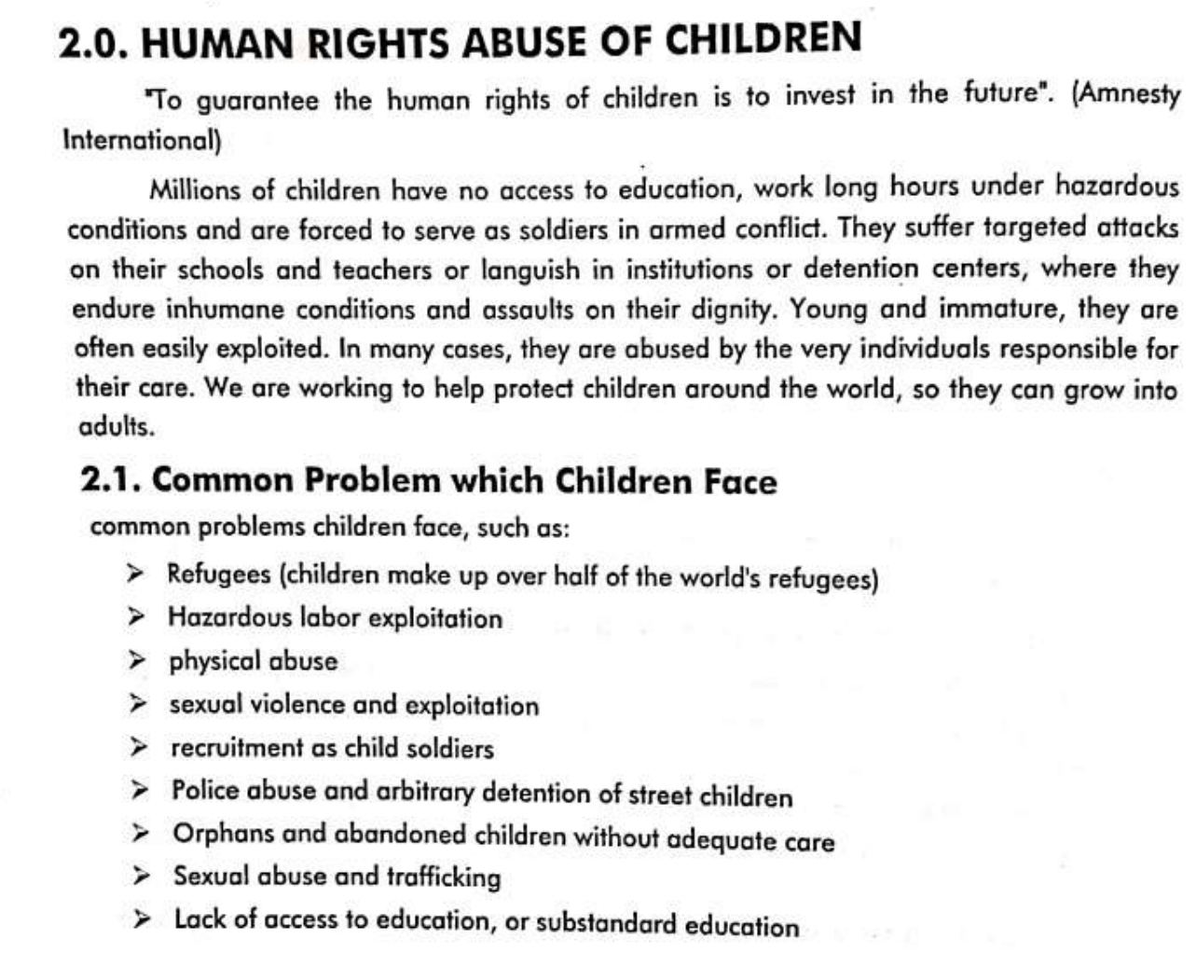

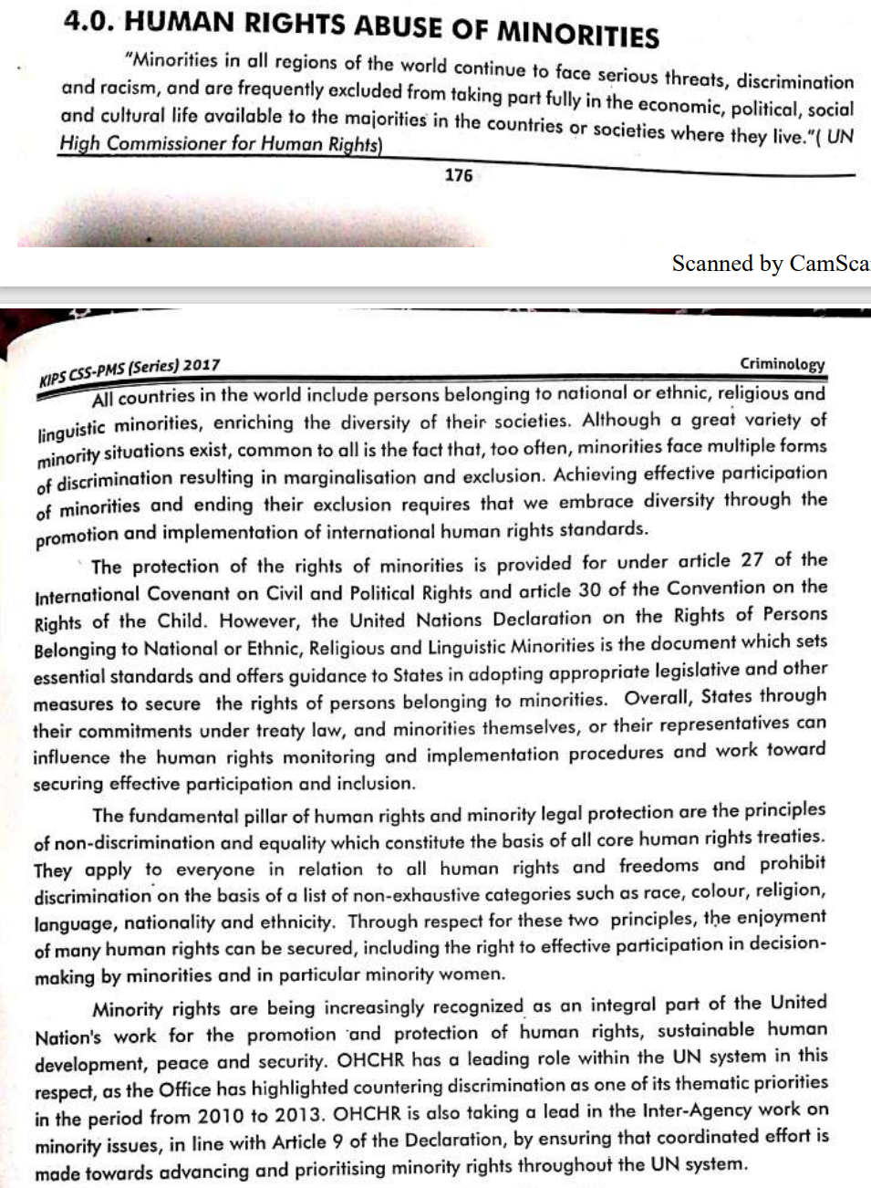

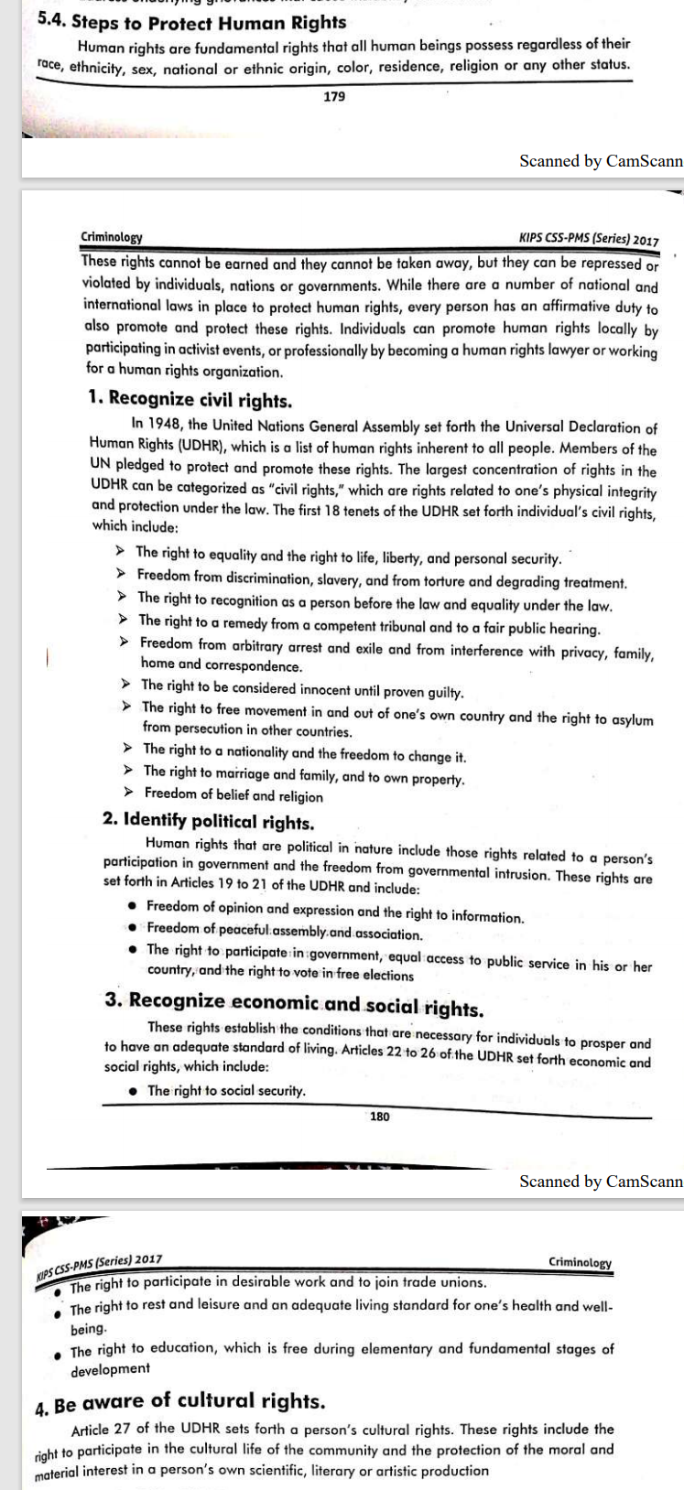

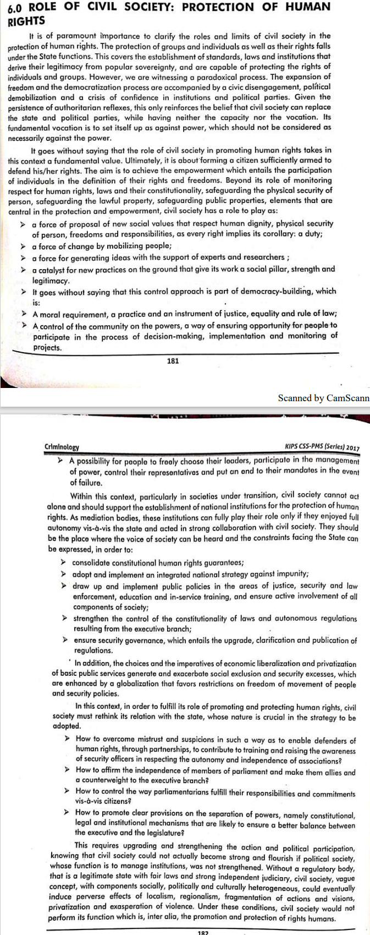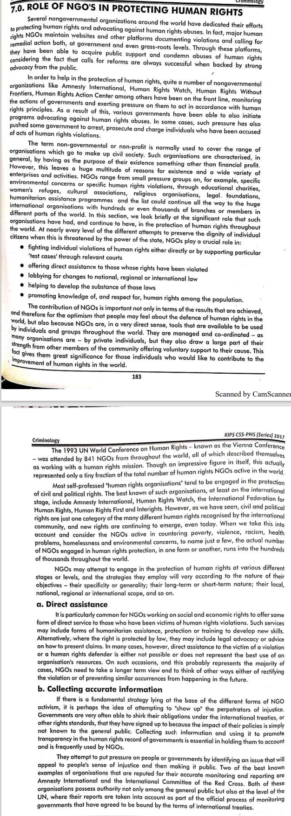

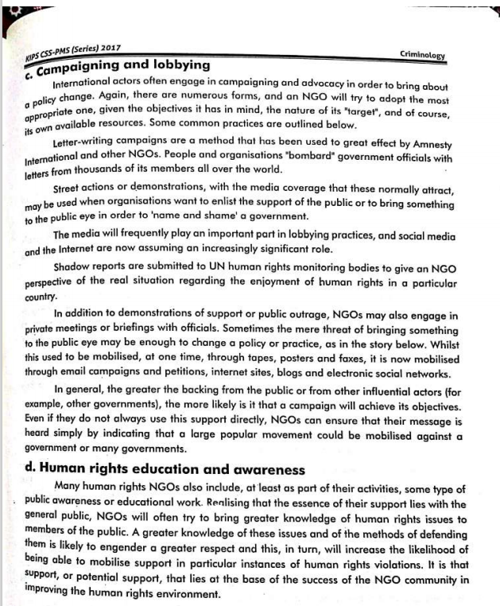

## Money laundering

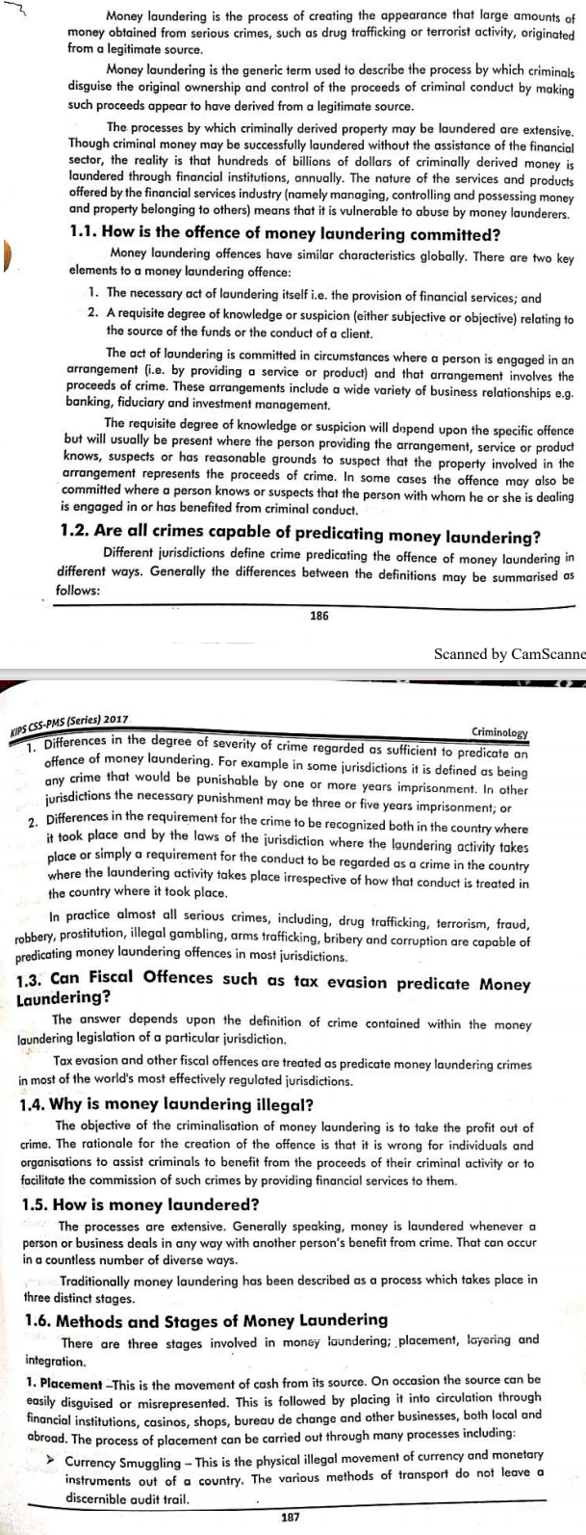



### Laws in Pak

Money laundering in Pakistan is a pervasive problem. Financial crimes related to narcotics trafficking, terrorism, smuggling, tax evasion, and corruption remain a significant problem in Pakistan. The proceeds of narcotics trafficking and funding for terrorist activities are often laundered by means of the alternative remittance system called hawala. This system is also widely used by the Pakistani people for legitimate purposes.

Offence of money laundering. -A person shall be guilty of offence of money laundering, if the person:

1. acquires, converts, possesses, uses or transfers property, knowing or having reason to believe that such property is proceeds of crime;
2. conceals or disguises the true nature, origin, location, disposition, movement or ownership of property, knowing or having reason to believe that such property is proceeds of crime;
3. holds or possesses on behalf of any other person any property knowing or having reason to believe that such property is proceeds of crime; or
4. participates in, associates, conspires to commit, attempts to commit, aids, abets, facilitates, or counsels the commission of the acts specified in clauses (a), (b) and (c).

The State Bank of Pakistan (SBP) has in the past issued detailed AML/CFT regulations, as well as guidelines on a risk-based approach in 2012. The SBP is the regulator for AML controls for banking and related services while the Securities and Exchange Commission (SECP) is the regulator for all other entities. Other regulatory authorities include the National Accountability Bureau (NAB), the Anti Narcotics Force (ANF), the Federal Investigative Agency (FIA), and the Customs Authorities oversee Pakistan’s AML law enforcement efforts.

Punishment for money laundering Under Section 4 of Money Laundering Act. — Whoever commits the offence of money laundering shall be punishable with rigorous imprisonment for a term which shall not be less than one year but may extend to ten years and shall also be liable to fine which may extend to one million rupees and shall also be liable to forfeiture of property involved in money laundering or property of corresponding value.

The Anti-Terrorism Act of 2002, which defines the crimes of terrorist finance and money laundering and establishes jurisdictions and punishments (amended in October 2004 to increase maximum punishments).

The National Accountability Ordinance of 1999, which requires financial institutions to report suspicious transactions to the NAB and establishes accountability courts.

The Control of Narcotic Substances Act of 1997, which also requires the reporting of suspicious transactions to the ANF, contains provisions for the freezing and seizing of assets associated with narcotics trafficking, and establishes special courts for offenses (including financing) involving illegal narcotics. All these laws include provisions to allow investigators to access financial records and conduct financial investigations.

In 2007, Pakistan enacted the AML Ordinance, establishing regulations for AML and combating the financing of terrorism and criminalizing money laundering. Under the Ordinance, the Financial Monitoring Unit (FMU) is created. The FMU serves as Pakistan's FIU and is in charge of handling Suspicious Transaction Reports (STRs).

In 2010, the SBP passed the Anti-Money Laundering Act, replacing the 2007 AML Ordinance. The FMU works with several Pakistani law enforcement agencies that are responsible for enforcing financial crime laws, including the National Accountability Bureau (NAB), the Anti-Narcotics Force (ANF), the Directorate of Customs Intelligence and Investigations (CII), and the Federal Investigative Agency (FIA).

### Institutional framework

The Institutional Framework of money laundering in Pakistan is regulated by Anti Money Laundering Act 2010. Given below is the Detail of the Institutions.

#### National Executive Committee (NEC)

NEC is the topmost body entrusted to implement the Money laundering Framework in Pakistan.

Its Composition is given hereunder.

(a) Minister for Finance or Advisor to the Prime Minister on Finance (Chairperson) (b) Minister on Foreign Affairs (c) Minister for Law and Justice (d) Minister for Interior (e) Governor SBP (f) Chairman SECP (g) Director General FMU(Secretary)

Roles and Functions of NEC are given under Section 5 of the Act.

• Develop, review and oversee the implementation of national strategy to fight money laundering and financing of terrorism. • Determine offences existing in Pakistan that may be considered to be predicate offences for the purposes of this Act. • Provide guidance and sanction in framing of rules and regulations under this Act. • Make recommendations to the Federal Government for effective implementation of this Act and framing of national policy to combat money laundering and financing of terrorism. • Issue necessary directions to the agencies involved in the implementation and administration of this Act; • Discuss any other issue of national importance relating to money laundering and financing of terrorism • Undertake and perform such other functions as assigned to it by the Federal Government, relating to money laundering and financing of terrorism.

#### General Committee

Headed by the Secretary Finance, the General Committee is required to assist the NEC in discharge of the statutory functions. The Composition of General Committee is given hereunder.

(a) Secretary Finance: Chairman (b) Secretary Interior: Member (c) Secretary Foreign Affairs :Member (d) Secretary Law :Member (da) Chairman National Accountability Bureau :Member (db) Chairman Federal Board of Revenue: Member (dc) Director General, Federal Investigation Agency :Member (dd) Director General, Anti Narcotics Force: Member (e) Deputy Governor SBP :Member (f) Commissioner SECP : Member (g) Director General: Member( Secretary)

#### Financial Monitoring Unit

The FMU is the functional arm of anti-Money Laundering Frame work in Pakistan. Its designated as Financial Intelligence Unit as required under FATF Regulations. FMU receives Suspicious Transactions Reports(STR) and Currency Transaction Reports(CTR) from Financial Institutions and Non-Financial Business Professions.

Section 6(2) provides great deal of autonomy to the Financial Monitoring Unit in following manner.

The FMU shall have independent decision-making authority on day-to-day matters coming within its areas of responsibility.

Other functions and powers of Financial Monitoring Unit are given in the Act in following manner.

a. To receive Suspicious Transaction Reports and CTRs from financial institutions and such non-financial businesses and professions as may be necessary to accomplish the objects of this Act;

b. To analyse the Suspicious Transaction Reports and CTRs and in that respect the FMU may call for record and information from any agency or person in Pakistan related to the transaction in question. All such agencies or persons shall be required to promptly provide the requested information;

c. To disseminate on a confidential basis, after analyzing the Suspicious Transaction Reports, and CTRs and other record, necessary information or materials to the concerned investigating or prosecuting agencies for enquiry or other action under this Act or any other applicable law;

d. To create and maintain a data base of all Suspicious Transaction Reports and CTRs, related information and such other materials as the Director General determines are relevant to the work of the FMU and in that respect, the FMU is authorised to establish necessary analytic software and computer equipment to effectively search the database, sort and retrieve information and perform real time linkages with databases of other agencies both in and outside Pakistan as may be required from time to time;

e. To co-operate with financial intelligence units in other countries and to make reciprocal arrangements after due administrative process to share, request and receive information relating to money laundering and financing of terrorism;

f. to frame regulations in consultation with SBP and SECP for ensuring receipt of Suspicious Transaction Reports and CTRs from the financial institutions and non-financial businesses and professions with the approval of the National Executive Committee.

#### Suspicious transactions

The following are examples of potential suspicious transactions for both money laundering and terrorist financing. The lists of situations given below are intended mainly as a means of highlighting the basic ways in which money may be laundered. 1. Transactions which do not make economic sense. 2. Transactions inconsistent with the customer's business. 3. Transactions involving large amounts of cash. 4. Transactions involving structuring to avoid reporting or identification requirement. Transactions involving forcing currency exchanges that are followed within a short time by wire transfers to locations of specific concern (for example, countries designated by national authorities, FATF nonco-operative countries and territories, etc). 5. Transactions involving accounts. 6. Transactions involving transfers to and from abroad. Stated occupation of the transact or is not commensurate with the level or type of activity (for example, a student or an unemployed individual who receives or sends large numbers of wire transfers, or who makes daily maximum cash withdrawals at multiple locations over a wide geographic area). 7. Investment related transactions. 8. Transactions involving unidentified parties. 9. Transactions involving insurance. A customer obtains a credit instrument or engages in commercial financial transactions involving movement of funds to or from locations of specific concern when there appears to be no logical business reasons for dealing with those locations. 10. Transactions involving embassy and foreign consulate accounts.

#### Flaws in institutional framework

• Shortage of resources provided to FMU • FMU’s office restricted to Karachi • Lack of Oversight upon NFBPs • NEC not exercising its role • Lack of Institutional Coordination • Non-Submission of Annual Reports • Undocumented Economy • Lack of expertise in Investigating Agency

#### FATF and Pak’s steps

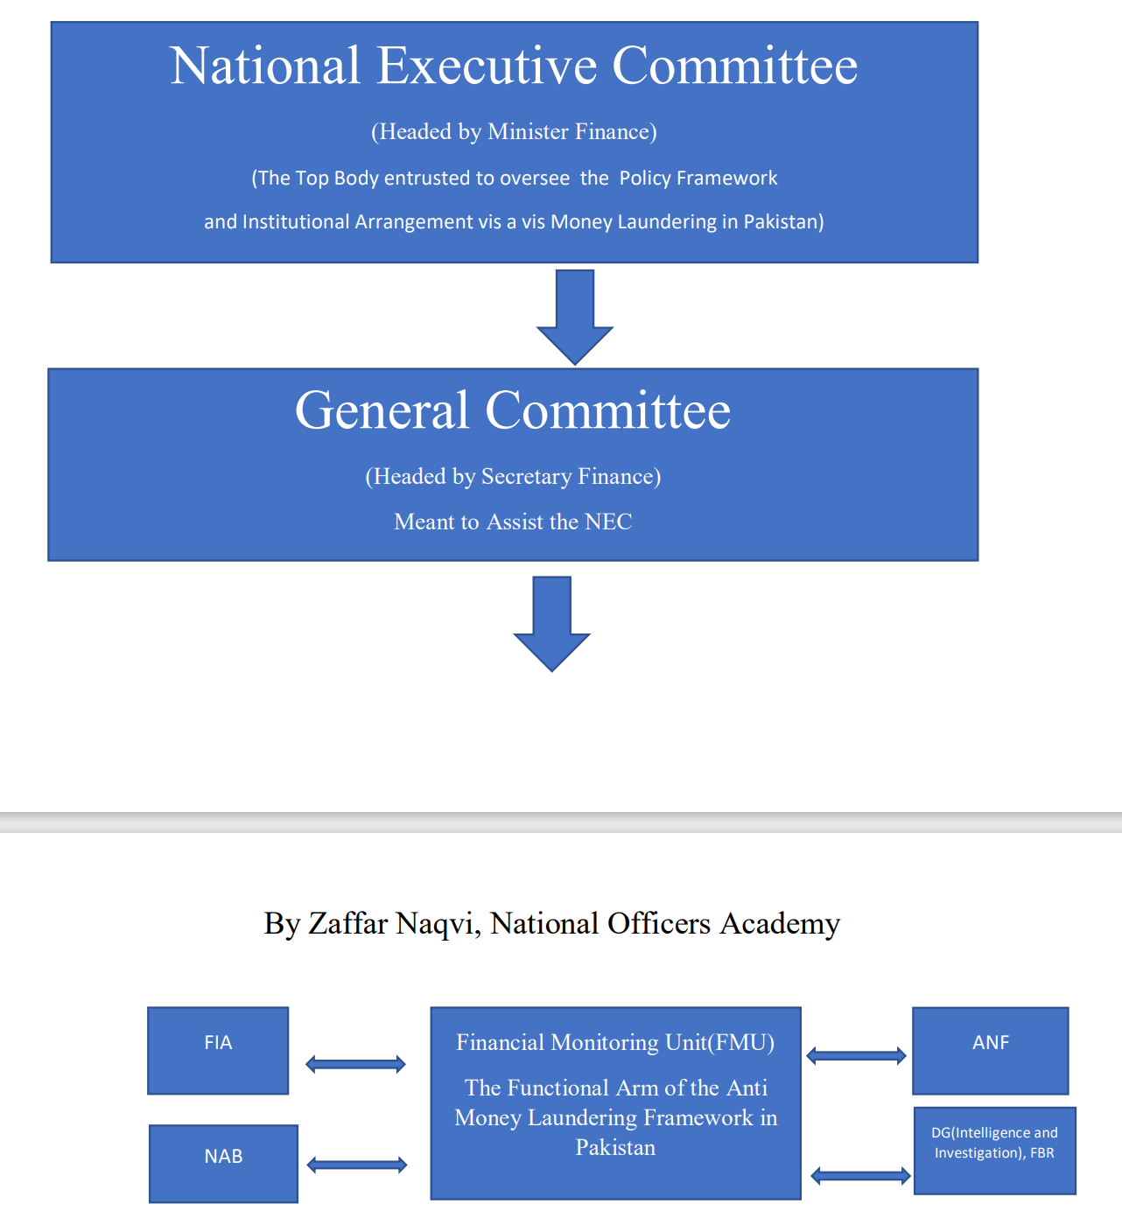

#### FATF and Pak’s steps

The Fed­eral Investigation Agency (FIA) has established a special squad to curb money laundering and illegal currency exchanges in line with the government’s commitments to the Financial Action Task Force (FATF).

The National Accountability Bureau (NAB) has established the Anti-Money Laundering and Combating the Financing of Terrorism (AML&CFT) cell to check financial crimes and illegal transfer of resources.

However, the main responsibility to investigate terror financing cases will still lie with the Federal Investigation Agency (FIA).

In 2019, the Securities and Exchange Commission of Pakistan (SECP) had issued the Anti-Money Laundering/Combating Financing of Terrorism guidelines for non-profit organisations on the basis of the FATF’s recommendations.

“In order to discourage money laundering, NAB established the Anti-Money Laundering and Combating the Financing of Terrorism (AML&CFT) Cell. This shows the bureau’s commitment and compliance towards the resolution of the international community,” an official press release issued by anti-graft watchdog said.

Proposed amendments

As per the amendment proposed for the AML Act, the punishment for money laundering crimes will be increased to up to 10 years' imprisonment while the fine will be increased to Rs5 million.

It was also decided that relevant clauses of the AML Act will be included in the Anti-Terrorism Act (ATA), 1997.

It was proposed that Foreign Exchange Regulations Act FERA 1947 should be amended to increase the punishment for an offence under the law from two years' imprisonment to five years. Through the proposed amendment, offences under FERA will be made cognizable and non-bailable. The trial of such will be completed between six months and one year.

## Cyber Crime

https://www.dawn.com/news/1666254/dark-cyberworld

A criminal activity in which a computer is used either as object or tool for committing the crime. The term cybercrime has been defined by the United Nations during its 10th Congress on the Prevention of Crime and the Treatment of Offenders, in following manner52 .

Cybercrime in a narrow sense (computer crime) covers any illegal behaviour directed by means of electronic operations that target the security of computer systems and the data processed by them. Cybercrime in a broader sense (computerrelated crimes) covers any illegal behaviour committed by means of, or in relation to, a computer system or network, including such crimes as illegal possession and offering or distributing information by means of a computer system or network.

The first cyber crime in the modern history is said to have been taken place in 1820.Joseph M jacquard was a French cloth manufacturer. He made a program , the first computer program in the history of ma kind, whereby some tasks were repeated automatically by the looms with out human intervention. The employees of Jacquard feared losing jobs and therefore they sabotaged the program. This is known to be the first cyber crime in the history.

### Stages of cybercrime

According to Christopher Donner and his associates, cybercrime has gone through three stages of development: ■ The first generation of cybercrime involved deviant acts characterized by the illegal exploitation of mainframe computers and operating systems. These behaviours involved crimes that were in existence before the creation of computers and the Internet, but technological innovations provided another method of commission. They were designed for financial gain or destruction of restricted information. ■ The second generation of cybercrime used computer networks and is considered hybrid crime. It involves criminality that was already in existence but has expanded and adapted through the use of the Internet. Hacking and cracking are common forms of this generation, as they were a product of early "phone phreakers." (Phone phreakers dialed around the telephone network to understand how the phone system worked, then used their knowledge to make free long distance calls, wiretap telephones, or steal telephone company equipment.) These crimes were created prior to the creation of the Internet but could now be performed in a more criminally effective manner. Using the Internet made cybercrime more difficult to detect and rendered cybercriminals more immune from prosecution. ■ The third generation of cybercrime is identified by the nature of distribution and was solely developed by the creation of the Internet. These crimes would not exist if not for the Internet. Dissemination of malware, such as viruses or Trojan horses, is an example of this generation of cybercrime.

### Contemporary cybercrime

The vast network of mobile and stationary computer networks has become a target for illegal activities and enterprise. Criminals are becoming more technologically sophisticated, routinely using the Internet to carry out their criminal conspiracies. Some cybercriminals use modern technology to sell illegal goods and services, or conversely, to illegally appropriate legitimate products and services. Cybertheft schemes range from illegal copying of copyrighted material to using technology to commit traditional theft-based offenses such as larceny and fraud. Some cybercriminals engage in cyberdeviance, the sale and distribution of morally tainted material and products over the Net. Other cybercriminals are motivated less by profit and more by the urge to commit cybervandalism or technological destruction. They aim their malicious attacks at disrupting, defacing, and destroying technology that they find offensive. A fourth type of cybercrime, cyberwar, involves the actions by a nation-state or international organization to attack and attempt to damage another nation's computers or information networks through, for example, computer viruses or distributed denial-of-service attacks (DDoS). 10 One element, cyberterrorism , aims to undermine the social, economic, and political system of an enemy nation by destroying its electronic infrastructure and disrupting its economy.

In sum, some cybercriminals are high-tech thieves while others are high-tech vandals; the property they destroy is electronic rather than physical. Some use the Internet to plot and carry out terrorist activities, going as far as to wage cyberwar (see Concept Summary 15.1). This array of modern crimes presents a compelling challenge for the justice system and law enforcement community because (a) it is rapidly evolving with new schemes being created daily, (b) it is difficult to detect through traditional law enforcement channels, and (c) its control demands that agents of the justice system develop technical skills that match those of the perpetrators. Cybercrimes also present a significant challenge for criminologists because they defy long-held assumptions about the cause of crime. How can we say that crime is a function of social forces, the social environment, or the social structure, when these contemporary criminals are typically highly educated and technologically sophisticated people who commit their crimes in places far removed from their victims? By their very nature, cybercrimes demand a high degree of self-control and planning, something a truly impulsive or mentally unstable person would have difficulty achieving As cybercrime expert Majid Yar explains, it may be that "considerable theoretical innovation" will be required before criminologists can fully understand this phenomenon.

### Types

Cybertheft: computer fraud, theft from atms, ransomware, illegal copyright infringement, internet securities fraud, identity theft

Cyberdeviance: distributing pornography, ehooking, distributing dangerous drugs

Cybervandalism: Website defacement, cyberstalking, cyberbullying, Denial-of-Service attacks, viruses, spam

Cyberwar: cyberespionage, cyberattacks, cyberterrorism

During last two decades, some radical Muslim organizations like TTP and ISIS have also shifted their focus on social media publications and video message to support their violent acts and radical thoughts by propagating the meaning of Jihad.

the classical and somewhat radical writers have associated Jihad with holy war against infidels and this thought has been followed by radical groups like TTP, ISIS and Al-Qaeda to fight the government or state bodies for implementation of Sharia or Islamic laws. Initially, the message or Fatwas were sent through electronic or press release, e.g. Osama Bin Laden's fatwa entitled "Declaration of War against the Americans Occupying the Land of the Two Holy Places"

### Pakistan

The principal Law which deals with cybercrimes in Pakistan is “Prevention of Electronic Crimes Act 2016.

A unit in FIA, named National Response centre for Cyber Crime (NR3C) is working for prosecution of cybercrimes in Pakistan. It is the only unit of its kind in the country and in addition to the directly received complaints, it also assists other law-enforcement agencies in their own cases.

NR3C has expertise in Digital Forensics, Technical Investigation, Information System Security Audits, Penetration Testing and Training. The unit since its inception has been involved in capacity-building of the officers of Police, Intelligence, Judiciary, Prosecutors and other Government. organizations. NR3C has also conducted a large number of seminars, workshops and training/awareness programmes for the academia, print/electronic media and lawyers. Cyber Scouts is the latest initiative of NR3C, in which, selected students of different private/public schools are trained to deal with computer emergencies and spreading awareness amongst their fellow students, teachers and parents.

ACCORDING to latest reports, the Federal Investigating Agency (FIA) received a total of 102,356 complaints related to cybercrime in the year 2021. The figure of 102,356 is only that of complaints; of these, 80,641 complaints went into verification by the FIA, and according to the FIA, only 15,932 passed their criteria for initiating inquiry. Ultimately, a total of 1,202 cases were registered in 2021 under Peca, and a total of 1,300 suspects arrested by the FIA. However, it is important to analyse what the FIA’s performance looks like for citizens beyond the numbers.

Firstly, the FIA is acutely under-equipped. As per Peca, cybercrime cases are to be registered with the FIA, not the Police, and the FIA is only present in the largest cities of Pakistan. This means that most people outside big cities have to travel hundreds of kilometers to be able to file a formal complaint. Same is the case with cybercrime courts, for which people have to travel regularly, in many cases every month for hearings after filing complaints for there to be progress on their complaint and then trial of their cases.

According to the reports, the FIA plans to set up offices in every district, and setting these up in existing police stations will expedite this and save resources as well. {Solution}

Second, the FIA staff often does not take complaints seriously. The sheer low number of cases registered as opposed to complaints made shows that citizens find the process of seeking justice through courts under Peca with FIA as the investigation agency very cumbersome. This is especially true for women and minorities, and especially for people who do not have powerful connections. Many women are reported to have been told by FIA officials that threats made to them and their non-consensual images being shared by, for example their ex-husbands for blackmailing are not serious enough crimes; others indulge in victim-blaming, further traumatising survivors.

Third, there is a major issue with FIA investigating officers’ work and their cooperation with courts. In many cases, they do not show up in court; and evidence files of important cases have been lost, and only appeared when a case was filed in the high court. Such undue delays put a question mark over the FIA’s sincerity and competence, and need to be addressed.

Fourth, the FIA is on record complaining that social media companies do not cooperate in investigations. Issues related to this are largely due to lack of policy level engagement by the Pakistani government on international fronts. Pakistan does not have a Mutual Legal Assistance Treaty with the United States where most of these companies are based and whose laws they follow. If at a policy level, an MLAT was pursued by the government of Pakistan, a lot of legal issues with requests related to legal cases from Pakistan involving social media companies can be addressed.

Similarly, Pakistan is not a signatory to the Convention on Cybercrime which is also known as the Budapest Convention. Similarly, on matters related to taxing internet-based companies, Pakistan has not been involved in the OECD’s Model Reporting Rules for Digital Platforms which could enable it to tax internet companies. These are **acute policy failures** that need to be addressed if Pakistan is serious about its digital policies and accruing economic benefits as well as redressal of legal issues it faces related to cybercrime cases.

#### Solutions

It is of utmost importance that fundamental rights be protected and due process be followed in all cybercrime cases. Social media companies are more likely to cooperate with governments if they are confident that data shared will not be abused by states to violate human rights of citizens, especially the right to freedom of speech and right to privacy that the current government seems happy to routinely violate.

The FIA, in which more women officers should be inducted, also needs to be given more resources and adequate training especially on gender sensitivity, and a sense of protecting fundamental rights and due process when investigating cases of cybercrime.

## Role of NAB, FIA, ANF

#### NAB

National Accountability Bureau is the Prime Agency entrusted to curb corruption in Pakistan.It was Established under National Accountability Ordinance 1999.

Following objectives have been mentioned for the NAB in the Law.

• Detection, investigation, prosecution and speedy disposal of cases involving corruption, corrupt practices, misuse/abuse of power, misappropriation of property, kickbacks, commissions and for matters of similar nature • Recovery of outstanding amounts from those persons who have committed default in the repayment of amounts to Banks, Financial Institutions, government and other agencies • Recovery of state money and other assets from those persons who have misappropriated or removed such assets through corruption, corrupt practices and misuse of power and/or authority

NAB is headed by a chairman appointed by President in consultation with PM and Opposition leader for a term of 4 years which is not extendable.

ELIGIBILITY FOR APPOINTMENT AS CHAIRMAN NAB

• Retired judge of supreme court or retired Chief Justice of High Court • Retired Armed Forces Officer to the Rank of Lieutenant General • Retired Civil Servant BS-22

Removal of Chairman: Can be removed only by Supreme Judicial Council.

Criticism: • Politicization • Witch Hunting • Selective Accountability • Scope • Lack of internal Accountability • Plea Bargain and Voluntary Return • Remand Period • Appointment of Chairman • Centralized Power • Lack of requisite Capacity to deal with technical cases

##### Recommendations

Transparency International has made following Recommendations for improvement of NAB’s performance.

• Eligibility criteria for Appointment of Chairman NAB be Broad Based (Not restricted to Judges, General and Bureaucrats) • The provision of Voluntary Return should be eliminated. • he option of Plea Bargain should only be exercised for approver/s in a transparent manner, only when the main accused in a corruption case can be prosecuted on the approver’s confession • 1% of Gross Domestic Product (GDP) should be allocated to NAB • An Oversight Committee should be formulated for NAB’s Accountability. • Anti-Corruption should be included in the curriculum of the elementary, secondary and degree programs of educational institutions. • NAB should increase collaboration with the media. • NAB should make a thorough analysis of the entire chain of system to improve its conviction rate. • Prosecutors and investigating ocers of NAB should receive training in specialized -elds. • NAB should make full use of social media as a catalyst for public engagement. • NAB should ensure that its investigation procedures should be completely compliant with the basic rights of the citizens enshrined in Qanoon-e-Shahdat and the country’s constitution. • The timeline for inquiries should be in accordance with the provision in Ehtesab Act 1996. • NAB should deal with the accused and the witnesses in a dignied and respectful manner. • Precautionary measures need to ensure the agency does not itself become a source for extortion and corruption. • NAB should ensure that the reference prepared and successfully tried in the Accountability Courts should be upheld in all subsequent review petitions in High Courts and Supreme Court.

#### FIA

FIA stands for Federal Investigation Agency. It was established under FIA Act, 1974 (Act-VIII of 1975) promulgated on 13-01-1975. FIA was established with objective to deal with following cases:

• Smuggling, • Narcotics, • Currency offences, • Enforcement of Laws relating to Foreigners, • Immigration & Passports and • offences having inter-provincial ramifications .

#### ANF

Governing Law: The Anti-Narcotics Force Act 1997

Objective: Enquiry and investigation of offences relating to narcotics and Narcotics Trafficking

Mandate

• To inquire, investigate and prosecute all offences related or connected with intoxicants, narcotics and precursors. • Trace and freeze the assets. • Coordinate elimination and destruction of Poppy cultivation. • Provide assistance to other law enforcement agencies and share information with all national and International agencies on drug related matters. • Arrange and coordinate training of own staff and members of other law enforcement agencies related to narcotics. • Maintain liaison with all international narcotics control authorities and represent Pakistan in conferences and seminars. • Perform any other related functions that may be assigned by the Federal Government.

Head of The Force: Force is headed by a Director General. The post has been manned by a serving Major General since creation of the force on 26th August 1993.

## Crime and Urbanization

“TWENTY years ago, our front gate used to remain open, today not only do we keep the gate locked, we employ guards and have installed a security system. This is the extent to which public safety has deteriorated in our lifetime.” This is the verdict of an irate male focus group conducted in Lahore. It turns out that evidence supports these observations.

The Institute of Development and Economic Alternatives’ (IDEAS) Lahore Crime Survey shows that in 2016 one in eight citizens of Lahore were victims of crimes like theft, robbery, burglary, extortion, assault, kidnapping and attempts at these crimes. Estimates suggest that one in 25 citizens would have experienced similar incidents in the city in 1991. This is a trebling of the crime rate in Lahore in 25 years!

Long-term deterioration in public safety is not unique to Lahore; it is a challenge it shares with other big (one million-plus) cities. We find that the per capita crime rate in Punjab’s big city districts (those with one million-plus cities) was double the rate in other districts during the last quarter century. Clearly, big city districts are ‘crowding in’ crime at a disproportionate rate compared to other districts.

‘Crowding in’ is happening because the same level of unemployment has a bigger effect on crime in big city districts compared to other districts. We find that a 10 per cent rise in youth unemployment increases the crime rate by 15pc to 20pc in big city districts in Punjab — which is a very large effect! As opposed to this, a similar rise in youth unemployment increases the crime rate by only 2pc to 6pc in other districts. The larger effect of youth unemployment appears to be due to the absence of community safety nets that buffer young adults against employment shocks.

Big cities also ‘crowd in’ crime because getting away with it seems much easier here. The Punjab police data shows that an increase in incarceration reduces crime rates in all districts except big city districts. That is, putting more people in jail literally has no effect on the crime rate in big cities. This raises a puzzle — why is the same criminal justice system much less effective in a big city environment?

In Punjab’s big cities this is partly because victims and communities have less information about perpetrators and are less able to identify them for the police. The crime survey finds that only 19pc of victims were able to give any significant information about their perpetrators. We call this the “urban anonymity challenge”. This challenge explains why the percentage of untraced offenders in registered cases is twice as high in Punjab’s big city districts compared to other districts.

The urban anonymity challenge weakens deterrence in big cities by lowering the quality of investigation and making it harder to apprehend the right offenders swiftly. It also weakens deterrence because the chance that offenders are penalised becomes negligible if they are not nominated in the FIR.

This suggests the need for police reforms that introduce modern institutions of metropolitan policing in big cities. This has to be an important component of the election manifestos of political parties. The adoption of forensic technology, biometric databases and integrated command, control and communication systems (IC3) for cities by the Punjab government has strengthened the informational foundations to mitigate the urban anonymity challenge and enhance deterrence.

Leveraging the benefits of this investment will require reforming the 19th-century model of decentralised policing, which centres on a large number of geographically dispersed police stations. Our evidence suggests that police stations remain plagued with delays in FIR registration and high case pendency, which sustain low citizen trust in spite of investments in modern technology.

It is important to recognise that modern technologies like the IC3 have created the potential for radical reform of city policing. It allows the institutionalisation of ‘centralised response systems’ that integrate calls for service, complaint registration, patrol and scene of the crime investigation that can replace the decentralised model. This promises greater efficiency as it has the potential to reduce the time and cost of communication between victims and first responders and improve the quality of scene of crime investigation.

It also promises stronger accountability as calls for service are recorded and can be reviewed by independent supervisors. Officer accountability is also strengthened as first responders and scene of the crime teams are visible to the central system and their process efficiency is logged and can be monitored by independent supervisors.

Is it not time to create 21st-century policing institutions that embed modern technology to deal with 21st-century challenges in our cities?

## Gender and Crime

### Gender differences in crime rate

Early criminologists pointed to emotional, physical, and psychological differences between males and females to explain the differences in crime rates. Cesare Lombroso's 1895 book The Female Offender argued that a small group of female criminals lacked "typical" female traits of "piety, maternity, undeveloped intelligence, and weakness." 102 In physical appearance as well as in their emotional makeup, delinquent females appeared closer to men than to other women. Lombroso's theory became known as the masculinity hypothesis ; in essence, a few "masculine" females were responsible for the handful of crimes women commit.

Another early view of female crime focused on the supposed dynamics of sexual relationships. Female criminals were viewed as either sexually controlling or sexually naive, either manipulating men for profit or being manipulated by them. The female's criminality was often masked because criminal justice authorities were reluctant to take action against a woman. 103 This perspective is known as the chivalry hypothesis, which holds that much female criminality is hidden because of the culture's generally protective and benevolent attitude toward women. 104 In other words, police are less likely to arrest, juries are less likely to convict, and judges are less likely to incarcerate female offenders. Although these early writings are no longer taken seriously, some criminologists still believe that gender-based traits are a key determinant of crime rate differences. Among the suspected differences include physical strength and hormonal influences. According to this view, male sex hormones (androgens) account for more aggressive male behaviour, and gender-related hormonal differences explain the gender gap in the crime rate. 1

### Socialization and Development

Although there are few gender-based differences in aggression during the first few years of life, girls are socialized to be less aggressive than boys and are supervised more closely by parents. 106 Differences in aggression become noticeable between ages 3 and 6 when children are first socialized into organized peer groups such as the daycare center or school. Males are more likely to display physical aggression while girls display relational aggression-excluding disliked peers from playgroups, gossiping, and interfering with social relationships. Males are taught to be more aggressive and assertive and are less likely to form attachments to others. They often view their aggression as a gender-appropriate means to gain status and power, either by joining deviant groups and gangs or engaging in sports. Even in the middle-class suburbs, they may seek approval by knocking down or running through peers on the playing field, while females literally cheer them on. The male search for social approval through aggressive behaviour may make them more susceptible to criminality, especially when the chosen form of aggression is antisocial or illegal. Jean Bottcher found that young boys perceive their roles as being more dominant than young girls 107 Male perceptions of power, their ability to have freedom and hang with their friends, helped explain the gender differences in crime and delinquency.

In contrast, girls are encouraged to care about other people and avoid harming them; their need for sensitivity and understanding may help counterbalance the effects of poverty and family problems. And because they are more verbally proficient, many females may develop social skills that help them deal with conflict without resorting to violence. Females are taught to be less aggressive and to view belligerence as a lack of self-control-a conclusion that is unlikely to be reached by a male. Girls learn-directly or indirectly-to respond to provocation by feeling anxious and depressed , whereas boys are encouraged to retaliate. Overall, when they are provoked, females are much more likely to feel distressed than males----experiencing sadness, anxiety, and uneasiness. Although females may get angry as often as males, many have been taught to blame themselves for harboring such negative feelings. Females are therefore much more likely than males to respond to anger with feelings of depression, anxiety, fear, and shame. Although females are socialized to fear that their anger will harm valued relationships, males react with "moral outrage," looking to blame others for their discomfort.

### Cognitive differences

Psychologists note significant cognitive differences between boys and girls that may impact on their antisocial behaviours. Girls have been found to be superior to boys in verbal ability, while boys test higher in visual-spatial performance. Girls acquire language faster, learning to speak earlier and faster with better pronunciation. Girls are far less likely to have reading problems than boys, while boys do much better on standardized math tests. (This difference is attributed by some experts to boys receiving more attention from math teachers.) In most cases these cognitive differences are small, narrowing, and usually attributed to cultural expectations. When given training, girls demonstrate an ability to increase their visual-spatial skills to the point where their abilities become indistinguishable from the ability of boys.

Cognitive differences may contribute to behavioural variations. Even at an early age, girls are found to be more empathic than boys-that is, more capable of understanding and relating to the feelings of others. 109 Empathy for others may help shield girls from antisocial acts because they are more likely to understand a victim's suffering. Girls are more concerned with relationship and feeling issues, and they are less interested than boys are in competing for material success. Boys who are not tough and aggressive are labeled sissies and cry babies. In contrast, girls are given different messages; they are expected to form closer bonds with their friends and share feelings. Their superior verbal skills may allow girls to talk rather than fight. When faced with conflict, women might be more likely to attempt to negotiate rather than to either respond passively or to physically resist, especially when they perceive increased threat of harm or death.

### GBV

From gender studies

### Feminist criminology

As this chapter is being written, we can say that a lot is known about the nature and extent of criminal offending. The earliest thinking about crime came from religious leaders and philosophers; often, these perspectives speculated on both the origins and morality of criminal acts as well as the proper sort of responses to these offenses. The first true empirical studies of criminal offending were conducted by Cesare Lombroso, who believed that there was an important link between biological factors and crime causation. In other words, it was believed that certain offenders were born criminal and could be identified by certain biological defects, such as high cheekbones, baldness, and shifty eyes. Scholarship on the nature and extent of crime has moved far beyond these appearance-based biological factors. Contemporary thinking about crime causation is much more complex and often involves a mix of sociological or psychological factors.

Regardless of the scope of the theoretical perspective taken or the variables included, criminology has historically been a field dominated by male scholars seeking to explain the criminality of other men. Girls and women who committed crimes were for too long the forgotten offenders. Indeed, the term the invisible offender is often used by feminist scholars to describe the lack of scholarship on and knowledge of female offenders. Women were either eliminated from samples or data on them were excluded from analyses seeking to explain crime or understand the effectiveness of the criminal justice system. The result of this andocentric focus is that theories of crime and justice were really theories of male crime and justice. The specific focus on female offenders began in the 1970s largely because of the work of feminist scholars. Indeed, the number of scholars labeled feminist criminologists has continuously increased during this time span and has resulted in a widening of the research agenda for scholars exploring the topic of gender and crime. Prior to this era, research on girls or women and crime tended to be haunted by stereotypes about “evil” and “bad” women, and the work focused almost exclusively on prostitution. Feminist scholars, by contrast, began to explore whether girls and women committed crime for different reasons than boys and men; they also focused on a wider range of offenses. Thus, part of feminist scholarship in this area was and is to question criminological knowledge that was male based and male informed as well as to build a new criminology with female offenders squarely as the center of inquiry. Feminist scholars also began an exploration of girls’ and women’s experiences in the criminal justice system, most specifically, the experience of women in prison.

### Rape

Rape (from the Latin rapere, to take by force) is defined in common law as "the carnal knowledge of a female forcibly and against her will. "72 It is one of the most loathed, misunderstood, and frightening crimes. Under traditional common-law definitions, rape involves nonconsensual sexual intercourse that a male performs against a female he is neither married to nor cohabitating with. 73 There are of course other forms of sexual assault, including male on male, female on female, and female on male sexual assaults, but these are not considered within the traditional definition of rape.74 However, recognizing changing contemporary standards, almost every state and the federal government (as in the Uniform Crime Reports) have now revised their rape statutes, making them gender neutral and including other forms of sexual assault beyond nonconsensual sexual intercourse. 75 In addition, states now recognize that rape can occur among married couples and people who previously have been sexually intimate. 76 And of course, regardless of what form it takes, rape has long-term effects on the victim's emotional and physical well-being.

#### Pak law

Rape and punishment of rape fall under Sections 375 and 376 respectively of the Pakistan Penal Code.

The punishment for rape is death or imprisonment not less than 10 years or more than 25 years and a fine.

For gang-rape, each of persons shall be punished with death or imprisonment for life.

Section 375 defines rape as:

**Rape:**

A man is said to commit rape who has sexual intercourse with a woman under circumstances falling under any of the five following descriptions,

(i) against her will.

(ii) without her consent

(iii) with her consent, when the consent has been obtained by putting her in fear of death or of hurt,

(iv) with her consent, when the man knows that he is not married to her and that the consent is given because she believes that the man is another person to whom she is or believes herself to be married;

(v) With or without her consent when she is under sixteen years of age.

#### Causes

According to the **gender conflict view**, as women make progress toward social, political, and economic equality, men fear them as a threat to their longheld dominance. 147 Men react through efforts of formal and informal controls over women. One informal method of social control is to dominate women sexually through the commission of rape. The male-dominated criminal justice system may exert less effort in handling rape cases in an effort to maintain male superiority Research by Richard Johnson does in fact show that regions with higher levels of progress toward gender equality actually experience higher rates of rape and lower rates of rape case clearances.

**Social learning**: Social Learning This perspective submits that men learn to commit rapes much as they learn any other behaviour. For example, sexual aggression may be learned through interaction with peers who articulate attitudes supportive of sexual violence. 143 Nicholas Groth found that 40 percent of the rapists he studied were sexually victimized as adolescents.144 A growing body of literature links personal sexual trauma with the desire to inflict sexual trauma on others. 145 Watching violent or pornographic films featuring women who are beaten, raped, or tortured has been linked to sexually aggressive behaviour in men.

**Male socialization:** Some researchers argue that rape is a function of modern male socialization. Some men have been socialized to be aggressive with women and believe that the use of violence or force is legitimate if their sexual advances are rebuffed-that is, "women like to play hard to get and expect to be forced to have sex." Those men who have been socialized to believe that "no means yes" are more likely to be sexually aggressive. 134 The use of sexual violence is aggravated if pro-force socialization is reinforced by peer group members who share similar values.

**Sexual motivation:** Most criminologists believe rape is a violent act that is not sexually motivated. Yet it might be premature to dismiss the sexual motive from all rapes. 149 NCVS data reveal that rape victims tend to be young and that rapists prefer younger, presumably more attractive , victims. Richard Felson and his associates found this effect when they studied the risk of sexual and physical assault in prisons and jails. 15° Felson found that male inmates of all ages tend to sexually assault young men and that the young are sexually assaulted because of their sexual attractiveness rather than because of their vulnerability Older rapists tend to harm their victims more than younger rapists. This pattern indicates that older criminals may rape for motives of power and control, whereas younger offenders may be seeking sexual gratification and may therefore be less likely to harm their victims.

**Psychological abnormality:** Another view is that rapists suffer from some type of personality disorder or men - tal illness. Research shows that a significant percentage of incarcerated rapists exhibit psychotic tendencies, and many others have hostile, sadistic feelings toward women. 140 A high proportion of serial rapists and repeat sexual offenders exhibit psychopathic personality structures. 141 There is evidence linking rape proclivity with narcissistic personality disorder, a pattern of traits and behaviours that indicate infatuation and fixation with one's self to the exclusion of all others and the egotistic and ruthless pursuit of one's gratification, dominance , and ambition.

# MISC

## CT NAP

AT a recent meeting of the National Action Plan (NAP) apex committee, civil and military leaders vowed to meet all security challenges. This was a belated but welcome move in view of re-emerging militant and extremist threats. The TTP and similar other outfits have been emboldened by the Afghan Taliban’s victory. There has been a surge in terrorist attacks on law-enforcement and military personnel. Attacks on Chinese nationals involved in CPEC projects are of special concern.

After the APS tragedy, a working group of professionals, civilian and military met on Dec 21, 2014, on the invitation of the interior ministry, and based on their experience and expertise, identified the internal security fault lines that posed a mortal threat. The proposed kinetic and non-kinetic, short and long-term counterterrorism and counter-extremism (CE) measures resulted in the 20-point CT NAP. The implementation strategy contained short-, medium- and long-term measures for review by apex committees jointly steered by the chief ministers and army corps commanders.

However, the then political and military leadership were trapped in a power struggle, resulting in a military-centric focus on CT-related kinetic measures at the expense of long-term inter-institutional and cross-cutting CE measures envisaged by NAP. The National Counter-Terrorism Authority (Nacta) eventually came up with a policy review on CT NAP in 2019 and 2020. Most of its recommendations have been approved in the latest apex committee meeting seen as a positive attempt to restore the balance between CT and CE strategies.

The decision to set up a National Crisis Information Management Cell appears to be a revival of the post 9/11 Musharraf-era National Crisis Management Cell (NCMC) set up within the interior ministry and headed by a retired brigadier. After Nacta’s establishment, the NCMC was correctly disbanded and merged with Nacta. The creation of NCIMC, with a brigadier in charge and again placed within the interior ministry, appears to undermine the civilian coordination authority and further formalise the militarisation of the internal security mechanism.

The latest decision to revive a crisis management cell along with the earlier establishment of National Intelligence Coordination Committee reflects the military establishment’s domineering role in national security. The NICC is led by the ISI. The IB and FIA are civilian departments with distinct legal mandates. They cannot and must not take dictation from any other institution. One notices in the composition of the National Security Committee that civilian law-enforcement and intel agencies like Nacta, FIA and IB are missing. The NSC deliberates on internal security issues, and the absence of law-enforcement agencies from the highest security forum of the federal government reinforces the view that the military establishment has primacy on security-related issues. A democratic government must dispel this impression.

The CT NAP review addressed the proliferation of weapons in society. A firm arms-control policy with zero tolerance for illicit weapons and a complete ban on licences for prohibited bore arms are needed, but Pakistan hasn’t even ratified the UN Protocol on Illicit Firearms.

The government’s track record in improving governance and the criminal justice system reflects indifference or lack of capacity. In a cabinet meeting last October, it was decided that a CE commission would be set up to deal with religious intolerance and violent extremism. But the terms of reference and legal mandate of the proposed body still haven’t been finalised. Similarly, only lip service is paid to judicial reforms. The average tenure of the IG police of the largest province has been just six months over the last three years. There is no security of tenure for federal secretaries or provincial chief secretaries. Judges’ appointment, even in the apex court, lacks transparency. Court cases are piling up. Accountability of public office holders is a sham. Despite the Supreme Court’s strictures, NAB continues to pursue a flawed accountability campaign.

The much-needed focus on soft approaches like education, counter-narratives, and deradicalisation is missing once again.

## Policing principles

<https://www.dawn.com/news/1581867>

## Women policing in pak

Women role has changed considerably during the last few decades and Pakistani women are joining those professions where they could not enter in the past. Despite this trend, women face difficulties in the form of socio-cultural constraints to join law enforcing agencies. Women police face problems in the police department in the form of discouragement from co-workers, senior officials, un-conducive work environment inside police stations, lack of facilities, strict working hours, lack of career development opportunities, discrimination and sexual harassment. In addition, due to male dominancy and cultural values the women has to seek the permission of their male head of the house to join police. These problems hinder women to join police force due to which their representation is meagre as compared to other countries.

In law enforcing agencies especially in police force women can play an effective role but their representation is meagre. Although 10 % quota has been reserved for women in police force, still women make up less than 1% of the total police force. The number of female police officers in the country is just over 4,000 or 0.94% of the total police force of over 425,000. The situation in Balochistan is not good with only103 female officers out of a total strength of 32,937 — less than one third of a per cent. In Punjab and Sindh, the number of female officers is 1,798 of a total of 149,719 (1.2%) and 902 of a total of 147,782 (0.61%), respectively. In Khyber Pakhtunkhwa, the number of serving female police officers is just 438 (Sheikh, 2015). Recently the Government of Khyber Pakhtunkhwa appointed the first batch of women police officers in Bajaur Tribal District. The people of the area appreciated this positive move from the provincial government and hoped that this initiative will help in maintaining law and order in the local area. While some local people criticised this move and declared it as an immature step taken in hast.

Women police can be traced back to the pre-partition Colonial times – before Pakistan and India existed on the map of the world – when in 1939, a lady head constable and seven lady police constables were recruited to control the female farmers agitation in Punjab. After the independence of Pakistan, the first significant female police induction came in 1952 with an ASI, two lady head constables and twenty lady constables recruited into the police force (Gilmore,2015). The most significant milestone in female police was in 1994 when the first women police station was established at Rawalpindi. This was followed by setting up similar police stations in Peshawar, Abbotabad, Lahore, Karachi, Multan and Larkana. There are now over 3700 lady police serving in the force and 18 women police stations are operational in the country (CHRI and HRCP, 2011). The establishment of women-only police stations resulted due the increasing number of complaints against the male police regarding arrests, investigation and handling of the female by the members of male police.

Physical conditions matter a lot in any organization or workplace that is committed to integrating gender equality in their roles. In addition working hours, distance from home during training and other official engagements are also responsible factors due to which women seldom try to join police (CHRI, 2015). In Pakistan the infrastructure of police stations is out-dated, established in temporary buildings, lack fuel for patrolling, travel expenses, stationary and petty cash (Individual land, 2012). In addition lack of separate washroom facility for women police, unavailability of rest room for whole staff and lack of privacy in police stations further affect their performance (Pakistan Institute of Development Economics).

In police department, there are very few opportunities for women police to get promoted to higher ranks. Male officers seldom accept women officers because of their superiority complex and consider police as male oriented profession. The women police face discrimination even in availing training and professional development opportunities (Gosset & Williams, 1998).. When trainings are organized they often takes place for long periods and training venues are located very far from their homes which discourages women from participating especially when child care facilities are not available.

Culture values and male dominancy

In South Asia in general and Pakistan in particular women are reluctant to join police force due to its bad image in the general public. Another salient feature of police force is the Thana culture– having its roots very deep in the police system. The said Thana culture exists in the system since the colonial era and has thrived because of the influential segments in the society like politicians, local khans and bureaucrats. The culture signifies misuse of power, torture, illegal detentions, rude and violent behaviour of the police, inefficiency and corruption; and the promotion and support of this culture ensures the vested interests of the powerful segments of the society (Azeem, 2014). It is the existing thana culture that make the female population hesitant to join the force. In the prevalent police culture, the women – who are already vulnerable- can hardly report a case of mental or physical abuse at the hands of their husband or any other family member to the police. This culture needs a drastic change and overhaul.

).Research study conducted by Sethna, Masood and Jahangir (2018) reveals that women officers in general and constables in particular are harassed by their male colleagues. Although there is anti harassment drives in most districts, and it has been tried to change mindsets, but it‘s a slow process. Similar situation was faced by 140 women traffic wardens in Lahore who faced harassment while in public duty. These traffic wardens are now performing their duties in offices.

**Recommendations**

The study recommends that police department needs to be overhauled in respect of provision of equal opportunities to all irrespective of their bio-physical being. Thana culture should be changed and women police officers should be given facilities like day care for the women police officers having children, rest rooms with toilet facility should be provided so that lactating mothers can feed their children in privacy. The pregnant women police officers should be allowed to avail maternity leave as per rules/regulations. In addition flexible working hours and pick and drop facility should be provided to the women police officers. Attractive packages and other incentives should be provided so that more and more women join police. In addition service structure like that of men police officers should be framed for women police so that they can go up the ladder to the senior level position. Complaint centre should be established for reporting of sexual harassment cases and the culprits should be given exemplary punishment. The numbers of women police stations should be increased and the required number of staff should be hired on urgent basis. Women specific training centre should be set up under the supervision of female instructors where women can get their trainings in conducive environment. Police department needs to be re-structured and should be made accountable to the public. The police department should promote gender balance culture so that the increasing rate of female criminality can be controlled. Women police should be engaged in investigation as well as operational activities in order to bring them in to the mainstream of police department.

## Recidivism

Recidivism is one of the most fundamental concepts in criminal justice. It refers to a person's relapse into criminal behaviour, often after the person receives sanctions or undergoes intervention for a previous crime.

Recidivism is an important feature when considering the core criminal justice topics of incapacitation, specific deterrence and rehabilitation.

* Incapacitation refers to the effect of a sanction to stop people from committing crime by removing the offender from the community.
* Specific deterrence is the terminology used to denote whether a sanction stops people from committing further crime, once the sanction has been imposed or completed.
* Rehabilitation refers to the extent to which a program is implicated in the reduction of crime by "repairing" the individual in some way by addressing his or her needs or deficits.

An important connection exists between the concept of recidivism and the growing body of research on criminal desistance. Desistance refers to the process by which a person arrives at a permanent state of nonoffending. In effect, an offender released from prison will either recidivate or desist. To the extent that interventions and sanctions affect the process of desistance, the research overlaps.

Norway has a recidivism rate of only 20pc as its humane prison system encourages healing of prisoners through problem-solving, counselling and raising their self-esteem.

## Police Reforms

There are essentially two dimensions to police reform. One focuses on internal systemic changes which affect the efficiency, performance and transparency of the system. The other covers expectations regarding public service delivery and accountability. As all police organisations tread their unique paths of evolution, the paradigm of internal reform gives them more power to harness change from within.

This new approach to reforming the criminal justice system enables the police leadership to engage with methods which save time and increase efficiency in performance. Wherever technology has been employed for service delivery in policing, it has helped simplify processes and ensured easier access to a number of services. For instance, the process of acquiring character certificates or driving licences, for Pakistanis in the country as well as abroad, is less cumbersome now.

## Witness Protection

https://www.dawn.com/news/1644579/witness-protection

## Investigation of Violence against women

### Offences

LIST OF IMPORTANT OFFENCES SPECIFIC TO VIOLENCE AGAINST WOMEN UNDER THE PPC

* Punishment for giving a female in marriage or otherwise in badal-i-sulh, wani or swara (Section 310-A PPC)
* 2. Hurt caused by corrosive substance (Section 336-A PPC)
* 3. Assault or use of criminal force to woman and stripping her of her clothes (Section 354-A PPC)
* 4. Kidnapping, abducting or inducing woman to compel for marriage etc. (365-B PPC)
* 5. Procreation of minor girl (Section 366-A PPC) 6.
* Kidnapping or abducting in order to subject person to unnatural lust (Section 367-A PPC) 7.
* Selling person for purposes of prostitution etc. (Section 371-A PPC) 8.
* Buying person for purpose of prostitution etc. (Section 371-B PPC) 9.
* Rape (Section 375 PPC) 10.
* Unnatural Offences (Section 377 PPC) 11.
* Sexual Abuse (Section 377-A PPC) 12.
* Cohabitation caused by a man deceitfully inducing a belief of lawful marriage (Section 493-A PPC) 13.
* Enticing or taking away or detaining with criminal intent a woman (Section 496-A PPC) 14.
* Prohibition of Forced Marriage (Section 498-B) 15.
* Insulting modesty or causing sexual harassment (Section 509 PPC)

### Honour killings

Honour killings are nothing but murders with certain motives. Therefore, the investigation of honour killing cases should be done on the same lines and procedures as that of an investigation in Homicide cases, discussed above. That being said, there are some additional factors that an investigator needs to be mindful of when investigating these offences. The same are discussed in this section.

SPECIFIC ACTIONS BY THE IO TO BE TAKEN IN CASES OF HONOUR CRIMES

* In honour killing cases, the accused may have surrendered before the police and given his version of the incident. Before IO visits the scene, he should be mindful of the version narrated by the accused and should assess the crime scene accordingly. 263 2.
* When the offender surrenders or is apprehended (which occurs at the initial state in honour killing), the body and clothing of the offender should be searched and preserved whenever blood or trace evidence is found on the clothing. 3.
* Forensic evidence collected from the scene or offender’s body should be promptly sent for expert opinion. 4.
* IO should not confine investigation around the single accused but go deeper into the entire circumstances of the case to find abettors and facilitators. 5.
* IO should not depend upon the witnesses provided by the family who may be near relatives or friends. Some of them may be accomplice to the crime. He must look for other witnesses according to circumstances of the case. 6.
* IO should gather intelligence whether any sort of Jirga was held to declare the victims as Karo or Kari or whether there were informal consultations among the family members regarding the dishonour brought to the family. 7.
* In situations where family declines to peruse the investigation as a result of compromise, the IO should never accept the compromise or dilute the investigation. Entire process should be completed with in-depth investigation. The law does not permit compounding of such cases by police.

### Sexual assault cases

Sexual assault cases are reported generally under the following categories:

1. Rape/Gang Rape 2. Outraging modesty of a woman and acts of public humiliation 3. Sexual harassment

In dealing with these cases, the SHO must ensure that proper penal sections are applied in each category of offence so that the investigation proceeds on the right lines from the beginning. Accordingly, the IOs must develop a sound understanding, go through these laws and understand the ingredients to be able to apply them to the situations before them.

#### GUIDELINES FOR INVESTIGATION OF SEXUAL OFFENCES

Phase of the investigation: steps to be taken

**Preservation of the Crime Scene:** First responder to the sexual offence may not be the IO so main responsibility of first responder is to preserve the crime scene and secure the evidence present on the scene so that it can be collected, analyzed and produced before the court.

**Visit of the Crime Scene**: Carry out search of the crime scene and special attention should be paid to the following points:

1. Sings of struggle present at the scene. 2. Presence of impressions, finger or footprints. 3. In outdoor scene, body imprints like knee and elbow marks in sand or soil. 4. Presence of portions of torn clothes, fragments of textile fiber, buttons, etc. 5. Presence of semen, blood or vomitus. 6. Samples of fibers, dirt, sand, earth and vegetation collected from the scene for comparison with similar materials on the clothes of the criminal and the victim. 7. Bedcovers, mats, gunny bag, seat covers of a vehicle, etc. if found on the scene to be sent for laboratory examination.

**Vital Sources of Evidence**: Other than the crime scene, the following sources will provide the most vital piece of evidence:

1. Victim 2. Suspect

It is important that search of bodies/clothes of the victim and the suspect/s is conducted at the first opportunity and evidence/articles sized properly for further analysis. The following evidence can be obtained:

1. Clothes of the victim and suspect for detection of semen. 2. Clothes can also provide other evidence such as blood, hair, fiber and materials transferred mutually or from the scene of crime. 3. Other apparel like towel, handkerchief, tissue papers, dusters which may have been used before, during or after the assault and contain valuable traces of evidence. 4. Timing is crucial in gathering evidence from suspect and victim. Evidence may be destroyed after washing the clothes or taking a bath.

**Medical Evidence:** The medical evidence provided by the MLO is critical in sexual assault cases, and medical examination of the victim should only be done by a medico-legal officer according to the provisions of the Police Rules 25.22 read with Section 164-A and 164-B of the Cr.P.C.

**Interviewing Victims of Sexual Assault**: Interview of the victim in sexual assault cases is a very sensitive issue and requires specialized training. Efforts should be made to procure the services of a trained female interviewer though supervisory officers:

1. The place where interview takes place should be free from distractions as much as possible. Ensure both visual and auditory privacy. 2. If there is a genuine requirement, a part of interview may take place at the scene of the offence, to facilitate the interviewee and to reconstruct the details of the incident. 3. Prior to the interview, consideration should be given to the mental and physical state of both the victim and witnesses. 4. The initial part of the interview should be used to relax the victim as much possible and the victim/witness should feel that they are in a safe environment. 5. Police jargon and unfamiliar words should be avoided. 6. Asking questions about one subject and moving to the next question relating to a completely different subject should be avoided. 7. When closing the interview, the victim/witness should be thanked for her contribution.

**Evaluation of Evidence** 1. Ensure that the correct offence(s) is applied. 2. Whether the evidence fulfils the standard of Hadd (if applicable) 3. Is there any contradiction in the witness statements? If so, steps are taken to rectify or justify the same. 4. Whether the report of MLO and other laboratory reports, support the allegations of rape. 5. Whether forensic evidences link the accused with the offence is available. 6. Whether the experts report, tally with other evidence and prosecution story. 7. Scrutinize the case file to ensure that all memos and other documents are prepared as per legal requirement. 8. Prepare final report for submission before the court as per requirement of section 173 of Cr.P.C.